1.m.cnbeta.com

length:same

md5:different

time delay

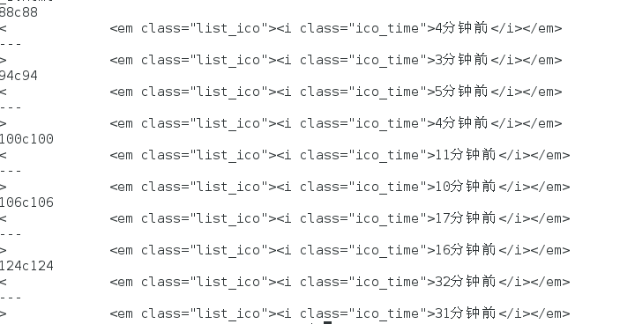

length,md5:different:

(1) html tag (added one space)

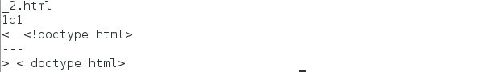

(2)time delay

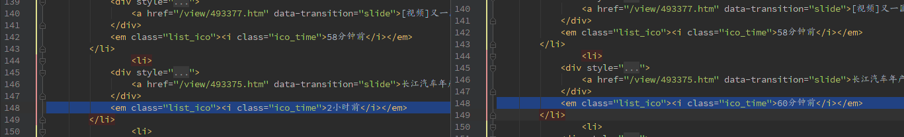

m.cnbeta.com/list_latest_1.htm

length:same

md5:different

information order:

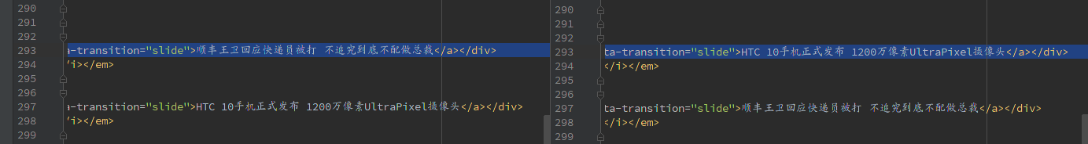

length,md5: different

(1)信息右侧图标指数

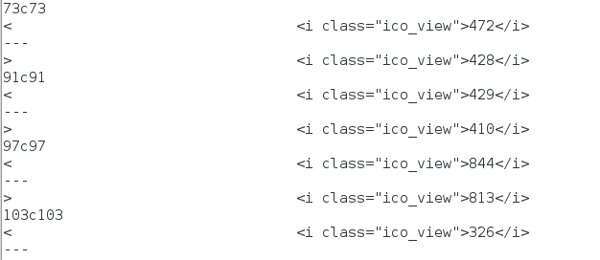



(2) 请求分节点ＩＰ的信息內容少一行

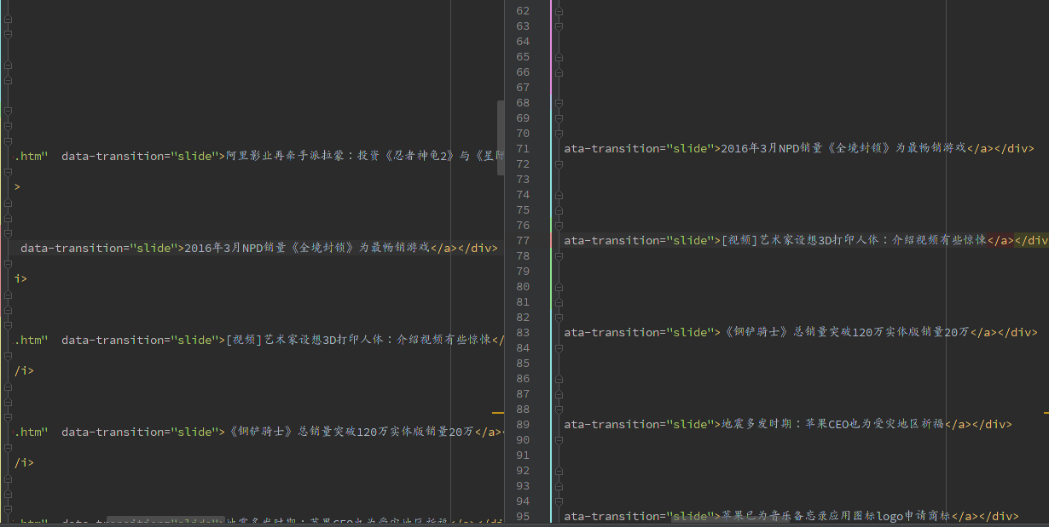

m.cnbeta.com/mobile/wap

length:same

md5:different

time:

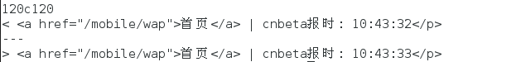

length,md5 :different

html tag (added one space)

