Components of AeroLink

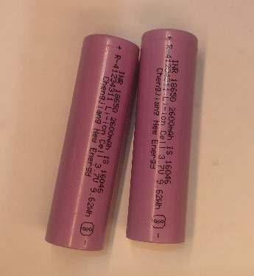

Fig-Energy Source (Batteries)

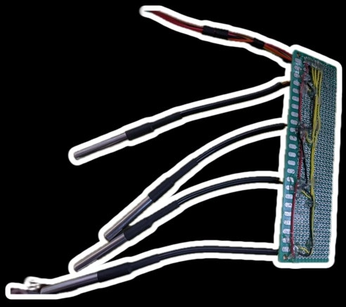

Fig-Temperature Probe Interfacing Board

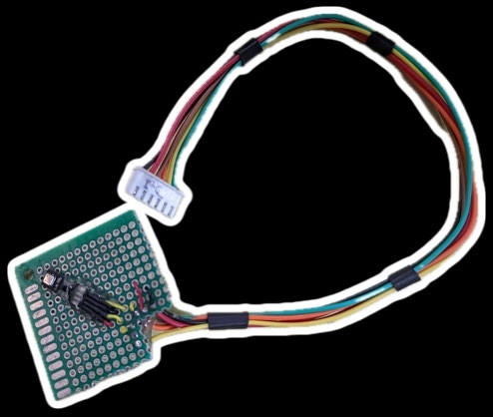

Fig-Chemical Particle Sensor Interfacing Board

