Pcb’s of AeroLink

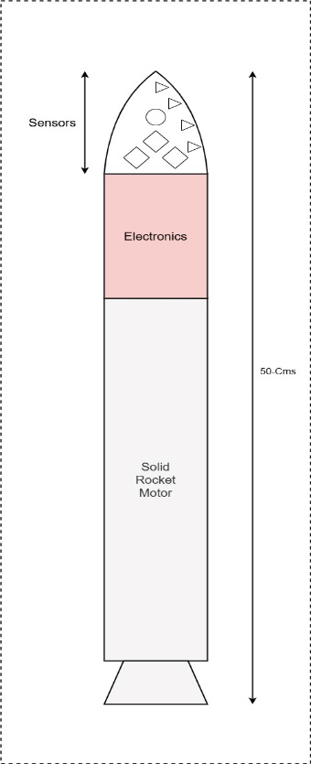

Fig-PCB Stack Configuration of Integrated Electronic Sub

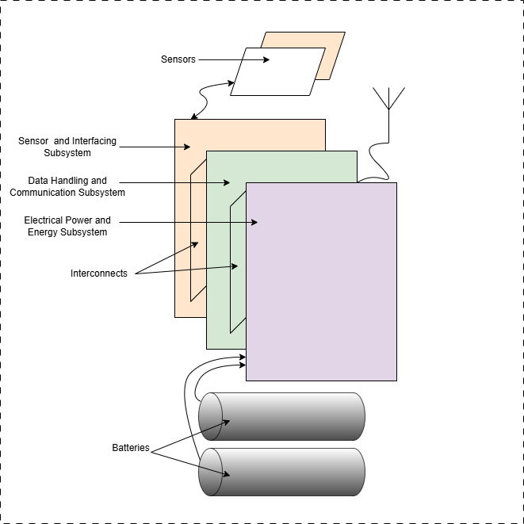

Fig-PCB Stack Configuration of Integrated Electronic System

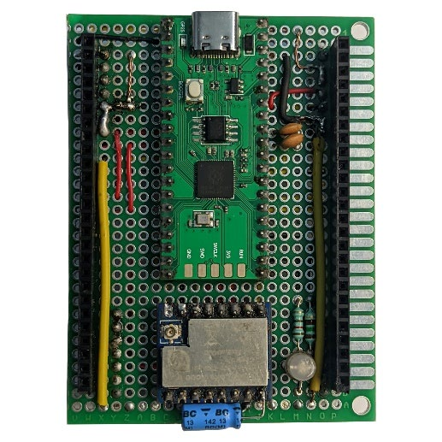

Fig-PCB for Data Handling and Communication

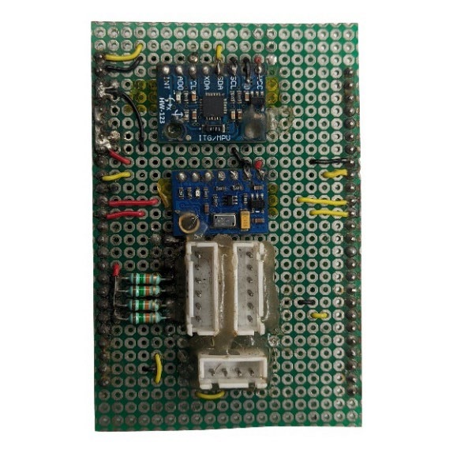

Fig-Sensor and Interfacing PCB

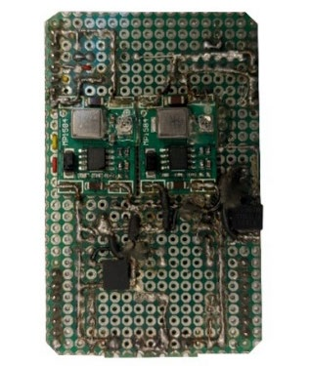

Fig-Electrical Power Subsystem PCB

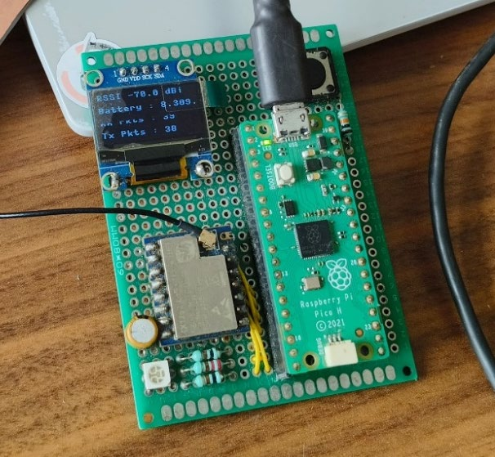

Fig-Ground Control Station PCB

