**iRedMail (Open Source Mail Server)**

## System Requirements:

iRedMail is designed to be deployed on a **FRESH** server system, which means your server does **NOT** have mail related components installed, e.g. MySQL, OpenLDAP, Postfix, Dovecot, Amavisd, etc. iRedMail will install and configure them for you automatically. Otherwise it may override your existing files/configurations althought it will backup files before modifying, and it may not be working as expected.

To install iRedMail on RHEL or CentOS Linux, you need:

* A **FRESH**, working RHEL or CentOS system. Supported releases are listed on [Download](http://www.iredmail.org/download.html) page.
* 2 GB of memory is recommended for a low traffic production server. Spam/Virus scanning will take most system resource.

## Preparations:

* Set a fully qualified domain name (FQDN) hostname on your server
* No matter your server is a testing machine or production server, it's strongly recommended to set a fully qualified domain name (FQDN) hostname.

1. Enter command hostname -f to view the current hostname:

$ hostname -f

csr.scm4u.com

1. For RHEL/CentOS/Scientific Linux 6, hostname is defined in /etc/sysconfig/network:

HOSTNAME=csr.scm4u.com

1. For RHEL/CentOS/Scientific Linux 7, hostname is defined in /etc/hostname.

csr.scm4u.com

1. /etc/hosts: hostname <=> IP address mapping. Warning: List the FQDN hostname as first item.

127.0.0.1 csr.scm4u.com csr localhost localhost.localdomain

1. Verify the FQDN hostname. If it wasn't changed, please reboot server to make it work.

$ hostname -f

csr.scm4u.com

### Disable SELinux.

* iRedMail doesn't work with SELinux, so please disable it by setting below value in its config file /etc/selinux/config. After server reboot, SELinux will be completely disabled.

SELINUX=disabled

* If you prefer to let SELinux prints warnings instead of enforcing, you can set below value instead:

SELINUX=permissive

* Disable it immediately without rebooting your server.

# setenforce 0

1. Visit [Download page](http://www.iredmail.org/download.html) to get the latest stable release of iRedMail.

* Upload iRedMail to your mail server via ftp or scp or whatever method you can use, login to the server to install iRedMail. We assume you uploaded it to /root/iRedMail-x.y.z.tar.bz2 (replace x.y.z by the real version number).
* Uncompress iRedMail tarball:

# cd /root/

# tar xjf iRedMail-x.y.z.tar.bz2

## Start iRedMail installer

* It's now ready to start iRedMail installer, it will ask you several simple questions, that's all required to setup a full-featured mail server.

# cd /root/iRedMail-x.y.z/

# chmod +x iRedMail.sh

# bash iRedMail.sh

## Screenshots of installation:

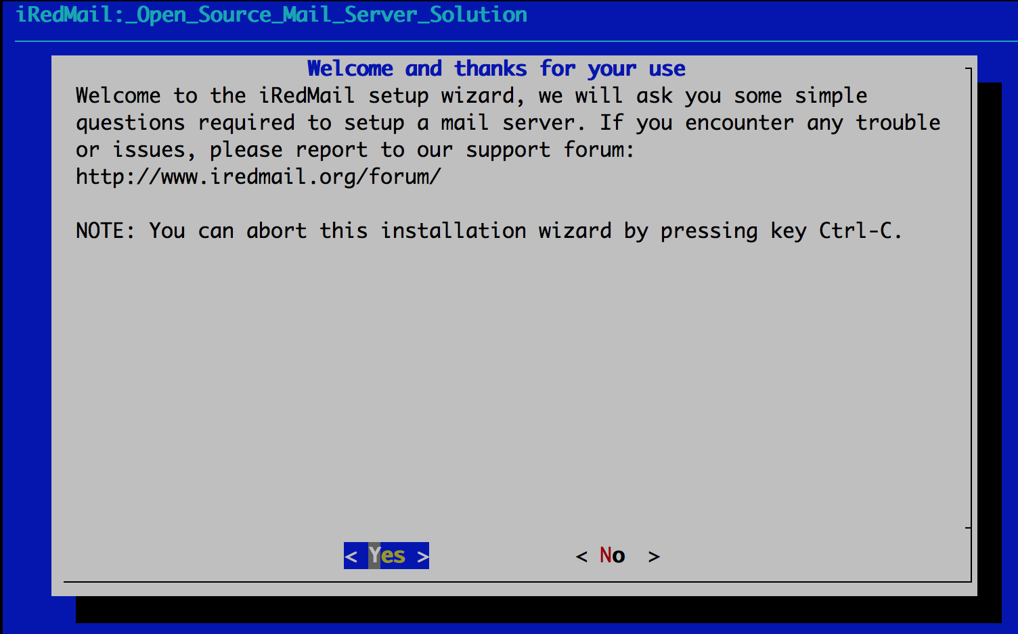

* Specify location to store all mailboxes. Default is /var/vmail/.

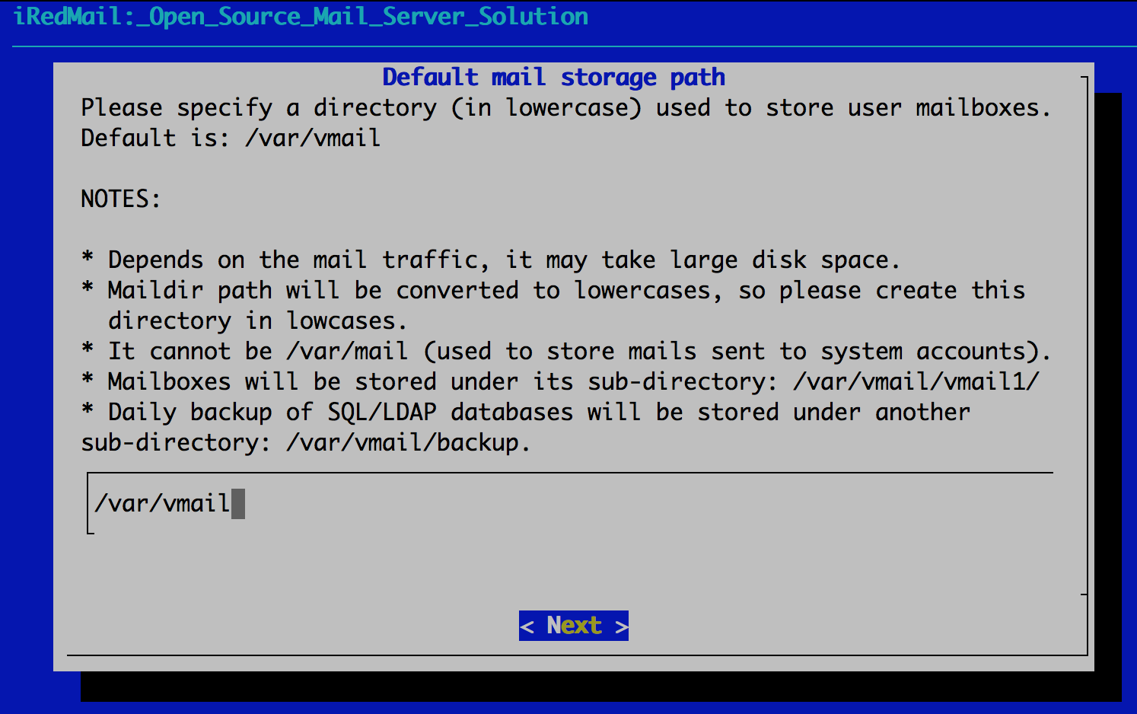

* Select your preferable webserver

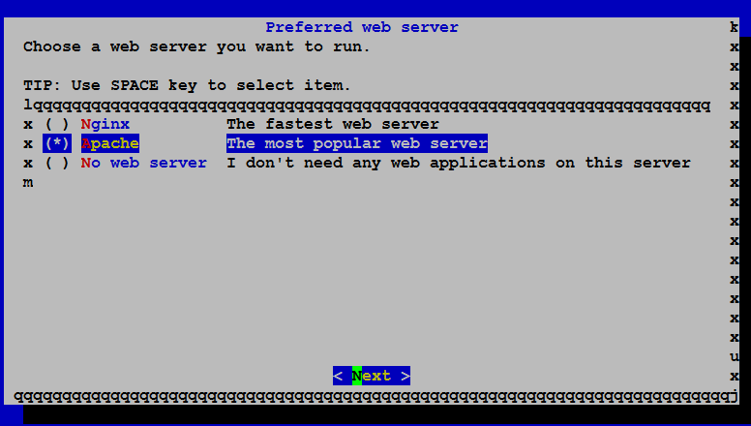

* Choose backend used to store mail accounts. You can manage mail accounts with iRedAdmin, our web-based iRedMail admin panel.

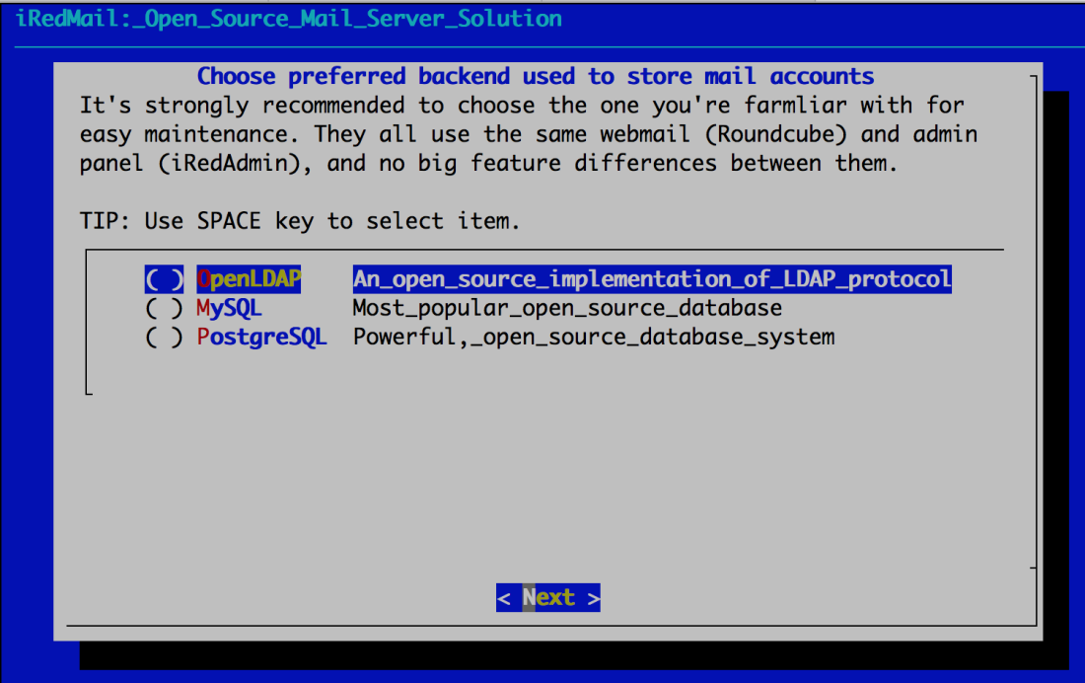

* If you choose to store mail accounts in OpenLDAP, iRedMail installer will ask to set the LDAP suffix.

**To MySQL/MariaDB/PostgreSQL users**

If you choose to store mail accounts in MySQL/MariaDB/PostgreSQL, iRedMail installer will generate a random, strong password for you. You can find it in file iRedMail.tips.

* Add your first mail domain name
* Set password of admin account of your first mail domain.

**Note**: This account is an admin account and a mail user. That means you can login to webmail and admin panel (iRedAdmin) with this account, login username is full email address.

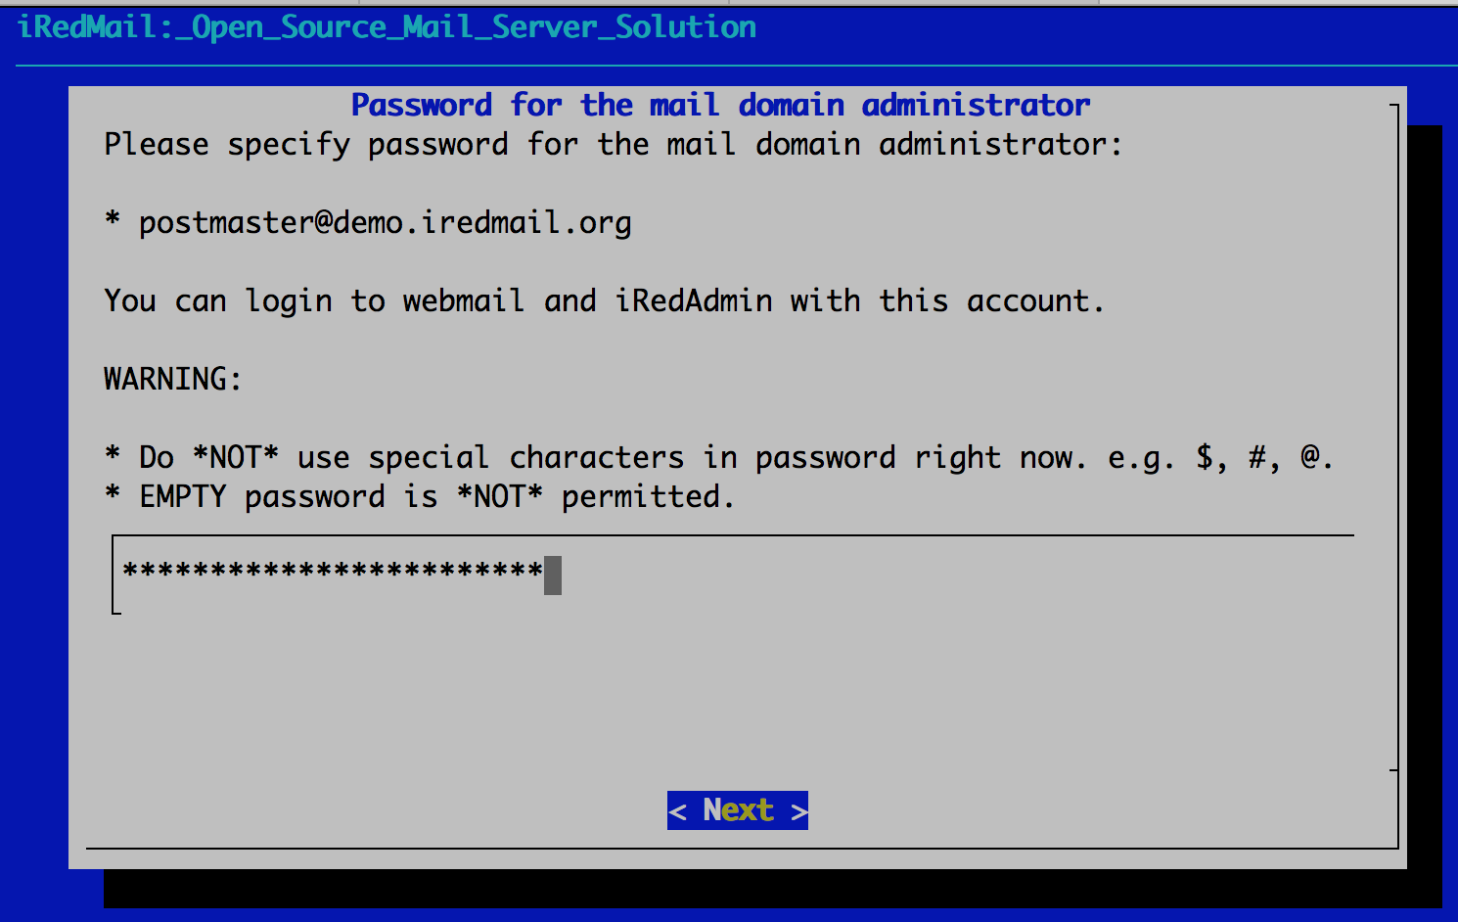

* Choose optional components

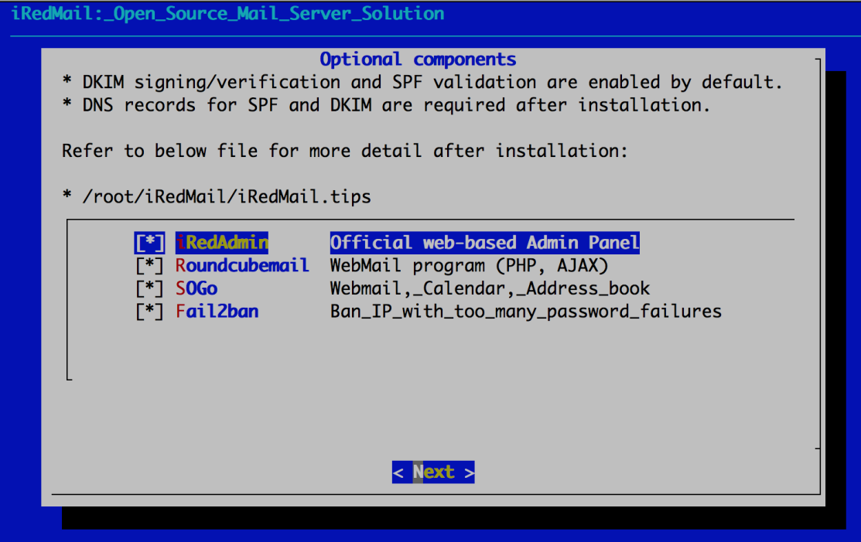

After answered above questions, iRedMail installer will ask you to review and confirm to start installation. It will install and configure required packages automatically. Type y or Y and press Enter to start.

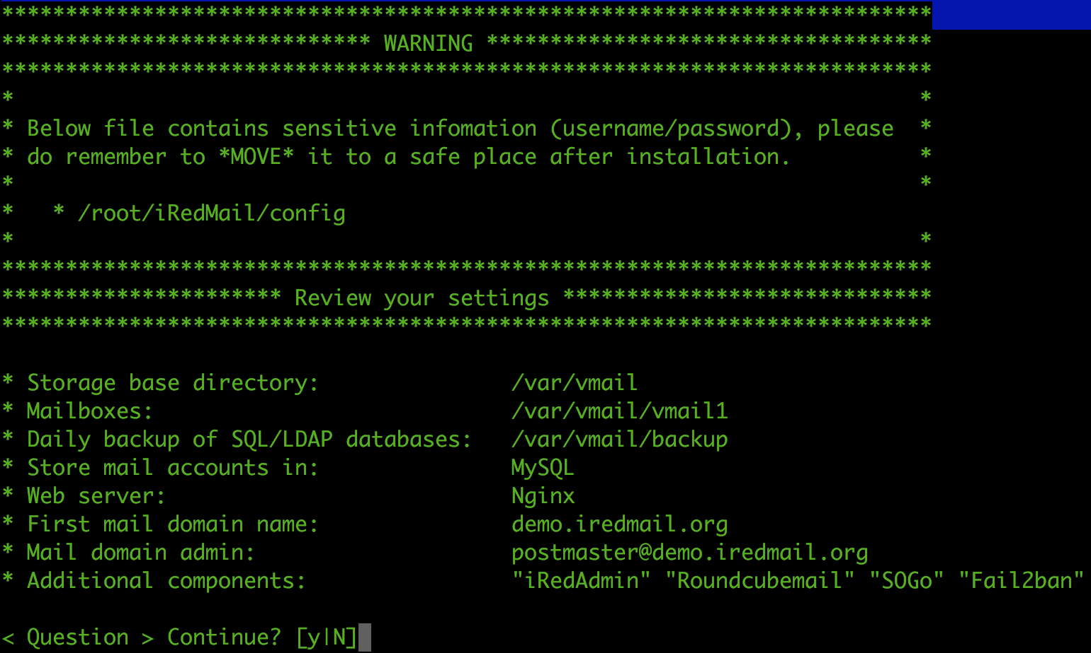

## Important things you ****MUST**** know after installation

**Warning**

The weakest part of a mail server is user's weak password. Spammers don't want to hack your server, they just want to send spam from your server. Please **ALWAYS ALWAYS ALWAYS** force users to use a strong password.

* Read file /root/iRedMail-x.y.z/iRedMail.tips first, it contains:
  + - URLs, usernames and passwords of web-based applications
    - Location of mail service related software configuration files. You can also check this tutorial instead: [Locations of configuration and log files of major components](http://www.iredmail.org/docs/file.locations.html).
    - Some other important and sensitive information
* [Setup DNS records for your mail server](http://www.iredmail.org/docs/setup.dns.html)
* [How to configure your mail clients](http://www.iredmail.org/docs/index.html#configure-mail-client-applications)
* [Locations of configuration and log files of major components](http://www.iredmail.org/docs/file.locations.html)
* It's highly recommended to get a SSL cert to avoid annonying warning message in web browser or mail clients when accessing mailbox via HTTPS/IMAPS/POP3/SMTPS. [Let's Encrypt offers **FREE** SSL certificate](https://letsencrypt.org/). We have a document for you to [use a SSL certificate](http://www.iredmail.org/docs/use.a.bought.ssl.certificate.html).
* If you need to bulk create mail users, check our document for [OpenLDAP](http://www.iredmail.org/docs/ldap.bulk.create.mail.users.html) and [MySQL/MariaDB/PostgreSQL](http://www.iredmail.org/docs/sql.bulk.create.mail.users.html).
* If you're running a busy mail server, we have [some suggestions for better performance](http://www.iredmail.org/docs/performance.tuning.html).

## Access webmail and other web applications

After installation successfully completed, you can access web-based programs if you choose to install them. Replace your_serverbelow by your real server hostname or IP address.

* **Roundcube webmail**: <https://your_server/mail/>
* **SOGo Groupware**: <https://your_server/SOGo>
* **Web admin panel (iRedAdmin)**: [httpS://your_server/iredadmin/](https://your_server/iredadmin/)
* **Awstats**: [httpS://your_server/awstats/awstats.pl?config=web](https://your_server/awstats/awstats.pl?config=web) (or ?config=smtp for SMTP traffic log)