**[Project]**

**DETAIL DESIGN DOCUMENT**

**Data design**

**Project Code:**

**Document Code: <Project code>-DD – v<Version>**

### <Location, issued date of the Document>

**RECORD OF CHANGE**

#### *A - Added M - Modified D – Deleted

|  |  |  |  |  |
| --- | --- | --- | --- | --- |
| Effective Date | Changed Items | A* M, D | Change Description | New Version |
| 16/11/2017 | Table: product | A | Add two column into table product. This is product_price and product_quantity. | 1.0.1 |
| 16/11/2017 | Table : user | A | Add two column into table user. This is user_addpress and user_phone. |
| 16/11/2017 | Database:Xe_May |  | Add table customer into database Xe_May |
| 14/12/2017 | Table: Customer | D |  | 1.0.2 |
| Table Moto_model | M | Delete all columns but remain two column are moto_model_id and moto_model_name. |
|  |  |  |  |  |
|  |  |  |  |  |
|  |  |  |  |  |
|  |  |  |  |  |

**SIGNATURE PAGE**

**ORIGINATOR:**<Name>Nguyễn Hoàng Duy <Date>16/11/2017

#### <Position>Trà sữa Domino.

**REVIEWERS:** <Name>Nguyễn Trung Thức <Date>16/11/2017

#### <Position>Trà sữa Domino

<Name>Nguyễn Văn Khoa <Date>16/11/2017

#### <Position>Trà sữa Domino

<Name>Đặng Ngọc Ánh <Date>16/11/2017

#### <Position>Trà sữa Domino

**APPROVAL:** <Name>Nguyễn Trung Thức <Date>16/11/2017

#### <Position>Trà sữa Domino

<Name>Nguyễn Văn Khoa <Date>16/11/2017

#### <Position>Trà sữa Domino

<Name>Đặng Ngọc Ánh <Date>16/11/2017

#### <Position>Trà sữa Domino

MỤC LỤC

<Location, issued date of the Document> 1

1. MÔ HÌNH DỮ LIỆU QUAN HỆ 5

2. DATABASE 6

2.1 User table 7

2.2 Moto_model table 7

2.3 Producer table 7

2.4 Orders_Detail table 8

2.5 Employer_table 8

2.6 Orders_table 8

2.7 Product_table 9

2.8 Categories_table 10

2.9 Main_detail Table: 10

# MÔ HÌNH DỮ LIỆU QUAN HỆ

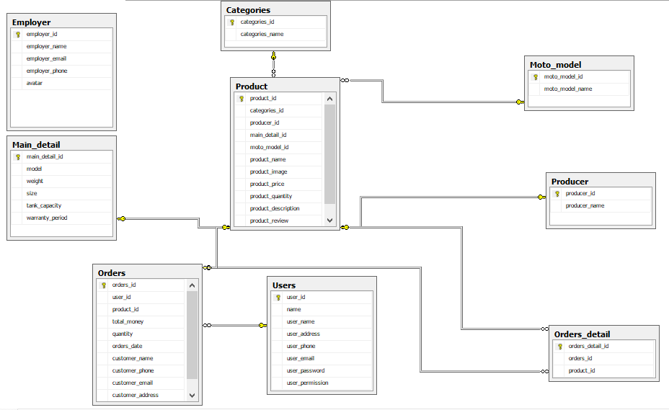

# DATABASE

<List of tables and brief description>

|  |  |  |
| --- | --- | --- |
| **No** | **Table Name** | **+Decription** |
| 01 | Categories | Contain information about kinds of motobike |
| 02 | Orders | Order made by customer to buy one or more products |
| 03 | Moto_model | Save model motobike. |
| 04 | Producer | Save name and ID of producer. |
| 05 | Employer | Save information of employer. |
| 06 | Users | Save information of user. |
| 07 | Orders_detail | Detail information of each products and orders in order |
| 08 | Product | Contains all information products of the store |
| 09 | Main_detail | Contain detail information of model |

## User table

|  |  |  |  |  |  |  |  |  |  |  |
| --- | --- | --- | --- | --- | --- | --- | --- | --- | --- | --- |
| **No** | **Field Name** | **Type** | **Length** | **Size** | **Null** | **Unique** | **P/F Key** | **Default** | **Check** | **Description** |
| 01 | user_id | int |  |  |  | x | P |  |  | Auto number |
| 02 | user_name | nvarchar | 100 |  | x |  |  |  |  | Name of user |
| 03 | user_address | nvarchar | 500 |  | x |  |  |  |  | Address of user |
| 04 | user_phone | int | 11 |  | x |  |  |  |  | Phone of user |
| 05 | user_email | nvarchar | 100 |  | x |  |  |  |  | Email of user |
| 06 | user_password | nvarchar | 32 |  | x |  |  |  |  | Password of account user |
| 07 | user_permission | int | 1 |  | x |  |  |  |  | Permission for user |

## Moto_model table

|  |  |  |  |  |  |  |  |  |  |  |
| --- | --- | --- | --- | --- | --- | --- | --- | --- | --- | --- |
| **No** | **Field Name** | **Type** | **Length** | **Size** | **Null** | **Unique** | **P/F Key** | **Default** | **Check** | **Description** |
| 01 | moto_model_id | int |  |  |  | x | P |  |  | Auto number |
| 02 | moto_model_name | nvarchar | 500 |  | x |  |  |  |  | Name of moto_model |

## Producer table

|  |  |  |  |  |  |  |  |  |  |  |
| --- | --- | --- | --- | --- | --- | --- | --- | --- | --- | --- |
| **No** | **Field Name** | **Type** | **Length** | **Size** | **Null** | **Unique** | **P/F Key** | **Default** | **Check** | **Description** |
| 01 | Producer_id | int |  |  |  | x | P |  |  | Auto number |
| 02 | producer_name | nvarchar | 500 |  | x |  |  |  |  | Name of producer |

## Orders_Detail table

|  |  |  |  |  |  |  |  |  |  |  |
| --- | --- | --- | --- | --- | --- | --- | --- | --- | --- | --- |
| **No** | **Field Name** | **Type** | **Length** | **Size** | **Null** | **Unique** | **P/F Key** | **Default** | **Check** | **Description** |
| 01 | Orders_detail_id | int |  |  |  | x | P |  |  | Auto number |
| 02 | orders_id | nvarchar | 100 |  | x |  | F |  |  | Information of orders |
| 03 | product_id | nvarchar | 500 |  | x |  | F |  |  | Information of product |

## Employer_table

|  |  |  |  |  |  |  |  |  |  |  |
| --- | --- | --- | --- | --- | --- | --- | --- | --- | --- | --- |
| **No** | **Field Name** | **Type** | **Length** | **Size** | **Null** | **Unique** | **P/F Key** | **Default** | **Check** | **Description** |
| 01 | employer_id | int |  |  |  | x | P |  |  | Auto number |
| 02 | employer_name | nvarchar | 100 |  | x |  |  |  |  | Name of employer |
| 03 | employer_email | nvarchar | 500 |  | x |  |  |  |  | Email of employer |
| 04 | employer _phone | int | 11 |  | x |  |  |  |  | Phone of employer |

## Orders_table

|  |  |  |  |  |  |  |  |  |  |  |  |
| --- | --- | --- | --- | --- | --- | --- | --- | --- | --- | --- | --- |
| **No** | **Field Name** | **Type** | | **Length** | **Size** | **Null** | **Unique** | **P/F Key** | **Default** | **Check** | **Description** |
| 01 | orders_id | | int |  |  |  | x | P |  |  | Auto number |
| 03 | Product_id | | int |  |  | x |  | F |  |  | Information of product |
| 04 | User_id | | int |  |  | x |  | F |  |  | Information of user buy product |
| 05 | Total_money | | int |  |  | x |  |  |  |  | Count money customer or user buy product |
| 06 | quantity | | int |  |  | x |  |  |  |  | quantity bought product |
| 07 | Orders_date | | datatime |  |  | x |  |  |  |  | Date write orders |
| 08 | customer_name | | nvarchar | 100 |  | x |  |  |  |  | Name of customer |
| 09 | customer_phone | | int | 11 |  | x |  |  |  |  | Phone number of customer |
| 10 | customer_email | | nvarchar | 11 |  | x |  |  |  |  | Email of customer |
| 11 | customer_address | | nvarchar | 100 |  | x |  |  |  |  | Address of customer |

## Product_table

|  |  |  |  |  |  |  |  |  |  |  |
| --- | --- | --- | --- | --- | --- | --- | --- | --- | --- | --- |
| **No** | **Field Name** | **Type** | **Length** | **Size** | **Null** | **Unique** | **P/F Key** | **Default** | **Check** | **Description** |
| 01 | product_id | int |  |  |  | x | P |  |  | Auto number |
| 02 | producer_id | int |  |  | x |  | F |  |  | Information of producer |
| 03 | Categories_id | int |  |  | x |  | F |  |  | Information of categories |
| 04 | Main_detail_id | int |  |  | x |  | F |  |  | Information of main_detail |
| 05 | moto_model_id | int |  |  | x |  | F |  |  | Information of moto_model |
| 06 | product_name | nvarchar | 500 |  | x |  |  |  |  | Name of product |
| 07 | product_image | nvarchar | 500 |  | x |  |  |  |  | Image of product |
| 08 | product_price | int |  |  | x |  |  |  |  | Price product |
| 09 | product_quantity | int |  |  | x |  |  |  |  | Quantity of product |
| 10 | product_description | nvarchar | 1000 |  | x |  |  |  |  | Description product |
| 11 | product_review | nvarchar | 1000 |  | x |  |  |  |  | Review product |

## Categories_table

|  |  |  |  |  |  |  |  |  |  |  |
| --- | --- | --- | --- | --- | --- | --- | --- | --- | --- | --- |
| **No** | **Field Name** | **Type** | **Length** | **Size** | **Null** | **Unique** | **P/F Key** | **Default** | **Check** | **Description** |
| 01 | categories_id | int |  |  |  | x | P |  |  | Auto number |
| 02 | categories_name | nvarchar | 100 |  | x |  |  |  |  | Name of categories |

## Main_detail Table:

## 

|  |  |  |  |  |  |  |  |  |  |  |
| --- | --- | --- | --- | --- | --- | --- | --- | --- | --- | --- |
| **No** | **Field Name** | **Type** | **Length** | **Size** | **Null** | **Unique** | **P/F Key** | **Default** | **Check** | **Description** |
| 01 | Main_detail_id | int |  |  |  | x | P |  |  | Auto number |
| 02 | model | nvarchar | 500 |  | x |  |  |  |  | Model |
| 03 | weight | float |  |  | x |  |  |  |  | Weight of motobike |
| 04 | size | float |  |  | x |  |  |  |  | Size of motobike |
| 05 | tank_capacity | float |  |  | x |  |  |  |  | Tank_capacity of motobike |
| 06 | warranty_period | nvarchar | 50 |  | x |  |  |  |  | Period of warranties |