**Project Report**

Sudoku Game

Created using basic OOP concepts

Project Title: Sudoku Game

Course no: CSE 1206

Course Title: Object-Oriented Programming Laboratory

Submitted To:

**Md. Repon Islam**

Lecturer  
Department of Computer Science and Engineering  
Khulna University of Engineering & Technology, Khulna

**Safin Ahmmed**  
Lecturer  
Department of Computer Science and Engineering  
Khulna University of Engineering & Technology, Khulna

Submitted By:

**Ankon Roy**

Roll: **2107113**

Department: Department of Computer Science and Engineering

Khulna University of Engineering and Technology, Khulna

Submission Date: 24-09-2023

***Project Overview***

Sudoku game is a puzzle-type game that we all love to play from children to old people in this project I tried to make this puzzle game in C++ programming language.

**Objectives**

The primary objective of this project is to play sudoku games on a virtual platform like a computer:

1. Interactive Taxonomy:

The project provides an interactive interface that allows users to make changes in different positions.

1. Use of C++ OOP Concepts and more:

The project demonstrates the use of object-oriented programming (OOP) principles in C++. It employs inheritance, polymorphism, and encapsulation to represent the taxonomic hierarchy. Special keywords in C++ like ‘friend’ keywords were used to use concepts of function outside of the classes.

***Code Structure***

The code is structured into two classes to represent the game. The key classes and functions are include:

* Sudoku: Represents the base of classification.

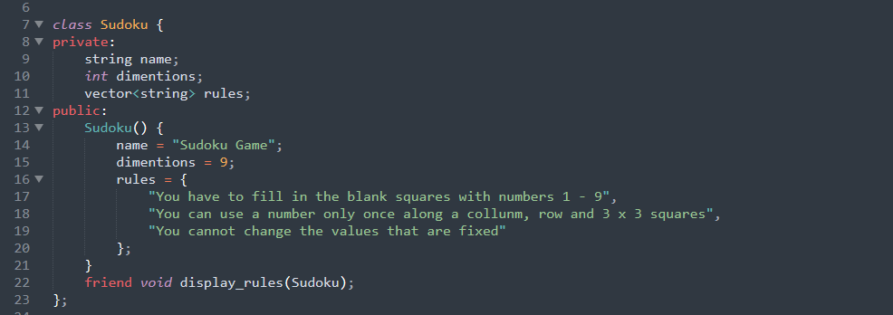

* SudokuHard: Represents the derivation of Sudoku.

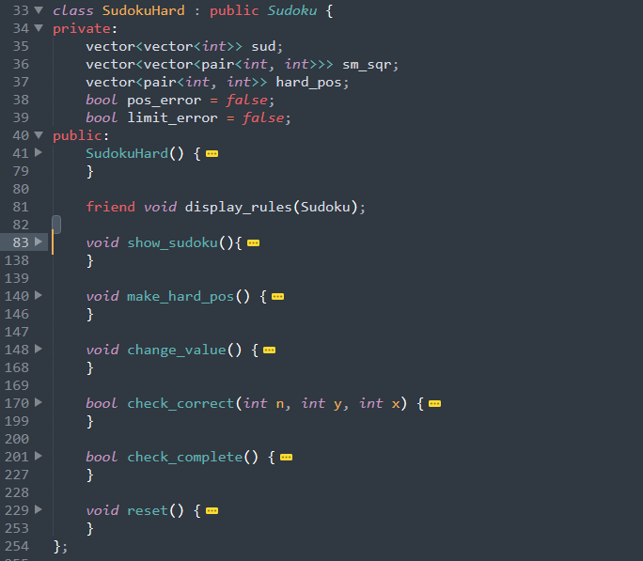

* display_rules(): Shows the rules to play the game.

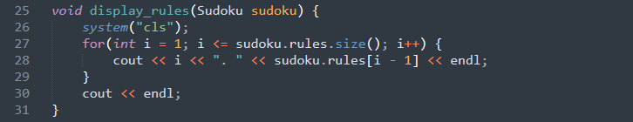

* show_sudoku(): Shows the main sudoku game.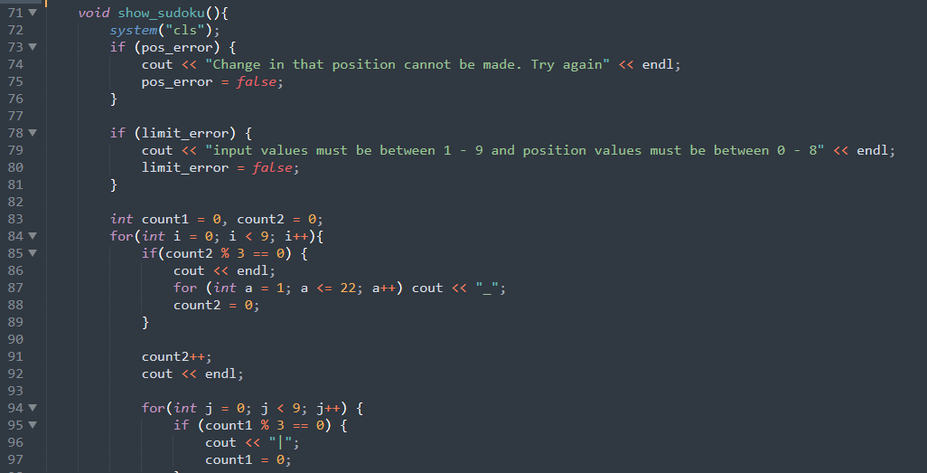

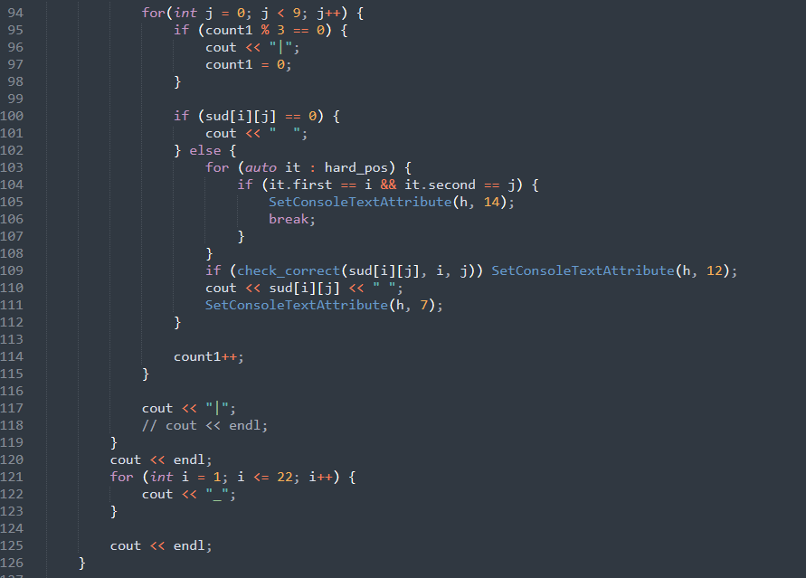

* make_hard_pos(): Sets the position of the values that cannot be changed.

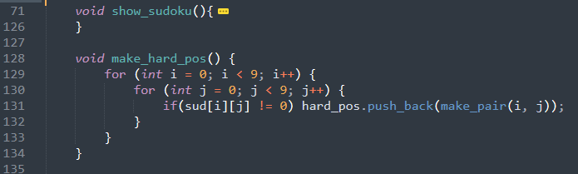

* change_value(): This function is used to assign a value at a position.

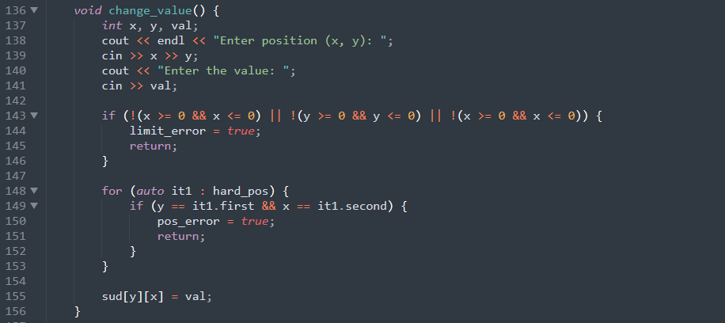

* check_correct(): This function checks if a value in a position is valid or not.

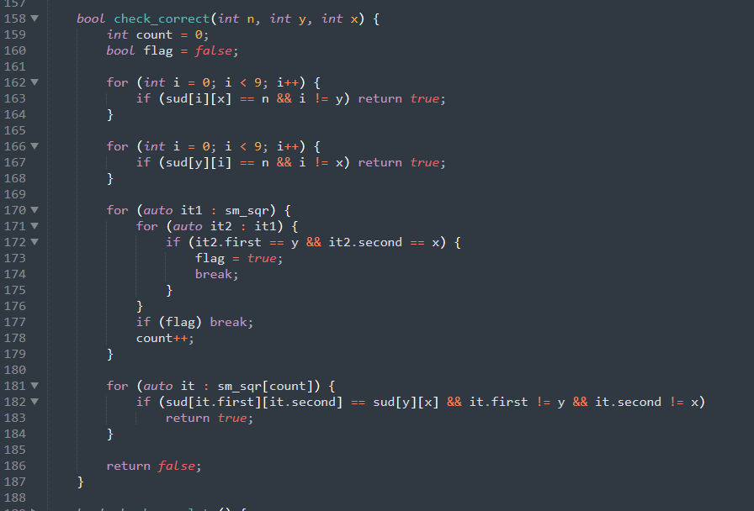

***Key Features***

* **Interactive Interface**

The project provides an interactive and friendly interface for the user. After running the program the program will show the basic rules of playing a sudoku game. Then it will ask the user if he wants to play the game.

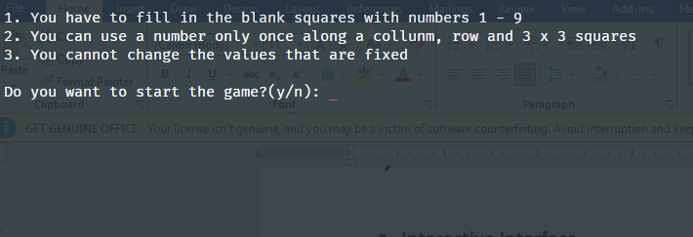

After the game starts The sudoku game will be displayed as shown in the picture. The user will be asked for the position and value in that position. If a user makes any silly mistake it will also warn the user about it.

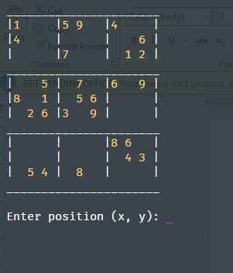 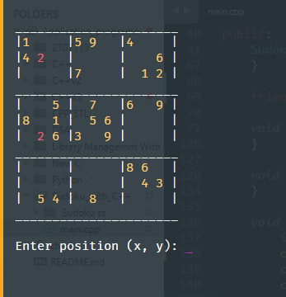

***Possible Future Enhancements***

To further improve this project, the following enhancements can be considered:

**Database Integration:**

In the future, we can add a database of sudoku games. Currently, there is only one puzzle in the project. But if we use the database, we can use multiple puzzles in our game.

**Calculate time:**

Develop a feature to keep track of how much time is taken by the user to solve the puzzle. We can also store the value to calculate the highest scores and make a list of top players.

***Conclusion***

**Sudoku**, also known as **Su Doku**, popular form of number game. A simple and most common configuration, sudoku consists of a 9 × 9 grid with numbers appearing in some of the squares. The object of the puzzle is to fill the remaining squares, using all the numbers 1–9 exactly once in each row, column, and the nine 3 × 3 subgrids. Sudoku is based entirely on logic, without any arithmetic involved, and the level of difficulty is determined by the quantity and positions of the original numbers.

The goal of this project was to bring this amazing puzzle game to a computer platform so that people could play this game on their computers. They can simply run the program and get ready to play. Otherwise playing this game in real life can require a lot of paper which is not good for the environment.