Talent Acquisition

1. Department Head will request a job acquisition
2. HR or GM will approve it
3. Once it is approved it will be a “open position”
4. Requisition Approval
5. Requisition Status
6. Resume Management
7. Schedule Interviews Send Emails, Invite Managers, Calendar Functions
8. Select Candidate
9. Onboarding
10. Background Checks
11. HR

Admin

1. Setup Company
2. Setup Master User/ Login
3. See Screen Shot
4. Subscription Settings
   * + 1. Enter User Name
       2. Create Password or system generated
       3. Confirm Password
       4. Email Information
       5. Personal Information; First Name, Last Name, Title
       6. Company Information, Company Name, Address1, Address2, City, State, Zip & Phone Number.
       7. Welcome Email
       8. Subscription Settings, Start Date, End Date (30 Days) 1 Year, 2 Year, No Expiration.
       9. Type: Client, Partner, Prospect, Staff
       10. Billable- Demo, Per Employee, Onetime Fee Per month
       11. 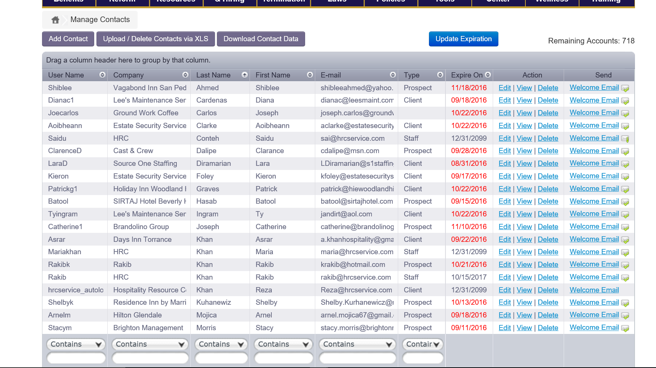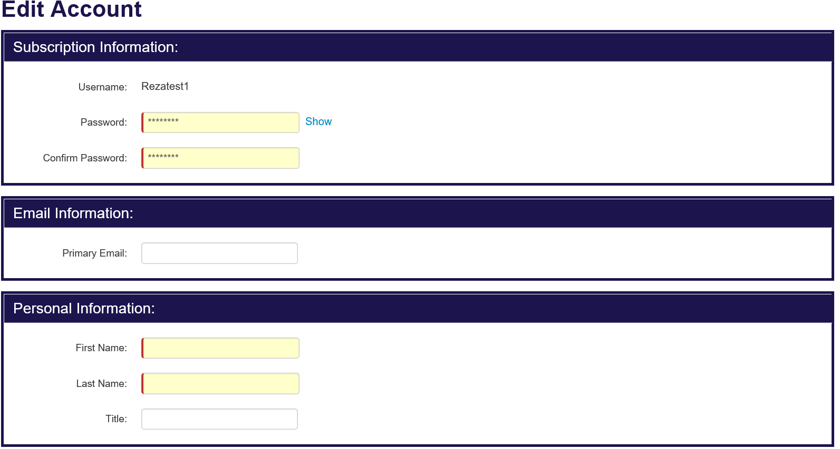

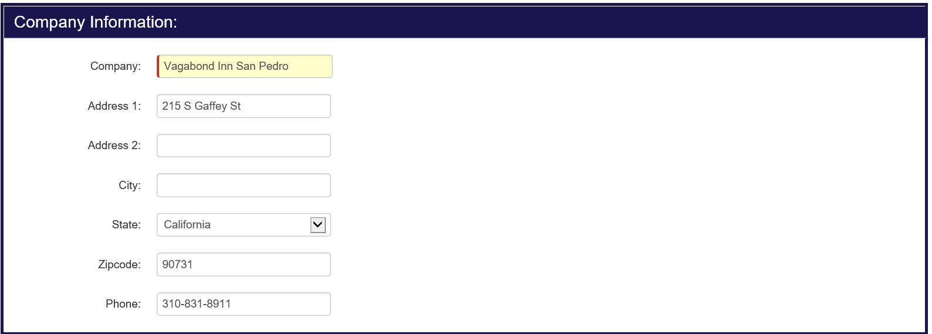



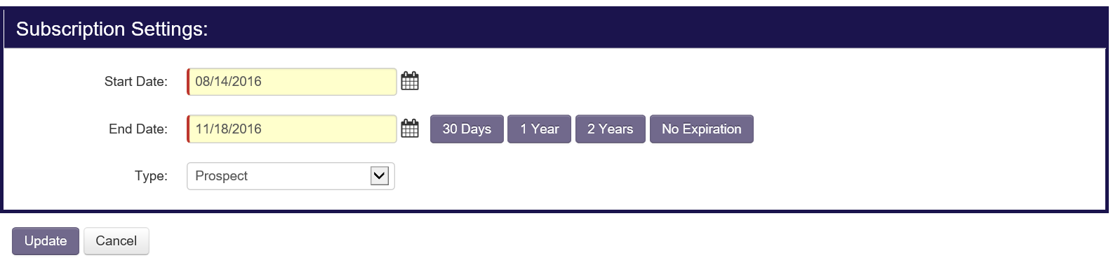

FORMS: