Background Check:

Background check module will be use to track information regarding an employee or applicant. Depending on Company’s requirements.

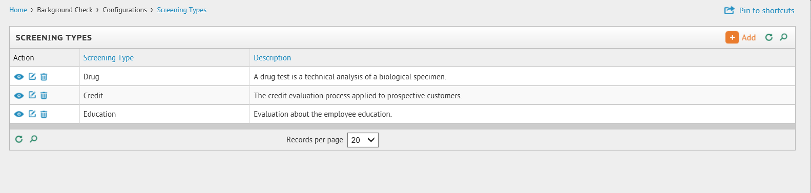

There are many types of background checks. First 5 of them are most common.

1. Credit Check
2. Drug Test
3. Education Check
4. Previous Employer Verification
5. Criminal background checks

Additional Types:

* Driving records
* Vehicle registration
* Credit records
* Criminal records
* Social Security no.
* Education records
* Court records
* Workers' compensation
* Bankruptcy
* Character references
* Medical records
* Property ownership
* Military records
* State licensing records
* Drug test records
* Past employers
* Personal references
* Incarceration records
* Sex offender lists

Agencies:

There are many 3 parties available in the U.S. to perform the background checks for the employers, and Agency information and contact information needs to be in place.

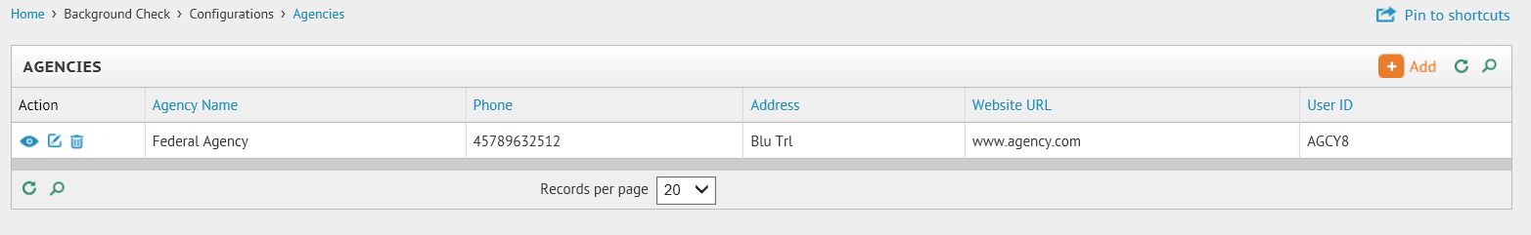

[We](https://www.payrollrelief.com/Help/Acct/searchresults1.htm) will need the following:

1. Employee/Applicant should be available from the drop down menu or search for the employee/applicant.
2. Status Showing :

