First used the npm install to download the necessary files that going to be used in folder

Then to start the server we used to run continue

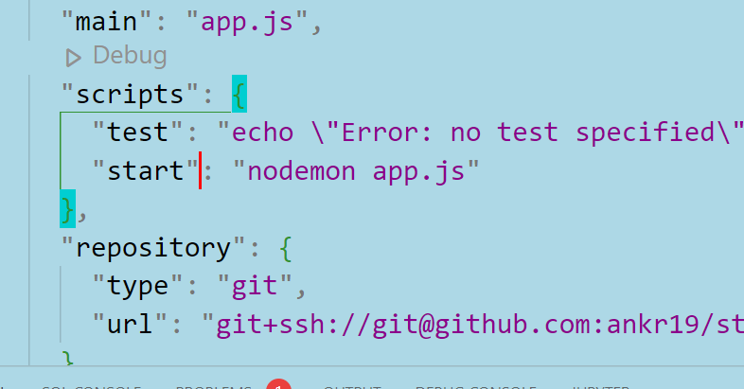

Add the start command to run the server using the nodemon.

In Database Folder

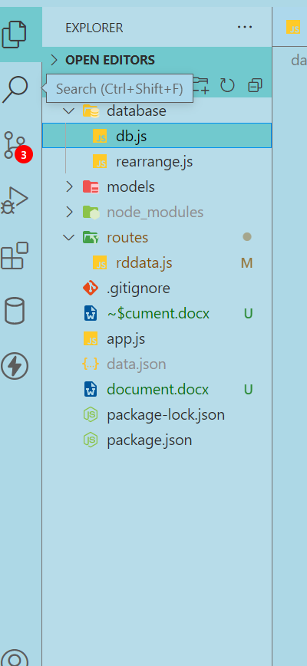

Db.js file change the mongodb url = "url/rdData

?readPreference=primary

&appname=MongoDB%20Compass

&ssl=false";

In routes folder

In the rddata.js file, only the router 3 and router 4 is need for transferring the data into the server. In the try the data is collected and then in finally part the data is rearrange with the and is more particular.

All the folder the just the going to be same.

Now using the postman we can using simply send the json data back to the server 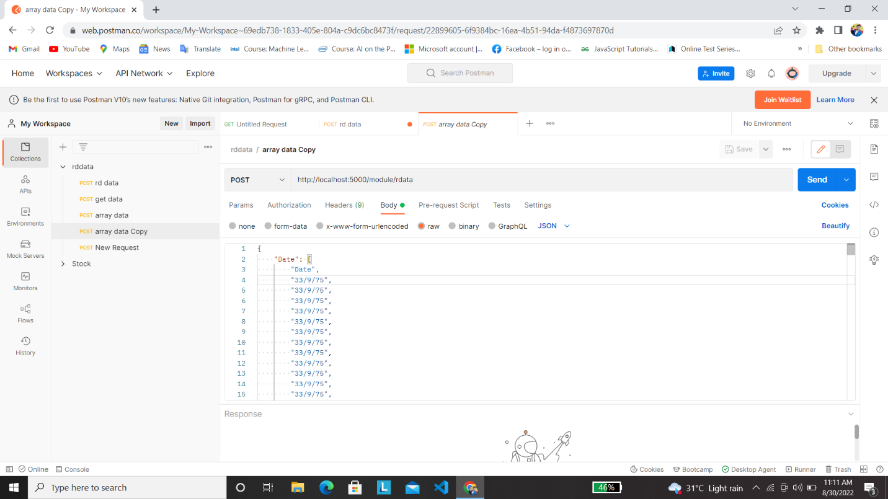

In the first arrow,

url is http://localhost:5000/module/rdata/ -> to store the raw data and refine the data to recollect the data.

url is <http://localhost:5000/module/getData> -> to give the all data that is stored into the server.