**Practical: 3.6**

**Aim:**

Consider Bank Table with attributes AccountNo, Customer Name, Balance, Phone and Address. Write a JDBC Program which allows insertion, updation and deletion of record in Bank Table. Print values of all customers whose balance is greater then specified amount. (Hint: program should be menu driven).

**Description:**

In this program, we are creating main account class which contains the menu driven of insertion updation, selection and deletion according to the user choice. I have created separate class file for insertion, updation, selection and deletion each. This four class contains methods of that respectively. This class will be called according to user choice. And I have also created a database named as account which contains table of account with column account no, account name, amount and contact no.

**Program code:**

**Account.java**

//STEP 1. Import required packages

**import** java**.**util**.**Scanner**;**

public class Account **{**

public static void main**(**String args**[])**

**{**

Insert insert **=** **new** Insert**();**

Delete delete **=** **new** Delete**();**

Update update **=** **new** Update**();**

Select select **=** **new** Select**();**

int ch**;**

**do**

**{**

System**.**out**.**println**();**

System**.**out**.**println**(**"Please enter your choice:"**);**

System**.**out**.**println**();**

System**.**out**.**println**(**"1. For Creating a new user:"**);**

System**.**out**.**println**(**"2. For Updating a Existig user:"**);**

System**.**out**.**println**(**"3. For Deleting a Existig user:"**);**

System**.**out**.**println**(**"4. For Selecting a user according to their account value:"**);**

System**.**out**.**println**(**"5. Exit."**);**

System**.**out**.**println**();**

Scanner sc**=new** Scanner**(**System**.**in**);**

ch **=** sc**.**nextInt**();**

**switch(**ch**)**

**{**

**case** 1**:** insert**.**insert**();**

**break;**

**case** 2**:** update**.**update**();**

**break;**

**case** 3**:** delete**.**delete**();**

**break;**

**case** 4**:** select**.**select**();**

**break;**

**case** 5**:** System**.**out**.**println**(**"Thank You for using our service."**);**

**break;**

**default:** System**.**out**.**println**(**"Please enter the right choice:"**);**

**}**

**}while** **(**ch **!=** 5**);**

**}**

**}**//end main

**Insert.java**

//STEP 1. Import required packages

**import** java**.**sql**.*;**

**import** java**.**util**.**Scanner**;**

public class Insert **{**

public void insert**()**

**{**

// JDBC driver name and database URL

final String JDBC_DRIVER **=** "org.postgresql.Driver"**;**

final String DB_URL **=** "jdbc:postgresql://127.0.0.1:5432/s14008"**;**

// Database credentials

final String USER **=** "postgres"**;**

final String PASS **=** "gopiraj"**;**

Connection conn **=** **null;**

Statement stmt **=** **null;**

**try{**

//STEP 2: Register JDBC driver

Class**.**forName**(**JDBC_DRIVER**);**

//STEP 3: Open a connection

System**.**out**.**println**(**"Connecting to a selected database..."**);**

conn **=** DriverManager**.**getConnection**(**DB_URL**,** USER**,** PASS**);**

System**.**out**.**println**(**"Connected database successfully..."**);**

//STEP 4: Execute a query

// System.out.println("Creating table in given database...");

stmt **=** conn**.**createStatement**();**

String Acc_name**;**

System**.**out**.**print**(**"Please enter your account no:"**);**

Scanner sc**=new** Scanner**(**System**.**in**);**

int Acc_no **=** sc**.**nextInt**();**

System**.**out**.**print**(**"Please enter your account name:"**);**

Acc_name **=** sc**.**next**();**

System**.**out**.**print**(**"Please enter your account balance:"**);**

int balance **=** sc**.**nextInt**();**

System**.**out**.**print**(**"Please enter your contact number:"**);**

String contact_no **=** sc**.**next**();**

String sql **=** "INSERT INTO Account values("**+**Acc_no**+**",'"**+**Acc_name**+**"',"**+**balance**+**",'"**+**contact_no**+**"')"**;**

stmt**.**executeUpdate**(**sql**);**

System**.**out**.**println**(**"Data inserted in given table..."**);**

**}catch(**SQLException se**){**

//Handle errors for JDBC

se**.**printStackTrace**();**

**}catch(**Exception e**){**

//Handle errors for Class.forName

e**.**printStackTrace**();**

**}finally{**

//finally block used to close resources

**try{**

**if(**stmt**!=null)**

conn**.**close**();**

**}catch(**SQLException se**){**

**}**// do nothing

**try{**

**if(**conn**!=null)**

conn**.**close**();**

**}catch(**SQLException se**){**

se**.**printStackTrace**();**

**}**//end finally try

**}**//end try

**}**

**}**//end JDBCExample

**Select.java**

//STEP 1. Import required packages

**import** java**.**sql**.*;**

**import** java**.**util**.**Scanner**;**

public class Select **{**

public void select**()**

**{**

// JDBC driver name and database URL

final String JDBC_DRIVER **=** "org.postgresql.Driver"**;**

final String DB_URL **=** "jdbc:postgresql://127.0.0.1:5432/s14008"**;**

// Database credentials

final String USER **=** "postgres"**;**

final String PASS **=** "gopiraj"**;**

Connection conn **=** **null;**

Statement stmt **=** **null;**

**try{**

//STEP 2: Register JDBC driver

Class**.**forName**(**JDBC_DRIVER**);**

//STEP 3: Open a connection

System**.**out**.**println**(**"Connecting to a selected database..."**);**

conn **=** DriverManager**.**getConnection**(**DB_URL**,** USER**,** PASS**);**

System**.**out**.**println**(**"Connected database successfully..."**);**

//STEP 4: Execute a query

System**.**out**.**println**(**"Please eneter the amount:"**);**

Scanner sc**=new** Scanner**(**System**.**in**);**

int Amount **=** sc**.**nextInt**();**

stmt **=** conn**.**createStatement**();**

String sql **=** "select * from account where balance > "**+**Amount**+**""**;**

//stmt.executeUpdate(sql);

ResultSet rs **=** stmt**.**executeQuery**(**sql**);**

**while(**rs**.**next**())**

**{**

int acc_no**=**rs**.**getInt**(**"Acc_no"**);**

String name**=**rs**.**getString**(**"name"**);**

String bal**=**rs**.**getString**(**"balance"**);**

String no**=**rs**.**getString**(**"contact_no"**);**

System**.**out**.**println**(**"Account number:"**+**acc_no**);**

System**.**out**.**println**(**"Account Name:"**+**name **);**

System**.**out**.**println**(**"Account Balance:"**+**bal**);**

System**.**out**.**println**(**"Contact Number:"**+**no**);**

System**.**out**.**println**();**

**}**

// System.out.println("Created table in given database...");

**}catch(**SQLException se**){**

//Handle errors for JDBC

se**.**printStackTrace**();**

}catch(Exception e){

//Handle errors for Class.forName

e.printStackTrace();

}finally{

//finally block used to close resources

try{

if(stmt!=null)

conn.close();

}catch(SQLException se){

}// do nothing

try{

if(conn!=null)

conn.close();

}catch(SQLException se){

se.printStackTrace();

}//end finally try

}//end try

System.out.println("Goodbye!");

}

}//end JDBCExample

**Delete.java**

//STEP 1. Import required packages

**import** java**.**sql**.*;**

**import** java**.**util**.**Scanner**;**

public class Delete **{**

// JDBC driver name and database URL

public void delete**()**

**{**

final String JDBC_DRIVER **=** "org.postgresql.Driver"**;**

final String DB_URL **=** "jdbc:postgresql://127.0.0.1:5432/s14008"**;**

// Database credentials

final String USER **=** "postgres"**;**

final String PASS **=** "gopiraj"**;**

Connection conn **=** **null;**

Statement stmt **=** **null;**

**try{**

//STEP 2: Register JDBC driver

Class**.**forName**(**JDBC_DRIVER**);**

//STEP 3: Open a connection

System**.**out**.**println**(**"Connecting to a selected database..."**);**

conn **=** DriverManager**.**getConnection**(**DB_URL**,** USER**,** PASS**);**

System**.**out**.**println**(**"Connected database successfully..."**);**

//STEP 4: Execute a query

System**.**out**.**println**(**"Please enter the account no which you want to delete:"**);**

stmt **=** conn**.**createStatement**();**

Scanner sc**=new** Scanner**(**System**.**in**);**

int acc_no **=** sc**.**nextInt**();**

String sql **=** "delete from account where Acc_no = "**+**acc_no**+**""**;**

stmt**.**executeUpdate**(**sql**);**

System**.**out**.**println**(**"Data has been deleted."**);**

**}catch(**SQLException se**){**

//Handle errors for JDBC

se**.**printStackTrace**();**

**}catch(**Exception e**){**

//Handle errors for Class.forName

e**.**printStackTrace**();**

**}finally{**

//finally block used to close resources

**try{**

**if(**stmt**!=null)**

conn**.**close**();**

**}catch(**SQLException se**){**

**}**// do nothing

**try{**

if(conn!=null)

conn.close();

}catch(SQLException se){

se.printStackTrace();

}//end finally try

}//end try

System.out.println("Goodbye!");

}

}//end JDBCExample

**Update.java**

//STEP 1. Import required packages

**import** java**.**sql**.*;**

**import** java**.**util**.**Scanner**;**

public class Update **{**

public void update**()**

**{**

// JDBC driver name and database URL

final String JDBC_DRIVER **=** "org.postgresql.Driver"**;**

final String DB_URL **=** "jdbc:postgresql://127.0.0.1:5432/s14008"**;**

// Database credentials

final String USER **=** "postgres"**;**

final String PASS **=** "gopiraj"**;**

Connection conn **=** **null;**

Statement stmt **=** **null;**

**try{**

//STEP 2: Register JDBC driver

Class**.**forName**(**JDBC_DRIVER**);**

//STEP 3: Open a connection

System**.**out**.**println**(**"Connecting to a selected database..."**);**

conn **=** DriverManager**.**getConnection**(**DB_URL**,** USER**,** PASS**);**

System**.**out**.**println**(**"Connected database successfully..."**);**

//STEP 4: Execute a query

System**.**out**.**println**(**"Creating table in given database..."**);**

stmt **=** conn**.**createStatement**();**

System**.**out**.**println**(**"Please select any choice which you want:"**);**

System**.**out**.**println**(**"1. update name."**);**

System**.**out**.**println**(**"2. update amount."**);**

System**.**out**.**println**(**"3. update contact no."**);**

Scanner sc**=new** Scanner**(**System**.**in**);**

int ch **=** sc**.**nextInt**();**

**if(**ch **==** 1**)**

**{**

System**.**out**.**println**(**"Please enter account no:"**);**

int acc_no **=** sc**.**nextInt**();**

System**.**out**.**println**(**"Please enter new name:"**);**

String name **=** sc**.**next**();**

String sql **=** "update account set name = '"**+**name**+**"' where acc_no = "**+**acc_no**+**""**;**

stmt**.**executeUpdate**(**sql**);**

**}**

**if(**ch **==** 2**)**

**{**

System**.**out**.**println**(**"Please enter account no:"**);**

int acc_no **=** sc**.**nextInt**();**

System**.**out**.**println**(**"Please enter new amount:"**);**

String amount **=** sc**.**next**();**

String sql **=** "update account set balance = "**+**amount**+**" where acc_no = "**+**acc_no**+**""**;**

stmt**.**executeUpdate**(**sql**);**

**}**

**if** **(**ch **==** 3**)**

**{**

System**.**out**.**println**(**"Please enter Contact number:"**);**

int acc_no **=** sc**.**nextInt**();**

System.out.println("Please enter new name:");

String no = sc.next();

String sql = "update account set contact_no = "+no+" where acc_no = "+acc_no+"";

stmt.executeUpdate(sql);

}

//stmt.executeUpdate(sql);

System.out.println("Data updated successfully.");

}catch(SQLException se){

//Handle errors for JDBC

se.printStackTrace();

}catch(Exception e){

//Handle errors for Class.forName

e.printStackTrace();

}finally{

//finally block used to close resources

try{

if(stmt!=null)

conn.close();

}catch(SQLException se){

}// do nothing

try{

if(conn!=null)

conn.close();

}catch(SQLException se){

se.printStackTrace();

}//end finally try

}//end try

System.out.println("Goodbye!");

}

}//end JDBCExample

**Input Output:**

Inserting a new user.

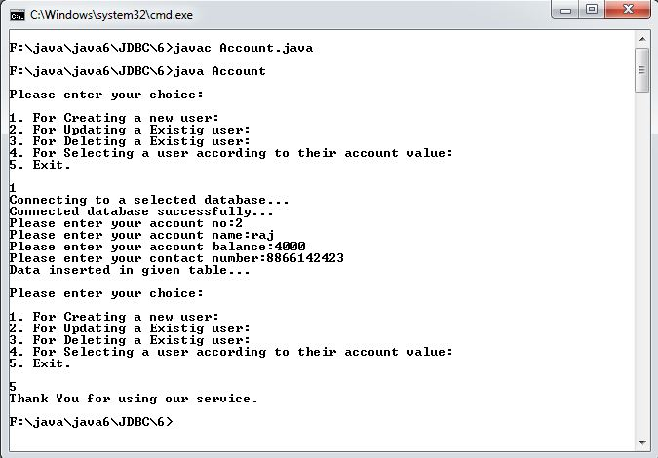

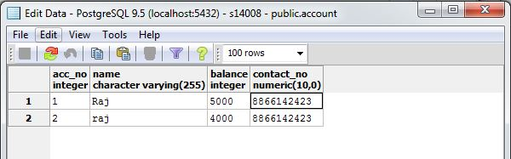

Updating the existing user.

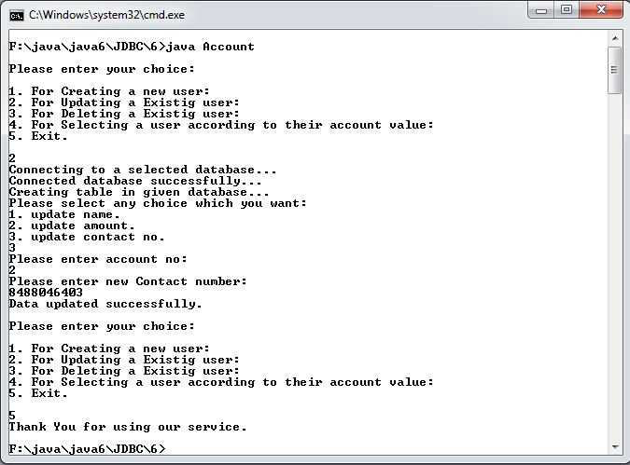

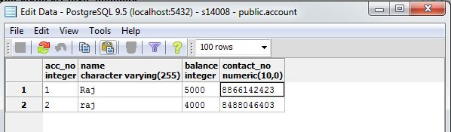

Selecting a data of user.

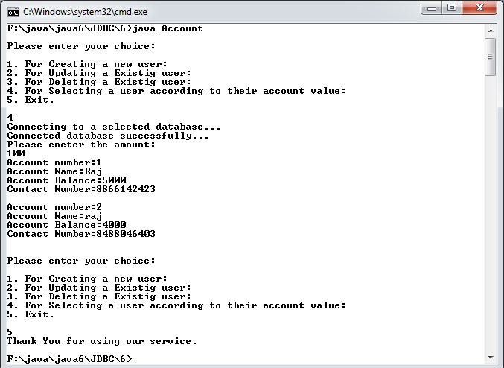

Deleting the existing user.

