aprntc
Design & Solution Document
A self-improving agent that shadows a live agent, distills lessons from its behavior, and is promoted — gated by a human — to a measurably better successor. Codename “Shadow.”
Status: Feature-complete · 288 tests passing
Reference stack: BytePlus ModelArk + VikingDB
Generated: 2026-06-14

Contents

This document describes the system as built — every component below is implemented and tested, and the self-improvement loop has been verified end-to-end on live infrastructure. It pairs with the in-repo docs/DESIGN_AND_SOLUTION.md, the ADRs in docs/decisions/, and docs/PRODUCTION.md.

1. The concept
The #1 limitation of production LLM agents is that they don’t learn from experience — they stay stateless and need manual prompt and dataset work to improve. aprntc closes that gap with an autonomous observe → label → distill → evaluate → promote loop, with a human only at the promotion gate.
An apprentice (“child”) agent is cloned from a live parent, passively shadows it, distills lessons from what worked and what didn’t, becomes measurably better, and — once a human approves — is promoted to replace it. Then the cycle repeats.
SCOPING PRINCIPLE (LOAD-BEARING)
aprntc is not a monitoring or observability product. It learns from the parent’s overall response quality to produce a better successor — episode- and task-level quality signal is the target, not exhaustive trace capture.

2. What the “child” actually is
The single most important thing to understand: there is no separate “child program.” An agent = a fixed engine (the LLM, retrieval, tools, the loop) + a Playbook (a config artifact: system prompt + directives + exemplars + “watch-out” lessons). Parent and child share the exact same engine — the only difference between them is the Playbook.
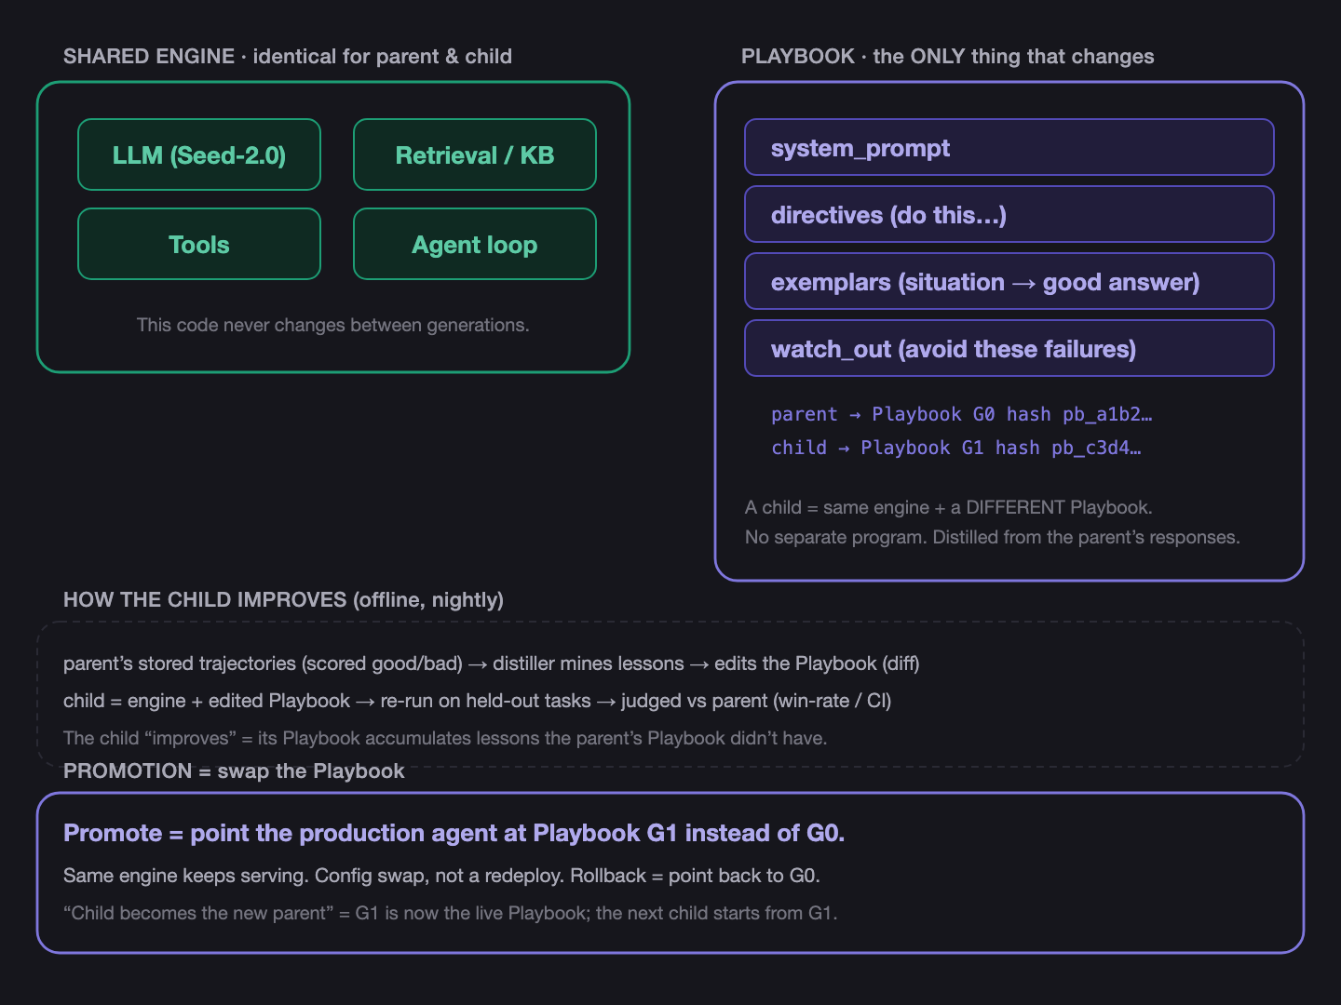
Figure 1 — The parent and child share one engine. Only the Playbook differs; promotion swaps it.
This is the Phase-1 mechanism: playbook distillation, not fine-tuning. The consequences map directly to real-world constraints:
- Works on closed-source LLMs. You can’t fine-tune Seed-2.0 or DeepSeek — but you can change how they’re prompted and what examples and lessons they’re given.
- Attributable. Every lesson traces back to the trajectories that produced it.
- Reversible. A bad promotion is one config swap to undo — no opaque weight changes.

3. The closed loop
Each stage below is implemented; the path from parent run → distilled lesson → memory → child retrieval is verified live (scripts/demo_byteplus_loop.py), where a distilled child won 65–85% of head-to-head comparisons against a real BytePlus support agent.
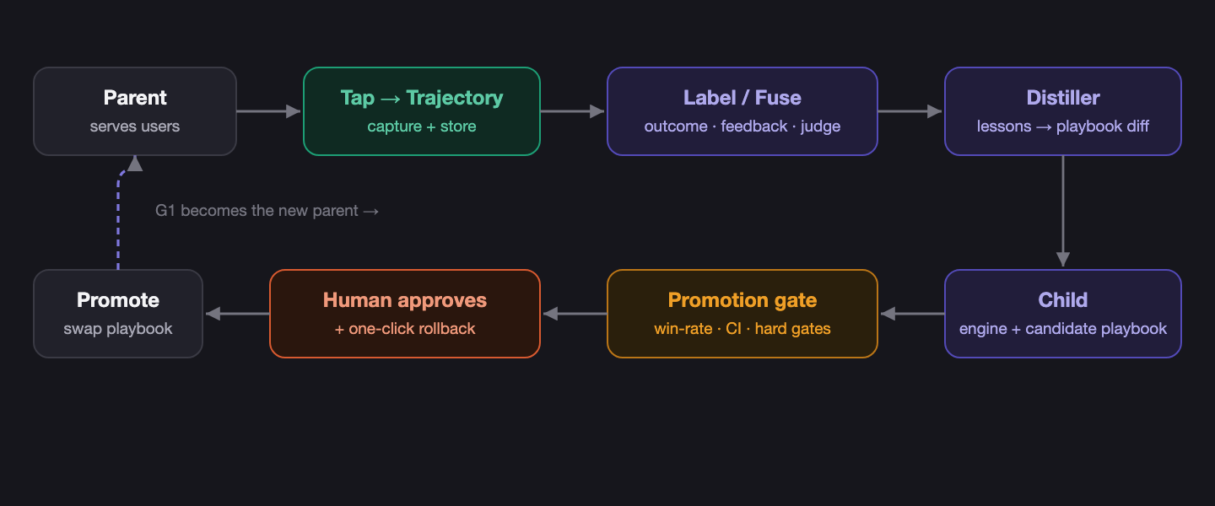
Figure 2 — observe → label → distill → evaluate → promote. The dashed arrow is the only write back to the live agent (a gated config swap).
Cadence | What runs
Continuous (ms) | Tap captures live interactions into the trajectory store — async, fail-open, never on the user’s response path.
Hourly | Judge + outcome scoring label the trajectories.
Nightly (batch) | Distill lessons → build child G(n+1) → run the gate on a held-out set.
Weekly (human) | Reviewer sees the diff + metrics in the dashboard → clicks Promote.
On regression | One-click rollback, or auto-rollback if a live metric degrades after promotion.

4. Production integration
aprntc sits beside your agent, never in front of it. The production agent keeps running exactly as today; aprntc is a separate service that observes, improves, and proposes. It is never in the user request path — if it’s down or wrong, production is unaffected.
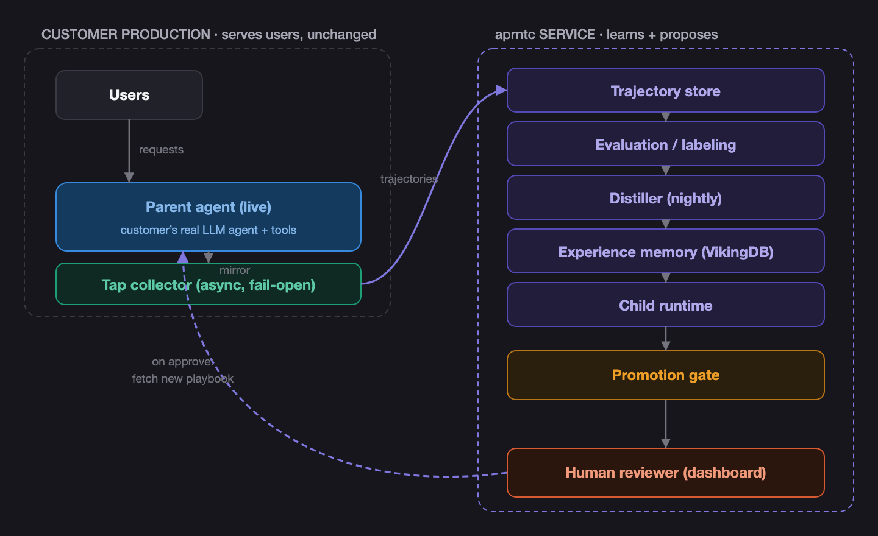
Figure 3 — aprntc observes via a read-only tap (inbound) and serves the improved playbook the agent pulls (outbound). The gated config swap is the only write back to production.

Connecting an external agent
aprntc owns neither the agent’s code nor its prompt, so the Playbook becomes a contract with two halves:
- Inbound (observe). The agent’s traffic flows into aprntc via a tap (egress proxy / OpenTelemetry / MCP gateway). Read-only. This is how aprntc sees behavior without owning the code.
- Outbound (control). The agent pulls its active playbook from aprntc’s config-fetch API (GET /api/playbooks/{id}/active). Promotion updates what’s served; the agent picks it up. Rollback serves the prior version. No redeploy.
Initial G0 = the customer registers their current system prompt (aprntc needs only the prompt text, not the code); if they don’t, aprntc infers an approximate G0 from the system prompt the tap observed.

5. Component design
Component | Module | Responsibility
LLMProvider seam | providers/ | One complete() contract; model-agnostic (Seed / DeepSeek / OpenAI / Anthropic / Gemini).
AgentTap + collectors | tap/ | SDK wrapper (full fidelity) · LiteLLM egress proxy · OTel ingester · MCP gateway — all normalize into one Trajectory; async + fail-open.
Trajectory schema + store | trajectory/ | Canonical Episode/Turn/Step; SQLite store; PII scrub at ingest; fused reward; GDPR delete + TTL.
Evaluation / labeling | eval/ | Recused pairwise judge · deterministic outcome scorers (the anchor) · health metrics · learned fusion weights.
Experience memory | memory/ | VikingDB REST adapter (own SigV4 signer) · filtered hybrid search + MMR · curated, generation-versioned lessons.
Distillation + child | distill/ | Playbook + attributable diff · distiller (success→directives/exemplars, failure→watch-outs) · child runtime.
Promotion | promote/ | Gate (Wilson CI + hard gates) · lineage DAG + rollback · auto-promotion policy (default-off, hard-gated).
Online | online/ | Shadow runner (judge child vs parent on live traffic) · canary with auto-rollback.
Fleets | fleet/ | Many parents, each own lineage · gated cross-agent lesson sharing.
Serving | serving/ | Playbook registry + config-fetch API (the outbound integration).
Tenancy / auth | tenancy/, auth/ | API-key tenant isolation (machine) · Google sign-in + sessions (human).
Ops | ops/ | Scheduler (nightly cadence) · retry/backoff · self-metrics + /api/ops.
Dashboard | web/ | React + Vite + Tailwind; 5 screens, light/dark, thumbs feedback, Google login.

6. Quality & the acceptance bar
Quality is anchored on outcomes. Reliability order: outcome > explicit user feedback > implicit > LLM judge (the judge is a prior, never the authority). Fusion weights are learned from how well each source historically agreed with the anchor — a judge that disagrees with real outcomes or feedback is automatically down-weighted.
A distilled child is promotable only when all of the following hold on a frozen held-out set the distiller never saw:
Check | Threshold | Type
Win-rate (child vs parent, recused judge) | ≥ 55% | quality
Confidence | 95% CI lower bound > 50% (powered N) | statistical
Loss-rate | < 10% | quality (downside)
Regression suite | 0 failures | hard gate
Safety probes | 0 new violations | hard gate
Promote + rollback | both work from the UI | operational

HONEST FINDING
A playbook makes the agent reliably apply lessons — it can’t teach the base model capabilities it lacks. The apprentice only measurably wins where the parent genuinely fails or is inconsistent and there’s ground truth to steer toward. On a real BytePlus support agent with honest headroom (a thin parent), the distilled child won 65–85% of comparisons.

7. Key decisions (ADRs)
# | Decision
0001 | VikingDB via REST (own Signature-V4 signer; SDK as a dev-only oracle).
0002 | Recused judge (judge ≠ policy) to prevent self-preference.
0003 | Experience Memory = VikingDB (curated lesson index, not a doc corpus).
0004 | Tap = protocol-boundary collectors, wrapping OSS.
0005 | aprntc is a learning product, not observability (best-effort capture).
0006 | Outcome-anchored quality + playbook distillation (no fine-tuning in Phase 1).
0007 | Canonical Trajectory schema.
0008 | Tap build order: core + SDK wrapper first.

HARD-WON LESSON
An SDK-equivalence (“oracle”) test only proves we match the SDK given the same inputs — it can’t catch a wrong input. The VikingDB signer matched the SDK byte-for-byte yet still returned 403 live, because both used service="air" when the V2 API needs service="vikingdb". The live API is the ultimate oracle — which is why every stage is verified against live infrastructure, not just unit tests.

8. Status & what’s built
The planned roadmap is complete: the MVP loop, the v1 feature set, and productionization.
- MVP loop — signing gate, trajectory schema/store, AgentTap, eval/labeling, VikingDB memory, distillation + child, promotion gate + lineage. Live-verified on BytePlus.
- v1 features — distillation quality, real BytePlus support agent, external collectors (proxy/OTel/MCP), online shadow + canary, learned fusion weights, auto-promotion, multi-agent fleets. (Fine-tuning parked — open-weight models only.)
- Productization — playbook registry + config-fetch API, Docker deploy, API-key tenancy, ops (scheduler/retry/metrics), Google sign-in.
- 288 tests passing. Docs: DESIGN_AND_SOLUTION, PRODUCTION, DEPLOY, ROADMAP, STATUS, 8 ADRs.

aprntc · Design & Solution Document · generated from the repository at feature-complete state. The in-repo Markdown sources remain the canonical, version-controlled record.

