Abstract: AgriSense is an AI-powered smart agriculture system that unifies IoT sensing, automated irrigation, plant disease detection and large-language-model reasoning in a single platform for small farms. An ESP32 sensor node samples air temperature and humidity (DHT11), soil moisture and rainfall every 10 seconds and writes the readings directly to a Supabase PostgreSQL database, from which the web dashboard and the Expo/React Native mobile app receive live updates through Supabase Realtime. Irrigation is decided on the board itself: dry soil with no rain switches the relay-driven pump on, while wet soil, rain or a disconnected probe force it off, so watering continues even when Wi-Fi, the cloud or the backend is unavailable. A 15-minute maximum runtime and a 30-minute cooldown bound every cycle, and the pump logic is self-tested at boot against 11 cases. A FastAPI backend adds timer schedules, a relay for a separate ESP32-CAM field camera, and a plant-diagnosis endpoint that returns species, condition, severity, symptoms, treatment and prevention from a single leaf photograph. A YOLO11n-cls classifier fine-tuned on 38 PlantVillage classes reaches 99.32% top-1 and 100% top-5 validation accuracy and is exported to ONNX for serving, with Gemini vision used as the fallback diagnosis source. A context-aware Farm Advisor chat receives the latest telemetry of the farm, so its answers reflect current field conditions. Row-level security, secret-based device pairing and server-side API keys protect every account and device.

S.B. JAIN INSTITUTE OF TECHNOLOGY, MANAGEMENT& RESEARCH, NAGPUR
DEPARTMENT OF EMERGING TECHNOLOGIES (ARTIFICIAL INTELLIGENCE & DATA SCIENCE)
“AgriSense: AI-Powered Smart Agriculture System”
By-Tisha Jhariya, Akiko Gajbhiye, Ansh Meshram, Agya Chourasia

References:
[1] S. P. Mohanty, D. P. Hughes, M. Salathé, “Using Deep Learning for Image-Based Plant Disease Detection,” Frontiers in Plant Science, vol. 7, p. 1419, 2016.
[2] D. P. Hughes, M. Salathé, “An Open Access Repository of Images on Plant Health to Enable the Development of Mobile Disease Diagnostics,” arXiv:1511.08060, 2015.
[3] D. Singh, N. Jain, P. Jain, P. Kayal, S. Kumawat, N. Batra, “PlantDoc: A Dataset for Visual Plant Disease Detection,” Proc. ACM IKDD CoDS-COMAD, pp. 249–253, 2020.
[4] G. Jocher, J. Qiu, “Ultralytics YOLO11,” GitHub repository, 2024.
[5] J. Gutiérrez, J. F. Villa-Medina, A. Nieto-Garibay, M. Á. Porta-Gándara, “Automated Irrigation System Using a Wireless Sensor Network and GPRS Module,” IEEE Trans. Instrum. Meas., vol. 63, no. 1, pp. 166–176, 2014.
[6] R. Samanta, B. Saha, S. K. Ghosh, “LeafSense: A Portable, Low-Cost, Low-Power Plant Disease Diagnostic Device Using TinyML,” Proc. 4th Int. Conf. AI-ML Systems, 2024.
[7] J. P. Nyakuri et al., “AI and IoT-Powered Edge Device Optimized for Crop Pest and Disease Detection,” Scientific Reports, vol. 15, p. 22905, 2025.

Conclusion and Future Scope:
Conclusion: AgriSense demonstrates that low-cost IoT hardware, a managed cloud database and modern AI models can be combined into a reliable decision-support system for small farms. Closed-loop irrigation runs on the sensor node with hard runtime limits and sensor-priority safety rules, so it keeps working without connectivity. The plant-disease classifier reaches 99.32% top-1 accuracy on PlantVillage validation data, and the full pipeline from training to ONNX export and serving runs end to end. Because PlantVillage contains laboratory images of single leaves on plain backgrounds, this figure is not expected to carry over directly to field photographs; field accuracy remains to be measured. The same database serves both the web dashboard and the mobile app in real time, while row-level security, secret-based device pairing and server-side API keys keep every farm's data and devices isolated. Grounding the Farm Advisor in the farm's own latest readings turns a general-purpose language model into advice specific to the current state of the field.

Future Scope: Future work will evaluate the classifier on real field images (PlantDoc and ESP32-CAM captures) and complete the two-stage species-then-disease pipeline. Quantized on-device inference will be explored for ESP32-S3-class hardware, and a flow meter will be added to measure water saved against a fixed schedule. Further sensors such as soil NPK and pH, multilingual voice support in the advisor, and weather-forecast-aware irrigation scheduling are also planned. In the longer term, the system will be extended to multiple sensor nodes covering separate plots, with LoRa links for fields beyond Wi-Fi range, and a field trial with farmers will measure its real effect on water use and crop health.

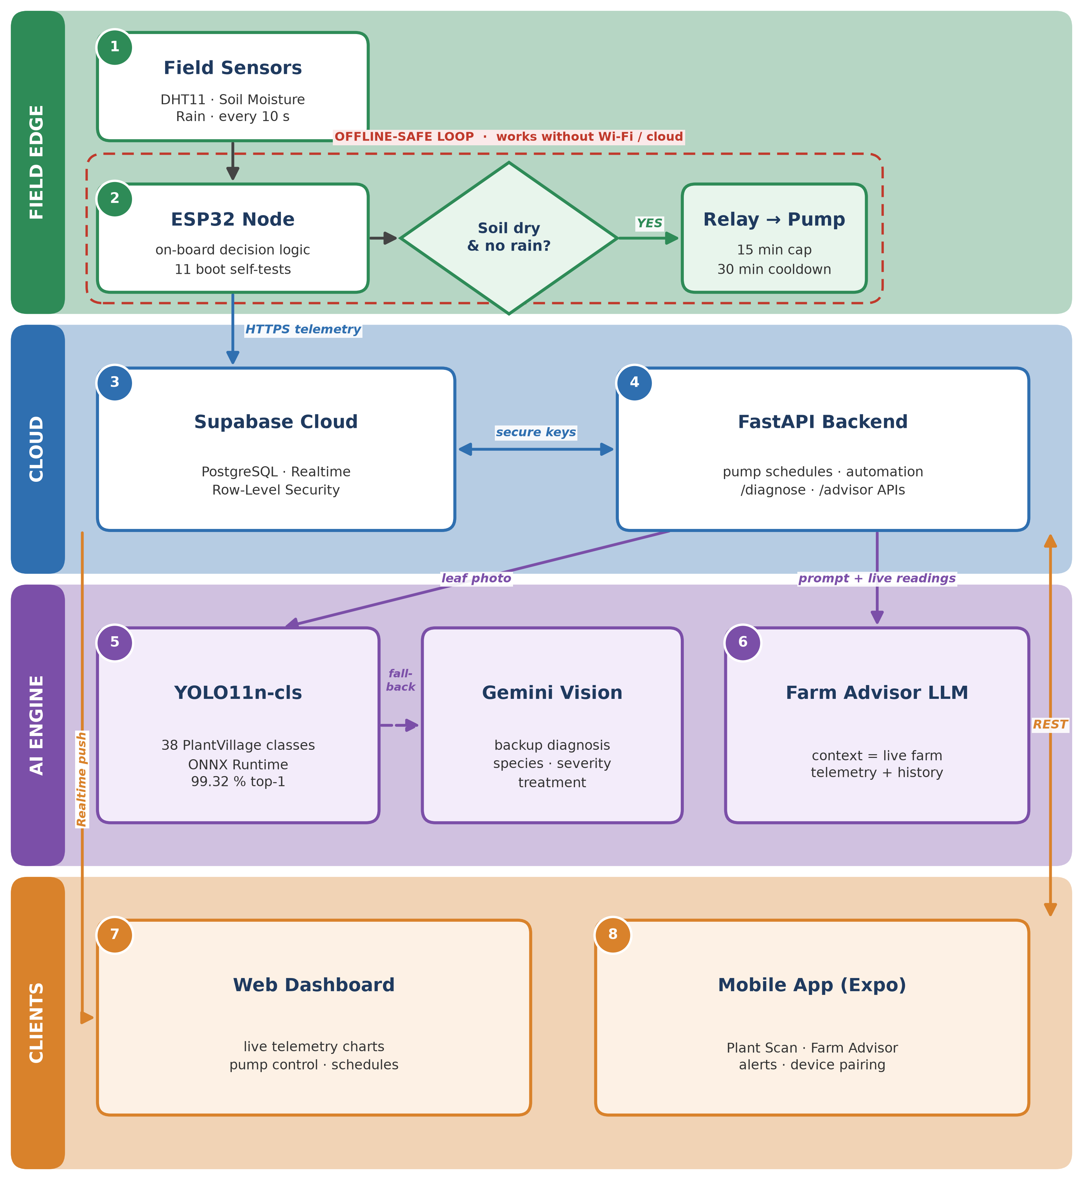
Proposed System:

Results:

Figure 3: Model Loss Over Epochs Figure 4: Model Accuracy Over Epochs

Introduction: Agriculture still depends heavily on manual observation, which leads to over- or under-irrigation, late detection of crop disease and avoidable yield loss, particularly on smallholder farms with limited access to agronomists. Low-cost microcontrollers, cloud databases and deep learning now make it possible to monitor a field continuously and act on the data automatically. AgriSense brings these pieces together: field sensors report environmental conditions in real time, the irrigation loop closes on the sensor node itself, a deep-learning model diagnoses plant disease from a leaf image, and an LLM-based advisor answers farmer questions grounded in the live readings of that farm. The goal is a practical, affordable decision-support system that reduces water waste, catches disease early and stays usable through intermittent connectivity.
Research Methodology: The system follows a three-tier design of field, cloud and client. In the field tier, an ESP32 DevKit V1 reads a DHT11 on GPIO 4, a capacitive soil-moisture probe on ADC GPIO 34 and a rain sensor on GPIO 33, and drives an active-low relay on GPIO 16; a safety gate treats a failed soil reading as a fault rather than as dry soil, preventing continuous pumping. A separate AI-Thinker ESP32-CAM captures field and leaf images on demand, since its camera bus occupies the pins used by the sensors. In the cloud tier, Supabase provides PostgreSQL storage, authentication, Realtime subscriptions and row-level security, while a Python FastAPI backend runs the automation engine, the camera relay, plant diagnosis and the advisor. For the vision model, a YOLO11n-cls network was transfer-learned at 224x224 resolution on PlantVillage (43,444 training / 10,861 validation images, 38 species-condition classes) for 5 epochs and exported to ONNX for an onnxruntime serving service. The client tier consists of a web dashboard and an Expo mobile app offering live telemetry, pump control, Plant Scan and the Farm Advisor chat. Irrigation is decided on the node itself: the pump runs only when the soil is dry and no rain is detected, each cycle is capped at 15 minutes and followed by a 30-minute cooldown, and the decision logic is self-tested at boot against 11 cases. Readings are sampled every 10 seconds and written over HTTPS to Supabase, from which both clients receive live updates through Realtime. For diagnosis, the backend forwards the uploaded leaf photograph to the ONNX classifier service, with Gemini vision as the backup source, and returns species, condition, severity, symptoms, treatment and prevention; the Farm Advisor receives the latest readings of the farm with every question. The classifier was evaluated by top-1 and top-5 accuracy and by training and validation loss after every epoch on the held-out PlantVillage split.
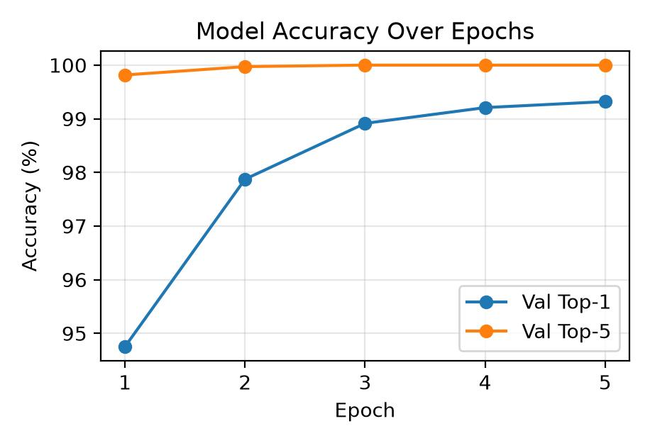
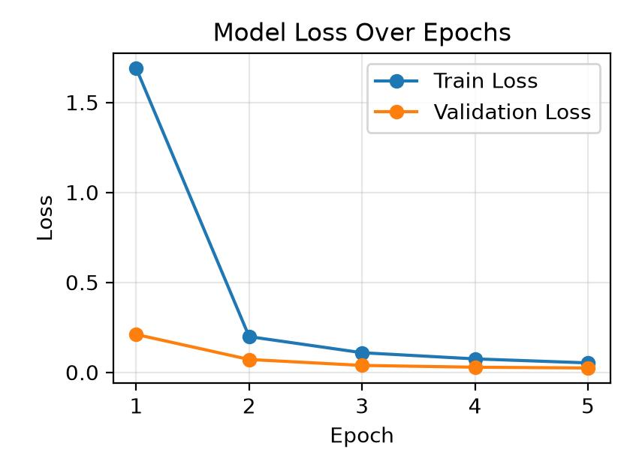
Figure 2: Farm Advisor

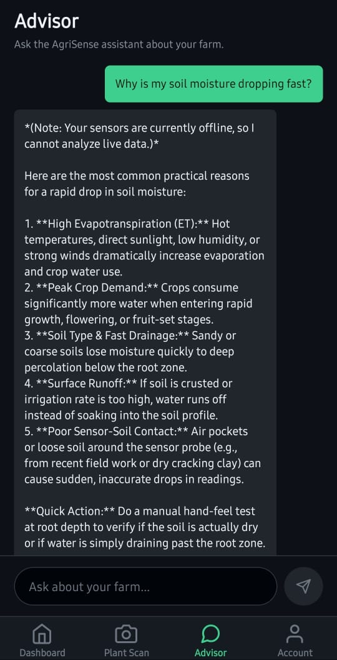
Figure 1: Plant Scan
