Abstract: The implementation of an Agentic AI system for Clinical Decision Support (CDS) involves a fundamental architectural shift from a single, passive Large Language Model (LLM) to a proactive, goal-directed Multi-Agent System (MAS). This framework is theoretically necessary to overcome the LLM's inherent limitations, such as hallucination and lack of deterministic action. The process begins with a Planner/Controller Agent that functions as the system's "brain," maintaining the clinical goal, decomposing complex diagnostic tasks into a sequence of steps, and managing the patient's context through a persistent memory buffer. This core reasoning is then supported by a dedicated Retrieval-Augmented Generation (RAG) Agent, whose theoretical role is to ensure all outputs are grounded by linking them to authoritative, external medical knowledge bases, thus addressing the critical need for verifiable evidence and minimizing unsupported medical claims. Complementing this is the Specialized Tool Agent, which executes necessary deterministic actions (e.g., drug checks, coding lookups) by interfacing with specialized rule-based clinical systems, ensuring precision where the probabilistic LLM core cannot. Crucially, the final step involves a Verification/Safety Agent that provides mandatory, multi-layered oversight, performing compliance checks (like HIPAA anonymization) and evaluating the entire reasoning chain before a final, explainable, and traceable recommendation is routed for mandatory clinician supervision, thereby achieving a theoretical framework for accountable and reliable Human-AI collaboration.

S.B. JAIN INSTITUTE OF TECHNOLOGY, MANAGEMENT& RESEARCH, NAGPUR
DEPARTMENT OF EMERGING TECHNOLOGIES (ARTIFICIAL INTELLIGENCE & DATA SCIENCE)
“Transforming Healthcare with Agentic AI”
By-Kalyani Pendke, Pranay Borikar, Divyanshi Bokade, Gauri Atalkar, Uday Agre

References:
[1] N. Karunanayake, “Next-generation agentic AI for transforming healthcare,” Informatics and Health, vol. 2, no. 2, pp. 73–83, 2025.
[2] Fan Bai, Yuxin Du, Tiejun Huang, Max Q.-H. Meng, Bo Zhao, “M3D: Advancing 3D Medical Image Analysis with Multi-Modal Large Language Models,” 2024.
[3] Karan Singhal, Shekoofeh Azizi, Tao Tu, S. Sara Mahdavi, Jason Wei, Hyung Won Chung, “Large Language Models Encode Clinical Knowledge,”2022.
[4] Jun-Yu Wu, Cheng-Yun Wu, Bor-Jen Chen, Min-Yuh Day, “IMNTPU at NTCIR-18 MedNLP-CHAT Task: Evaluating Agentic AI for Multilingual Risk Assessment in Medical Chatbots,” 2025.
[5] Ajit Singh, “Agentic AI in Healthcare: Diagnosis and Treatment,” 2025.
[6] H. Yu et al., “Simulated patient systems are intelligent when powered by large language model-based AI agents,” arXiv [cs.CL], 2025.
[7] F. L. Barra et al., “From prompt to platform: an agentic AI workflow for healthcare simulation scenario design,” Adv. Simul., vol. 10, no. 1, p. 29, 2025.

Conclusion and Future Scope:
Conclusion: The main theoretical conclusion is that the transition of Large Language Models (LLMs) into responsible Clinical Decision Support (CDS) can be achieved by the required change in the role of statistical competency (demonstrated by models such as Med-PaLM 2 on such evaluations as MedNLP_CHAT) into accountable autonomy. Theoretically, the review finds that even though LLMs have the mental ability to engage in medical reasoning, its use is limited due to an ongoing reliability gap in the scenario of ambiguity or rare clinical cases. Consequently, the overall theoretical conclusion is that technological advances is inadequate, success eventually will depend on the essential formation of a Human-AI Teaming model, with enhanced attention paid to stringent safety measures and understandable logic in reinforcing the human-centered decision-making procedure in medicine, instead of eliminating it.

Future Scope: The future direction is characterized by three core, short-term doctrines: Integrated Modality: Achieve Unified Multimodal Synthesis (genomics, images, temporal data) so that awareness of longitudinal patient trajectory can be assured and individualized care delivery is possible. Accountable Agency (MAS): Advance to Hierarchical Multi-Agency Systems to include formal Orchestration Mechanism so that awareness of longitudinal patient trajectory can be made and individualized care delivery is viable. Trust and Sustainability (XAI): Resolve the black moreover, put Small Language Models (SLMs) and Federated Learning into priority due to their cheaper and privacy-sensitive deployment.

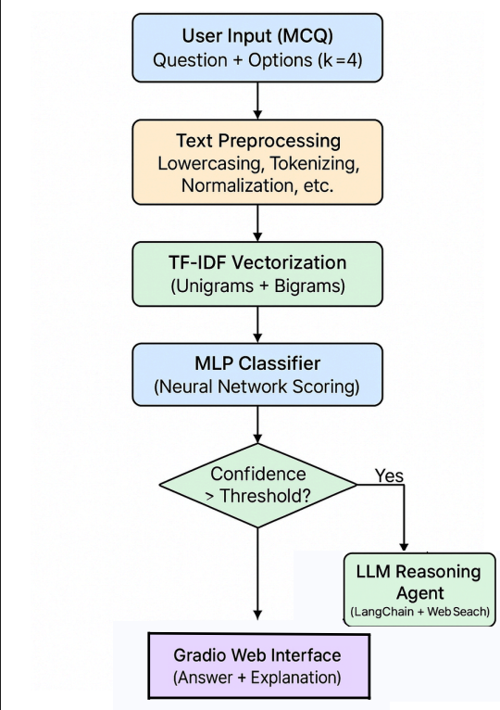
Proposed System:

Results:

Figure 3: Model Loss Over Epochs Figure 4: Model Accuracy Over Epochs

Introduction: The concept of Large Language Models (LLMs) developing into a full-fledged Clinical Decision Support (CDS) system is, theoretically, the transition of statistical language models to goal-oriented Agentic AI systems. The fundamental theoretical question is how to fill the gap between the contextual fluency demonstrated by an LLM (measured by such variables as MedNLP_CHAT) and the deterministic reliability of clinical use. Such a theoretical change requires replacing the use of a single, monolithic model with a Multi-Agent System (MAS) architecture, in which a complex clinical problem is brought down to task-specific collaborating agents. Theoretically, the system will be accurate as a Retrieval-Augmented Generation (RAG) Agent will base all outputs on confirmed medical evidence and, thus, reduce the chances of LLDL hallucinations. Lastly, the theoretical objective is not to reach complete autonomy, but to implement Human-AI Teaming, in which the system offers an evidence-based recommendation, openly shares its lack of knowledge, and directs high-stakes decisions through compulsory clinician oversight, and operational efficiency is maximized by considering resource-efficient Small Language Models (SLMs) enhanced with toolsets.
Research Methodology: The theoretical background of the research methodology is developed based on the guidelines of a Systematic Review, which is meant to introduce order and rigorous synthesis to the disorganized, high-velocity field of LLMs in clinical decision support. In principle the methodology fulfills its aim by four consecutive steps: Selection Theory. The theoretical objective was to reach focused depth, not exhaustive breadth, and hence required the selection of a very relevant set of thirty research articles. Such a choice was not arbitrary: it was a priority-based selection of the studies that deal with the practical clinical implementation of AI, in particular prioritizing the articles describing Multi-Agent System (MAS) designs, rigorous safety guidelines and simulated clinical validation system. This ensures that the ultimate synthesis is based on deployable theory with reference constants such as Med-PaLM 2 and MedNLP_CHAT. Extraction Theory (Decomposition to Synthesis): Each of the selected papers was theoretically broken down into four key data points which were considered to be critical: methodology, dataset, findings, and clinical implications. This methodical harvest guarantees that the unavoidable difference in individual research measures is defeated by establishing a shared framework on which comparative study is to be carried out, through which the synthesis will be able to identify dependably the technical breakthroughs and recognized shortcomings.
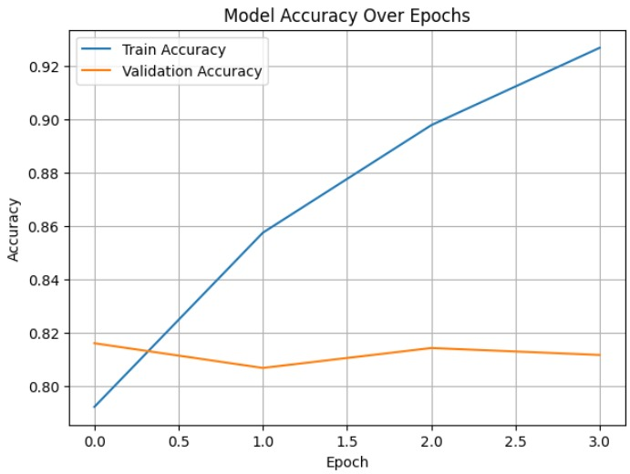
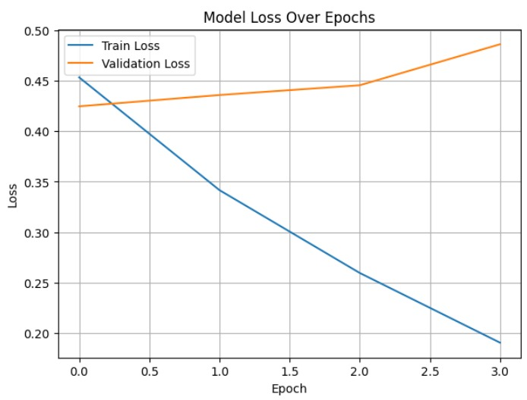
Figure 2: Classification report

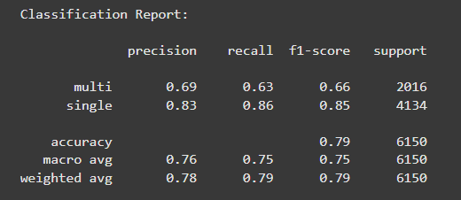
Figure 1: Agentic AI Output Interface
