Received [date], accepted [date], date of publication [date], date of current version [date]. Digital Object Identifier 10.1109/ACCESS.2026.DOI
IoT, Edge AI, and Large Language Models for Smart Agriculture: A Survey of Closed-Loop Irrigation, Crop Disease Diagnosis, and Their Deployment Gaps
TISHA JHARIYA¹, AKIKO GAJBHIYE¹, ANSH MESHRAM¹, AGYA CHOURASIA¹, AND [GUIDE NAME]¹
¹Department of Emerging Technologies (Artificial Intelligence & Data Science), S. B. Jain Institute of Technology, Management and Research, Nagpur, Maharashtra 441501, India
Corresponding author: [Guide Name] ([email address])

ABSTRACT Smart-agriculture research has converged on a recognisable stack: low-cost sensor nodes and cameras, wireless connectivity, automated irrigation, deep-learning disease diagnosis, and, most recently, large language models (LLMs) that answer agronomic questions. Existing surveys usually treat these layers separately, and most predate both the TinyML and LLM waves. This survey reviews the full stack in one frame and focuses on the question that matters for deployment: which reported results survive contact with real fields. We organise the literature into a five-branch taxonomy covering sensing and connectivity, irrigation control, disease diagnosis, edge AI, and LLM-based advisory with security. For each branch we compare representative methods and quantify recurring gaps. Three findings stand out. First, reported irrigation savings span roughly 9–50 %, yet few studies meter both a treatment and a control arm or specify behaviour under sensor failure. Second, plant-disease classifiers commonly report over 99 % accuracy on laboratory imagery but fall to about 31–68 % on field images, a gap compounded by near-duplicate leakage in random splits. Third, published feasibility results for disease models on ESP32-class microcontrollers contradict one another because class count, input resolution, quantization and chip variant are rarely reported together. We illustrate these issues with an open reference implementation, AgriSense AI, and close with a research agenda centred on field-validated evaluation, fail-safe control, memory-aware edge models, and grounded, auditable agricultural LLMs.
INDEX TERMS Smart agriculture, Internet of Things, precision irrigation, plant disease detection, deep learning, domain shift, TinyML, edge computing, large language models, survey.

I. INTRODUCTION
Feeding a growing population with less water and fewer chemical inputs is a defining challenge of this century. Agriculture already accounts for around 70 % of global freshwater withdrawals [1], and an expert survey across 67 countries estimates yield losses to pathogens and pests of 10–28 % for wheat, 25–41 % for rice, 20–41 % for maize, 8–21 % for potato and 11–32 % for soybean [2]. Plant disease has long been recognised as a threat to food security [3]. Both problems are worst for smallholders, who lack sensors, agronomists and reliable connectivity.
Digital agriculture promises to close this gap by measuring the field continuously and acting on it automatically [4], [5]. Over the past decade three technology waves have arrived in quick succession: Internet of Things (IoT) sensing and actuation [6]–[8], deep learning for image-based diagnosis [9], [10], and, since 2023, large language models (LLMs) and foundation models [11], [12]. In parallel, TinyML has made it plausible to run neural networks on microcontrollers costing a few dollars [13], [14].
The literature on each wave is large, but it is fragmented, and much of it reports results under conditions that do not hold in deployment: irrigation savings without metered controls, disease accuracies measured on laboratory photographs, and edge feasibility judged on a single operating point. This survey therefore asks not only what has been built but what has been shown to work in the field, and under what evaluation.
A. COMPARISON WITH EXISTING SURVEYS
Table 1 positions this survey against prior reviews. IoT surveys [5]–[8], [15], [16] cover sensing and networking in depth but treat disease diagnosis briefly; disease-detection reviews [17]–[19] cover models and datasets but not actuation or deployment hardware; and the foundation-model review of Li et al. [12] predates most agricultural LLM deployments. None jointly examines closed-loop control, diagnosis, edge feasibility and LLM advisory, nor treats evaluation validity as a cross-cutting theme.

TABLE 1. Scope of related surveys (● major focus, ◐ partial, ○ not covered; authors' assessment).
Survey | Year | IoT | Irrig. | Disease DL | Edge/TinyML | LLM | Domain shift
Tzounis et al. [5] | 2017 | ● | ◐ | ○ | ○ | ○ | ○
Kamilaris & Prenafeta-Boldú [9] | 2018 | ○ | ◐ | ● | ○ | ○ | ◐
Liakos et al. [20] | 2018 | ○ | ● | ◐ | ○ | ○ | ○
Elijah et al. [6] | 2018 | ● | ◐ | ○ | ◐ | ○ | ○
Ayaz et al. [7] | 2019 | ● | ● | ◐ | ○ | ○ | ○
Farooq et al. [8] | 2019 | ● | ● | ○ | ○ | ○ | ○
García et al. [21] | 2020 | ● | ● | ○ | ○ | ○ | ○
Gupta et al. [22] | 2020 | ● | ○ | ○ | ○ | ○ | ○
Friha et al. [15] | 2021 | ● | ◐ | ◐ | ● | ○ | ○
Li, Zhang & Wang [17] | 2021 | ○ | ○ | ● | ○ | ○ | ◐
Thakur et al. [19] | 2022 | ○ | ○ | ● | ○ | ○ | ◐
Li et al. [12] | 2024 | ○ | ○ | ◐ | ○ | ● | ◐
This survey | 2026 | ● | ● | ● | ● | ● | ●

B. CONTRIBUTIONS
1) A unified five-branch taxonomy of AI-enabled smart agriculture spanning sensing, control, diagnosis, edge inference and LLM advisory (Section III, Fig. 1).
2) A critical comparison of irrigation control strategies with attention to metered evaluation and fail-safe behaviour (Section V).
3) A synthesis of disease-diagnosis datasets and models together with the evidence on the laboratory-to-field gap and data leakage, and concrete evaluation recommendations (Sections VI–VII).
4) An analysis of the ESP32-class feasibility contradiction in edge disease diagnosis, reduced to a closed-form memory bound (Section VIII).
5) A review of LLMs for agricultural advisory and of security and multi-tenancy (Sections IX–X), a reference-implementation case study (Section XI) and a research agenda (Section XII).
II. SURVEY METHODOLOGY
We conducted a structured narrative review following the reporting principles of systematic reviews. Sources were IEEE Xplore, ScienceDirect, MDPI, SpringerLink/Nature, ACM Digital Library, Frontiers, Google Scholar and arXiv. Query strings combined a domain term (smart agriculture, precision irrigation, plant disease, crop disease) with a technology term (IoT, wireless sensor network, deep learning, CNN, vision transformer, TinyML, edge computing, ESP32, large language model, retrieval-augmented generation).
Inclusion criteria: peer-reviewed journal or conference papers, or widely cited preprints, published 2014–2026; a concrete system, model, dataset or evaluation; and reported quantitative results. Exclusion criteria: papers without an evaluation, duplicates of the same system, and non-English papers. Seminal earlier works were included where they define a method still in use. Every quantitative figure quoted below is taken from the cited source; where a source does not state a quantity we mark it n/s rather than estimate it.
III. BACKGROUND AND TAXONOMY
A smart-agriculture system closes a loop from measurement to decision to action [4]. Sensors and cameras measure the field; a connectivity layer moves data to edge or cloud computation; intelligence components decide when to irrigate, what disease is present and what the farmer should do; and actuators and user interfaces carry out the decision. Fig. 1 organises the surveyed literature along these lines into five branches, which structure the remainder of this paper.

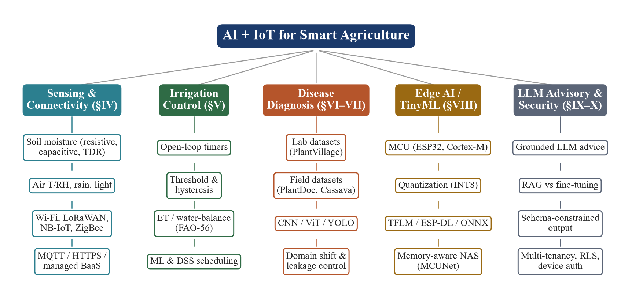
FIGURE 1. Taxonomy of AI- and IoT-enabled smart agriculture used in this survey, with the section covering each branch.

Two cross-cutting concerns run through all branches. Evaluation validity asks whether a reported number predicts field behaviour; failure behaviour asks what the system does when a sensor, link or model fails. Both are under-reported, and we return to them in every section.
IV. IOT SENSING AND CONNECTIVITY
A. FIELD SENSORS
Soil water is the primary irrigation input. Resistive probes are cheap but corrode; low-cost capacitive probes avoid galvanic contact and, for a soil with constant solid-to-volume ratio, give a reliable relation between output voltage and gravimetric water content, but they require per-soil calibration [23]. Air temperature and humidity (e.g., DHT11/DHT22 class sensors), rain detectors and light sensors complement soil data and feed evapotranspiration models [24]. Surveys of agricultural IoT catalogue many further sensors, including soil nutrient, pH and leaf-wetness probes [7], [8], [16].
A recurring, rarely discussed issue is sensor-failure semantics. A disconnected analogue input floats to an arbitrary or near-zero ADC value, which a naïve calibration maps to either saturated or bone-dry soil; in the latter case a threshold controller irrigates indefinitely. Explicit disconnect detection and fail-safe defaults are therefore a correctness requirement, not an optimisation (Section V-D).
B. CONNECTIVITY
Table 2 compares common link technologies. Wi-Fi suits farms with on-site infrastructure; LoRa/LoRaWAN trades data rate for kilometre-scale range and multi-year battery life [25]; NB-IoT and cellular links add licensed-spectrum reliability at higher cost. Camera streaming and image upload generally require Wi-Fi or cellular bandwidth, which pushes image-heavy nodes towards mains power or larger batteries.
TABLE 2. Qualitative comparison of field connectivity options.
Technology | Typical range | Data rate | Power | Fit
Wi-Fi (802.11n) | ~10–100 m | Mbps | High | Images, farm hubs
LoRa/LoRaWAN | km (rural) | ~0.3–50 kbps | Very low | Sparse sensor data
NB-IoT | km (cellular) | ~10s kbps | Low | Licensed, managed
ZigBee (802.15.4) | ~10–100 m | 250 kbps | Low | Mesh greenhouses
BLE | ~10–50 m | ~1 Mbps | Very low | Handheld, local
4G/5G cellular | km | Mbps+ | High | Video, remote sites

C. PLATFORMS AND DATA PATHS
Application protocols are dominated by MQTT and HTTPS/REST. Open-source IoT platforms such as ThingsBoard [26] and OpenRemote [27] provide device management, dashboards and multi-tenant isolation out of the box, and managed back-end-as-a-service databases with row-level security and real-time subscriptions [28] now allow a microcontroller to write directly to a secured store. Multi-tenancy is thus a commodity capability and should not be presented as a research contribution. A more consequential architectural decision is where the control decision lives: edge computing literature argues for placing latency- and availability-critical decisions close to the data source [29], [30].
V. IRRIGATION CONTROL STRATEGIES
A. FROM TIMERS TO CLOSED LOOPS
Irrigation control ranges from open-loop timers through sensor-based closed loops to model-based and learning-based scheduling (Table 3). Timer control is simple but waters regardless of rain or soil state. Threshold control with hysteresis switches on below a dry threshold and off above a wet threshold, avoiding actuator chatter. Water-balance scheduling uses reference evapotranspiration and crop coefficients following FAO-56 [24]. Decision-support systems [31] and machine-learning predictors that combine soil sensing with weather forecasts [32] aim to anticipate demand, and platform-scale systems such as SWAMP [33] integrate these into water-management services.

TABLE 3. Irrigation control strategies.
Strategy | Inputs | Strength | Weakness | Examples
Open-loop timer | Clock | Simple, robust | Ignores rain/soil | Commercial timers
Threshold + hysteresis | Soil moisture | Cheap, reactive | Needs calibration | [34]
Water balance (ET) | Weather, crop Kc | Physically grounded | Needs weather data | [24]
DSS / expert rules | Soil, weather, crop | Agronomic context | Site tuning | [31]
ML prediction | Sensors + forecasts | Anticipatory | Data hungry, opaque | [32]
Platform / multi-farm | Many sources | Scale, services | Complexity | [33]

B. REPORTED WATER SAVINGS
Reviews of IoT irrigation report savings spanning roughly 9–50 % [21], [35]. The width of this range reflects differences in crop, climate, baseline practice and, critically, measurement method. A well-instrumented recent trial reports 431.47 L under closed-loop control against 592.39 L for a fixed schedule, a 27.16 % reduction, while also reducing the soil-moisture standard deviation from 10.46 % to 1.35 % [36]; a multi-season IoT deployment reports improved water-use efficiency [37]. We define the saving as
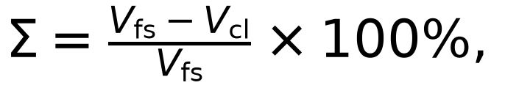 | (1)
where V_{fs} and V_{cl} are the metered volumes of the fixed-schedule and closed-loop arms. Because a controller can trivially "save" water by under-irrigating, Σ should always be reported with both volumes, the soil-moisture mean and spread of each arm, and a crop-health or yield proxy.
C. EVALUATION GAPS
• Many studies estimate savings from pump run-time rather than an inline flow meter.
• Treatment and control arms often differ in hardware or plot, confounding the comparison.
• Trials are short (days to weeks) relative to a crop season.
D. FAIL-SAFE DESIGN
Few papers specify controller behaviour under faults. We identify four practices that should be standard: (i) ordered rules in which sensor interlocks (failed probe, rain, saturated soil) dominate manual and cloud commands; (ii) hysteresis to bound switching; (iii) hard run-time limits and cooldowns that bound delivery under mis-calibration; and (iv) edge authority, so the node keeps controlling when connectivity is lost. Section XI shows one implementation.
VI. DEEP LEARNING FOR CROP DISEASE DIAGNOSIS
A. DATASETS
Table 4 summarises public datasets. PlantVillage [38] dominates the literature but contains single detached leaves photographed on uniform backgrounds. Field-condition datasets such as PlantDoc [39], iCassava [40], Plant Pathology 2020 [41] and PlantWild [42] are smaller per class but far closer to deployment conditions.

TABLE 4. Public plant-disease image datasets (counts as released or as in common mirrors).
Dataset | Images | Classes | Conditions | Typical use
PlantVillage [38] | 54,305 | 38 | Lab, plain background | Training benchmark
PlantDoc [39] | 2,598 | 27 | Field, web-sourced | Cross-domain test
iCassava / Cassava [40] | ~21k | 5 | Field, Uganda | Field training
Plant Pathology 2020 [41] | 3,651 | 4 | Field, apple | Field benchmark
PlantWild [42] | 30,030 | n/s | In-the-wild | Field training
Rice leaf [43] | 5,932 | 4 | Mixed | Crop-specific

B. MODEL FAMILIES
CNN transfer learning. Mohanty et al. fine-tuned AlexNet and GoogLeNet on PlantVillage to 99.35 % [10]; Ferentinos reported 99.53 % with VGG on a 58-class corpus [44], [45]; Too et al. compared fine-tuned architectures and reached 99.75 % with DenseNet [46]; Sladojevic et al. [47] and Brahimi et al. [48] reported similar figures on smaller taxonomies. Efficient backbones such as MobileNet [49], [50] and EfficientNet [51] trade a little accuracy for mobile deployment, as in the smartphone cassava diagnosis of Ramcharan et al. [52], [53]. Detectors localise lesions in cluttered scenes: Fuentes et al. compared Faster R-CNN, R-FCN and SSD on tomato [54], and YOLO-family detectors [55], [56] target real-time use. Vision transformers [57] now underpin the strongest cross-domain results [58]. Few-shot learning addresses the scarcity of labelled field images [59], and explainability studies show what CNNs attend to when diagnosing [60], [61].

TABLE 5. Representative disease-diagnosis studies (values as reported by each source).
Study | Model | Data | Reported result | Field?
Mohanty [10] | GoogLeNet | PlantVillage | 99.35 %; 31.4 % external | Ext. test
Sladojevic [47] | CaffeNet | Web images, 13 cl. | 96.3 % | No
Brahimi [48] | GoogLeNet | Tomato (PV) | 99.18 % | No
Ferentinos [44] | VGG | 58 classes | 99.53 % | Partly
Too [46] | DenseNet-121 | PlantVillage | 99.75 % | No
Ramcharan [52] | Inception v3 | Cassava field | 93 % | Yes
Fuentes [54] | R-FCN + ResNet | Tomato field | mAP 85.98 % | Yes
Salman [58] | ViT-based | PV → PlantDoc | 68 % cross-domain | Yes
Samanta [62] | Compact CNN | ESP32-CAM | 92 % | No
Aqasizade [63] | Quantised CNN | ESP32-S3 | 94.6 %, F1 0.94 | 7-day
Nyakuri [64] | CNN | Raspberry Pi 5 | 98.6 %, 16 ms | n/s

VII. DOMAIN SHIFT AND EVALUATION PITFALLS
A. THE LABORATORY-TO-FIELD GAP
The most important result in this literature is negative. Mohanty et al. themselves observed accuracy falling from 99.35 % to 31.4 % when their PlantVillage-trained network was applied to images from other sources [10]. On PlantDoc, the cross-domain state of the art for a PlantVillage-trained model is about 68 %, against 48 % for ViT-Base, 43 % for EfficientNet and 41 % for InceptionV3 [58] (Fig. 2). Barbedo attributes the gap to background clutter, illumination, capture variability and co-occurring symptoms absent from laboratory images [65], [66]; Picon et al. showed that training on images captured in the wild with mobile devices substantially improves field performance [67]. We define the gap on the same weights as
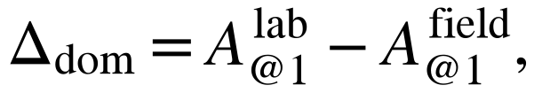 | (2)
and recommend reporting it with both operands, never as a ratio. The phenomenon is an instance of general distribution shift [68]–[71] and of shortcut learning on backgrounds [72].
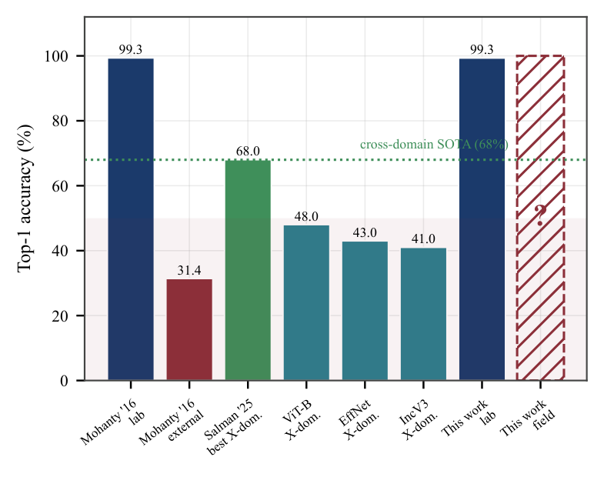
FIGURE 2. Published laboratory versus field/cross-domain accuracy [10], [58]. The two rightmost bars are the AgriSense case study of Section XI; its field value is not yet measured.
B. DATA LEAKAGE
Laboratory corpora contain several photographs of the same leaf. A random split places these near-duplicates in both training and test partitions, inflating accuracy without improving generalisation; leakage of this kind is now recognised as a leading cause of irreproducible machine-learning results [73]. Perceptual hashing [74] offers a cheap remedy: images whose 64-bit hashes differ in at most τ bits,
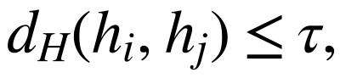 | (3)
are grouped, and each group is assigned to a single partition.
C. RECOMMENDATIONS
• Report at least one cross-domain or field test set never used for training or model selection.
• Use duplicate-group-aware splits and state the de-duplication method and threshold.
• Report macro-F1 alongside accuracy, because disease taxonomies are imbalanced.
• Report variation across seeds and test differences with paired statistics [75].
• Treat field accuracy above ~90 % from a laboratory-trained model as a red flag for leakage.
VIII. EDGE AI AND TINYML
A. WHY THE EDGE
Running inference on or near the sensor removes dependence on connectivity, reduces bandwidth and latency, and keeps images local [29], [30]. TinyML pushes this to microcontrollers with hundreds of kilobytes of SRAM [13], [76], [77]. Key enablers are integer quantization [78], [79], interpreters such as TensorFlow Lite Micro [80], memory-aware architecture search (MCUNet [14]) and patch-based inference that cuts peak activation memory [81]. MLPerf Tiny standardises benchmarking [82].
B. THE ESP32 FEASIBILITY CONTRADICTION
Published results disagree on whether disease classification fits ESP32-class parts. Nyakuri et al. report that ESP32-CAM, Raspberry Pi Pico and Arduino Nano 33 BLE Sense could not run their model and selected a Raspberry Pi 5 (98.6 %, 16 ms, about US$80) [64]; Samanta et al. run a classifier on ESP32-CAM at 92 % [62]; and Aqasizade et al. deploy a quantised model on ESP32-S3 at 94.6 % accuracy and 0.94 macro-F1 with a seven-day field deployment [63]. These are not contradictory once the binding constraint is made explicit. For an input of side r, c channels and b bytes per element, the input activation alone needs
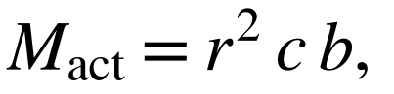 | (4)
which at 224×224×3 in FP32 is 588 KiB, already above the 520 KiB SRAM of the base ESP32 [83]. Feasibility is therefore a surface over class count, resolution, precision and chip (with or without PSRAM), not a yes/no property of a board (Fig. 3). We recommend that edge papers report all four together with peak RAM, flash, latency and energy per inference.
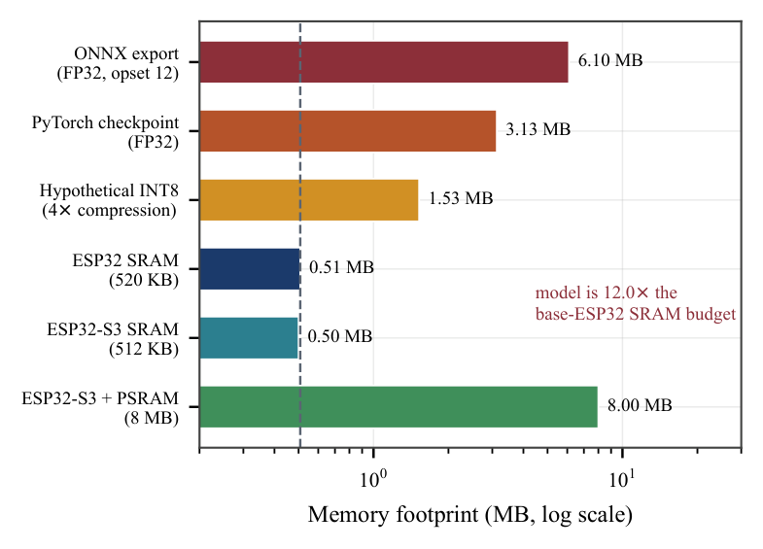
FIGURE 3. Footprint of a 1.57 M-parameter YOLO11n-cls classifier versus ESP32-family memory (case study of Section XI).
IX. LARGE LANGUAGE MODELS FOR AGRICULTURAL ADVISORY
LLMs can translate agronomic knowledge into conversational, localised advice. Tzachor et al. tested GPT-based models for cassava extension advice in Nigeria, found useful but sometimes inaccurate output, and proposed a design process with human experts in the loop [11]. Silva et al. evaluated GPT-4 on agriculture examinations [84]. Balaguer et al. compared retrieval-augmented generation (RAG) [85] with fine-tuning on agricultural data and found that fine-tuning improved accuracy by over six percentage points, with RAG adding about five more [86]. Li et al. survey language, vision, multimodal and reinforcement-learning foundation models for agriculture [12].
Three design patterns recur in deployed systems: grounding the model in live measurements (sensor telemetry, location, crop stage) so that advice is specific; schema-constrained output so that diagnoses can be parsed, validated and displayed consistently; and human oversight for high-stakes recommendations such as pesticide use. Open problems include hallucinated treatments, regional regulatory differences, low-resource languages, offline operation, and evaluation: few agricultural LLM systems report accuracy against expert-validated answers.
X. SECURITY, PRIVACY AND MULTI-TENANCY
Smart farms expose physical actuators and commercially sensitive data. Gupta et al. review threats across the smart-farming stack, from device tampering and wireless attacks to data-integrity and privacy risks [22]; Ferrag et al. survey security for green IoT-based agriculture including blockchain-based approaches [87]. Practical baseline controls are: per-device credentials and pairing that requires physical possession; token-authenticated APIs; row-level data isolation between tenants; keeping third-party API keys server-side; and, for actuators, safety interlocks on the device that no remote command can override.
XI. CASE STUDY: AGRISENSE AI REFERENCE IMPLEMENTATION
To ground the survey's recommendations we summarise AgriSense AI, an open implementation by the authors that integrates the five branches (Fig. 4).

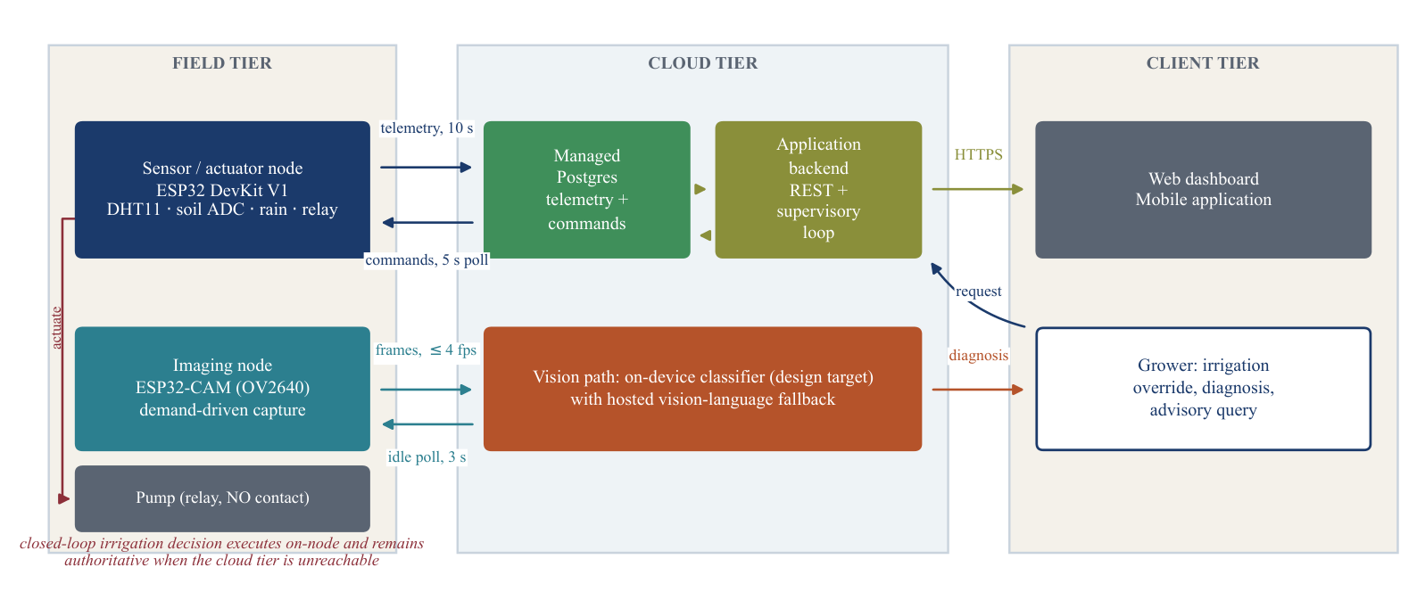
FIGURE 4. AgriSense AI three-tier architecture: ESP32 sensor node and ESP32-CAM, managed PostgreSQL with row-level security, FastAPI backend, web and mobile clients.

TABLE 6. Mapping survey findings to the AgriSense implementation.
Survey finding | AgriSense design response | Status
Cloud-dependent control | Ordered on-node rules; cloud only queues requests | Implemented
Fail-unsafe probes | ADC < 10 ⇒ probe failed ⇒ pump off; 11-case boot self-test | Implemented
Actuator chatter | 30/70 % hysteresis, 15 min cap, 30 min cooldown | Implemented, simulated
Unmetered savings | Timer mode as control arm; flow meter required | Pending
Lab-only accuracy | PlantDoc quarantined for evaluation only | Pipeline built; eval pending
Near-duplicate leakage | SHA-256 + pHash (τ = 5) groups; group-aware 80/10/10 split | Implemented
Edge feasibility | Memory bound: 588 KiB input > 520 KiB SRAM | Analysed; server inference
Ungrounded LLM advice | Live telemetry in system prompt; JSON schema for diagnosis | Implemented
Tenant isolation | Row-level security, ≤ 4 devices per account, keys server-side | Implemented

Its baseline YOLO11n-cls classifier reaches 99.32 % top-1 on 10,861 PlantVillage validation images across 38 classes and runs in about 6 ms per image on one laptop CPU thread, but was trained on a random split and has not yet been field-tested, so by this survey's own criteria it is a laboratory upper bound. The case illustrates that the gaps identified above are practical engineering choices that can be designed for from the start.
XII. OPEN CHALLENGES AND FUTURE DIRECTIONS
1) Field-first evaluation. Benchmarks built from images captured by deployed low-cost cameras, with standard cross-domain protocols and leakage-free splits.
2) Metered, controlled irrigation trials. Season-long, flow-metered comparisons on identical hardware, reporting volumes, moisture statistics and yield.
3) Feasibility surfaces for edge models. Systematic sweeps over chip, precision, resolution and class count with energy measurements, and hierarchical (species-then-disease) models to reduce per-model class count.
4) Sensor–vision fusion. Using microclimate data (humidity, leaf wetness, temperature) as priors for disease risk, with calibrated uncertainty.
5) Trustworthy agricultural LLMs. Retrieval over vetted extension material, expert-validated test sets, multilingual and offline small models, and provenance for every recommendation.
6) Fail-safe autonomy. Formal or test-based verification of actuator logic, and actuator-state feedback so that cloud and node never disagree silently.
7) Cost and accessibility. Reporting bill-of-materials cost, power autonomy (e.g., solar) and maintenance burden, which determine smallholder adoption.
XIII. CONCLUSION
This survey reviewed IoT sensing, irrigation control, crop-disease diagnosis, edge AI and LLM advisory as one system rather than separate fields. Across all five branches the dominant gap is not a missing algorithm but missing evidence under deployment conditions: irrigation savings without metered controls, disease accuracy without field tests or leakage control, and edge feasibility without the parameters that determine it. Closing these gaps calls for field-first benchmarks, fail-safe control designs, memory-aware edge models and grounded, evaluated agricultural LLMs. We hope the taxonomy, comparisons and recommendations here help future work report results that transfer from the paper to the farm.
ACKNOWLEDGMENT
The authors thank [Guide Name] and the Department of Emerging Technologies, S. B. Jain Institute of Technology, Management and Research, Nagpur, for support and the creators of the open datasets and tools discussed in this survey.
REFERENCES
[1] Food, and Agriculture Organization of the United Nations, “AQUASTAT: FAO's Global Information System on Water and Agriculture,” 2024. [Online]. Available: https://www.fao.org/aquastat/.
[2] S. Savary, L. Willocquet, S. J. Pethybridge, P. Esker, N. McRoberts, and A. Nelson, “The Global Burden of Pathogens and Pests on Major Food Crops,” Nature Ecology & Evolution, vol. 3, no. 3, pp. 430–439, 2019, doi: 10.1038/s41559-018-0793-y.
[3] R. N. Strange, and P. R. Scott, “Plant Disease: A Threat to Global Food Security,” Annual Review of Phytopathology, vol. 43, pp. 83–116, 2005, doi: 10.1146/annurev.phyto.43.113004.133839.
[4] S. Wolfert, L. Ge, C. Verdouw, and M. Bogaardt, “Big Data in Smart Farming – A Review,” Agricultural Systems, vol. 153, pp. 69–80, 2017, doi: 10.1016/j.agsy.2017.01.023.
[5] A. Tzounis, N. Katsoulas, T. Bartzanas, and C. Kittas, “Internet of Things in Agriculture, Recent Advances and Future Challenges,” Biosystems Engineering, vol. 164, pp. 31–48, 2017, doi: 10.1016/j.biosystemseng.2017.09.007.
[6] O. Elijah, T. A. Rahman, I. Orikumhi, C. Y. Leow, and M. H. D. N. Hindia, “An Overview of Internet of Things (IoT) and Data Analytics in Agriculture: Benefits and Challenges,” IEEE Internet of Things Journal, vol. 5, no. 5, pp. 3758–3773, 2018, doi: 10.1109/JIOT.2018.2844296.
[7] M. Ayaz, M. Ammad-Uddin, Z. Sharif, A. Mansour, and E. M. Aggoune, “Internet-of-Things (IoT)-Based Smart Agriculture: Toward Making the Fields Talk,” IEEE Access, vol. 7, pp. 129551–129583, 2019, doi: 10.1109/ACCESS.2019.2932609.
[8] M. S. Farooq, S. Riaz, A. Abid, K. Abid, and M. A. Naeem, “A Survey on the Role of IoT in Agriculture for the Implementation of Smart Farming,” IEEE Access, vol. 7, pp. 156237–156271, 2019, doi: 10.1109/ACCESS.2019.2949703.
[9] A. Kamilaris, and F. X. Prenafeta-Boldú, “Deep Learning in Agriculture: A Survey,” Computers and Electronics in Agriculture, vol. 147, pp. 70–90, 2018, doi: 10.1016/j.compag.2018.02.016.
[10] S. P. Mohanty, D. P. Hughes, and M. Salathé, “Using Deep Learning for Image-Based Plant Disease Detection,” Frontiers in Plant Science, vol. 7, Art. no. 1419, 2016, doi: 10.3389/fpls.2016.01419.
[11] A. Tzachor et al., “Large Language Models and Agricultural Extension Services,” Nature Food, vol. 4, pp. 941–948, 2023, doi: 10.1038/s43016-023-00867-x.
[12] J. Li et al., “Foundation Models in Smart Agriculture: Basics, Opportunities, and Challenges,” Computers and Electronics in Agriculture, vol. 222, Art. no. 109032, 2024, doi: 10.1016/j.compag.2024.109032.
[13] P. Warden, and D. Situnayake, TinyML: Machine Learning with TensorFlow Lite on Arduino and Ultra-Low-Power Microcontrollers. O'Reilly Media, 2019.
[14] J. Lin, W. Chen, Y. Lin, J. Cohn, C. Gan, and S. Han, “MCUNet: Tiny Deep Learning on IoT Devices,” in Advances in Neural Information Processing Systems (NeurIPS), 2020.
[15] O. Friha, M. A. Ferrag, L. Shu, L. Maglaras, and X. Wang, “Internet of Things for the Future of Smart Agriculture: A Comprehensive Survey of Emerging Technologies,” IEEE/CAA Journal of Automatica Sinica, vol. 8, no. 4, pp. 718–752, 2021, doi: 10.1109/JAS.2021.1003925.
[16] J. M. Talavera et al., “Review of IoT Applications in Agro-Industrial and Environmental Fields,” Computers and Electronics in Agriculture, vol. 142, pp. 283–297, 2017, doi: 10.1016/j.compag.2017.09.015.
[17] L. Li, S. Zhang, and B. Wang, “Plant Disease Detection and Classification by Deep Learning – A Review,” IEEE Access, vol. 9, pp. 56683–56698, 2021, doi: 10.1109/ACCESS.2021.3069646.
[18] J. Liu, and X. Wang, “Plant Diseases and Pests Detection Based on Deep Learning: A Review,” Plant Methods, vol. 17, Art. no. 22, 2021, doi: 10.1186/s13007-021-00722-9.
[19] P. S. Thakur, P. Khanna, T. Sheorey, and A. Ojha, “Trends in Vision-Based Machine Learning Techniques for Plant Disease Identification: A Systematic Review,” Expert Systems with Applications, vol. 208, Art. no. 118117, 2022, doi: 10.1016/j.eswa.2022.118117.
[20] K. G. Liakos, P. Busato, D. Moshou, S. Pearson, and D. Bochtis, “Machine Learning in Agriculture: A Review,” Sensors, vol. 18, no. 8, Art. no. 2674, 2018, doi: 10.3390/s18082674.
[21] L. García, L. Parra, J. M. Jimenez, J. Lloret, and P. Lorenz, “IoT-Based Smart Irrigation Systems: An Overview on the Recent Trends on Sensors and IoT Systems for Irrigation in Precision Agriculture,” Sensors, vol. 20, no. 4, Art. no. 1042, 2020, doi: 10.3390/s20041042.
[22] M. Gupta, M. Abdelsalam, S. Khorsandroo, and S. Mittal, “Security and Privacy in Smart Farming: Challenges and Opportunities,” IEEE Access, vol. 8, pp. 34564–34584, 2020, doi: 10.1109/ACCESS.2020.2975142.
[23] P. Placidi, L. Gasperini, A. Grassi, M. Cecconi, and A. Scorzoni, “Characterization of Low-Cost Capacitive Soil Moisture Sensors for IoT Networks,” Sensors, vol. 20, no. 12, Art. no. 3585, 2020, doi: 10.3390/s20123585.
[24] R. G. Allen, L. S. Pereira, D. Raes, and M. Smith, Crop Evapotranspiration: Guidelines for Computing Crop Water Requirements (FAO Irrigation and Drainage Paper 56). Rome, Italy: FAO, 1998.
[25] A. Augustin, J. Yi, T. Clausen, and W. M. Townsley, “A Study of LoRa: Long Range & Low Power Networks for the Internet of Things,” Sensors, vol. 16, no. 9, Art. no. 1466, 2016, doi: 10.3390/s16091466.
[26] ThingsBoard, “ThingsBoard Open-Source IoT Platform,” 2026. [Online]. Available: https://thingsboard.io/.
[27] OpenRemote, “OpenRemote Open-Source IoT Platform,” 2026. [Online]. Available: https://openremote.io/.
[28] Supabase, “Supabase: The Postgres Development Platform,” 2026. [Online]. Available: https://supabase.com/docs.
[29] W. Shi, J. Cao, Q. Zhang, Y. Li, and L. Xu, “Edge Computing: Vision and Challenges,” IEEE Internet of Things Journal, vol. 3, no. 5, pp. 637–646, 2016, doi: 10.1109/JIOT.2016.2579198.
[30] M. Satyanarayanan, “The Emergence of Edge Computing,” Computer, vol. 50, no. 1, pp. 30–39, 2017, doi: 10.1109/MC.2017.9.
[31] H. Navarro-Hellín, J. Martínez-del-Rincón, R. Domingo-Miguel, F. Soto-Valles, and R. Torres-S\'anchez, “A Decision Support System for Managing Irrigation in Agriculture,” Computers and Electronics in Agriculture, vol. 124, pp. 121–131, 2016, doi: 10.1016/j.compag.2016.04.003.
[32] A. Goap, D. Sharma, A. K. Shukla, and C. Rama Krishna, “An IoT Based Smart Irrigation Management System Using Machine Learning and Open Source Technologies,” Computers and Electronics in Agriculture, vol. 155, pp. 41–49, 2018, doi: 10.1016/j.compag.2018.09.040.
[33] C. Kamienski et al., “Smart Water Management Platform: IoT-Based Precision Irrigation for Agriculture,” Sensors, vol. 19, no. 2, Art. no. 276, 2019, doi: 10.3390/s19020276.
[34] J. Gutiérrez, J. F. Villa-Medina, A. Nieto-Garibay, and M. Porta-G\'andara, “Automated Irrigation System Using a Wireless Sensor Network and GPRS Module,” IEEE Transactions on Instrumentation and Measurement, vol. 63, no. 1, pp. 166–176, 2014, doi: 10.1109/TIM.2013.2276487.
[35] D. Vallejo-Gómez, M. Osorio, and C. A. Hincapié, “Smart Irrigation Systems in Agriculture: A Systematic Review,” Agronomy, vol. 13, no. 2, Art. no. 342, 2023, doi: 10.3390/agronomy13020342.
[36] K. Usman, and A. Zubairu, “The Use of AI in IoT-Based Smart Irrigation,” CEDTECH International Journal of Natural and Applied Sciences, vol. 7, no. 1, pp. 57–72, 2026, doi: 10.5281/zenodo.20611846.
[37] Z. E. Mohamed, M. K. Afify, M. M. Badr, and O. A. Omar, “IoT-Driven Smart Irrigation System to Improve Water Use Efficiency,” Scientific Reports, vol. 16, Art. no. 2609, 2026, doi: 10.1038/s41598-025-33826-6.
[38] D. P. Hughes, and M. Salathé, “An Open Access Repository of Images on Plant Health to Enable the Development of Mobile Disease Diagnostics,” arXiv preprint arXiv:1511.08060, 2015.
[39] D. Singh, N. Jain, P. Jain, P. Kayal, S. Kumawat, and N. Batra, “PlantDoc: A Dataset for Visual Plant Disease Detection,” in Proc. 7th ACM IKDD CoDS and 25th COMAD, 2020, pp. 249–253, doi: 10.1145/3371158.3371196.
[40] E. Mwebaze, T. Gebru, A. Frome, S. Nsumba, and J. Tusubira, “iCassava 2019 Fine-Grained Visual Categorization Challenge,” arXiv preprint arXiv:1908.02900, 2019.
[41] R. Thapa, K. Zhang, N. Snavely, S. Belongie, and A. Khan, “The Plant Pathology Challenge 2020 Data Set to Classify Foliar Disease of Apples,” Applications in Plant Sciences, vol. 8, no. 9, Art. no. e11390, 2020, doi: 10.1002/aps3.11390.
[42] T. Wei et al., “PlantWild: An In-the-Wild Plant Disease Recognition Dataset,” 2024. [Online]. Available: https://huggingface.co/datasets/uqtwei2/PlantWild.
[43] N. Sankalana, “Rice Leaf Disease Image Samples,” 2023. [Online]. Available: Kaggle dataset, https://www.kaggle.com/datasets/nirmalsankalana/rice-leaf-disease-image.
[44] K. P. Ferentinos, “Deep Learning Models for Plant Disease Detection and Diagnosis,” Computers and Electronics in Agriculture, vol. 145, pp. 311–318, 2018, doi: 10.1016/j.compag.2018.01.009.
[45] K. Simonyan, and A. Zisserman, “Very Deep Convolutional Networks for Large-Scale Image Recognition,” in Proc. Int. Conf. Learning Representations (ICLR), 2015.
[46] E. C. Too, L. Yujian, S. Njuki, and L. Yingchun, “A Comparative Study of Fine-Tuning Deep Learning Models for Plant Disease Identification,” Computers and Electronics in Agriculture, vol. 161, pp. 272–279, 2019, doi: 10.1016/j.compag.2018.03.032.
[47] S. Sladojevic, M. Arsenovic, A. Anderla, D. Culibrk, and D. Stefanovic, “Deep Neural Networks Based Recognition of Plant Diseases by Leaf Image Classification,” Computational Intelligence and Neuroscience, vol. 2016, Art. no. 3289801, 2016, doi: 10.1155/2016/3289801.
[48] M. Brahimi, K. Boukhalfa, and A. Moussaoui, “Deep Learning for Tomato Diseases: Classification and Symptoms Visualization,” Applied Artificial Intelligence, vol. 31, no. 4, pp. 299–315, 2017, doi: 10.1080/08839514.2017.1315516.
[49] A. G. Howard et al., “MobileNets: Efficient Convolutional Neural Networks for Mobile Vision Applications,” arXiv preprint arXiv:1704.04861, 2017.
[50] M. Sandler, A. Howard, M. Zhu, A. Zhmoginov, and L. Chen, “MobileNetV2: Inverted Residuals and Linear Bottlenecks,” in Proc. IEEE Conf. Computer Vision and Pattern Recognition (CVPR), 2018, pp. 4510–4520, doi: 10.1109/CVPR.2018.00474.
[51] M. Tan, and Q. V. Le, “EfficientNet: Rethinking Model Scaling for Convolutional Neural Networks,” in Proc. 36th Int. Conf. Machine Learning (ICML), 2019, pp. 6105–6114.
[52] A. Ramcharan, K. Baranowski, P. McCloskey, B. Ahmed, J. Legg, and D. P. Hughes, “Deep Learning for Image-Based Cassava Disease Detection,” Frontiers in Plant Science, vol. 8, Art. no. 1852, 2017, doi: 10.3389/fpls.2017.01852.
[53] A. Ramcharan et al., “A Mobile-Based Deep Learning Model for Cassava Disease Diagnosis,” Frontiers in Plant Science, vol. 10, Art. no. 272, 2019, doi: 10.3389/fpls.2019.00272.
[54] A. Fuentes, S. Yoon, S. C. Kim, and D. S. Park, “A Robust Deep-Learning-Based Detector for Real-Time Tomato Plant Diseases and Pests Recognition,” Sensors, vol. 17, no. 9, Art. no. 2022, 2017, doi: 10.3390/s17092022.
[55] J. Redmon, S. Divvala, R. Girshick, and A. Farhadi, “You Only Look Once: Unified, Real-Time Object Detection,” in Proc. IEEE Conf. Computer Vision and Pattern Recognition (CVPR), 2016, pp. 779–788, doi: 10.1109/CVPR.2016.91.
[56] J. Liu, and X. Wang, “Tomato Diseases and Pests Detection Based on Improved YOLO V3 Convolutional Neural Network,” Frontiers in Plant Science, vol. 11, Art. no. 898, 2020, doi: 10.3389/fpls.2020.00898.
[57] A. Dosovitskiy et al., “An Image is Worth 16×16 Words: Transformers for Image Recognition at Scale,” in Proc. Int. Conf. Learning Representations (ICLR), 2021.
[58] Z. Salman, A. Muhammad, and D. Han, “Plant Disease Classification in the Wild Using Vision Transformers and Mixture of Experts,” Frontiers in Plant Science, vol. 16, Art. no. 1522985, 2025, doi: 10.3389/fpls.2025.1522985.
[59] D. Argüeso et al., “Few-Shot Learning Approach for Plant Disease Classification Using Images Taken in the Field,” Computers and Electronics in Agriculture, vol. 175, Art. no. 105542, 2020, doi: 10.1016/j.compag.2020.105542.
[60] Y. Toda, and F. Okura, “How Convolutional Neural Networks Diagnose Plant Disease,” Plant Phenomics, vol. 2019, Art. no. 9237136, 2019, doi: 10.34133/2019/9237136.
[61] R. R. Selvaraju, M. Cogswell, A. Das, R. Vedantam, D. Parikh, and D. Batra, “Grad-CAM: Visual Explanations from Deep Networks via Gradient-Based Localization,” in Proc. IEEE Int. Conf. Computer Vision (ICCV), 2017, pp. 618–626, doi: 10.1109/ICCV.2017.74.
[62] R. Samanta, B. Saha, and S. K. Ghosh, “LeafSense: A Portable, Low-Cost, Low-Power Plant Disease Diagnostic Device Using TinyML,” in Proc. 4th Int. Conf. AI-ML Systems, 2024, doi: 10.1145/3703412.3703438.
[63] H. Aqasizade, M. Antonini, M. Vecchio, and F. Antonelli, “A TinyMLOps Pipeline for Coarse-Grained Plant Disease Classification in Precision Agriculture,” Sensors, vol. 26, no. 16, Art. no. 5029, 2026, doi: 10.3390/s26165029.
[64] J. P. Nyakuri, C. Nkundineza, O. Gatera, K. Nkurikiyeyezu, and G. Mwitende, “AI and IoT-Powered Edge Device Optimized for Crop Pest and Disease Detection,” Scientific Reports, vol. 15, Art. no. 22905, 2025, doi: 10.1038/s41598-025-06452-5.
[65] J. G. A. Barbedo, “Factors Influencing the Use of Deep Learning for Plant Disease Recognition,” Biosystems Engineering, vol. 172, pp. 84–91, 2018, doi: 10.1016/j.biosystemseng.2018.05.013.
[66] J. G. A. Barbedo, “Plant Disease Identification from Individual Lesions and Spots Using Deep Learning,” Biosystems Engineering, vol. 180, pp. 96–107, 2019, doi: 10.1016/j.biosystemseng.2019.02.002.
[67] A. Picon, A. Alvarez-Gila, M. Seitz, A. Ortiz-Barredo, J. Echazarra, and A. Johannes, “Deep Convolutional Neural Networks for Mobile Capture Device-Based Crop Disease Classification in the Wild,” Computers and Electronics in Agriculture, vol. 161, pp. 280–290, 2019, doi: 10.1016/j.compag.2018.04.002.
[68] S. Ben-David, J. Blitzer, K. Crammer, A. Kulesza, F. Pereira, and J. W. Vaughan, “A Theory of Learning from Different Domains,” Machine Learning, vol. 79, no. 1–2, pp. 151–175, 2010, doi: 10.1007/s10994-009-5152-4.
[69] A. Torralba, and A. A. Efros, “Unbiased Look at Dataset Bias,” in Proc. IEEE Conf. Computer Vision and Pattern Recognition (CVPR), 2011, pp. 1521–1528, doi: 10.1109/CVPR.2011.5995347.
[70] B. Recht, R. Roelofs, L. Schmidt, and V. Shankar, “Do ImageNet Classifiers Generalize to ImageNet?,” in Proc. 36th Int. Conf. Machine Learning (ICML), 2019, pp. 5389–5400.
[71] P. W. Koh et al., “WILDS: A Benchmark of in-the-Wild Distribution Shifts,” in Proc. 38th Int. Conf. Machine Learning (ICML), 2021, pp. 5637–5664.
[72] R. Geirhos et al., “Shortcut Learning in Deep Neural Networks,” Nature Machine Intelligence, vol. 2, no. 11, pp. 665–673, 2020, doi: 10.1038/s42256-020-00257-z.
[73] S. Kapoor, and A. Narayanan, “Leakage and the Reproducibility Crisis in Machine-Learning-Based Science,” Patterns, vol. 4, no. 9, Art. no. 100804, 2023, doi: 10.1016/j.patter.2023.100804.
[74] C. Zauner, “Implementation and Benchmarking of Perceptual Image Hash Functions,” Master's thesis, Upper Austria University of Applied Sciences, Hagenberg, 2010.
[75] J. Demšar, “Statistical Comparisons of Classifiers over Multiple Data Sets,” Journal of Machine Learning Research, vol. 7, pp. 1–30, 2006.
[76] R. Sanchez-Iborra, and A. F. Skarmeta, “TinyML-Enabled Frugal Smart Objects: Challenges and Opportunities,” IEEE Circuits and Systems Magazine, vol. 20, no. 3, pp. 4–18, 2020, doi: 10.1109/MCAS.2020.3005467.
[77] P. P. Ray, “A Review on TinyML: State-of-the-Art and Prospects,” Journal of King Saud University – Computer and Information Sciences, vol. 34, no. 4, pp. 1595–1623, 2022, doi: 10.1016/j.jksuci.2021.11.019.
[78] B. Jacob et al., “Quantization and Training of Neural Networks for Efficient Integer-Arithmetic-Only Inference,” in Proc. IEEE Conf. Computer Vision and Pattern Recognition (CVPR), 2018, pp. 2704–2713, doi: 10.1109/CVPR.2018.00286.
[79] R. Krishnamoorthi, “Quantizing Deep Convolutional Networks for Efficient Inference: A Whitepaper,” arXiv preprint arXiv:1806.08342, 2018.
[80] R. David et al., “TensorFlow Lite Micro: Embedded Machine Learning for TinyML Systems,” in Proc. Machine Learning and Systems (MLSys), 2021, pp. 800–811.
[81] J. Lin, W. Chen, H. Cai, C. Gan, and S. Han, “MCUNetV2: Memory-Efficient Patch-Based Inference for Tiny Deep Learning,” in Advances in Neural Information Processing Systems (NeurIPS), 2021.
[82] C. Banbury et al., “MLPerf Tiny Benchmark,” in Proc. NeurIPS Datasets and Benchmarks Track, 2021.
[83] Espressif Systems, “ESP32 Series Datasheet,” 2026. [Online]. Available: https://www.espressif.com/en/support/documents/technical-documents.
[84] B. Silva, L. Nunes, R. Estação, V. Aski, and R. Chandra, “GPT-4 as an Agronomist Assistant? Answering Agriculture Exams Using Large Language Models,” arXiv preprint arXiv:2310.06225, 2023.
[85] P. Lewis, E. Perez, A. Piktus et al., “Retrieval-Augmented Generation for Knowledge-Intensive NLP Tasks,” in Advances in Neural Information Processing Systems (NeurIPS), 2020, pp. 9459–9474.
[86] A. Balaguer et al., “RAG vs Fine-Tuning: Pipelines, Tradeoffs, and a Case Study on Agriculture,” arXiv preprint arXiv:2401.08406, 2024.
[87] M. A. Ferrag, L. Shu, X. Yang, A. Derhab, and L. Maglaras, “Security and Privacy for Green IoT-Based Agriculture: Review, Blockchain Solutions, and Challenges,” IEEE Access, vol. 8, pp. 32031–32053, 2020, doi: 10.1109/ACCESS.2020.2973178.
TISHA JHARIYA is with the Department of Emerging Technologies (Artificial Intelligence & Data Science), S. B. Jain Institute of Technology, Management and Research, Nagpur, India.
AKIKO GAJBHIYE is with the Department of Emerging Technologies (Artificial Intelligence & Data Science), S. B. Jain Institute of Technology, Management and Research, Nagpur, India.
ANSH MESHRAM is with the Department of Emerging Technologies (Artificial Intelligence & Data Science), S. B. Jain Institute of Technology, Management and Research, Nagpur, India.
AGYA CHOURASIA is with the Department of Emerging Technologies (Artificial Intelligence & Data Science), S. B. Jain Institute of Technology, Management and Research, Nagpur, India.
[GUIDE NAME] is with the Department of Emerging Technologies, S. B. Jain Institute of Technology, Management and Research, Nagpur, India. [Research interests.]

