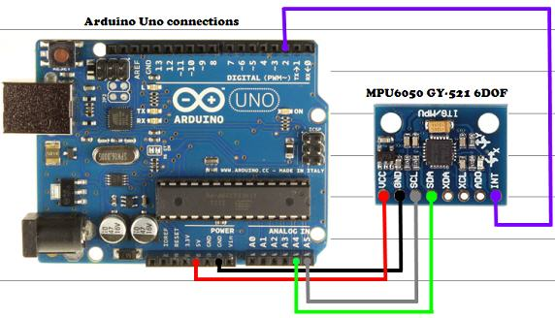

Cost:

Motors + ESC:

21.49\*4

Arduino Uno

MPU6050

Turnigy 2200mAh 3S: 21.45

Frame: Hobby Kinf F330

Eclipse project copy:

Copy: .cproject, .project .settings (must, otherwise AVR includes don’t work properly)

Make sure the correct configuration is selected

Close Eclipse and Reopen