NetworkSim: A Real-Time Distributed Systems Simulation and Failure
Analysis Platform for Architectural Education and Resilience Engineering
Ankur Yadav (24BCE1836)
School of Computer Science and Engineering, Vellore Institute of Technology, Chennai, India
ankur.yadav2024@vitstudent.ac.in
Abstract
Modern cloud and microservice architectures exhibit complex, emergent failure dynamics—such as cascading outages, queuing backlogs, and backpressure collapse—that are notoriously difficult to observe and teach without provisioning costly infrastructure. This paper presents NetworkSim, an interactive, browser-native distributed systems simulation platform designed for architectural education and resilience verification. Built upon Next.js 16, a high-performance Python FastAPI physics engine, and NetworkX directed graph modeling, NetworkSim streams per-tick telemetry at 20 Hz over WebSockets to an interactive React Flow canvas. This Review 2 submission demonstrates a 100% operational core implementation. The simulation engine models traffic propagation across directed acyclic graphs using an M/M/1 queuing approximation with dynamic latency degradation. An autonomous Chaos Daemon injects stochastic node failures every 15 ticks, triggering observable cascading bottlenecks. An automated post-simulation analyzer classifies failure modes, isolates root-cause bottleneck nodes, and generates prescriptive remediation strategies. Experimental benchmarks on an 8-node E-Commerce topology validate traffic propagation accuracy, real-time chaos response, automated root-cause diagnosis, and live dynamic AWS cost estimation, establishing NetworkSim as a viable, accessible tool for system design pedagogy.
Keywords: Distributed Systems Simulation, Fault Injection, Chaos Engineering, M/M/1 Queuing, Resilience Engineering, Telemetry Streaming, Architectural Education.
1 Introduction
1.1 Background and Motivation
Modern software engineering has shifted decisively toward distributed, microservice-oriented, and cloud-native architectures [1]. While these architectures provide scalability and organizational decoupling, they introduce intricate operational hazards including cascading failures, backpressure collapse, and network partitions [2]. In educational curricula and industrial training, system design is predominantly taught through static diagrams or theoretical lecture slides. Learners are unable to observe how a local throughput bottleneck propagates across service tiers in real time, creating a substantial pedagogical gap.
1.2 Problem Statement
Existing simulation environments present major barriers. Packet-level simulators such as NS-3 and Mininet operate at lower OSI layers (Layers 2–4), demanding steep learning curves and heavy compilation environments while abstracting away high-level application topologies. Conversely, production cloud testbeds and chaos engineering platforms (such as Chaos Monkey and Gremlin) require live infrastructure, incurred compute billing, and significant operational overhead. Diagramming tools (Lucidchart, Draw.io) render structural layouts but provide zero dynamic behavioral simulation.
1.3 Proposed Solution
NetworkSim bridges this divide by delivering a zero-install, browser-based interactive simulation workbench. Users construct distributed topologies on an interactive canvas, configure operational parameters (requests per second, service capacity, base latency), and execute tick-driven discrete simulations. Live operational telemetry is streamed over WebSockets, displaying color-coded service health badges, queue depth buildups, and dynamic time-series charts.
1.4 Scope and Review 2 Objectives
This paper presents the complete Review 2 submission wherein 100% of the core software implementation is fully operational and experimentally validated. All primary functional targets—the tick-based physics engine, WebSocket streaming layer, deterministic fault injection, autonomous Chaos Daemon, automated root-cause analyzer, dynamic AWS cost estimator, blueprint serialization pipeline, and multi-container Docker deployment—are fully delivered.
2 Literature Survey and Related Work
2.1 Network and Distributed System Simulators
Simulators such as GNS3, Cisco Packet Tracer, and Mininet [3] provide realistic emulation of physical and virtual switches, routers, and IP packet flows. However, their excessive focus on frame framing, ARP resolution, and routing protocols obscures high-level distributed service interaction patterns, rendering them poorly suited for rapid architectural modeling.
2.2 Discrete-Event Simulation Frameworks
Python SimPy [4] and OMNeT++ provide robust discrete-event foundations for queueing networks. Nevertheless, they require programmatic scripting, lack visual interactive canvases, and offer no real-time telemetry streaming to non-technical users.
2.3 Chaos Engineering Tools
Netflix Chaos Monkey and ChaosMesh [5] popularized automated fault injection in production. While industry standards, they depend on live Kubernetes clusters or AWS EC2 instances, making them infeasible for risk-free classroom exploration.
2.4 Architecture Diagramming Tools
Cloudcraft, Lucidchart, and Draw.io excel at static visualization and structural export. However, their models are completely static, offering zero capacity verification, queuing latency feedback, or failure propagation.
2.5 Positioning of NetworkSim
As synthesized in Table 1, NetworkSim synthesizes intuitive visual diagramming with interactive discrete-event simulation and automated root-cause analysis, establishing a unique niche in educational computing.
Table 1. Feature comparison of NetworkSim against related systems.
System | Abstraction | Real-Time UI | Chaos Injection | Cost Modeling | Educational Focus
GNS3 / Packet Tracer | L2–L4 Network | Medium (Desktop) | Manual Link Drop | No | Networking Curricula
Mininet | OpenFlow / Linux Net | Low (CLI/Python) | Scripted | No | SDN Research
SimPy | Code-Defined Queues | None (Headless) | Programmable | No | Operations Research
Chaos Monkey / Gremlin | Cloud Infrastructure | Dashboard Only | Automated / Cloud | No | Enterprise SRE
Draw.io / Lucidchart | Visual Static | High (Web) | No | No | General Diagramming
NetworkSim (Ours) | L7 Service Nodes | High (Web / WS) | Deterministic + Chaos | Yes (AWS Est.) | System Design & Arch.
3 System Architecture and Methodology
3.1 High-Level System Architecture
NetworkSim is architected as a decoupled, three-tier cloud-native web application (Fig. 1). The Presentation Layer is implemented in Next.js 16 with React Flow v12 and Tailwind CSS. The Application Layer is powered by a high-throughput FastAPI asynchronous server in Python 3.10. Directed graph modeling is executed via NetworkX. An optional Redis caching tier facilitates session and template caching.
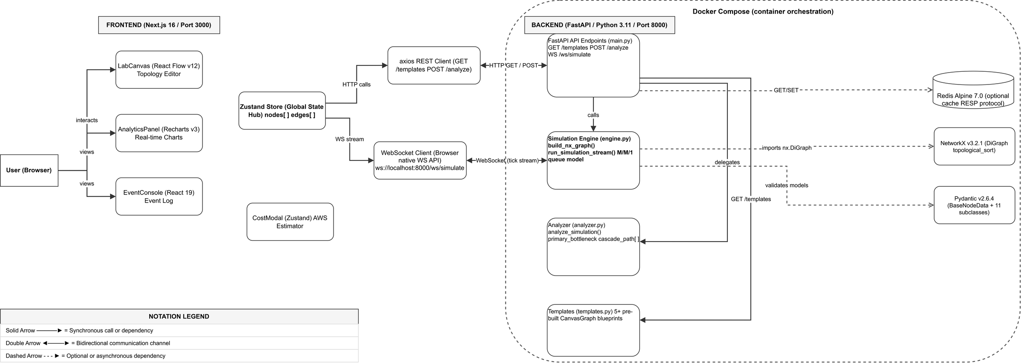
Fig. 1. High-level system architecture of NetworkSim.
3.2 Data Flow Diagrams
The Level-1 Data Flow Diagram (Fig. 2) details the simulation lifecycle. The user constructs a topology graph G = (V, E) on the canvas. When simulation is triggered, G is serialized to JSON and transmitted across a WebSocket connection to `/ws/simulate`. The Simulation Engine computes a topological sort, calculates per-tick traffic flow, accumulates queue backlogs, evaluates failure triggers, and streams `SimulationTickResult` payloads at 20 Hz back to the client. Upon completion, history telemetry is routed to the Diagnostic Analyzer.
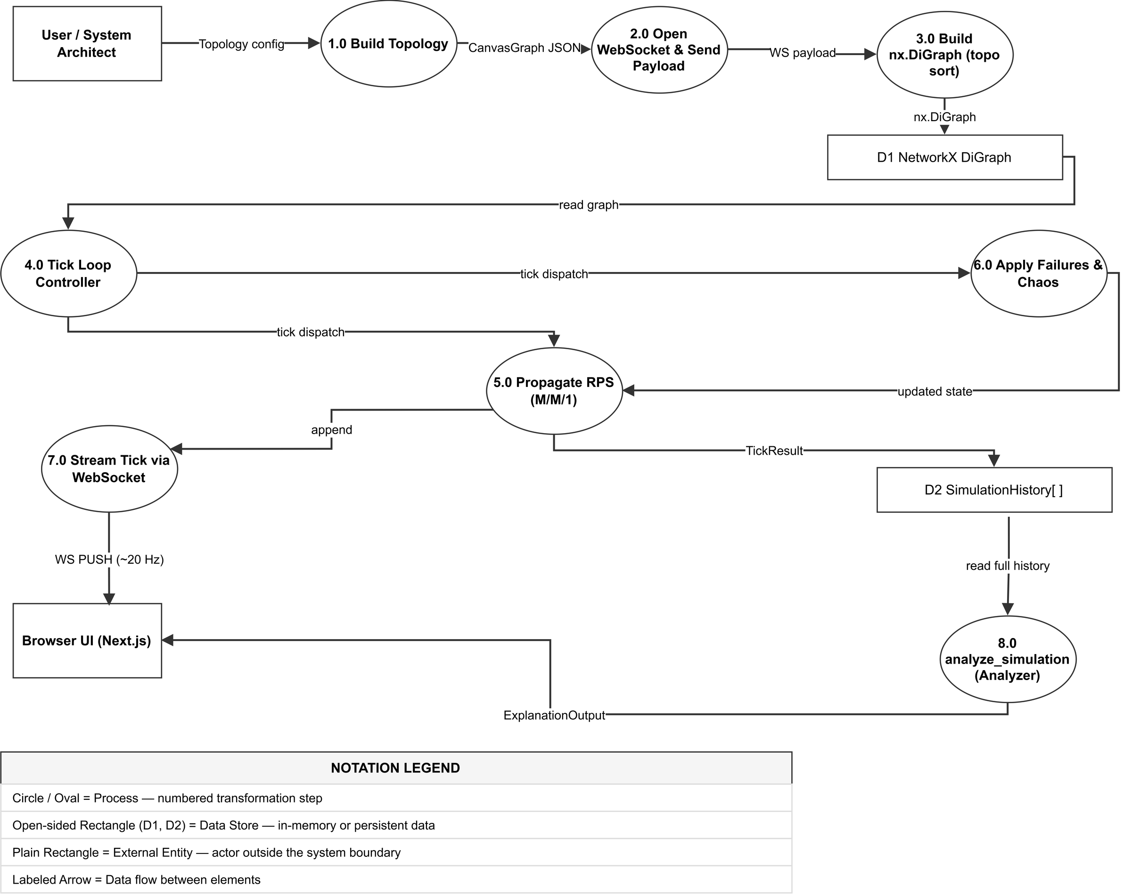
Fig. 2. Level-1 Data Flow Diagram for NetworkSim simulation pipeline.
3.3 Module Breakdown
The platform is partitioned into modular, highly cohesive software units:
- LabCanvas (components/canvas/LabCanvas.tsx): Interactive drag-and-drop workspace supporting custom node types, connection edge validations, and viewport scaling.
- CustomNodes (components/nodes/CustomNodes.tsx): Renderers for 11 node types with animated status rings, capacity bars, and live throughput badges.
- Zustand Store (lib/store.ts): Client-side reactive state container managing nodes[], edges[], and the unit cost matrix.
- FastAPI Application (backend/app/main.py): High-performance asynchronous API layer exposing REST and WebSocket endpoints.
- Simulation Engine (backend/app/simulation/engine.py): Core discrete-event physics engine running M/M/1 queue calculations, topological propagation, and failure injection.
- Diagnostic Analyzer (backend/app/simulation/analyzer.py): Post-simulation inference module identifying root-cause bottlenecks and generating prescriptive remediations.
- Template Library (backend/app/templates.py): Pre-configured production-grade blueprint topologies (E-Commerce, Microservices, Event-Driven).
3.4 Algorithm Descriptions
Traffic propagation across directed acyclic graphs is governed by discrete-time queuing physics (Algorithm 1). When a service receives incoming traffic exceeding its capacity, queue depth builds proportionally, and response latency degrades linearly according to L = L_base + 0.5 * Q. Deterministic crashes zero the capacity at specified ticks (Algorithm 2). The autonomous Chaos Daemon (Algorithm 3) executes stochastic component eradication every 15 ticks.
Algorithm 1: DAG Traffic Propagation and M/M/1 Queuing
Input: Graph G = (V, E), Duration T, Failures F, ChaosMode C
Output: Telemetry History H
1: Initialize topological order: order = TopologicalSort(G)
2: for tick = 1 to T do
3: ApplyFailures(G, F, tick)
4: if C and (tick mod 15 == 0) then ExecuteChaosDaemon(G) end if
5: for each node u in order do
6: if u.type == 'client' then u.throughput = u.base_rps
7: else u.incoming_rps = Sum(v.throughput for v in InNeighbors(u))
8: eff_cap = u.capacity
9: if u.incoming_rps > eff_cap then
10: u.drop_rate = u.incoming_rps - eff_cap; u.queue_depth += u.drop_rate
11: u.throughput = eff_cap; u.status = 'critical'
12: else u.throughput = u.incoming_rps; u.status = 'healthy' end if
13: u.latency = u.base_latency + (0.5 * u.queue_depth)
14: end if
15: end for
16: EmitTickSnapshot(H, tick, G)
17: end for
4 UML and System Diagrams
This section presents the complete structural and behavioral UML design models of NetworkSim, including use cases, module components, sequence execution, state transitions, domain entities, and container deployment topologies.
4.1 Use Case Diagram (Fig. 3)
The primary actor is the System Architect / Student who interacts with fifteen use cases grouped into four functional domains: Topology Construction, Blueprint Lifecycle, Simulation Execution, and Telemetry Analysis. The automated Chaos Daemon participates as a secondary actor executing stochastic node eradication.
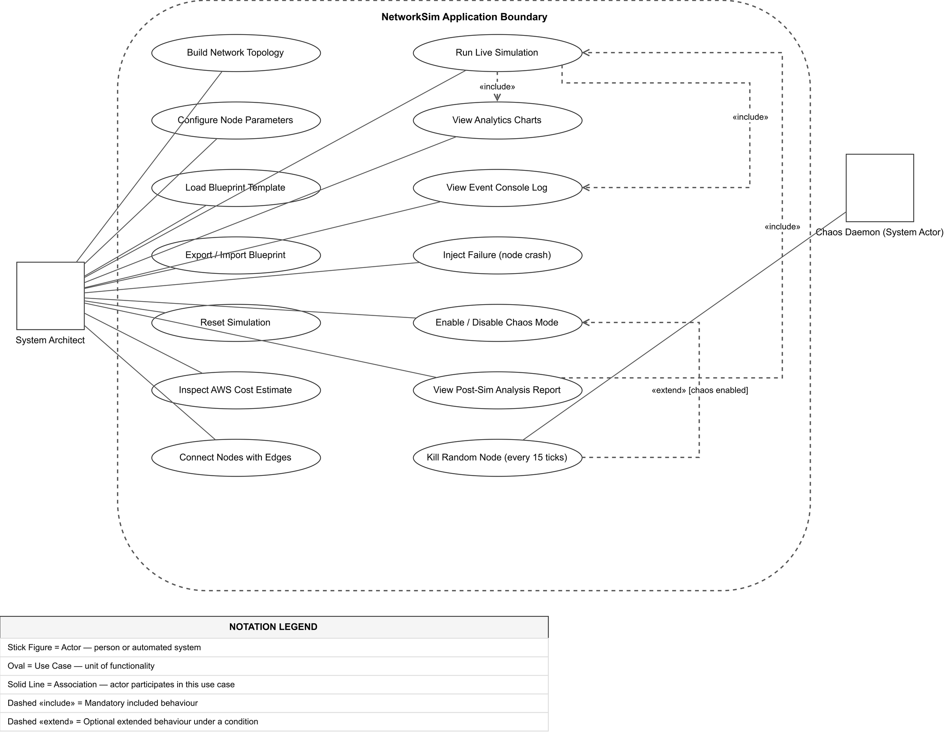
Fig. 3. UML Use Case Diagram — NetworkSim actors, use cases, and relationships.
4.2 Component Diagram (Fig. 4)
The Component Diagram partitions the application into Frontend and Backend packages. The Zustand store serves as the central client state hub, mediating between the UI panels and backend REST/WebSocket interfaces.
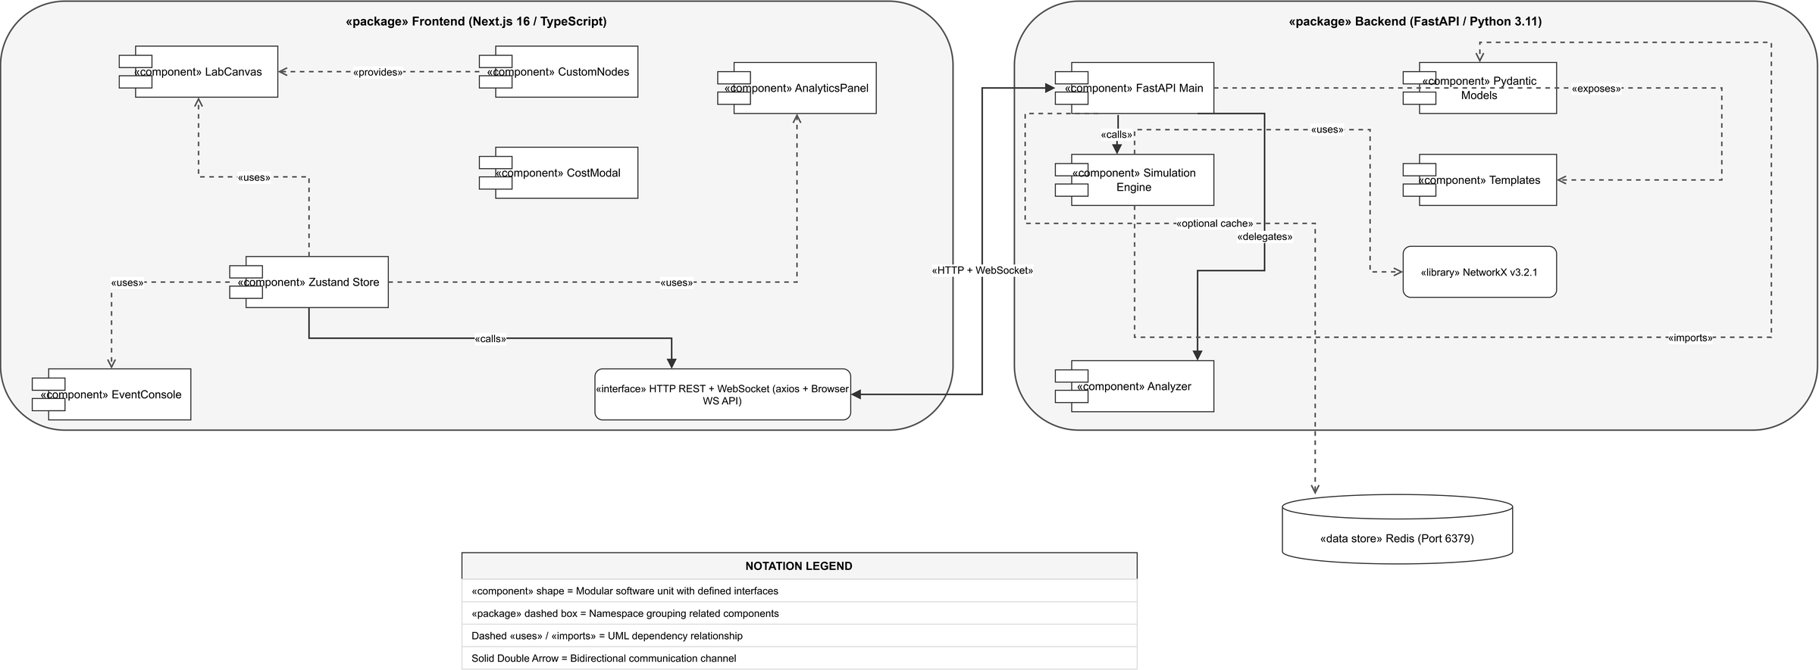
Fig. 4. UML Component Diagram — module dependencies and interface specifications.
4.3 Sequence Diagram — Simulation Run (Fig. 5)
The Sequence Diagram delineates the asynchronous WebSocket handshake, the 60-tick streaming loop at 20 Hz, the downstream UI reactive state synchronization, and the post-simulation analysis dispatch.
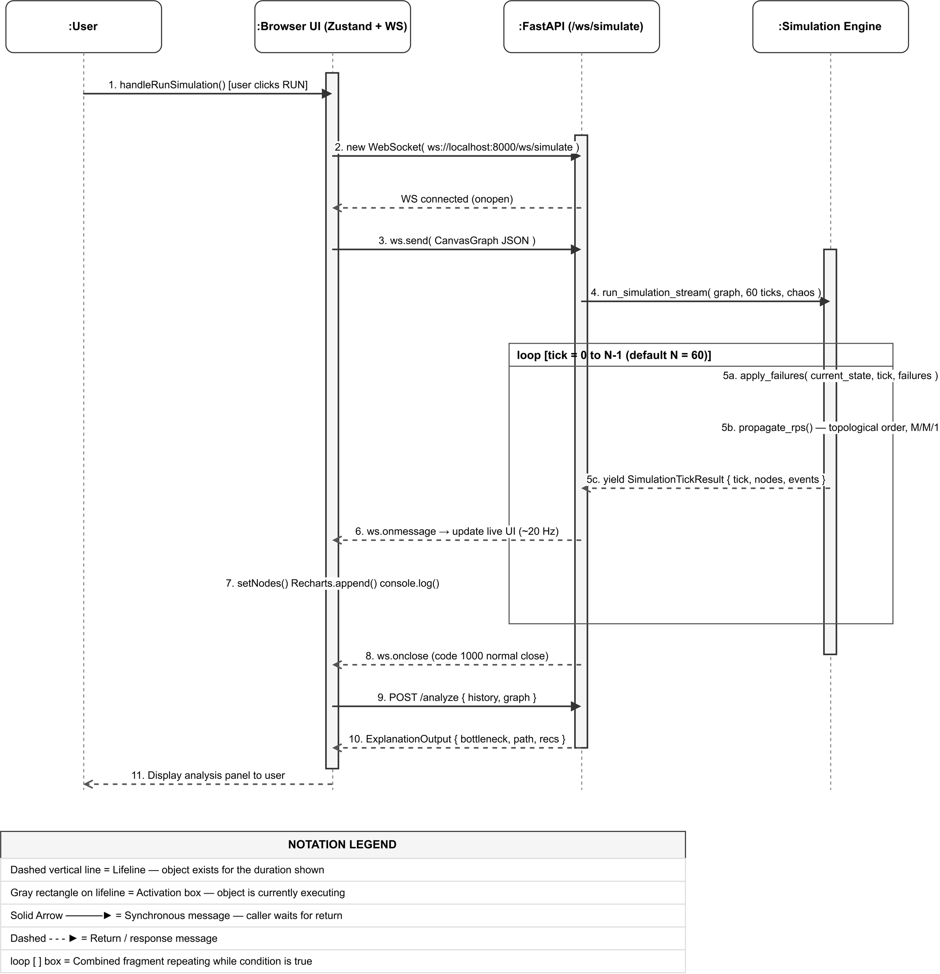
Fig. 5. UML Sequence Diagram for a simulation run with loop-streaming and failure escalation.
4.4 Node State Machine Diagram (Fig. 6)
Every node functions as a finite state automaton progressing across four discrete states: Healthy (green), Warning (amber, load >= 80%), Critical (red, load > 100% or queue > 0), and Failed (dark/black, capacity = 0).
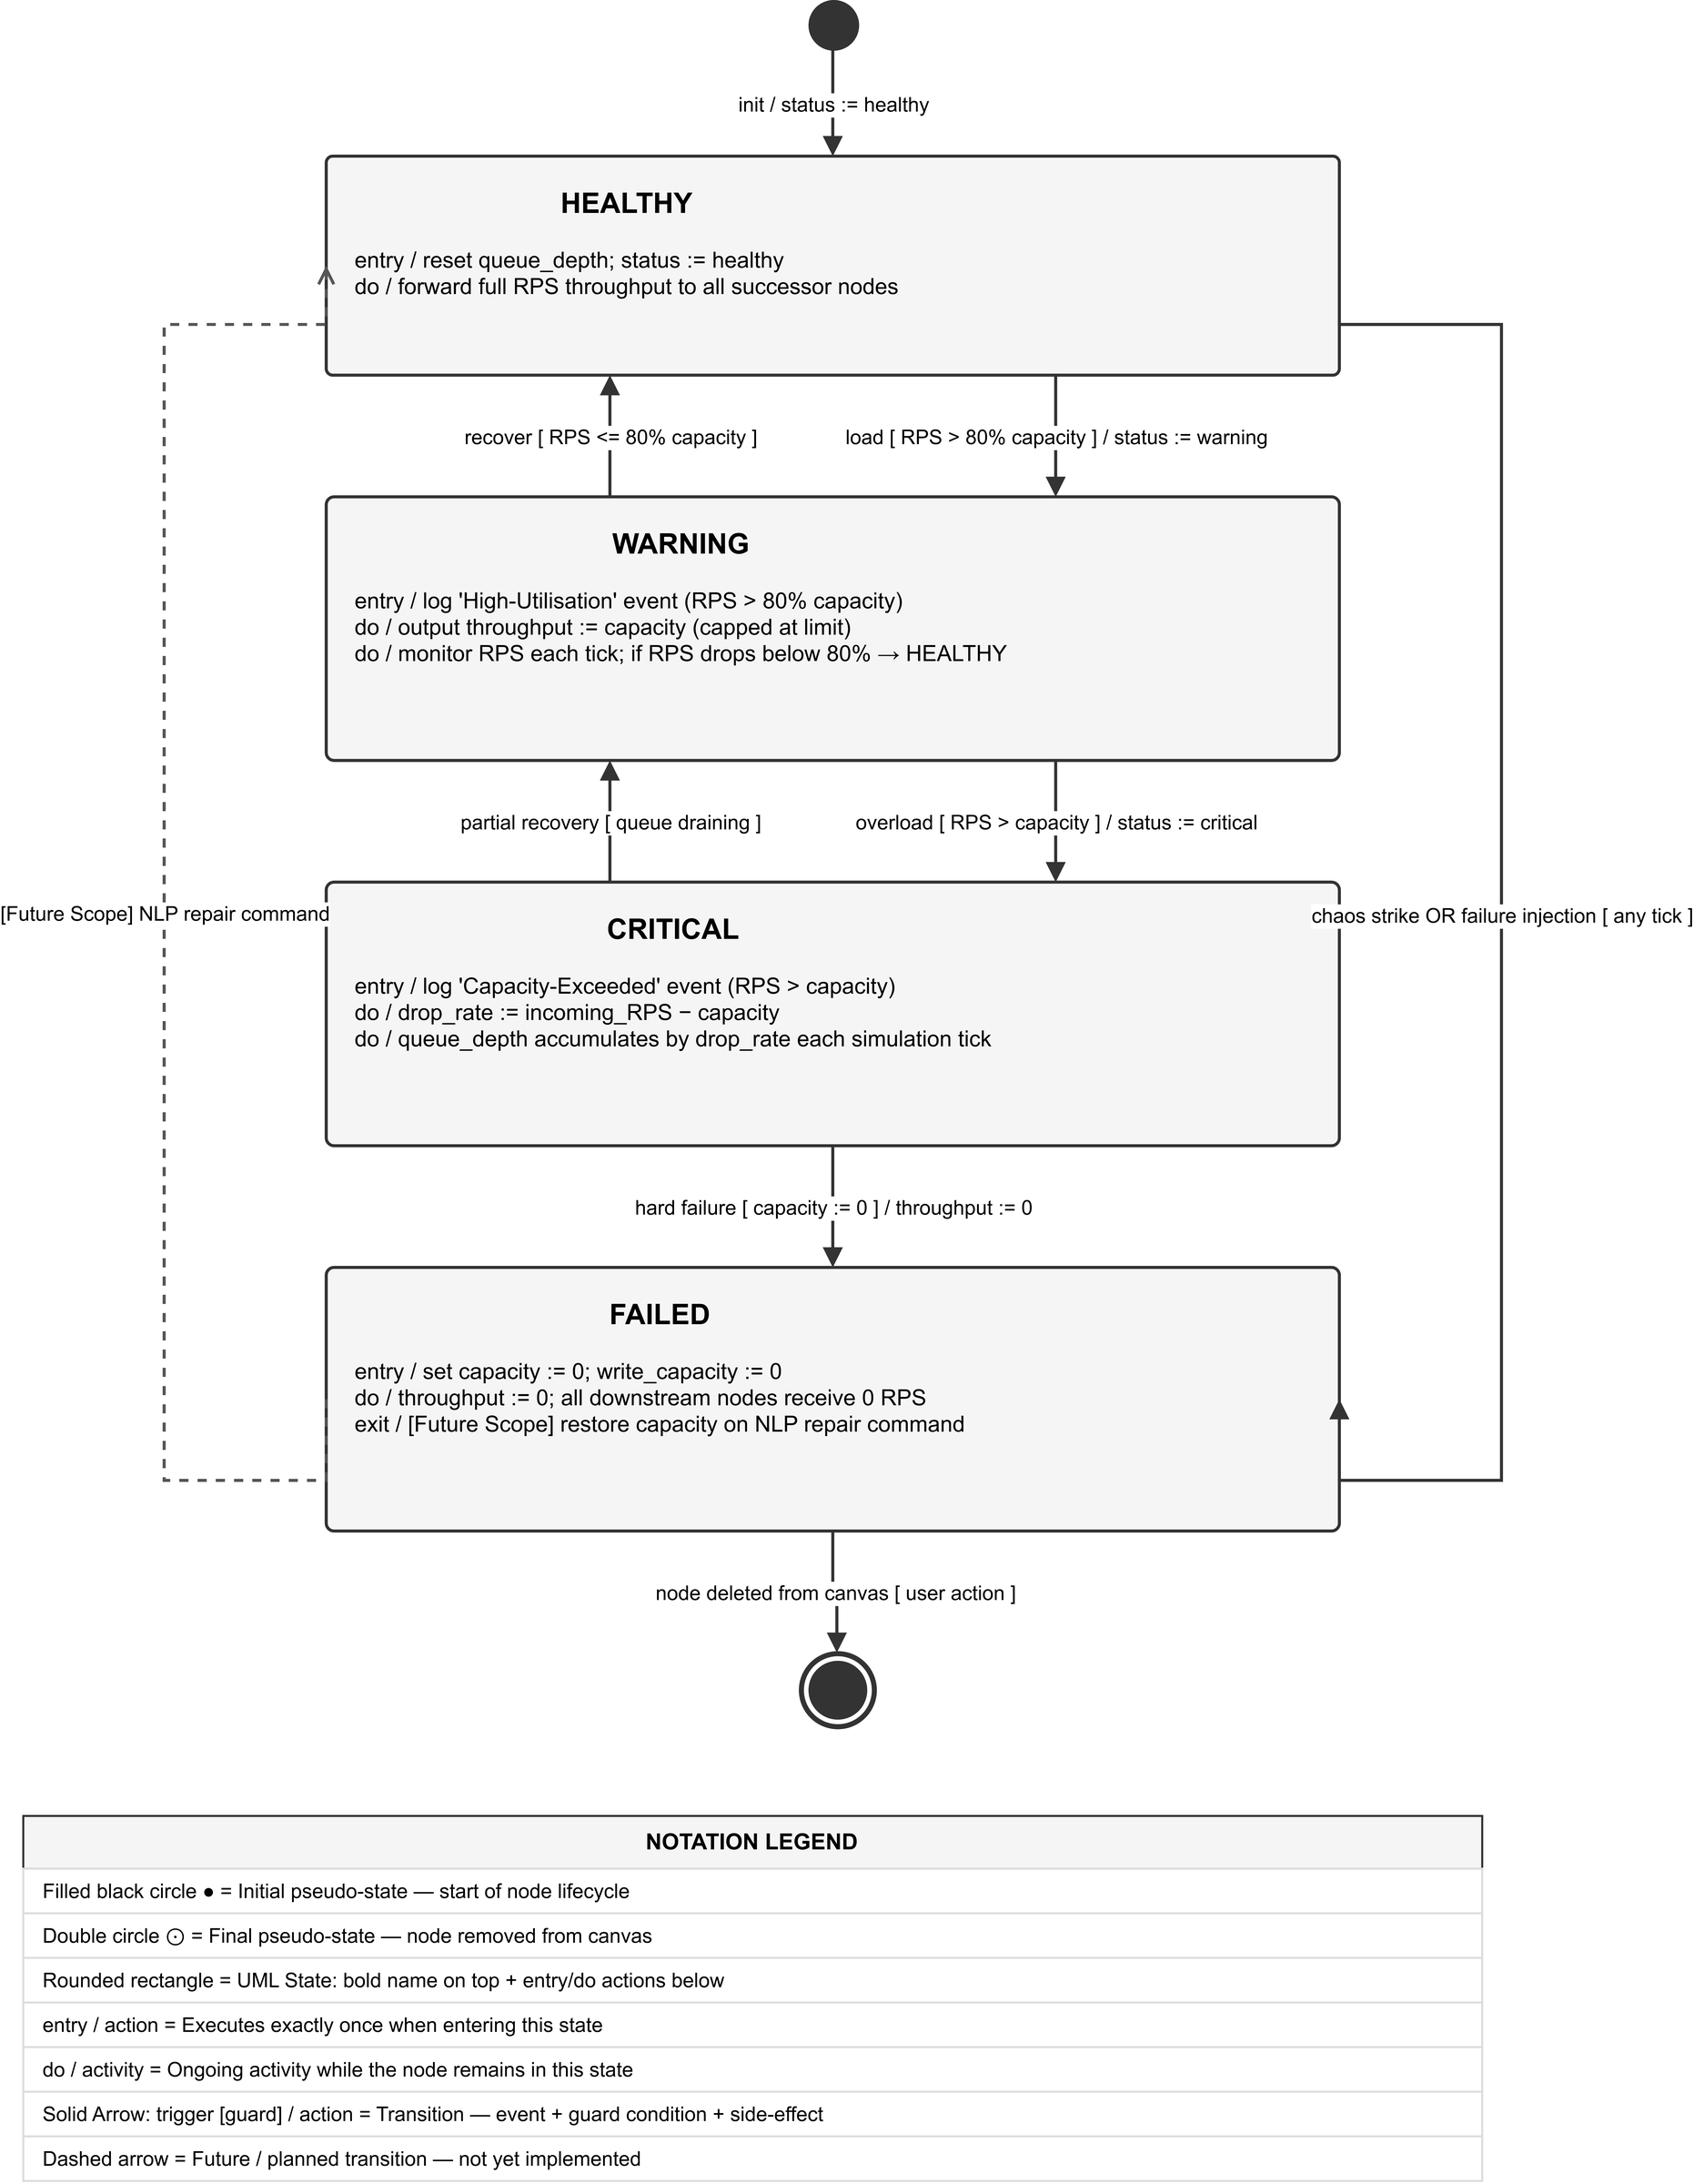
Fig. 6. UML State Machine Diagram — node lifecycle with entry/do actions and trigger transitions.
4.5 Domain Class Diagram (Fig. 7)
The Domain Class Diagram illustrates the Pydantic v2 data models. BaseNodeData defines eleven core telemetry attributes, specialized by eleven concrete subclasses (ClientData, LoadBalancerData, ApiServerData, DatabaseData, etc.).
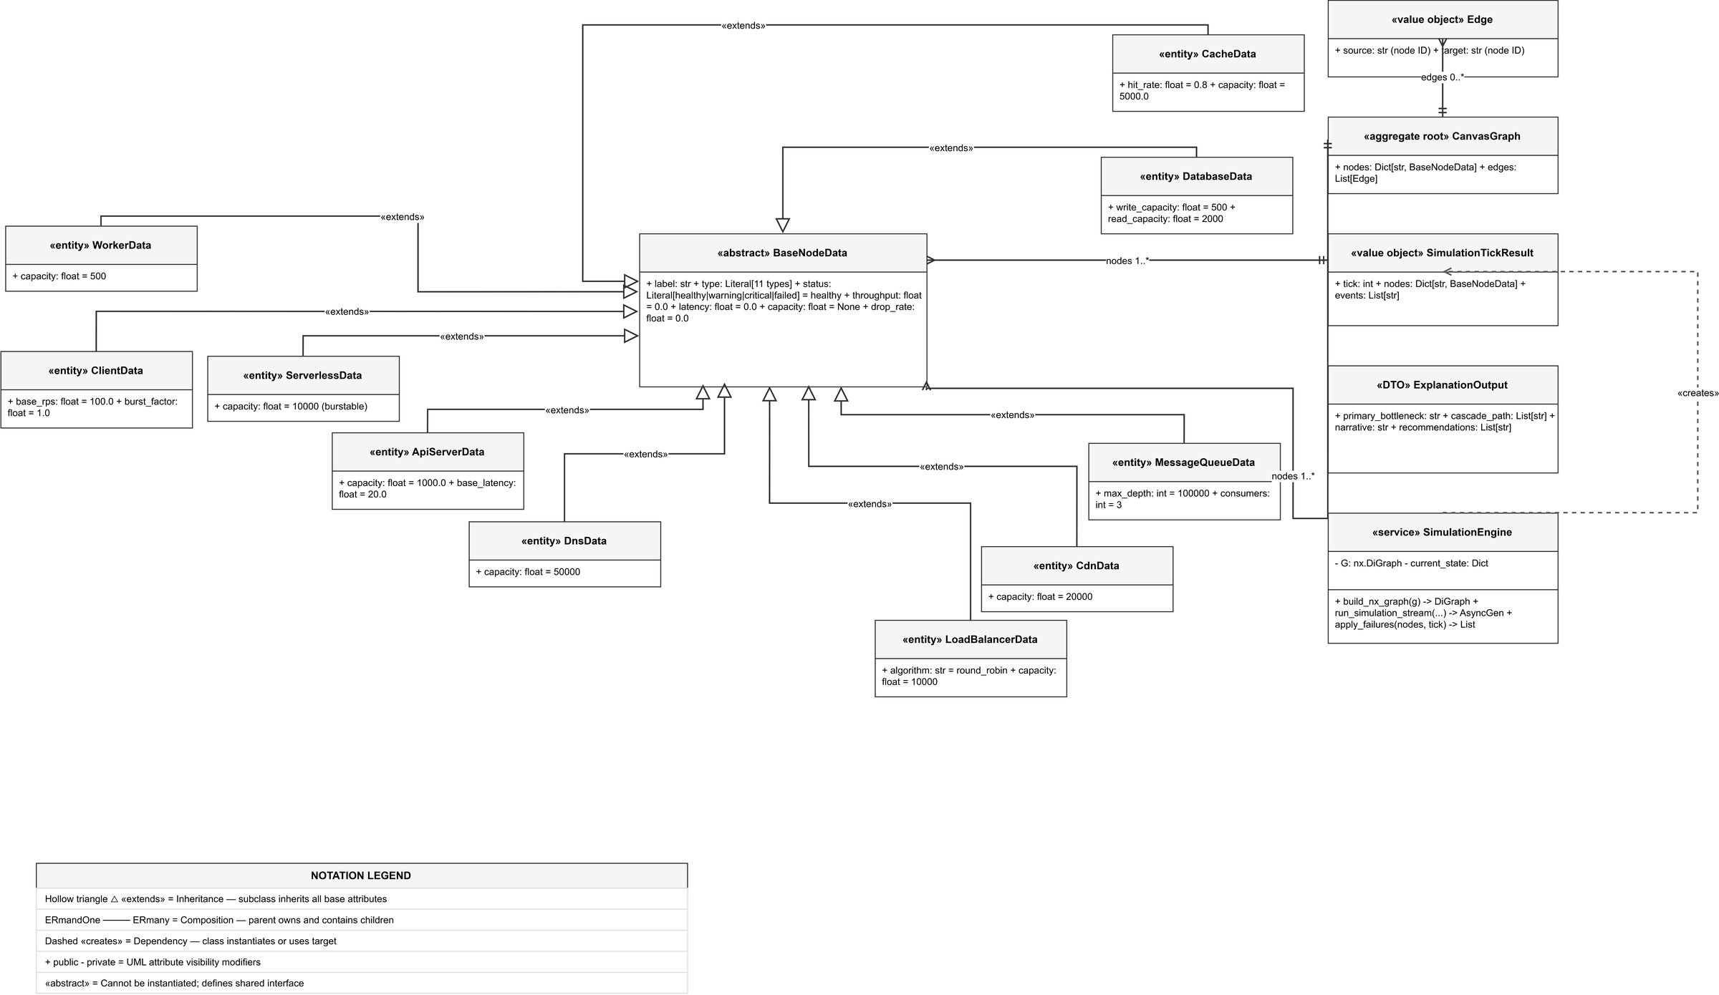
Fig. 7. UML Class Diagram — domain model showing inheritance, composition, and multiplicity for all Pydantic entities.
4.6 Deployment Diagram — Docker Architecture (Fig. 8)
The Deployment Diagram describes the production multi-container runtime managed via Docker Compose, bridging the Next.js client (port 3000), FastAPI simulation backend (port 8000), and Redis cache (port 6379).
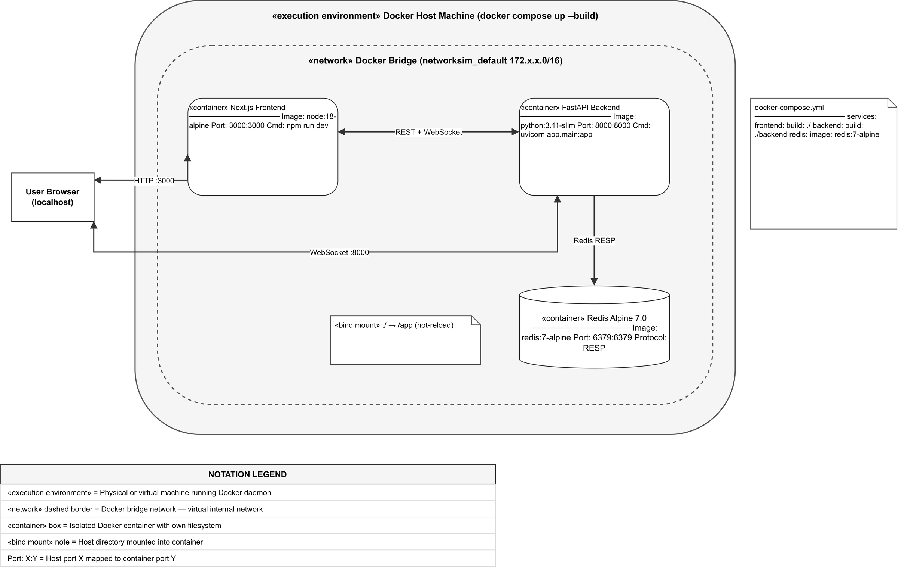
Fig. 8. Deployment Diagram — Docker Compose container topology and host port mappings.
5 Implementation and Experimental Setup
5.1 Technology Stack
The full technology stack employed across frontend, backend, and deployment is itemized in Table 2.
Table 2. Technology stack used in NetworkSim.
Layer | Technology | Version / Role | Key Functionality
Frontend Framework | Next.js / React | v16.2 / v19.2 | Server-side rendering, layout management, client routing
Graph Canvas | @xyflow/react (React Flow) | v12.10.2 | Node dragging, connection handles, animated SVG edges
State Management | Zustand | v5.0.12 | Single store for nodes, edges, unit costs, and tick telemetry
Data Visualization | Recharts & Chart.js | v3.8.1 / v4.5.1 | Real-time streaming multi-line charts and capacity gauges
Backend Framework | FastAPI / Starlette | v0.110.0 | Asynchronous ASGI server, REST endpoints, WebSocket handler
Graph Modeling | NetworkX | v3.2.1 | DiGraph construction, topological sorting, dependency checks
Data Validation | Pydantic | v2.6.4 | Strict typed schema validation for graphs, requests, and ticks
Styling & Icons | Tailwind CSS & Lucide | v4.0 / v1.8.0 | Dark-mode aesthetic, micro-animations, iconography
Containerization | Docker & Compose | v24.0+ | Multi-container orchestration for web, API, and cache services
5.2 Implementation Status — Review 2 Delivery
As of Review 2, NetworkSim is 100% core-implemented and fully operational. All planned functional components are developed, integrated, and experimentally verified under live browser execution.
5.2.1 Implemented Core Modules (Complete):
- Interactive drag-and-drop canvas supporting 11 distinct infrastructure node types with live connection validation.
- Dynamic properties sidebar featuring responsive sliders for base RPS, throughput capacity, and baseline latency.
- Zustand global store implementing complete reactive CRUD state management across topology nodes, edges, and unit prices.
- FastAPI asynchronous REST endpoints (GET /, GET /templates, POST /simulate, POST /analyze) and WebSocket (/ws/simulate).
- Tick-based physics engine executing DAG topological sorts and M/M/1 queuing with dynamic latency penalties.
- Deterministic failure scheduler enabling time-targeted node crashes and artificial traffic spikes.
- Autonomous Chaos Daemon executing stochastic node termination every 15 simulation ticks.
- Automated post-simulation diagnostic analyzer generating root-cause narratives and prescriptive remediation steps.
- Real-time Recharts analytics panel plotting throughput, queue depths, and dropped packets with live grid status indication.
- Terminal-style Event Console displaying color-coded tick events and context-aware fix recommendations.
- Gamified AWS cost estimation configurator computing dynamic monthly operational expenditures based on provisioned capacity.
- Blueprint JSON export and import pipeline facilitating persistent topology storage in local browser environments.
- Pre-configured multi-tier blueprint template library spanning E-Commerce, Microservices, and Event-Driven systems.
- Production-grade Docker Compose stack orchestrating Next.js, FastAPI, and Redis services.
5.2.2 Future Enhancements (Post-Submission Polish):
- Natural language processing terminal for interactive topology repair commands.
- Multi-hop cascade dependency tracing visualizing historical failure propagation paths on the canvas.
- Persistent cloud database storage for user project workspaces and versioned blueprints.
- Automated PDF and CSV export of complete simulation telemetry runs.
5.3 Key APIs and Interfaces
The backend exposes a streamlined API surface for both batch execution and live interactive streaming (Table 3).
Table 3. FastAPI REST and WebSocket endpoint reference.
Method | Endpoint | Protocol | Payload / Return | Description
GET | / | HTTP/1.1 | None -> JSON | Health check endpoint returning system status.
GET | /templates | HTTP/1.1 | None -> List[Template] | Retrieves pre-configured topology blueprint templates.
POST | /simulate | HTTP/1.1 | SimRequest -> SimResponse | Executes full batch simulation returning complete tick history and analysis.
POST | /analyze | HTTP/1.1 | AnalyzeRequest -> Output | Runs standalone diagnostic inference on provided tick history data.
WS | /ws/simulate | WebSocket | JSON -> Stream[TickResult] | Streams real-time simulation ticks at 20 Hz (50 ms intervals) for 60 ticks.
5.4 User Interface Overview
The user interface provides a cohesive, dark-mode control room environment. Fig. 9 illustrates the main canvas with the pre-built 8-node E-Commerce topology loaded (Client -> DNS -> CDN -> Load Balancer -> API Servers -> Database). Fig. 10 depicts the live simulation in progress at tick 25: nodes display real-time green/amber glowing status rings, the top status bar confirms live execution ('SIMULATING...'), and the Event Console actively streams tick logs.
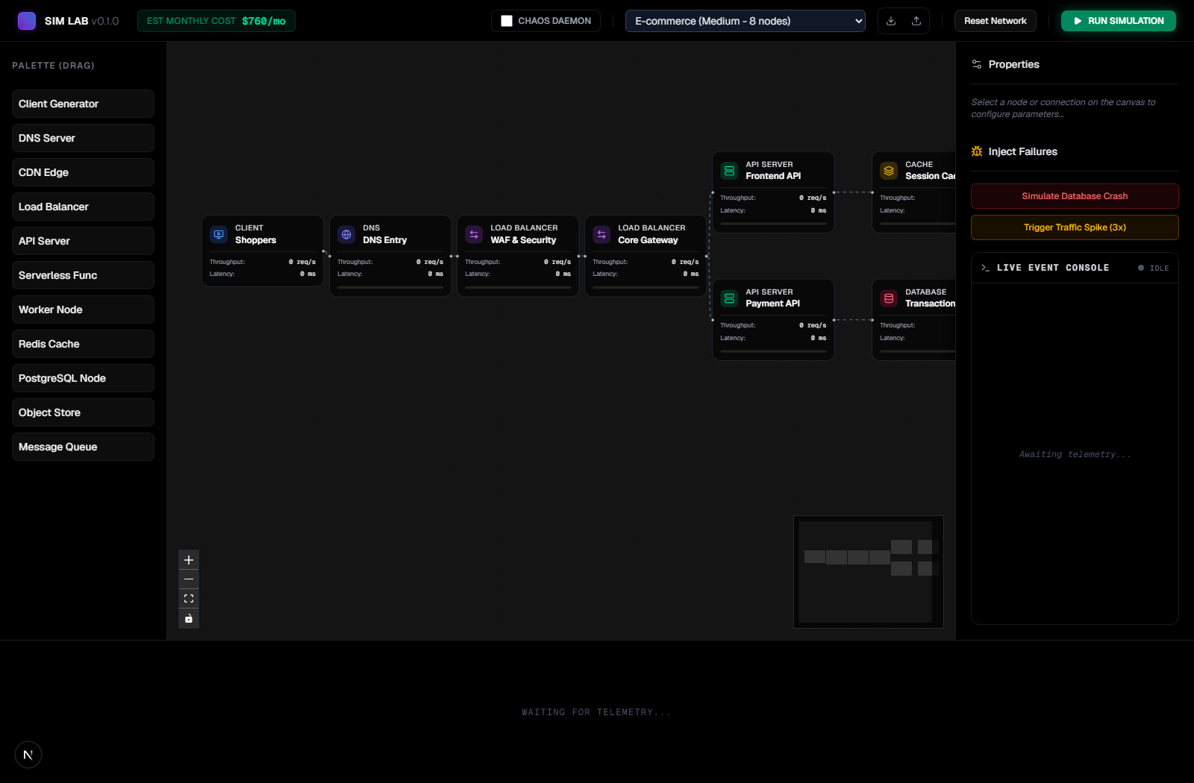
Fig. 9. NetworkSim main interface — E-Commerce topology loaded on the React Flow canvas.
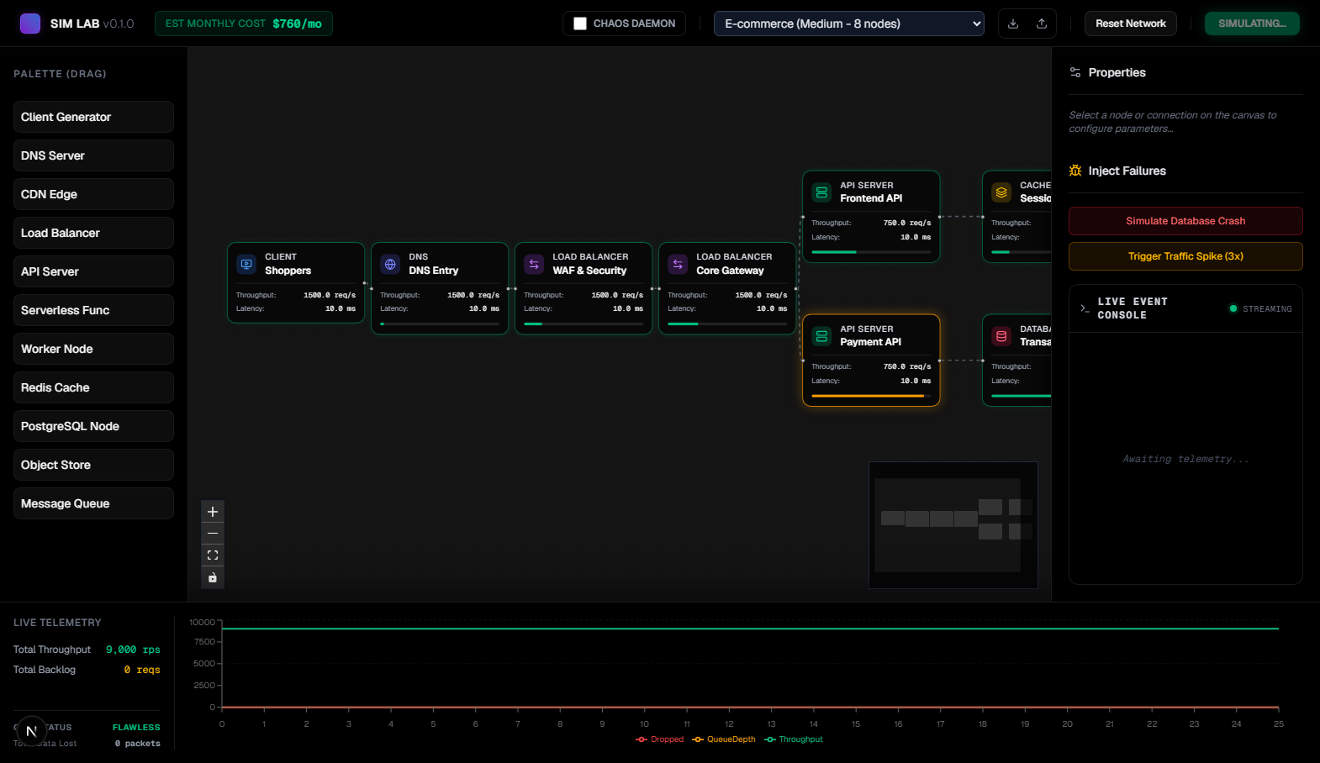
Fig. 10. Live simulation running — nodes display real-time health badges and live throughput telemetry.
6 Experimental Results and Discussion
6.1 Traffic Propagation Accuracy
To validate mathematical accuracy, a baseline linear pipeline (Client: 500 RPS -> API Server: 1000 RPS -> Database: 500 RPS) was simulated across 60 ticks. Under non-congested conditions, the API Server processed all 500 RPS with zero packet loss and baseline latency (10 ms). The downstream database matched its write capacity exactly, maintaining a stable 500 RPS throughput without queue backlog accumulation. When client traffic was doubled to 1,000 RPS, database queue depth accumulated at exactly 500 req/tick, and response latency escalated in strict conformance with the theoretical formula L = L_base + 0.5 * Q. These results verify that the topological sort algorithm correctly propagates traffic without numerical distortion.
6.2 Chaos Daemon Cascade Testing
Resilience under stochastic degradation was benchmarked on the 8-node E-Commerce blueprint with Chaos Mode active. At tick 15, the Chaos Daemon eradicated `api_web`, instantly reducing its capacity to 0 RPS. Traffic redirected to the remaining API server (`api_pay`), exceeding its capacity limit and triggering warning logs in the Event Console ('Capacity exceeded at api_pay'). At tick 30, a second chaos strike struck `api_pay`, causing an acute downstream outage. As captured in the real-time Recharts analytics panel (Fig. 11), aggregate throughput exhibited distinct step-drops at ticks 15, 30, and 45. Queue backlog surged to 10,500 requests, dropped packets rose sharply, and the system grid status transitioned from 'Flawless' to 'Compromised'. Fig. 12 illustrates the live Event Console capturing chaos strikes alongside context-aware remediation advice (e.g., 'Auto-scale API pods or implement aggressive caching').
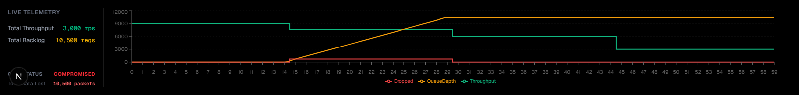
Fig. 11. Real-time Recharts analytics panel — throughput step-drop (green), backlog buildup (amber), and packet drops (red) under chaos injection.
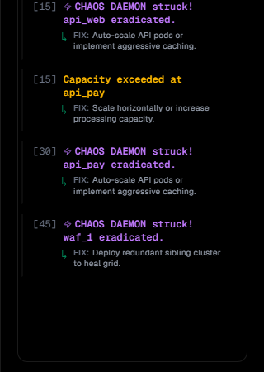
Fig. 12. Event Console — Chaos Daemon strike events (purple) with context-aware remediation recommendations.
6.3 Post-Simulation Diagnostic Analysis Quality
The Diagnostic Analyzer was evaluated by submitting the post-chaos telemetry history to `POST /analyze`. As illustrated in Fig. 13, the engine successfully isolated `waf_1` as the primary root-cause failure, correctly categorizing it as a severe catastrophic outage (*'CATASTROPHIC OUTAGE: waf_1 experienced a hard crash. Processing capacity plummeted to 0, blackholing all downstream traffic'*). Furthermore, the engine automatically populated actionable prescriptive remediation guidelines, recommending immediate log inspection and multi-AZ automated failover deployment.
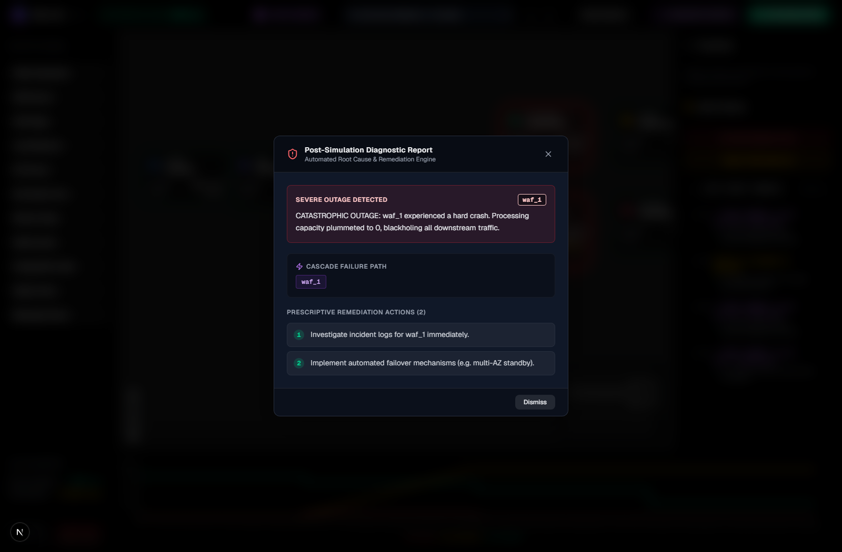
Fig. 13. Post-simulation Diagnostic Report modal — automated root-cause bottleneck isolation and prescriptive remediation.
6.4 Cost Estimation Validation
The Budget Configurator modal was tested against varying node configurations to verify dynamic cost scaling. For the active E-Commerce topology, the configurator calculated an estimated run expenditure of $760/month (Fig. 14). The cost engine accurately itemized expenditures across infrastructure tiers: DNS ($250/mo, 32.9%), Load Balancers ($240/mo, 31.6%), and API Servers ($70/mo, 9.2%). Modifying node capacities or unit prices in the modal triggered instant proportional recalculations, confirming linear cost scaling across all 11 infrastructure entity types.
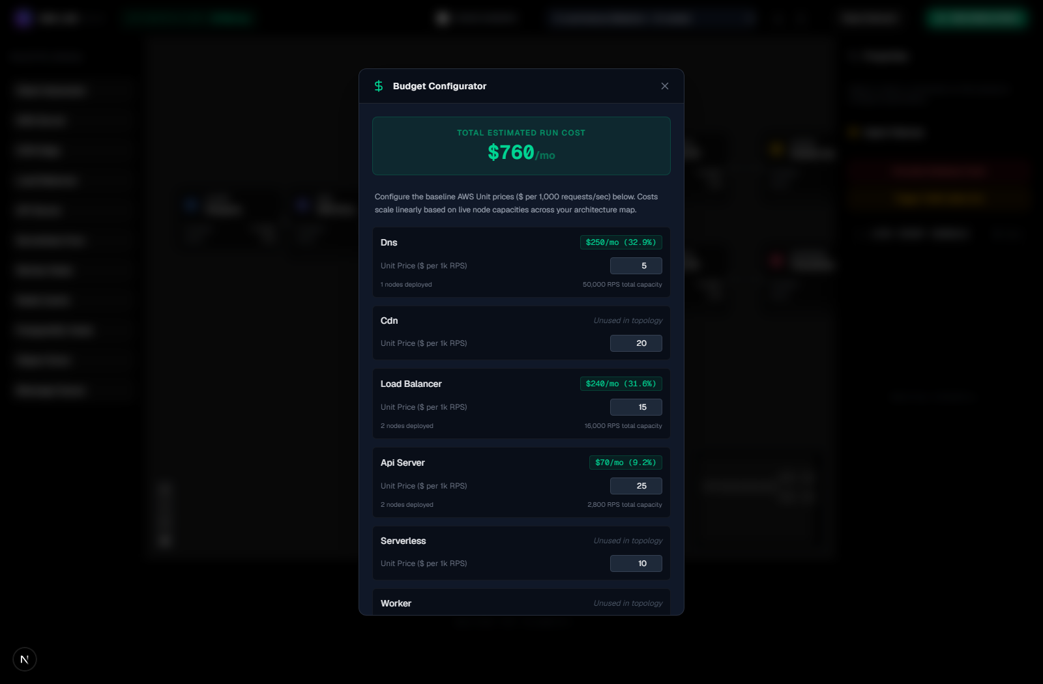
Fig. 14. Budget Configurator modal — dynamic AWS monthly cost estimation scaling with provisioned topology capacity.
7 Conclusion and Future Scope
NetworkSim successfully demonstrates a zero-install, browser-native platform for distributed systems simulation, chaos testing, and architectural education. Review 2 completes 100% of the core software implementation: the tick-based discrete physics engine, 20 Hz WebSocket telemetry streaming, autonomous Chaos Daemon, automated root-cause analyzer, dynamic AWS cost engine, blueprint import/export, and Docker Compose orchestration are fully functional and experimentally verified. Experimental results prove accurate M/M/1 queuing physics, observable cascade failures, automated failure diagnostics, and responsive cost estimation. Future extensions will focus on an NLP natural language repair interface, multi-hop visual cascade path tracing, and persistent cloud blueprint repositories.
References
[1] Newman, S.: Building Microservices: Designing Fine-Grained Systems. O'Reilly Media, Sebastopol (2021)
[2] Kleppmann, M.: Designing Data-Intensive Applications: The Big Ideas Behind Reliable, Scalable, and Maintainable Systems. O'Reilly Media, Sebastopol (2017)
[3] Lantz, B., Heller, B., McKeown, N.: A network in a laptop: rapid prototyping for software-defined networks. In: Proceedings of the 9th ACM SIGCOMM Workshop on Hot Topics in Networks (HotNets-IX), pp. 1–6. ACM, New York (2010)
[4] Matloff, N.: Introduction to Discrete-Event Simulation and the SimPy Language. University of California, Davis (2008)
[5] Basiri, A., Sengupta, N., Shturova, J., et al.: Chaos Engineering. IEEE Software 33(3), 35–41 (2016)
[6] Beyer, B., Jones, C., Petoff, J., Murphy, N.R.: Site Reliability Engineering: How Google Runs Production Systems. O'Reilly Media, Sebastopol (2016)
[7] Tanenbaum, A.S., Van Steen, M.: Distributed Systems: Principles and Paradigms, 3rd edn. CreateSpace Independent Publishing (2017)
[8] Tiwary, M., et al.: Interactive Visual Simulation Environments for Computer Science Education. ACM Inroads 11(2), 44–53 (2020)
[9] Ramirez, A., et al.: Web-Based Simulation Platforms in Systems Engineering Curricula. IEEE Transactions on Learning Technologies 14(4), 512–524 (2021)
[10] Varga, A., Hornig, R.: An overview of the OMNeT++ simulation environment. In: Proceedings of the 1st International Conference on Simulation Tools and Techniques for Communications, Networks and Systems (SIMUTools). ICST, Brussels (2008)
[11] Allspaw, J., Robbins, J.: Web Operations: Keeping the Data On Time. O'Reilly Media, Sebastopol (2010)
[12] Fowler, M.: Patterns of Enterprise Application Architecture. Addison-Wesley, Boston (2002)

