Topic – React Props

Copy data from dummyjson 10 products

Show them in react using props

Topic – conditional rendering

1.Make a list of packaging items – like

{id:1, item: ‘shoes’, ispacked :true , isHeavy : false}

Based on ispacked show text packed or rightsymbol and if true then background color green if not packed then no bgcolor

And isheavy is true then show bgcolor black and text white

2.Make a variable isdark and if true then show bgcolor dark color else white

3.Make a variable isOpen and if true then show a component else don’t show it

Topic – state and form

1. make five fields and show their input below them

hint : - (use event.preventDefault() on onSubmit event )

2.make an input number fields that add value to our count state

3. Make a state isdark and change isdark value on button click if true then show bgcolor dark color else white

4.Make a state isOpen and change isOpen value on button click if true then show a component else don’t show it

Topic – State

Todo list

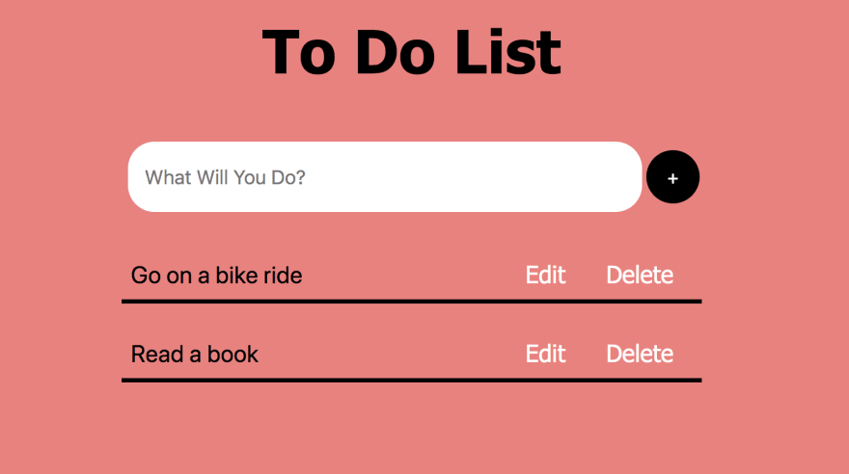

Packaging list:-

1.Make a list of packaging items using state and add input to add list item – like

{id:1, item: ‘shoes’, ispacked :true , isHeavy : false}

Based on ispacked show text packed or rightsymbol and if true then background color green if not packed then no bgcolor

And isheavy is true then show bgcolor black and text white