Topic – forms

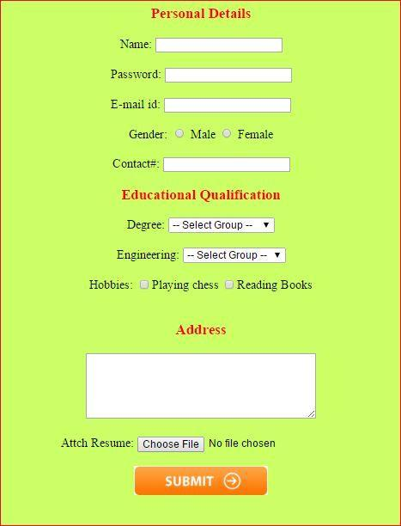

Topic – background

Make 4 articles in a box with background

Make 7 shapes using border-radius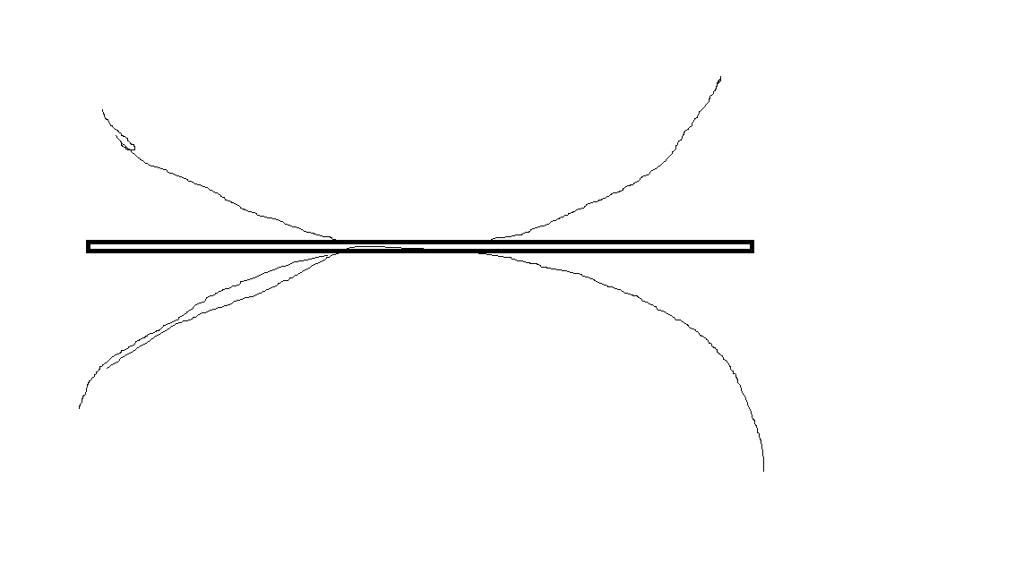

Topic – text ,font and shadow

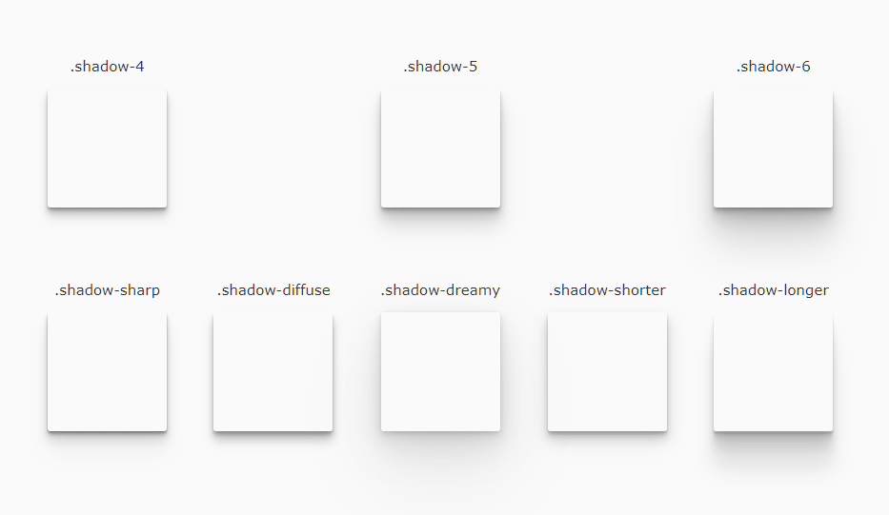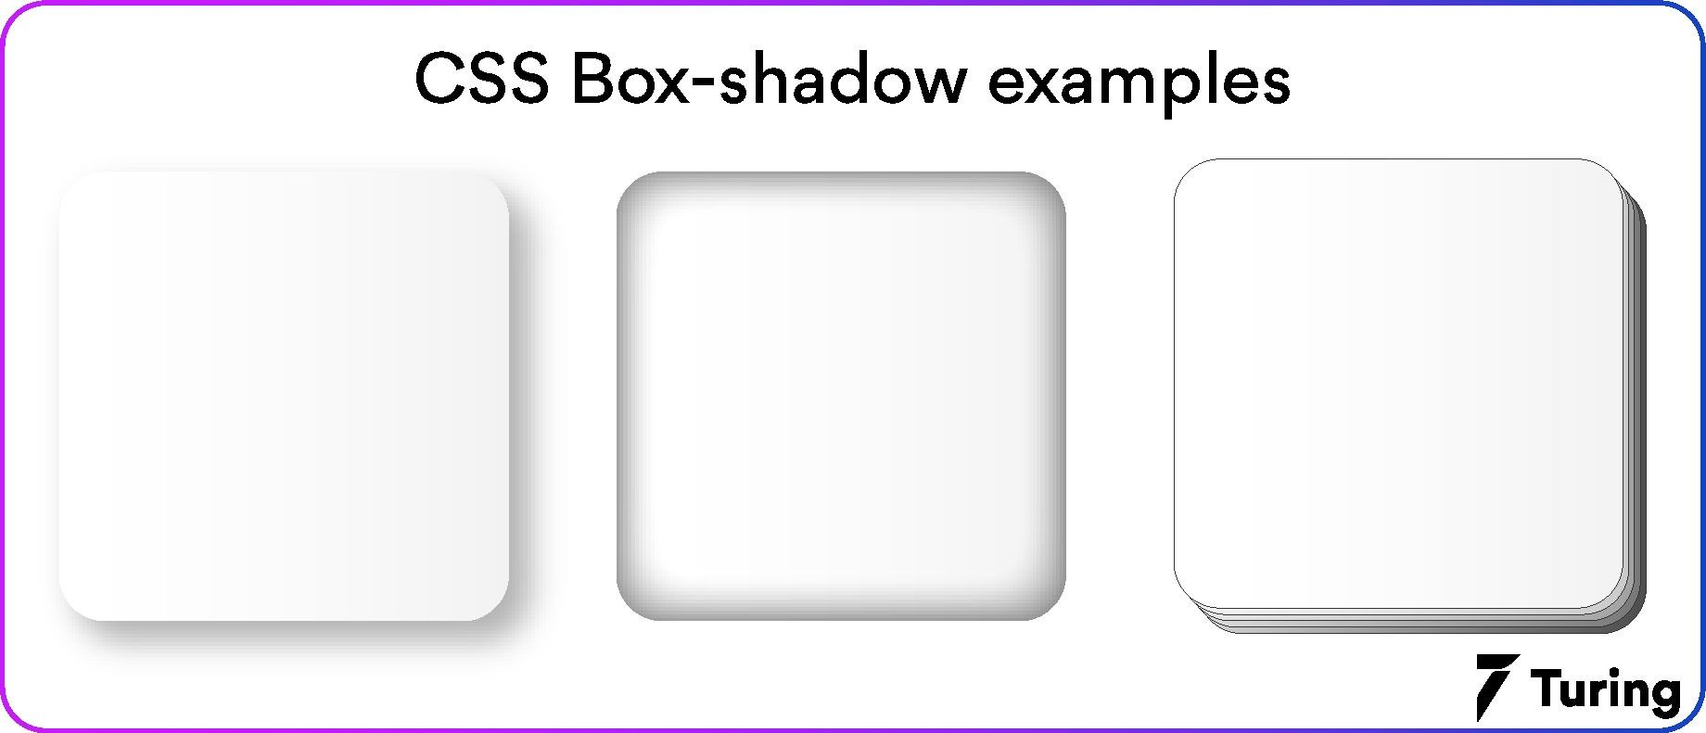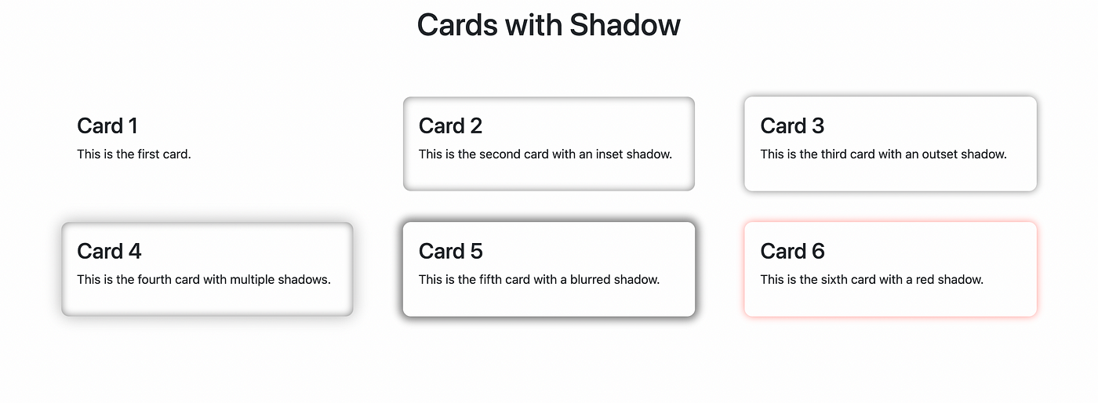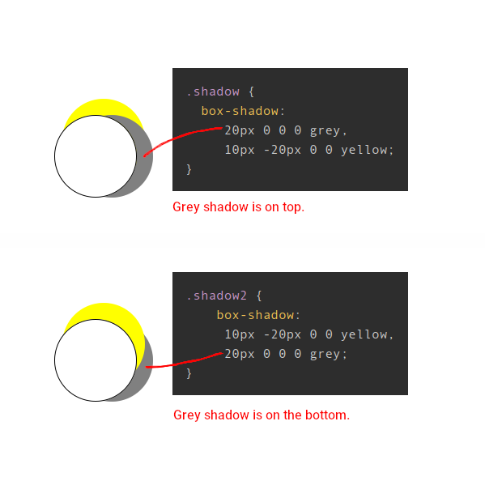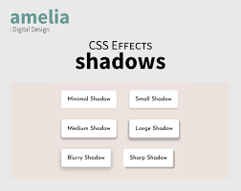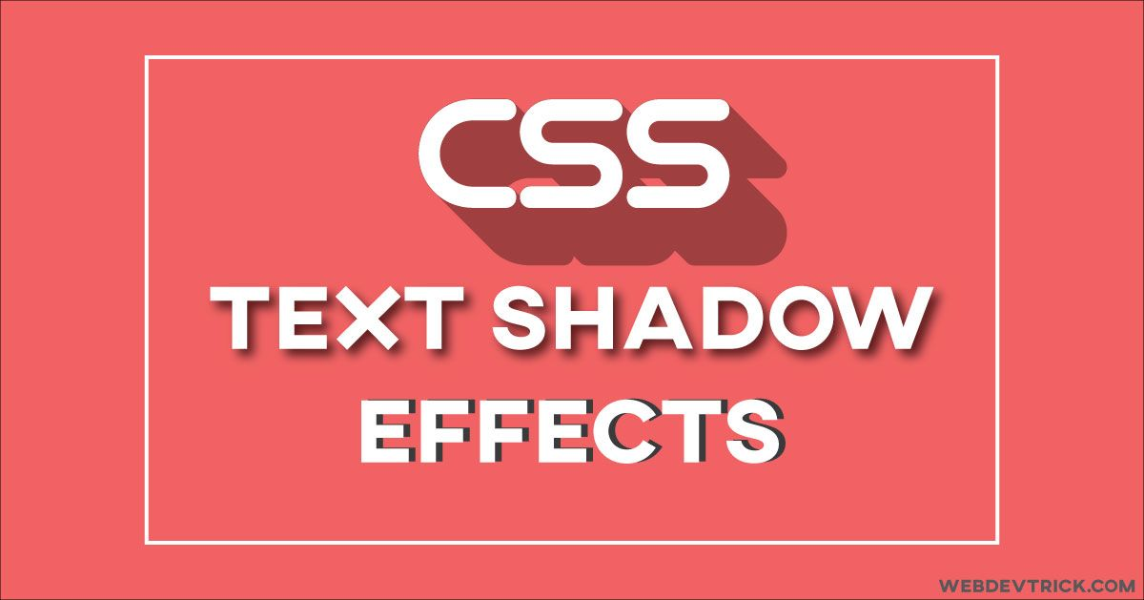

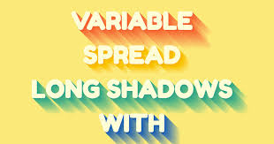

Topic :- float,colors

Side : - <https://templatemo.com/tm-589-lugx-gaming>

Navbar and 2 parts

Topic :-1. on hover add shadow to box(excluding top)

2.add transition to hide an element (opacity:0,display:none)

3.Add transition to convert a rectangular to circle

4. make a box in right bottom corner fixed position with 4 social media icons inside

5.last section of above webpage(lux gaming)

Topic : - flex

<http://www.htmltemplates.net/preview/template_3/index.html>

make complete webside of lux gaming

Topic: layout

<https://www.quackit.com/html/templates/download/bootstrap/business-1/index.html>

<https://www.quackit.com/html/templates/download/bootstrap/corporate-4/index.html>