**Assignment 12/06/24**

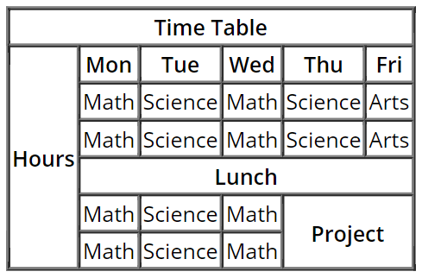

Topic – forms 13/06/24



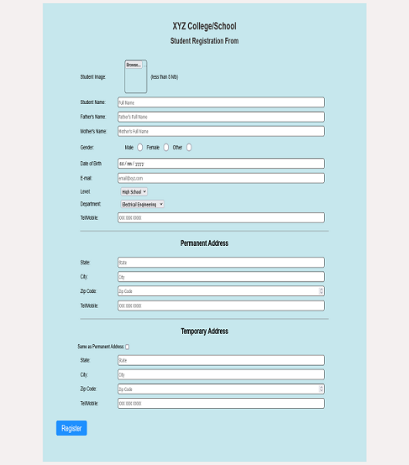

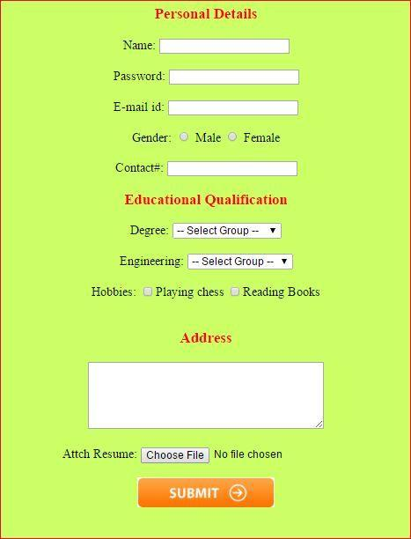

Topic – border, border-radius,margin ,padding

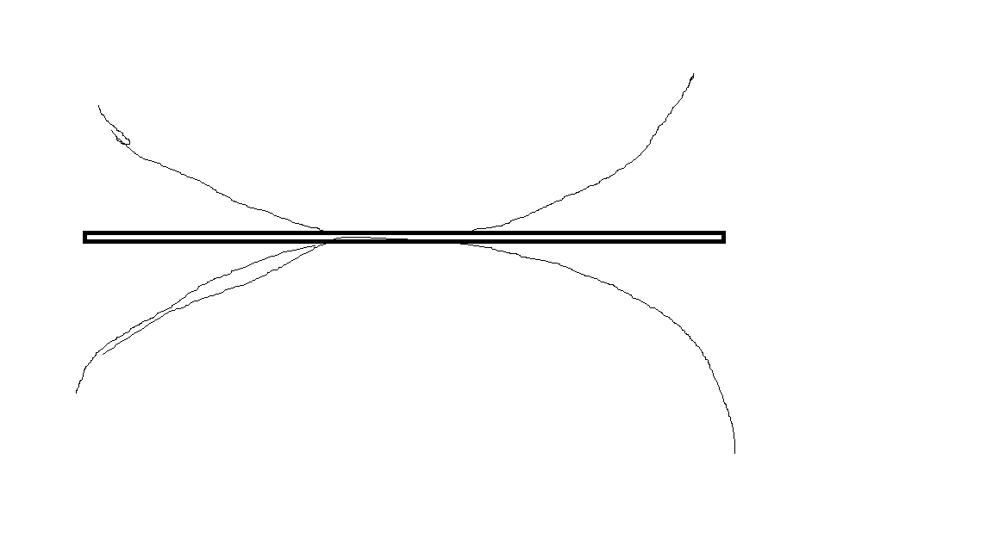

Make 5 shapes using border-radius

Make webpage like Wikipedia article on any topic related to technology

Topic : - background ,text,shadow

Make 5 boxes and write article inside these boxes and article heading should have center align and shadow.

Box – {width : 50 % ,center ,with box shadow ,with different fonts}

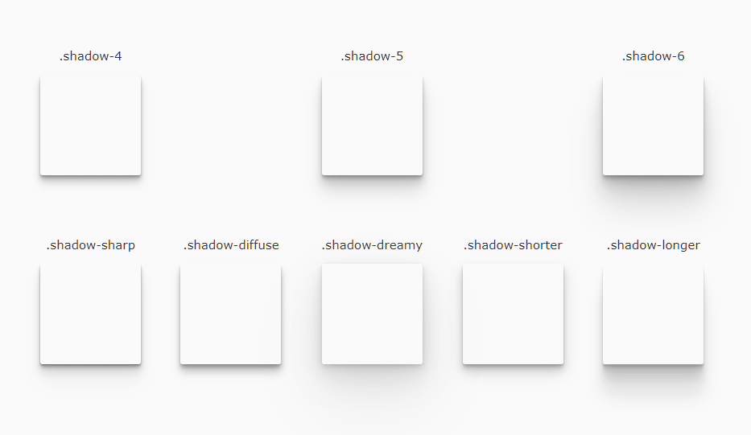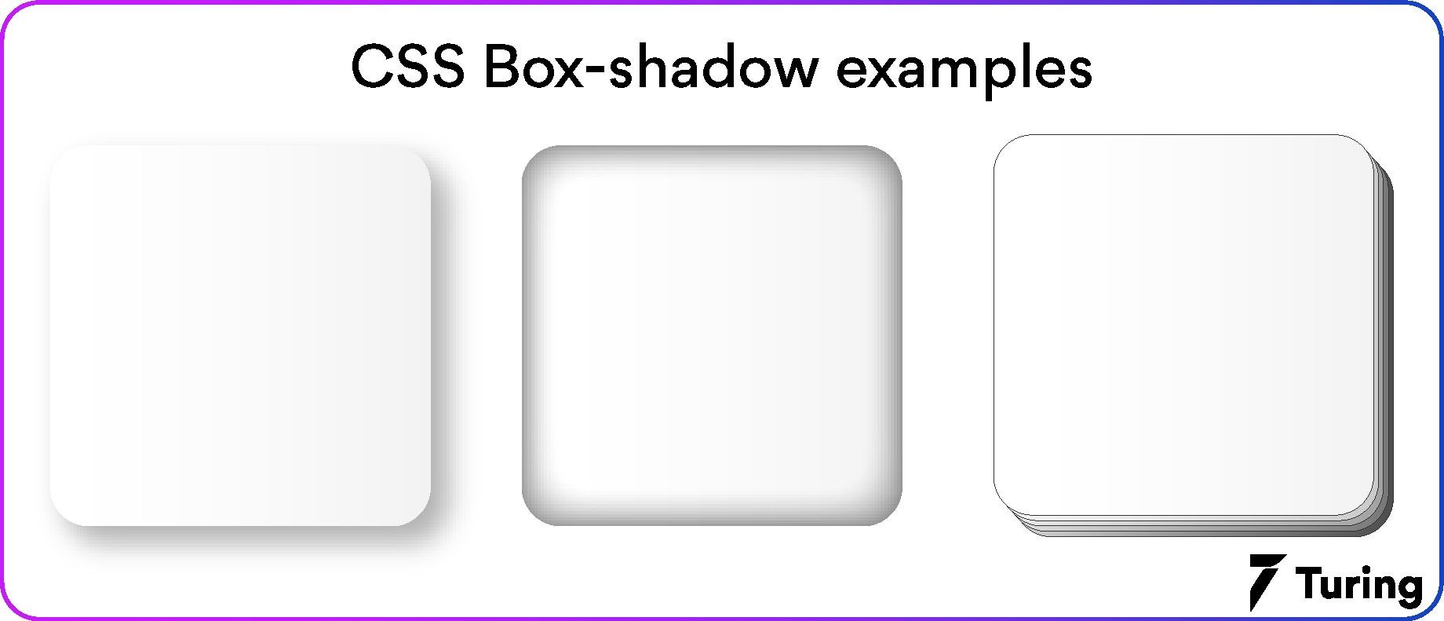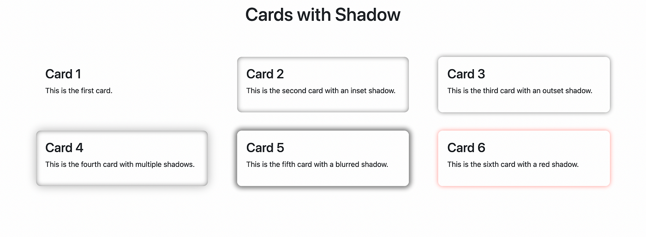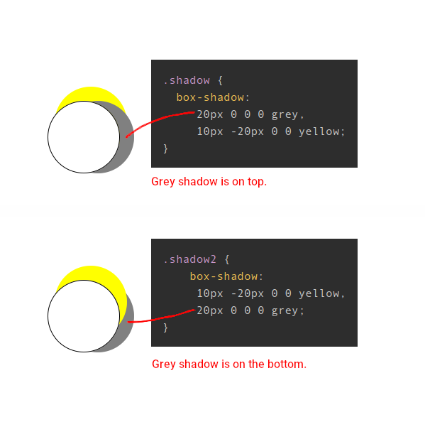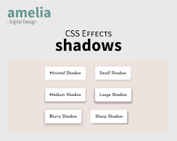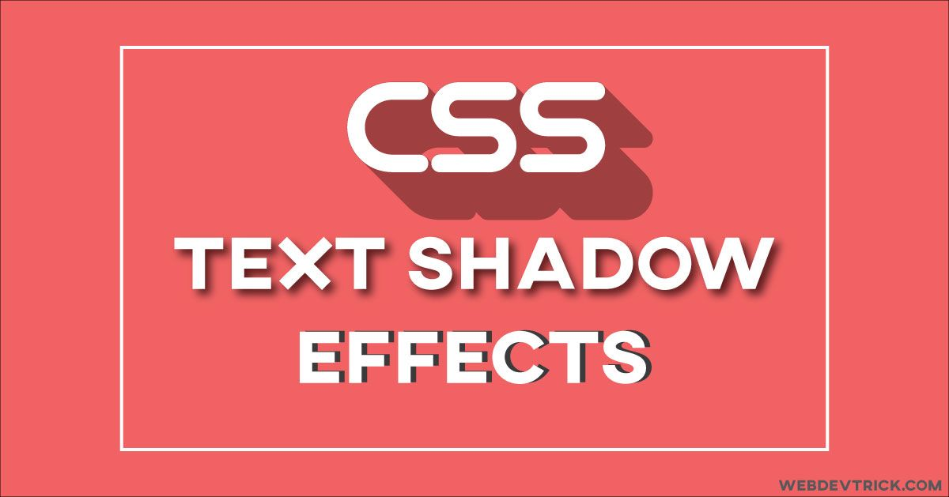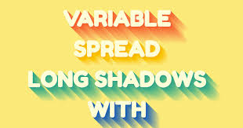

Topic: - float

Make this site : -https://www.html.am/templates/downloads/preview.cfm?template=css-templates/fixed-width-1-red.cfm

<https://templatemo.com/tm-589-lugx-gaming>

make navbar and last section of lux – gaming

download 4 icons (social media) iconfinder.com

fixed in bottom right corner

Topic flex: -

1. on hover add shadow to box(excluding top)

2.add transition to hide an element (opacity:0,display:none)

3.Add transition to convert a rectangular to circle

5.one section of above webpage(lux gaming)

Topic :- animation

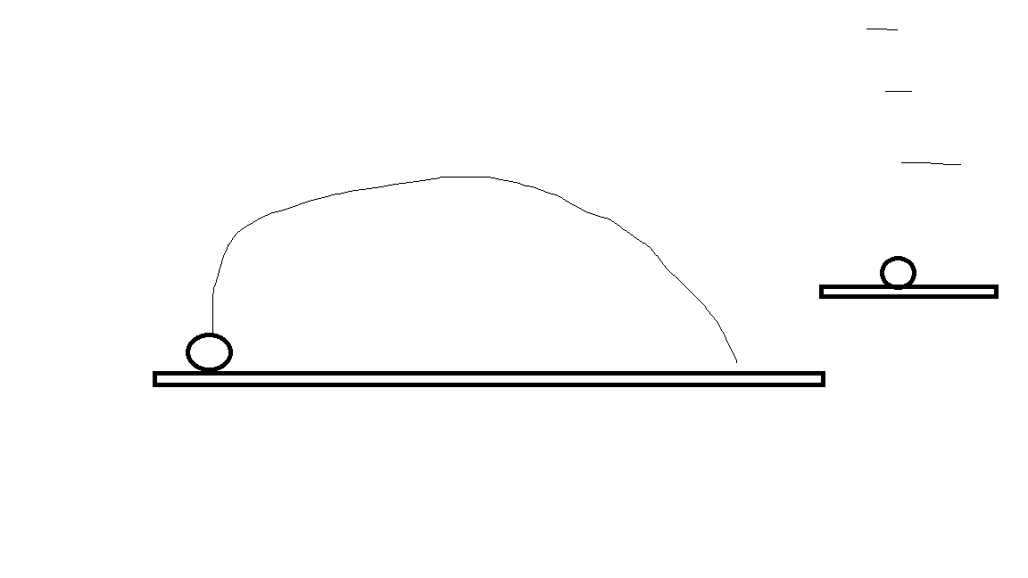

Topic: - dropdown

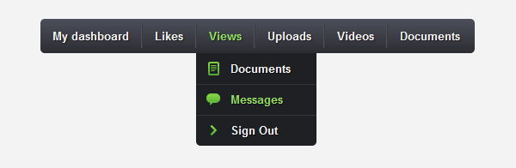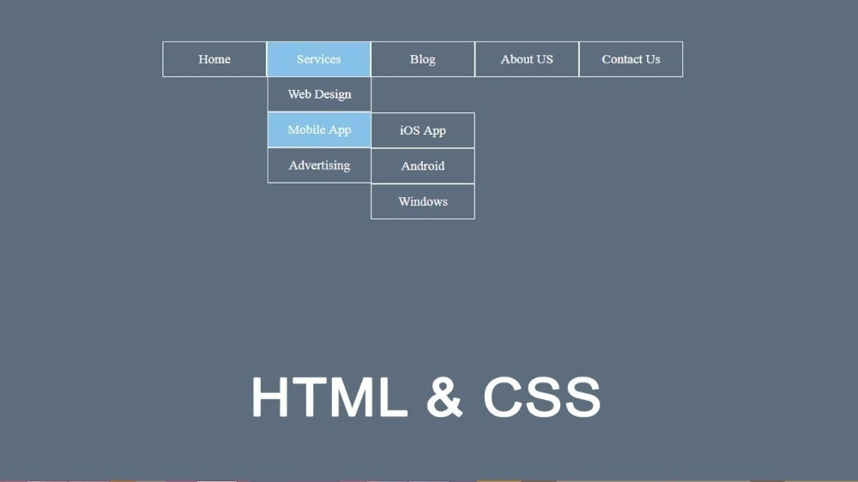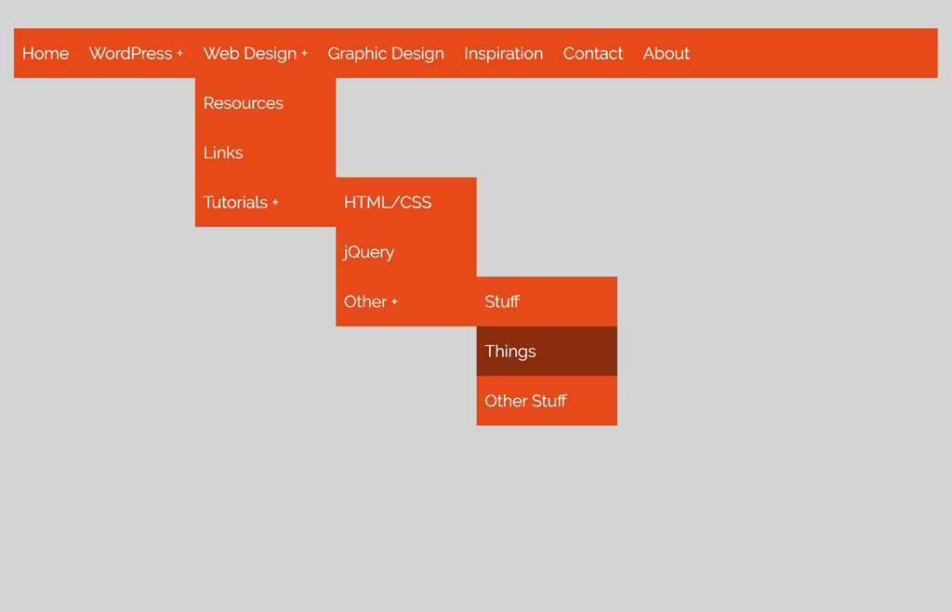

Topic :- js introduction

Explain all datatypes with examples

Explain all operators with examples

Send on whats app (txt /doc) with your name

Topic :- conditions

**1.** Write a JavaScript program that displays the largest integer among two integers.

**2.** Write a JavaScript conditional statement to find the sign of the product of three numbers. Display an alert box with the specified sign.  
*Sample numbers* : 3, -7, 2  
*Output*: The sign is -

**3.** Write a JavaScript conditional statement to sort three numbers. Display an alert box to show the results.  
*Sample numbers* : 0, -1, 4  
*Output*: 4, 0, -1

**4.** Write a JavaScript conditional statement to find the largest of five numbers. Display an alert box to show the results.  
*Sample numbers* : -5, -2, -6, 0, -1  
*Output*: 0

**5.** Write a JavaScript for loop that iterates from 0 to 15. For each iteration, it checks if the current number is odd or even, and displays a message on the screen.  
*Sample Output :*  
"0 is even"  
"1 is odd"  
"2 is even"  
----------  
----------

**6.** Write a JavaScript program that computes the average marks of the following students. Then, this average is used to determine the corresponding grade.

|  |  |
| --- | --- |
| **Student Name** | **Marks** |
| David | 80 |
| Vinoth | 77 |
| Divya | 88 |
| Ishitha | 95 |
| Thomas | 68 |

The grades are computed as follows :

|  |  |
| --- | --- |
| **Range** | **Grade** |
| <60 | F |
| <70 | D |
| <80 | C |
| <90 | B |
| <100 | A |

**7.** Write a JavaScript program that iterates integers from 1 to 100. But for multiples of three print "Fizz" instead of the number and for multiples of five print "Buzz". For numbers multiples of both three and five print "FizzBuzz".

**8.** According to Wikipedia a happy number is defined by the following process :  
"Starting with any positive integer, replace the number by the sum of the squares of its digits, and repeat the process until the number equals 1 (where it will stay), or it loops endlessly in a cycle which does not include 1. Those numbers for which this process ends in 1 are happy numbers, while those that do not end in 1 are unhappy numbers (or sad numbers)".  
Write a JavaScript program to find and print the first 5 happy numbers.

Topic : Loop

1.Print the numbers from 0 to 15

2.Print the numbers from 12 to 24

3.Print the ODD numbers from 7 to 31

4.Print the EVEN numbers from 10 to -20

5.Iterate through all numbers from 1 to 45. Print the following:

* For multiples of 3 print “Fizz”
* For multiples of 5 print “Buzz”
* For multiples of 3 and 5 print “FizzBuzz”

6. Print all nos that are divisible by 2 and 7 between 1 -100

7. reverse a given no. using loop

8. calculate factorial of a given no.

9. calculate sum of n natural no.s

10 find out no. is prime or not

11. make a calculator using switch case

Topic: -function ,dom

1.make a paragraph with some text and read its text and print it in console

2.make button to display a red circle below it when button is pressed and when button is pressed

Second time than circle is hidden

3. take a input a no. from user and make a button to display that nos square

Another to display that no.s table , 3rd button to display it’s cube

Topic: -

1.find the length of string without using a method

2. reverse a string in js

3.take a input name from user and show their name every character separated by ‘*’

4.make button to search text inside a given paragraph and highlight it

(hint: - on button click take input search text and find their text)

5.take first name and last name from user and show their full name on screen

6.make a btn to change the background color of a box . on every click box should change it’s color

From the list given below – yellow, blue ,red, green,tan,crimson

7.make 4 button left,right ,top,bottom to move a div on everyclick( like 10px)

Topic: write every method of array with example

2. make a to dimensional array and write it on document in a table

3. How do you add an element to the end of an array?

4. How do you remove the last element from an array?

Write a JavaScript function to check whether an `input` is an array or not.

Test Data :

console.log(is_array('w3resource'));

console.log(is_array([1, 2, 4, 0]));

false

true

2. Write a JavaScript function to clone an array.

Test Data :

console.log(array_Clone([1, 2, 4, 0]));

console.log(array_Clone([1, 2, [4, 0]]));

[1, 2, 4, 0]

[1, 2, [4, 0]]

3. Write a JavaScript function to get the first element of an array. Passing the parameter 'n' will return the first 'n' elements of the array.

Test Data :

console.log(first([7, 9, 0, -2]));

console.log(first([],3));

console.log(first([7, 9, 0, -2],3));

console.log(first([7, 9, 0, -2],6));

console.log(first([7, 9, 0, -2],-3));

Expected Output :

7

[]

[7, 9, 0]

[7, 9, 0, -2]

[]

4. Write a JavaScript function to get the last element of an array. Passing the parameter 'n' will return the last 'n' elements of the array.

Test Data :

console.log(last([7, 9, 0, -2]));

console.log(last([7, 9, 0, -2],3));

console.log(last([7, 9, 0, -2],6));

Expected Output :

-2

[9, 0, -2]

[7, 9, 0, -2]

5. Write a simple JavaScript program to join all elements of the following array into a string.

Sample array : myColor = ["Red", "Green", "White", "Black"];

Expected Output :

"Red,Green,White,Black"

"Red,Green,White,Black"

"Red+Green+White+Black"

6. Write a JavaScript program that accepts a number as input and inserts dashes (-) between each even number. For example if you accept 025468 the output should be 0-254-6-8.

7. Write a JavaScript program to sort the items of an array.

Sample array : var arr1 = [ -3, 8, 7, 6, 5, -4, 3, 2, 1 ];

Sample Output : -4,-3,1,2,3,5,6,7,8

8. Write a JavaScript program to find the most frequent item in an array.

Sample array : var arr1=[3, 'a', 'a', 'a', 2, 3, 'a', 3, 'a', 2, 4, 9, 3];

Sample Output : a ( 5 times )

9. Write a JavaScript program that accepts a string as input and swaps the case of each character. For example if you input 'The Quick Brown Fox' the output should be 'tHE qUICK bROWN fOX'.

10. Write a JavaScript program that prints the elements of the following array.

Note : Use nested for loops.

Sample array : var a = [[1, 2, 1, 24], [8, 11, 9, 4], [7, 0, 7, 27], [7, 4, 28, 14], [3, 10, 26, 7]];

Sample Output :

"row 0"

" 1"

" 2"

" 1"

" 24"

"row 1"

11. Write a JavaScript program to find the sum of squares of a numerical vector.

12. Write a JavaScript program to compute the sum and product of an array of integers.

13. Write a JavaScript program to add items to a blank array and display them.

Sample Screen :

add elements in an blank array

14. Write a JavaScript program to remove duplicate items from an array (ignore case sensitivity).

15. We have the following arrays :

color = ["Blue ", "Green", "Red", "Orange", "Violet", "Indigo", "Yellow "];

o = ["th","st","nd","rd"]

Write a JavaScript program to display the colors in the following way :

"1st choice is Blue ."

"2nd choice is Green."

"3rd choice is Red."

- - - - - - - - - - - - -

Note : Use ordinal numbers to tell their position.