Topic: basic structure, paragraph formatting

1.make a webpage of a topic with 4 articles using all paragraph formatting tags

2. write 6 question in heading tag (starting h1 to h6) and answers in paragraph

Make questions bold and italic and underline

Topic:- list,table and image

Make a ordered list of 5 chapters of a book and make a nested list of every chapter in unordered list with at least 3 sub -topics

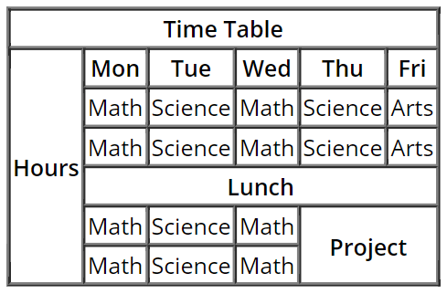

3. display image related to last assignment (article) after every paragraph in that assignment

Topic :- form, achor tag

Make a webpage like Wikipedia on any topic related to technology

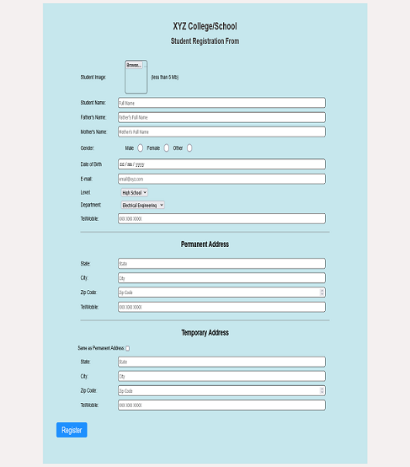

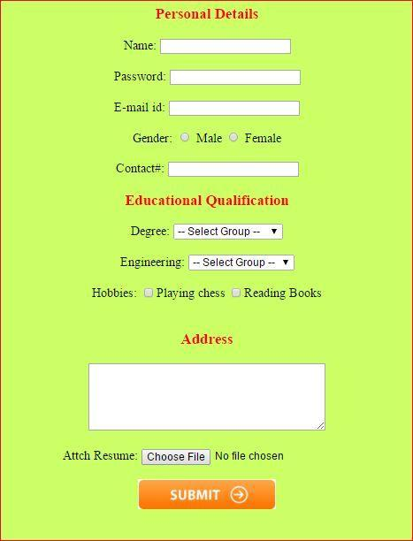

Topic – Basic css

1. Write all the ways to use css in a page
2. Write all basic selectors and explain them with uses
3. Wrap all paragaraphs in div in article in last assignment and align them center

Change heading color and font size and apply back ground image where necessary

And nicely format it

Topic : -text,font ,shadow,float

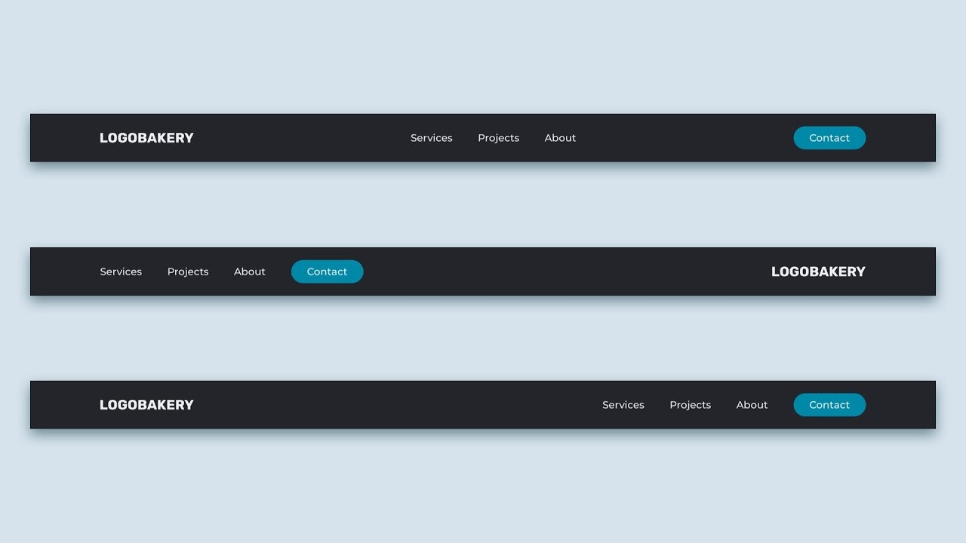

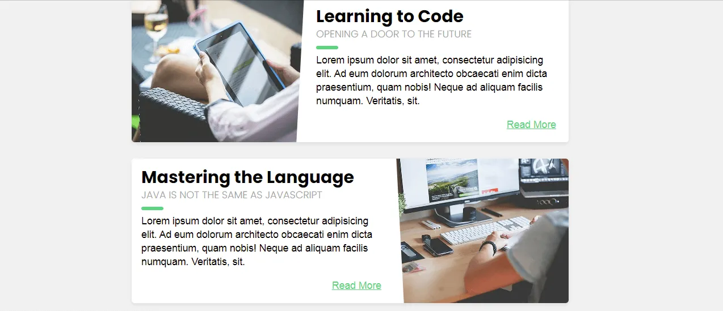

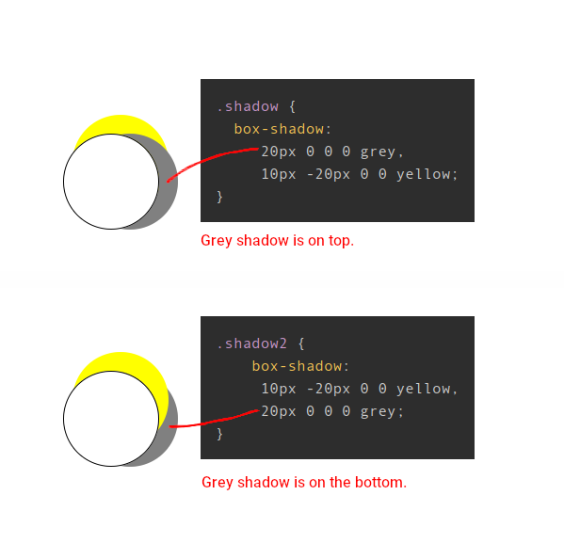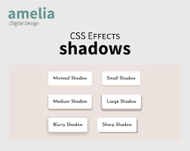

Topic :- float ,position

Make the first section of following webpage

<https://templatemo.com/live/templatemo_589_lugx_gaming>

Topic: flex

Make the following html layout

<https://www.html.am/templates/downloads/preview.cfm?template=css-templates/fixed-width-1-green.cfm>

Topic:dropdown

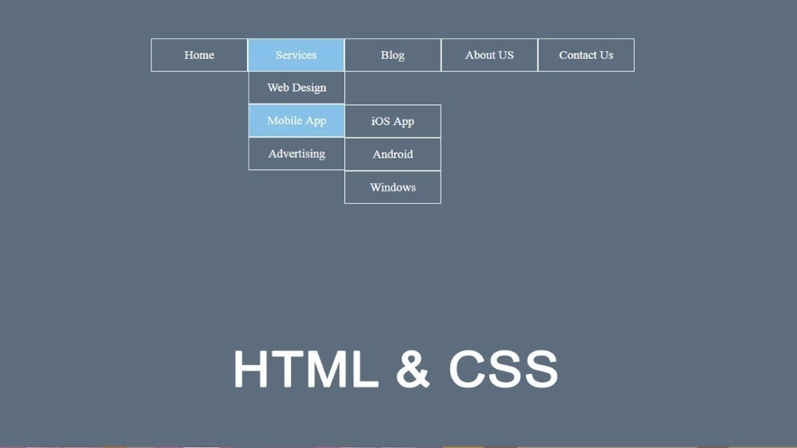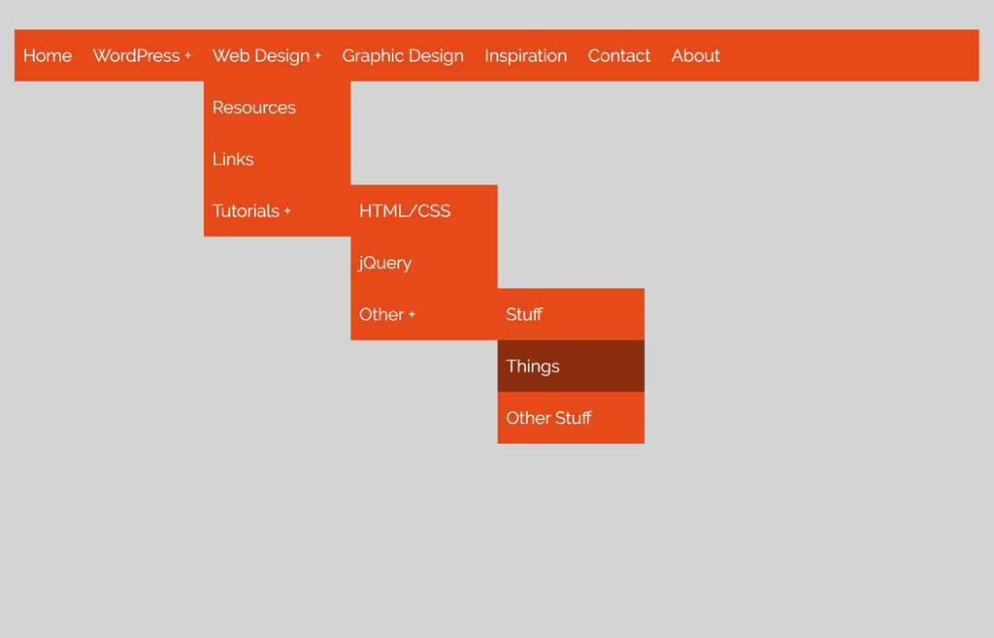

Topic : animation

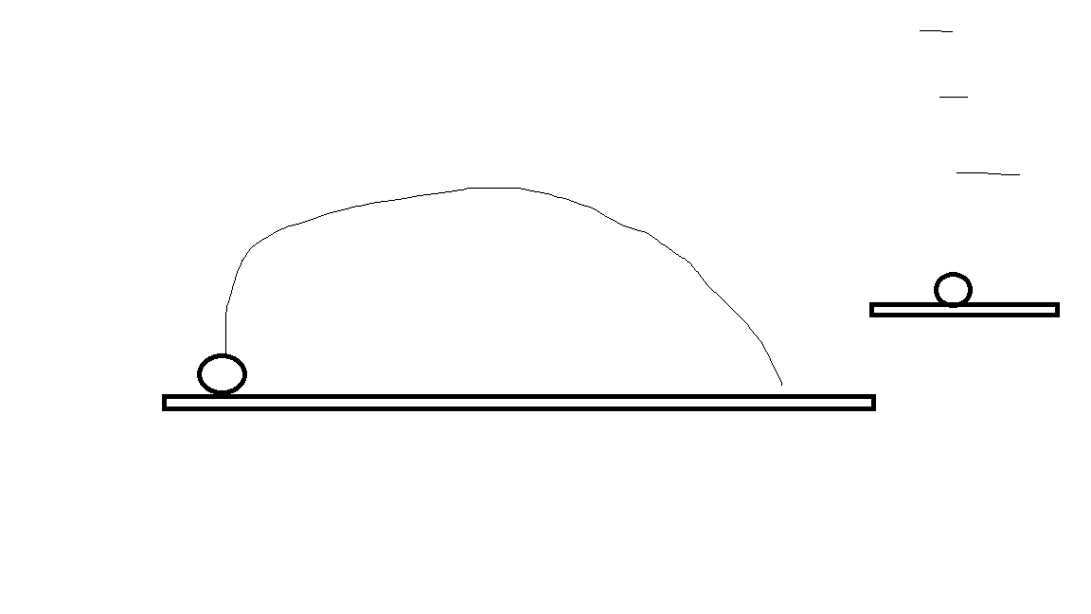

Final Assignment :- Make a responsive portfolio

You can get an idea from site below:-

<https://www.wix.com/website/templates/html/portfolio-cv/personal>

Task:-

1.make a friend component and make it dynamic using props and call at least 3 components with different props

2. make a posts data file (copy data from jsonplaceholder api) and make 2 component one for showing all posts and one for showing single post card and show atlease 10 posts data in website using single post comp with different data