TO : ??

FROM : Ankur Modi, Harsh Goyal, Uttam Patra, Zixiang Wang

SUBJECT : Ways for Accor Hotel to Embrace Digital Transformation

DATE : January 29, 2013

Recommendation

With the importance of online content kept growing in recent years, our first recommendation would be to find new collaborators in these new players and to gather good reviews in all kinds of social media. The hotel can leverage customer content from various social media sources, constantly monitor and provide feedbacks by addressing concerns in social media, and pervade all the analyzed content in different avenues of online media.

Accor Hotels should adopt a digital marketing strategy to tackle three aspects of online content:

1. Monitor customer feedbacks and brand value.

2. Influence customer’s perceptions and brand awareness.

3. Incentivize sharing of reviews and experiences.

By utilizing all kinds of ways, Accor Hotels should try to become a content-driven organization.

Content and Customer Journey

With Accor Hotel being successful in the past, it’s recent downturn shows the need of improvement in their online content. Social media websites and search engine are the two “mega trend” that impact hospitality industry significantly (Xiang & Gretzel, 2010), and it is necessary for Accor Hotel to embrace these new trends to influence the customer journey. The customer experience begins with informative videos to offer solutions to their pre-travel problems like city tours and travel tips. This provides you an opportunity to influence their decision and creating brand awareness through genuine content and honest feedback. However, excessive brand trumpeting should be avoided. To make a successful business you need to invest not only in bumping search results, but also showing positive and appealing reviews. The second step in the journey is reinforcing the customer’s trust in Accor hotels above others by highlighting positive reviews and customer testimonials. Lastly, there should be strategies for continuous engagement with customers throughout and beyond their journey. Effective online engagement is no doubt hard to achieve and manage (Park, Sun-Young, and Jonathan P. Allen., 2013). Nowadays, consumers have become producers by voicing their opinions and helping businesses improve on their services. Accor hotels should leverage such opinions by providing email services for feedback and offering targeted promotions or complementary services.

Customers from different market segment tend to focus on different points of review materials (Park, Sun-Young, and Jonathan P. Allen., 2013). Accor hotel has a similar share of Midscale and Economy market segment, and with Luxury segment about a third of the Economy segment. As the reviews accumulates, the mix of review from different segment can cause customer losing their focus in finding matching review, and thus lose competitiveness.

The company should stress on a mobile-first strategy for collecting consistent communication and feedback with the customers at the beginning, during and after the stay. Latest hospitality study by Gallup reveals service as the differentiating factor for customer engagement and loyalty [Exhibit 1]. The app can provide real time access to hotel services like booking spa appointment and restaurants, together with travel tours and suggestions, thus improving the overall customer experience. In addition, technology companies like HootSuite and Social Sprout provide software that can assist in monitoring the company’s entire social media presence.

Leverage Content

In the hospitality industry, harnessing data will play a significant role than just collecting the data to make you a better company. The customer data can be used to foresee their needs, and provide a personalized experience with targeted offers and information. The Accor staff should be trained to integrate the digital capabilities with the customer behavior. Accor should refrain from promoting false positive reviews to gain eminence, and the focus should be on building a long-term trustworthy e-reputation.

Accor can encourage the use of its own booking platform by leveraging the loyalty programs. Promoting rewards like free Spas for bookings and referrals, highlighting testimonials from satisfied customers and maintaining user history to provide the customers with personalized deals. An initial investment in promoting its website through search engines and social networking ads and partnerships with local city tours can provide a much needed initial push.

Accor hotel can utilize content from sources such as Instagram, Twitter, and Facebook using hashtags and looking for specific words that customers employ for the bad or good experience. According to Skift’s study on Starwood (2016), they used Instagram to create engaging content and social media stories from customers’ experiences. This increases the probability to shine chances in arousing customers through core real photos of various customers.

Using the above recommendation, Accor can influence customers by gathering data which users have liked and/or commented on photos shared by other customers (Skift, 2016) and sending them invitations for future interest in booking their hotels. Additionally, they can highlight all the customers’ testimonials posted on Instagram or Twitter or Facebook and devise marketing campaign on their website and ingesting a redirect link to the sources.

Disseminating content is possible nowadays with the availability of all type of digital media all around. One way is to partner with google, Accor can disseminate their ads only when people install OTA apps or any hotel booking apps and plan to achieve desired results similar to Premier Inn hotel chain strategy that raked 40% new customers (Think with Google, March 2015). Moreover, Google publish ads in Android apps as well to cater to a user’s search pertaining to hotel booking.

Become a content-driven organization

Social Media Presence: We recommend Accor to maintain Social media accounts (like Facebook, LinkedIn, Instagram, Twitter, YouTube). Accor should use social media links throughout their website, employee visiting cards, email signatures etc.

Analytics: Once the data is created and more customer data is collected from various channels, an analytics solution should be deployed to analyze data and identify patterns so that the customer journey may be improved. Content Strategy: There should be a strategy for creating and maintaining the digital content. A typical strategy would look like below.

Content Generation and Dissemination: To publish on the company website, new content needs to be created. This includes travel catalogs, educational videos, promotional photos etc.

Accor.com: Accor has many hotel chains for targeting different customer groups. We suggest that these names be accompanied by a mention of Accor.com for two reasons. First, it will help create a unified brand image among the customers. Second, the usage of .com acronym reflects that Accor is a truly digital organization and also inspired people to visit the company website.

Increasing number of contact points with Customers: To gain popularity among customers with online presence, Accor needs to take initiatives such as sponsoring blogs and events, especially where frequent travelers participate.

Continuous Employee Training: For continued employee support in their pursuit to become a content-driven organization, it is necessary for the employees to undergo training to understand the significance of the path the company would be on. Employees may be incentivised by offering bonus on increase in rating and other performance indicators.

Appendix A: SWOT Analysis

Appendix B: How to become a content-driven organization

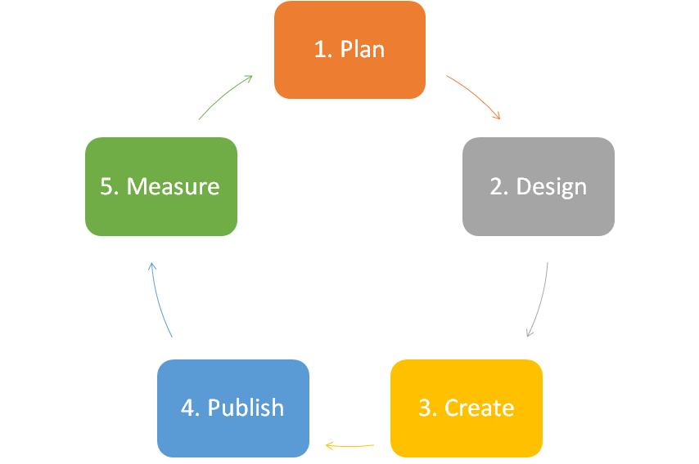

|  |  |
| --- | --- |
| **Phase** | **Description** |
| 1. Plan | Define the scope, goals and objectives of the content to be created.  Define KPIs and other metrics to assess content, when required. |
| 2. Design | Layout a design for the content to be created (or the updated design for the content to be modified) |
| 3. Create | Build content based on the goals and design. |
| 4. Publish | Publish and disseminate content. |
| 5. Measure  and Adapt | Use KPIs and metrics to measure how content is doing against the content goals and objectives.  Review analysis results and feed it as an input to the planning phase for the next cycle. |

Reference

Daniela Yu, John Timmerman. How Hotels Can Engage Gen X and Millennial Guests, Business Journal, July 29, 2014.

Instagram Case Study: Starwood Hotels' Innovative Influencer Strategy, 2016.

Leung, Daniel, Rob Law, Hubert Van Hoof, and Dimitrios Buhalis. "Social media in tourism and hospitality: A literature review." Journal of Travel & Tourism Marketing 30, no. 1-2 (2013): 3-22.

Premier Inn Captures 40% More Bookings from New Customers with Google Hotel Ads, 2015

Park, Sun-Young, and Jonathan P. Allen. "Responding to online reviews: Problem solving and engagement in hotels." Cornell Hospitality Quarterly 54, no. 1 (2013): 64-73.

Xiang, Z., & Gretzel, U. (2010). Role of social media in online travel information search. Tourism Management, 31(2), 179–188.

[6 Killer Examples of Content-Driven Experiences, 2016](http://typeacommunications.com/6-killer-examples-content-driven-experiences/).

[Performance driven content: the key to successful content, 2016](https://gathercontent.com/blog/performance-driven-content-key-successful-content).