sReact js Library helps us to create single page web applications so that page will not reload when you go to any other component
Benefits of using React .

Reacts provide built in packages and provide various hooks through props you can transfer data between components.
Such as for Routing we can have React Router dom package.
https://create-react-app.dev/docs/getting-started/ Basic create react app
Nodes js is a runtime for java script which allows it to use these resource outside of webapps.
npm is a package manager used to install packages
npx is a part of npm which is a one time run and we don’t need to preserve.
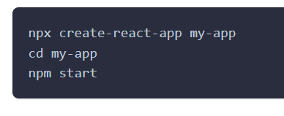
After installing when you open it in vs code it will look loke this

In your package.json your dependency will be there.
Also have .gitignore which you don’t want to push particular files into repo.
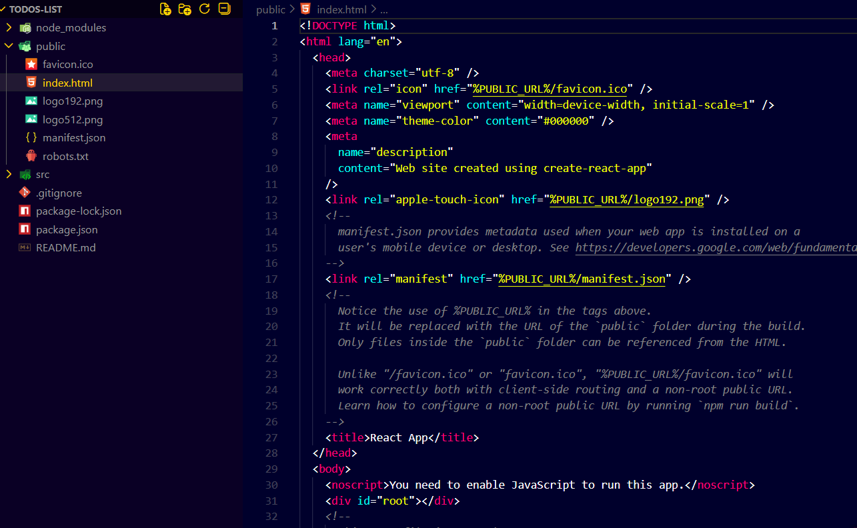
Then we have the public folder in that index.html we have a noscript tag also which will be used when js is not been executed.

So react provides way that from a single page source code to provide dynamic content through js which target here root .
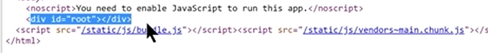
So in your src folder we have index.js so like this we will target root.
So we are telling here that in selector add the dynamic content of app.js
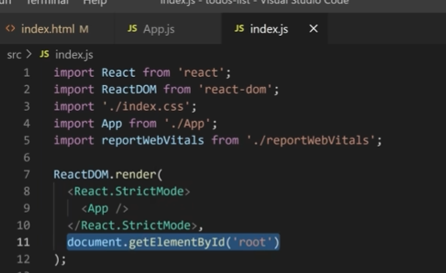
Here in App.js className is a part of JSX JavaScript Syntax which allows dynamic js with html content.
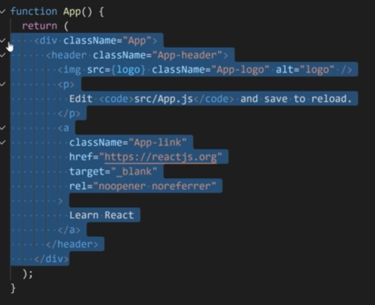
The thing which is mentioned in {} is a type of variable .
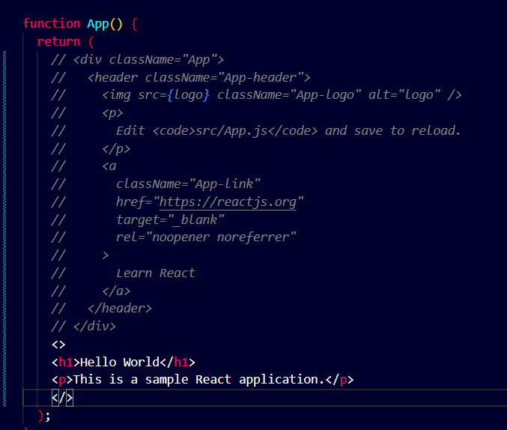
When you write the code in function return you need to mention it under opening and closing syntax.
Here in index.html we have included bootstrap.css
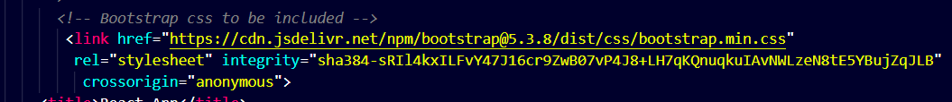
Here in rel means
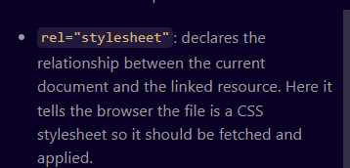

Bootstrap script to be included

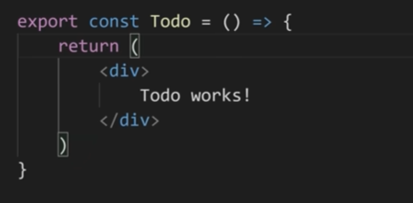
This is known as Named export you have to mention it under the name of variable .{}

export default will have to mention just name as imports.
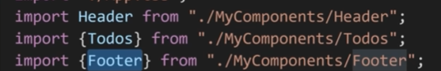
Props are the object which are passed from parent component to child component
Like here Prop is parent component in App.js
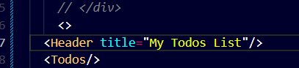
and in Header.js
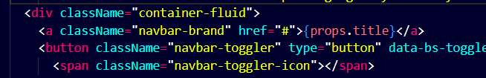
You can also take it as a variable then you don’t have to use props.
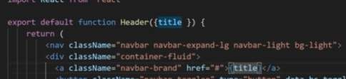
You can also pass the Boolean value and use it as a ternary operator .
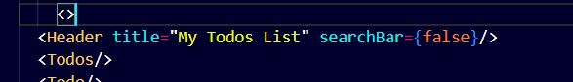
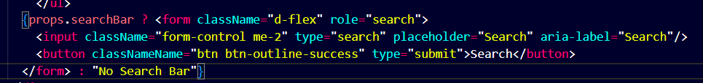
propTypes : for type checking errors.
When you pass integer instead of string you got the below error
DefaultProps : is used for to pass default value when you don’t pass the value
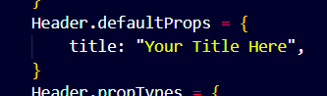
It is used to shown the default value when the value is not passed.
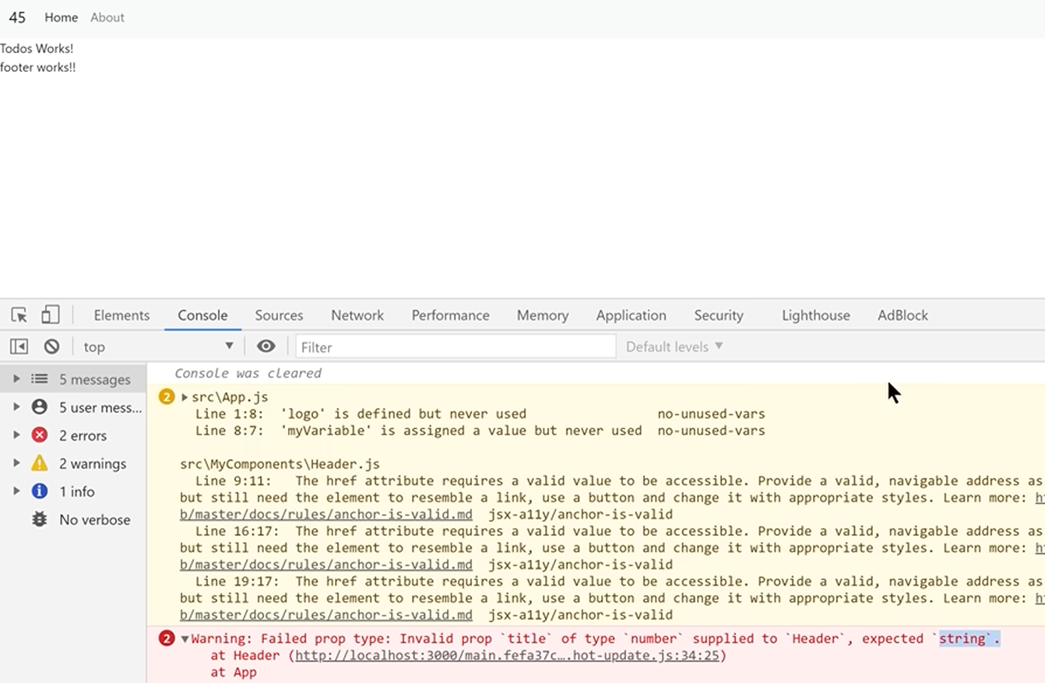
This is called as destructing of elements when you don’t use props and directly use the paramaters passed in parent class
In app.js
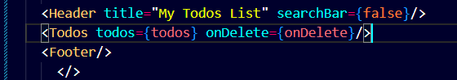
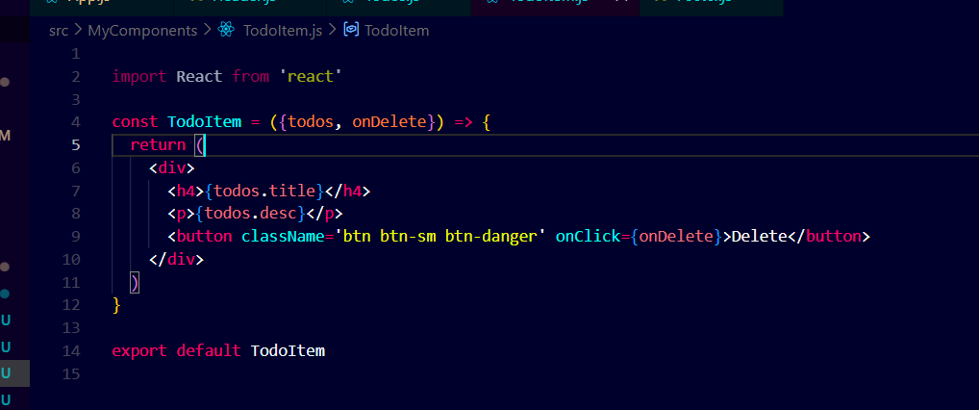
In react you will use hooks to update any state
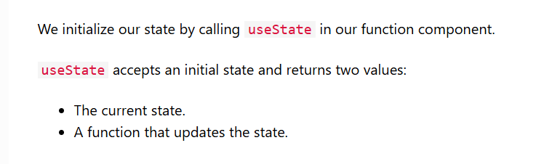
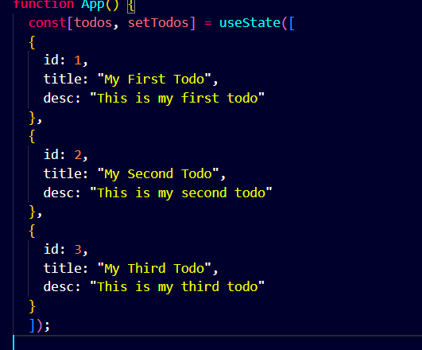
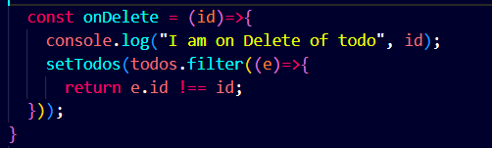
Here S. No : is important because it will give uniqueness to each and every element
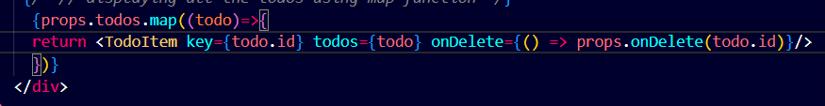
You can use internal and external css in this way
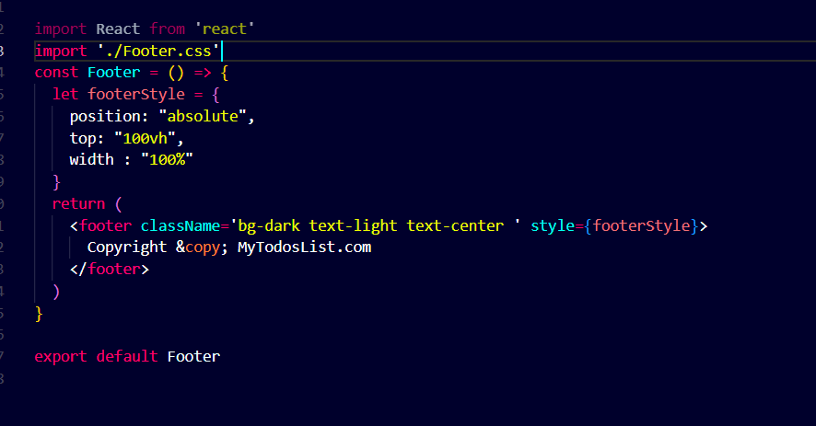
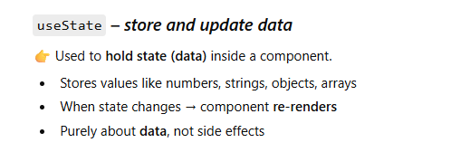
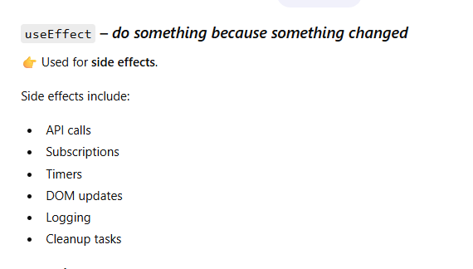
We use it to preserve data instead of giving hardcoded data in useState
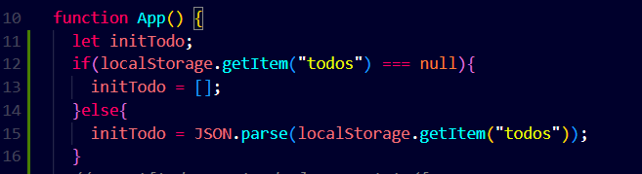
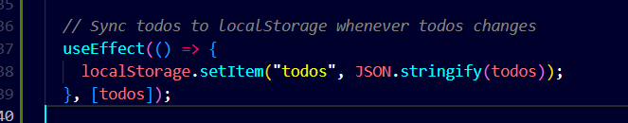
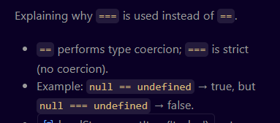
Here localStorage.setItem not immediately updates so we have to use it to with the useEffect.
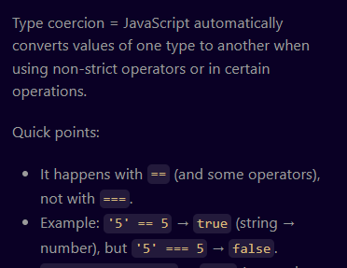
React-router enables you to load other pages without reload .

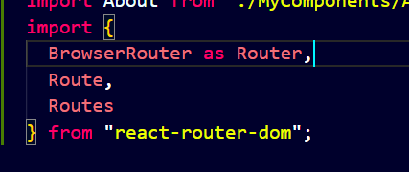
These are important tags used in routing .
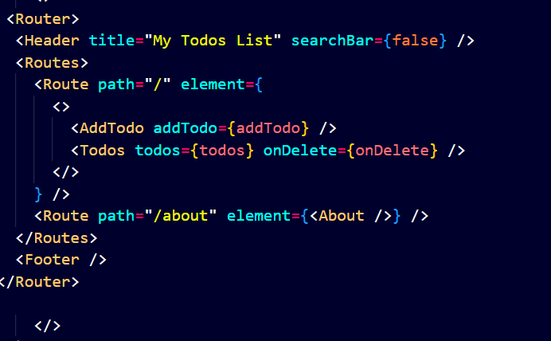
Here we wrap the element in Router where header and footer are shown in every section for path wise section we will use Routes.
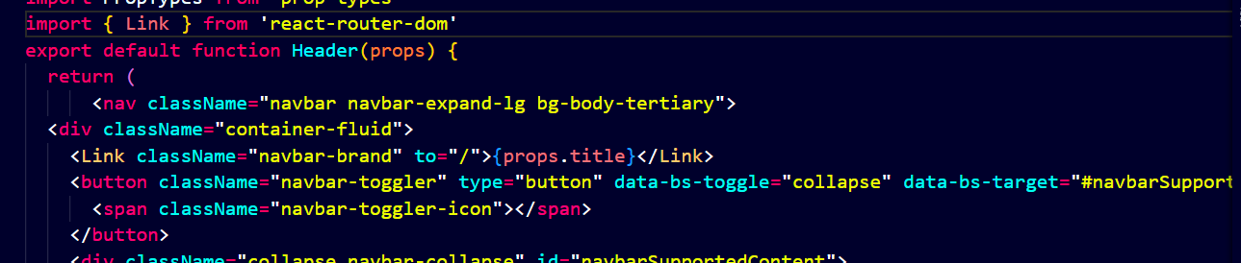
Here a anchor-tag is replaced by Link and href is replaced by to=”path”

