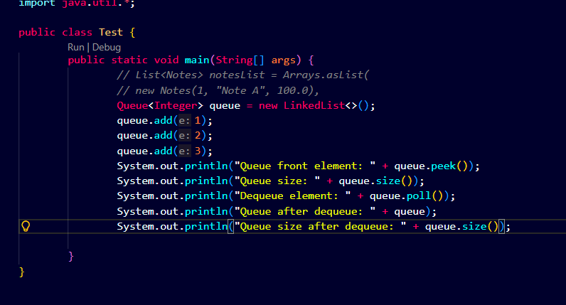
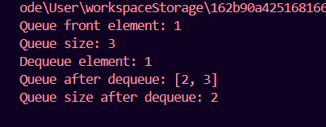
1. Implement Queue using Stack
👉 Concept:
- Use 2 stacks
- One for push, one for pop
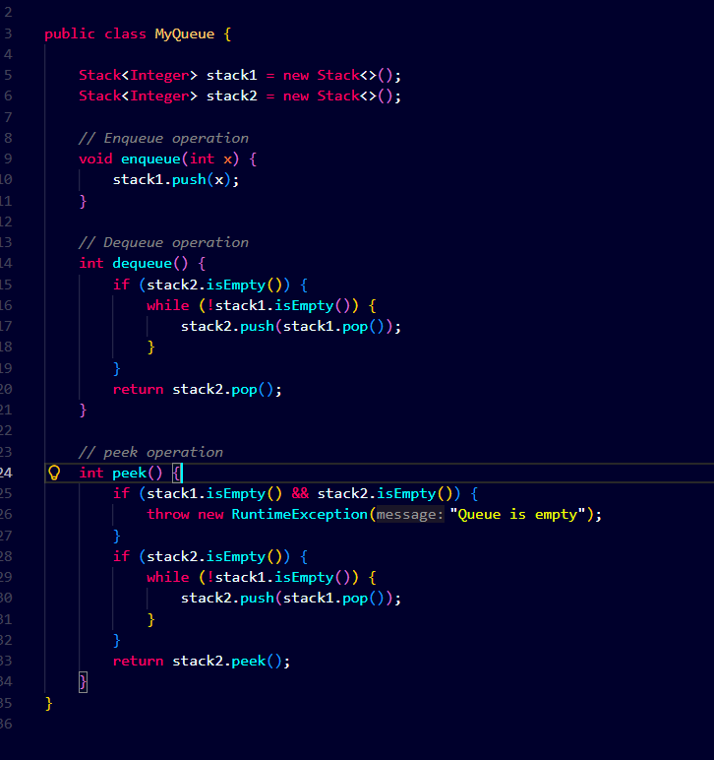
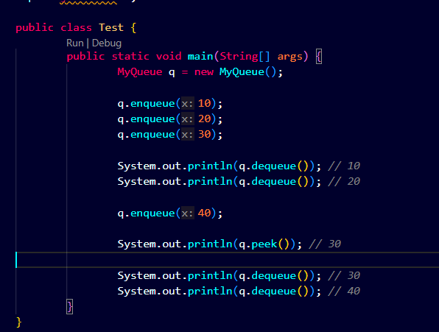
At the point q.deque will remove from stack2 top
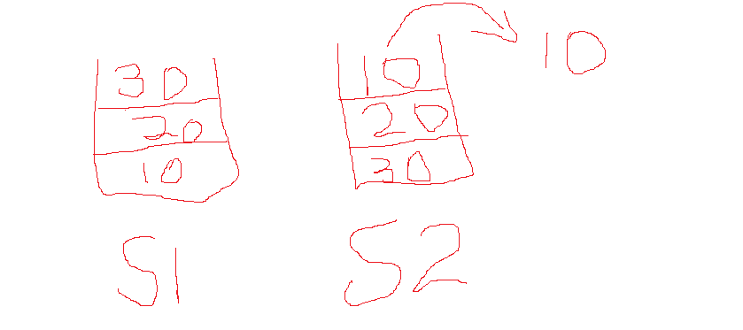
Now after this s2 is not empty so peek will give 30 and dequeue will not empty stack1 it will first pop out 30
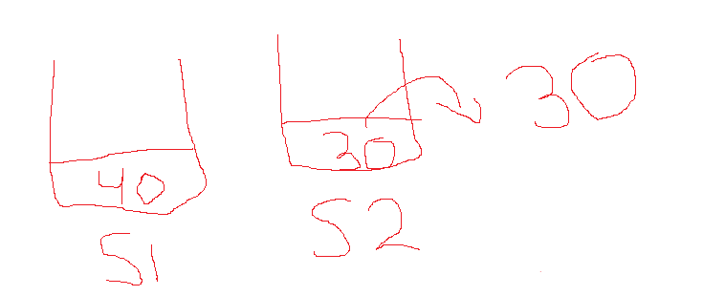
Once queue s2 is empty after 30 pop out 40 will move to s2.
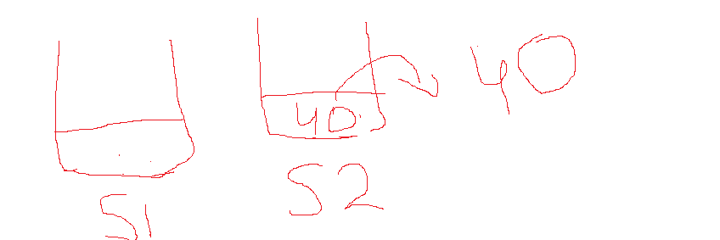
Reverse Queue ::
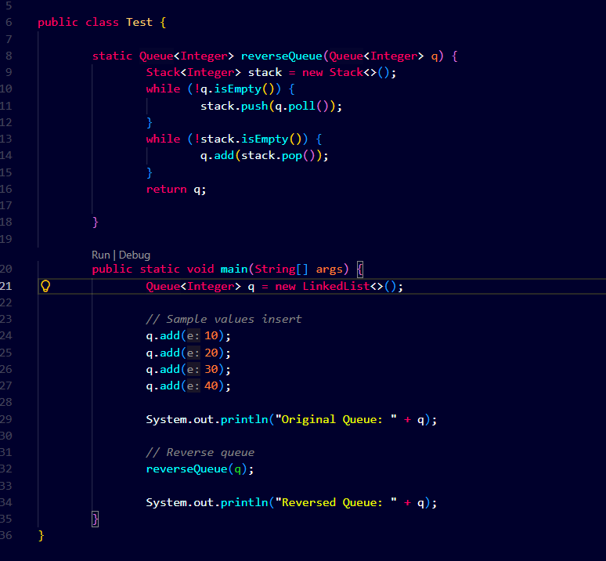
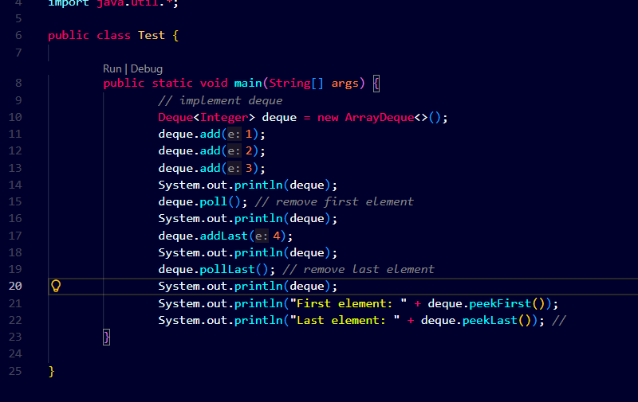
https://leetcode.com/problems/sliding-window-maximum/description
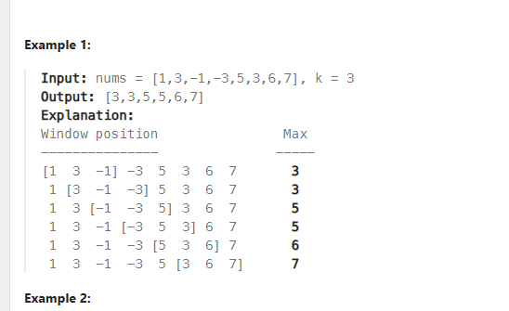
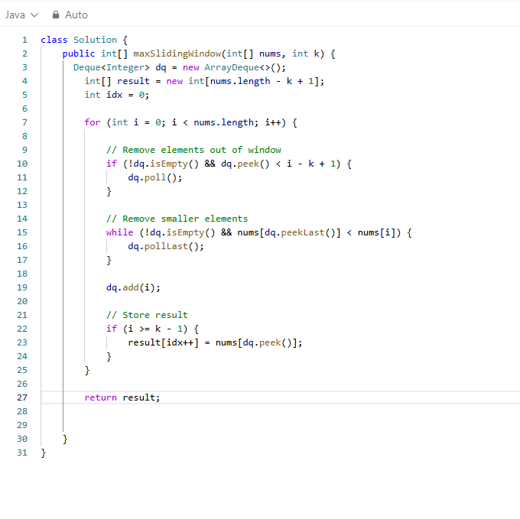
We are tracking k elements here k=3
We are maintaining monotonic stack decreasing stack here start point is bottom
so suppose index is 5 so we can scan 3 elements so window would be 3,4,5
so i-k+1 so elements greater than idx 2 5-3 =2
Now suppose at idx 5 value is 5 so monotonic greater element should be at front so peek last and poll last till it comes at front
once size is reach for window size store result

