Strings in Java :
In Java, string is basically an object that represents sequence of char values. An array of characters works same as Java string. For example:
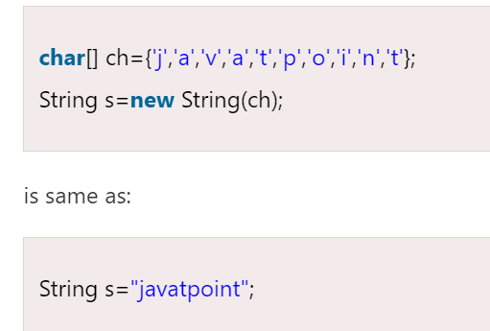
The java.lang.String class implements Serializable, Comparable and CharSequence interfaces.
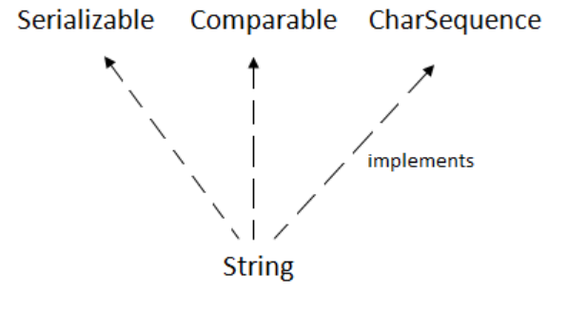
[1]CharSequence Interface : The CharSequence interface is used to represent the sequence of characters. String, StringBuffer and StringBuilder classes implement it.
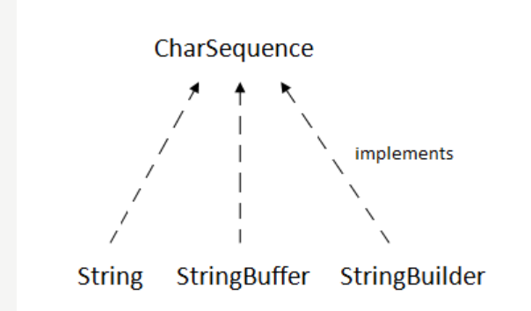
The Java String is immutable which means it cannot be changed. Whenever we change any string, a new instance is created.
For mutable strings, you can use StringBuffer and StringBuilder classes.
What is String in Java?
Generally, String is a sequence of characters. But in Java, string is an object that represents a sequence of characters.
java.lang.String class is used to create a string object
Ways To Create a String Object:
1) String Literal : String s="welcome";
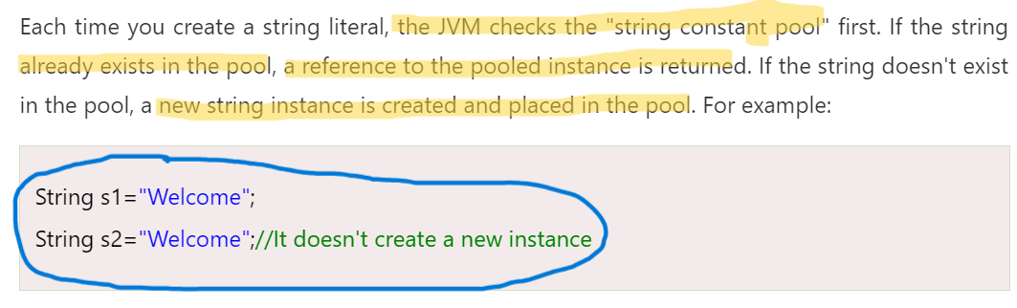
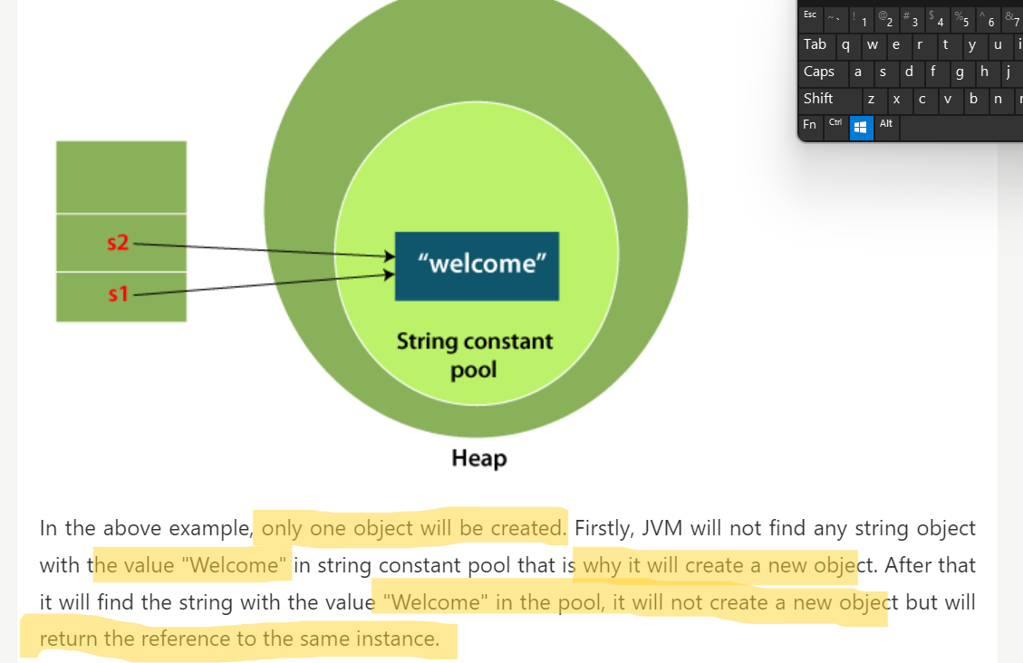
Why Java uses the concept of String literal?
To make Java more memory efficient (because no new objects are created if it exists already in the string constant pool).
---------------------------------------------------------------------------------------------------------------------------
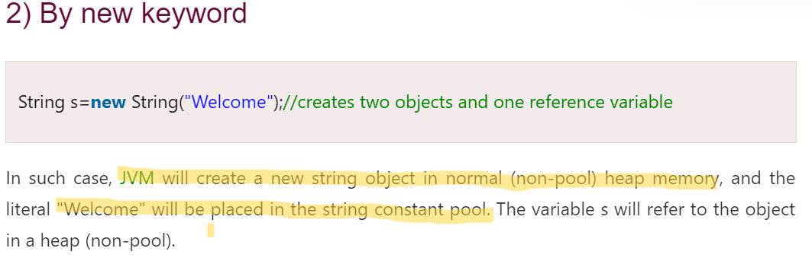
-------------------------------------------------------------------------------------------------------------------------
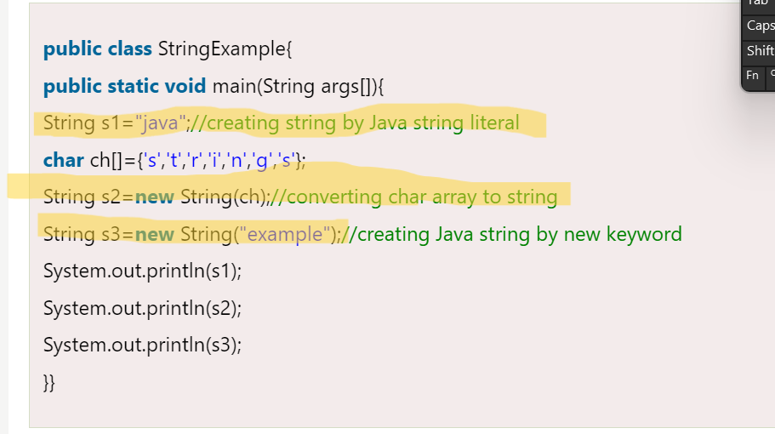
Output : java , string , example
Java String class methods :
[1]char charAt(int index): returns char value for the particular index.
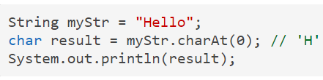
[2]int length(): It returns string length
String str="Hello";
System.out.println(str.length());

[3]static String format(String format, Object... args): returns a formatted string.
float number = 1234.6789f;
String str= String.format("%.2f",number);
System.out.println(str);
[4] String substring(int beginIndex): It returns substring for given begin index.
String Str = new String("Welcome to geeksforgeeks");
System.out.println("Extracted substring is::"+ Str.substring(3));
Output : Extracted substring is :: come to geeksforgeeks
[5]String substring(int beginIndex, int endIndex):
String Str = new String("Welcome to geeksforgeeks");
System.out.println("Extracted substring is::"+ Str.substring(3,9));
//will start from index 3 and print till 8 including spaces index 8 ->t
Output : Extracted substring is::come t
[6]boolean contains(CharSequence s) : returns true or false after matching the sequence of char value
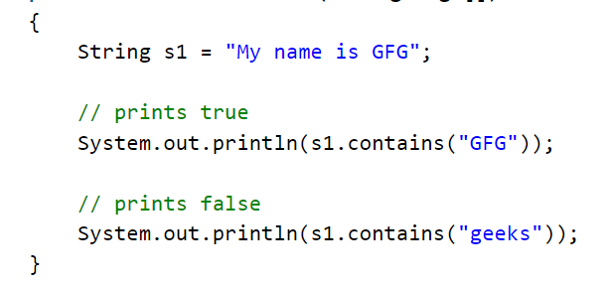
[7]static String join(CharSequence delimiter, CharSequence... elements): returns a joined string
Here delimeter means separator between str1 , str2 , str 3
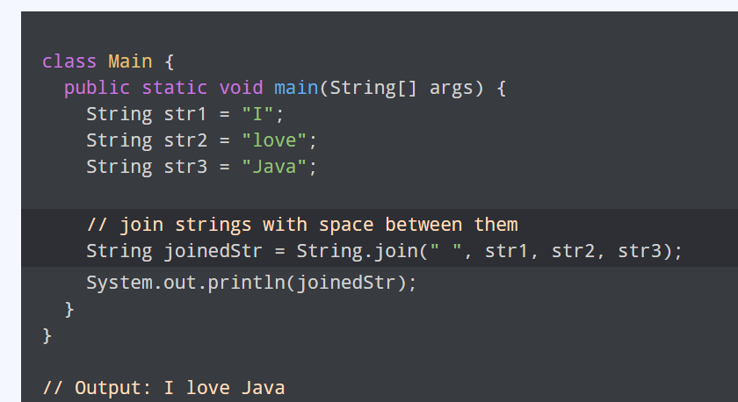
[8]static String join(CharSequence delimiter, Iterable<? extends CharSequence> elements):
returns a joined string.
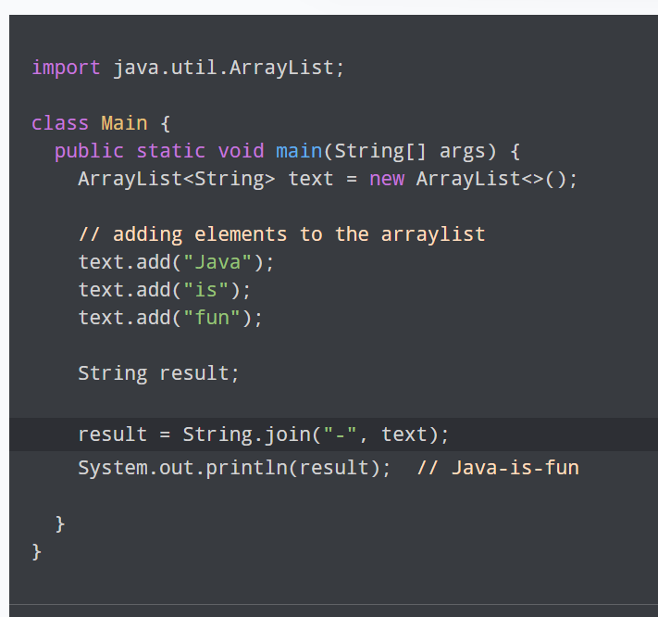
[9]boolean equals(Object another): checks the equality of string with the given object.
String str= "hello";
String str2 ="hello";
System.out.println("String is Equal?:"+str.equals(str2)); // returns true
[10]boolean isEmpty() : checks if string is empty.
String str= "hello";
System.out.println("String is Empty?"+str.isEmpty());
// will return false
[11] String concat(String str) : concatenates the specified string.
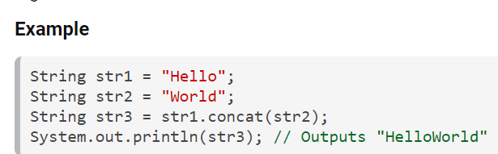
[12]String replace(char old, char new) : replaces all occurrences of the specified char value.
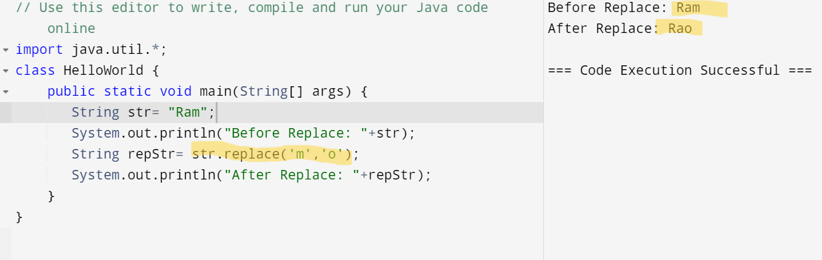
13 String replace(CharSequence old, CharSequence new): replaces all occurrences of the specified CharSequence
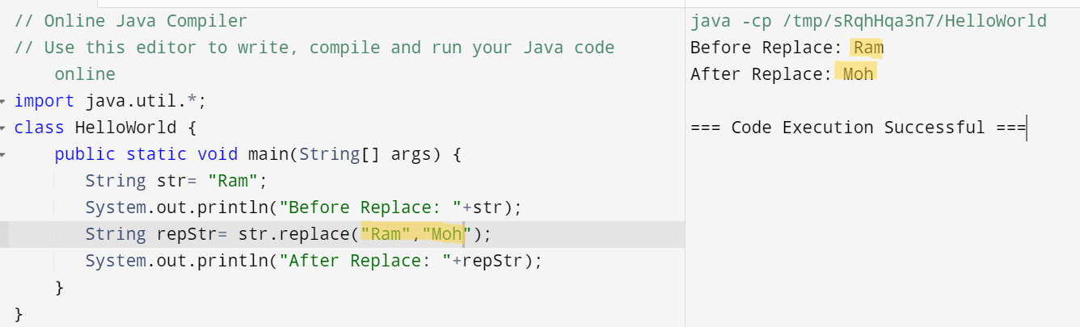
14 static String equalsIgnoreCase(String another) : compares another string. It doesn't check case.
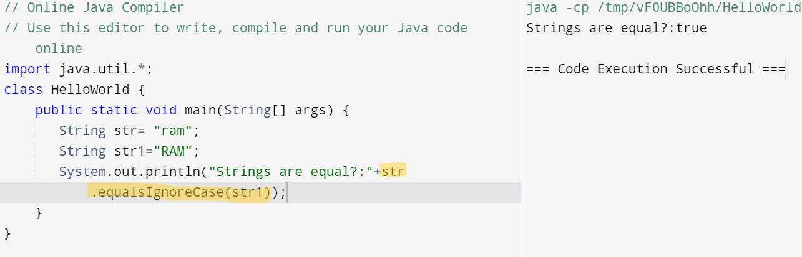
15. String[] split(String regex): returns a split string matching regex
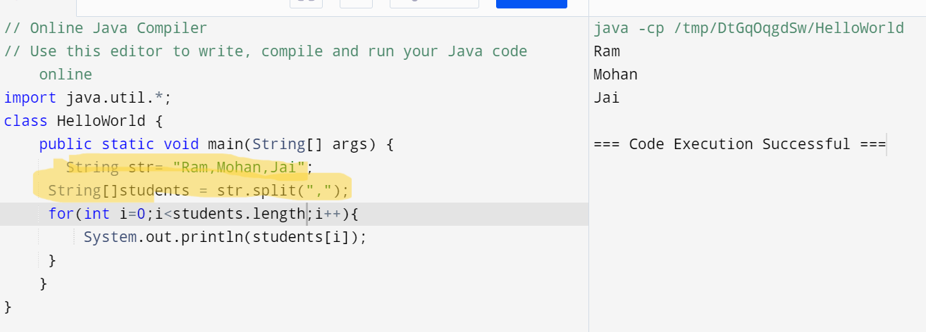
[16]String[] split(String regex, int limit): returns a split string matching regex and limit.
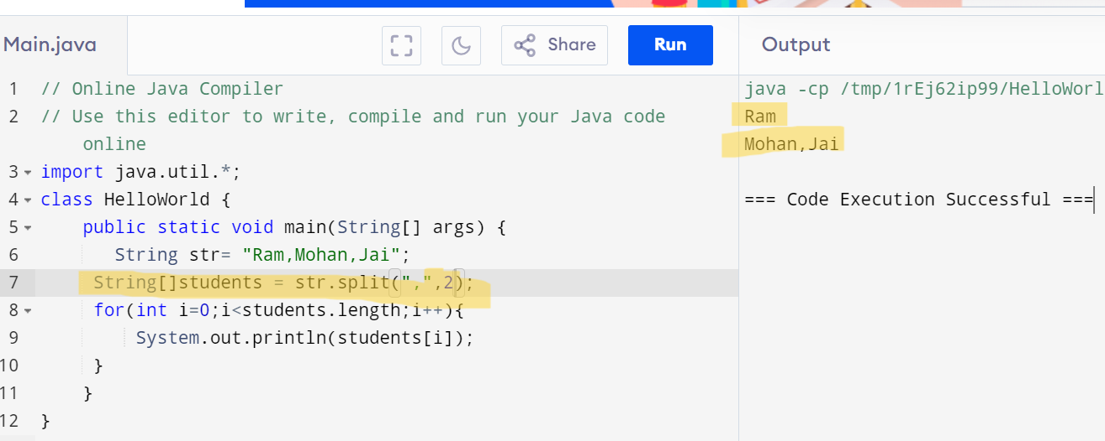
[17]int indexOf(int ch): returns the specified char value index
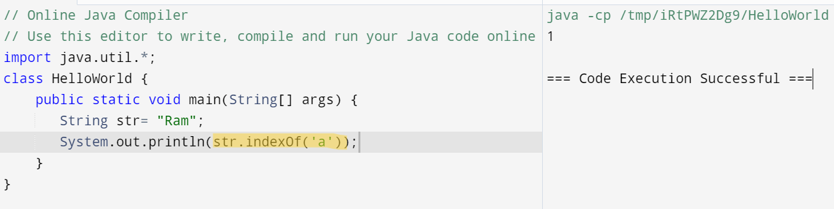
18.int indexOf(int ch, int fromIndex):returns the specified char value index starting with given index.
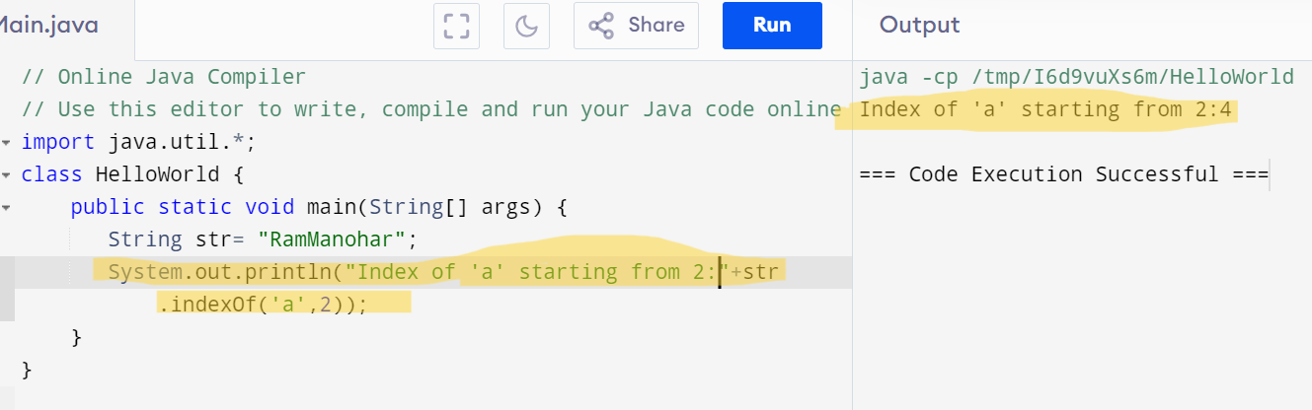
19.int indexOf(String substring): returns the specified substring index.
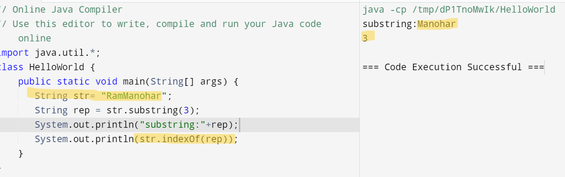
20 String toLowerCase()
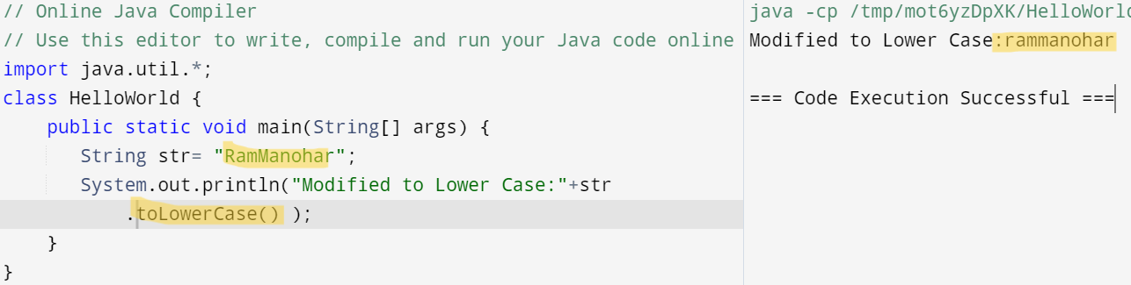
21.String toUpperCase()
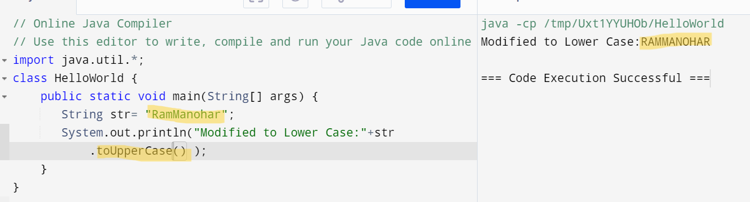
22.static String valueOf(int value): converts given type into string.
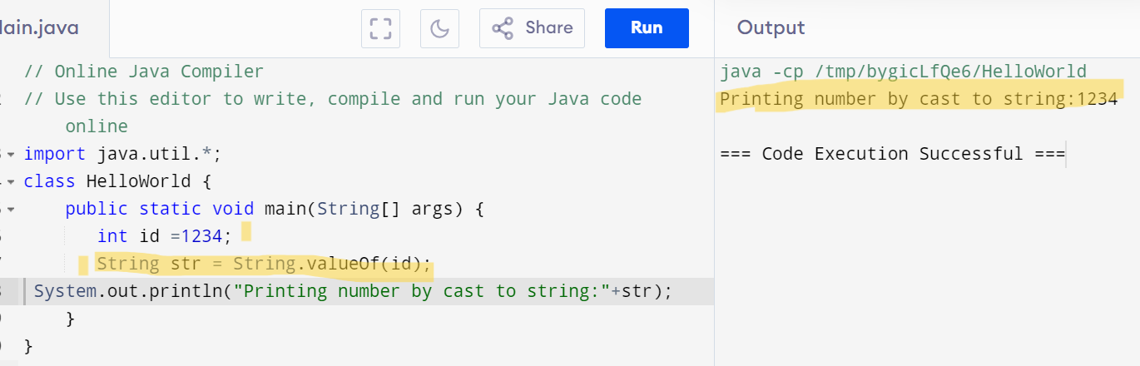
23 . compareTo() : compares the given string with the current string lexicographically. It returns a positive number, negative number, or 0.
if s1 > s2, it returns positive number
if s1 < s2, it returns negative number
if s1 == s2, it returns 0
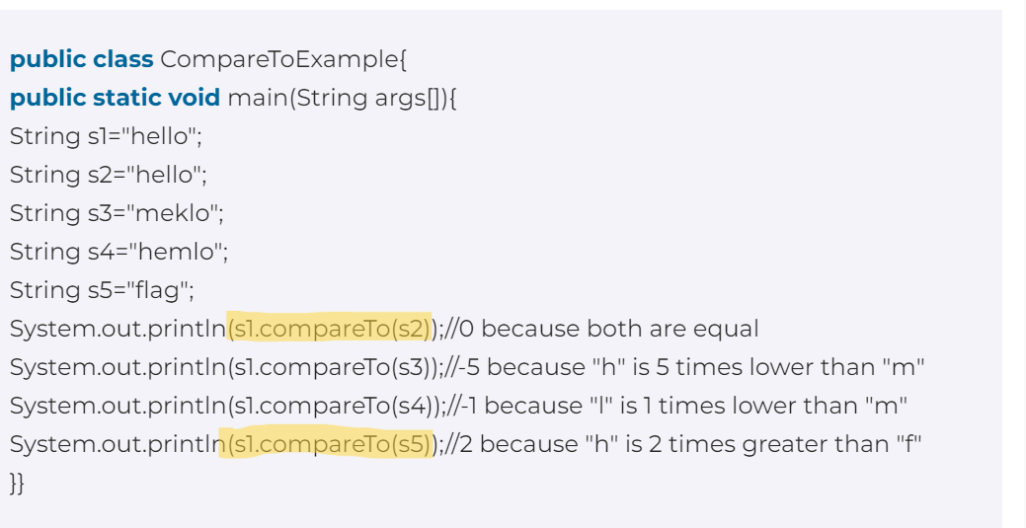
Java Regex :
The Java Regex or Regular Expression is an API to define a pattern for searching or manipulating strings.
widely used to define the constraint on strings such as password and email validation.
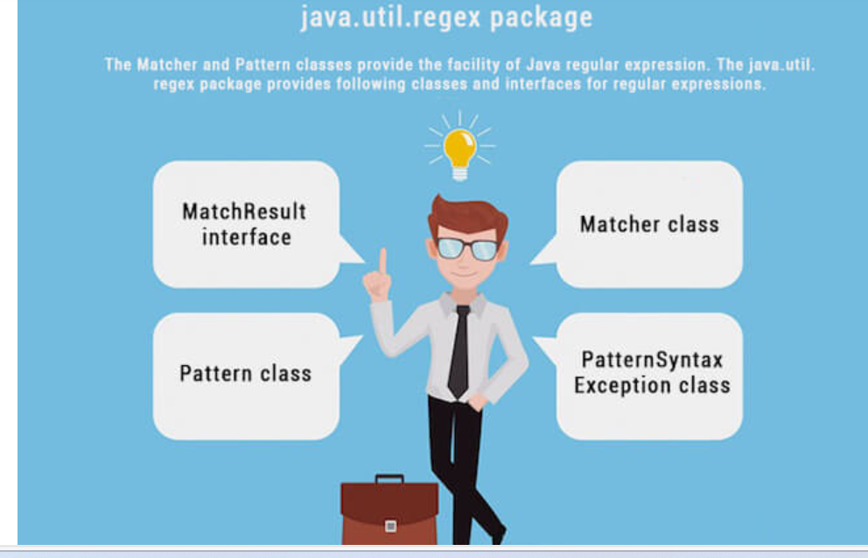
Matcher Class:
[1] boolean matches() : test whether the regular expression matches the pattern.
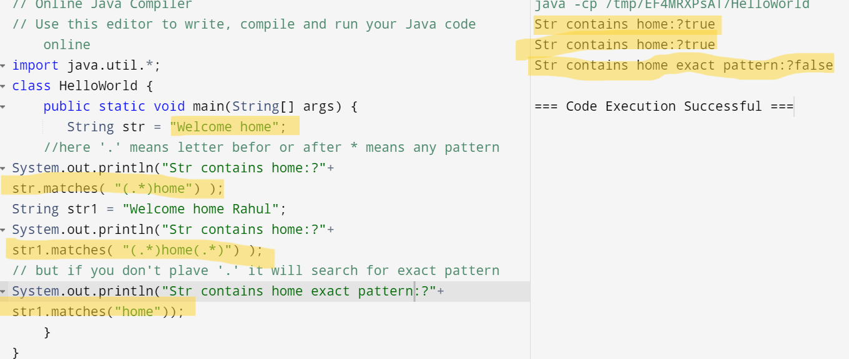
[2] boolean find() : finds the next expression that matches the pattern
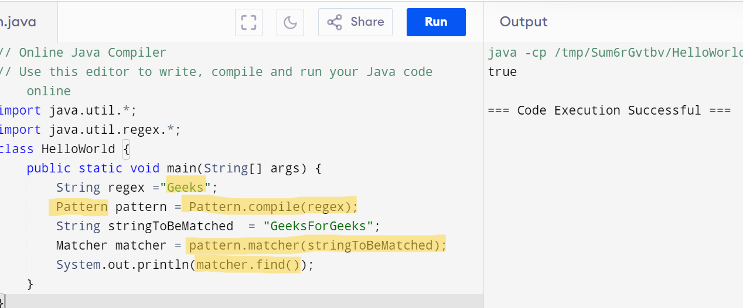
[3] boolean find(int start) : finds the next expression that matches the pattern from the given start number.
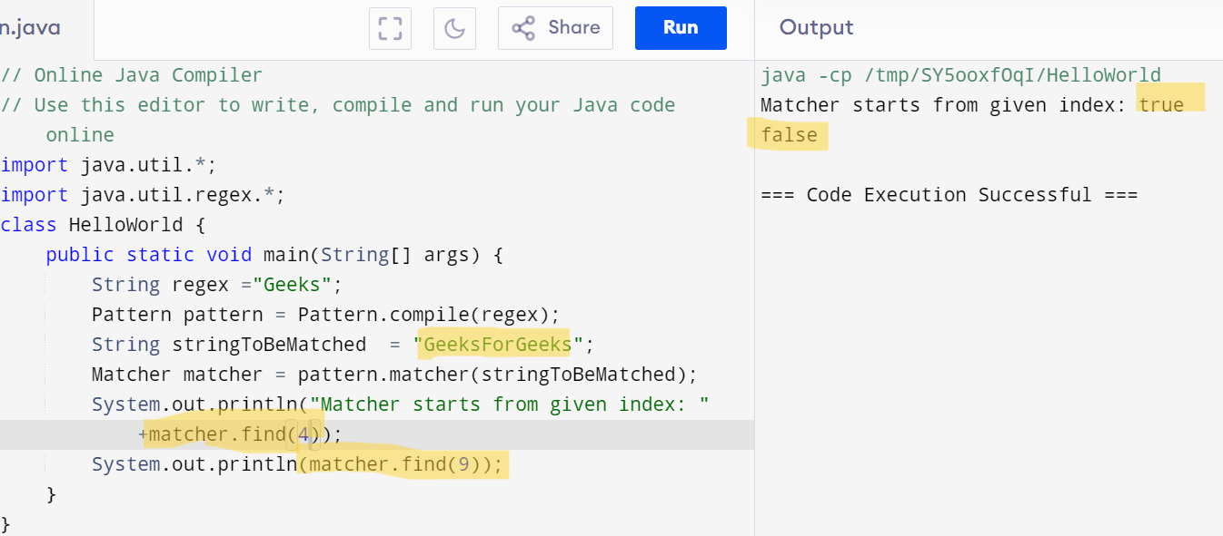
[4]String group() : returns the matched subsequence.
https://www.geeksforgeeks.org/matcher-group-method-in-java-with-examples/
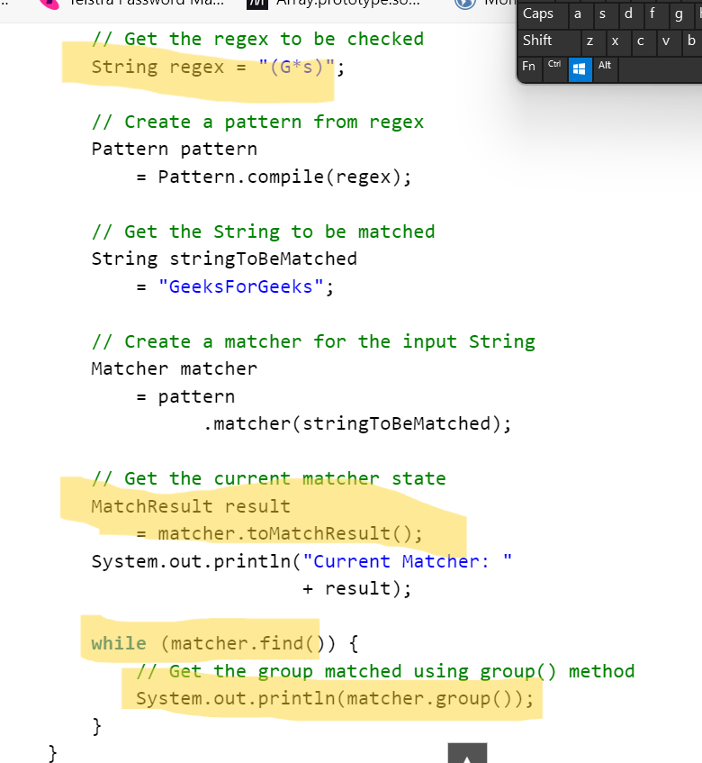
//How many times s come will print matcher.group()
Output:
Current Matcher: java.util.regex.Matcher[pattern=(G*s) region=0, 13 lastmatch=]
s
s
[4]int start() : returns the starting index of the matched subsequence.
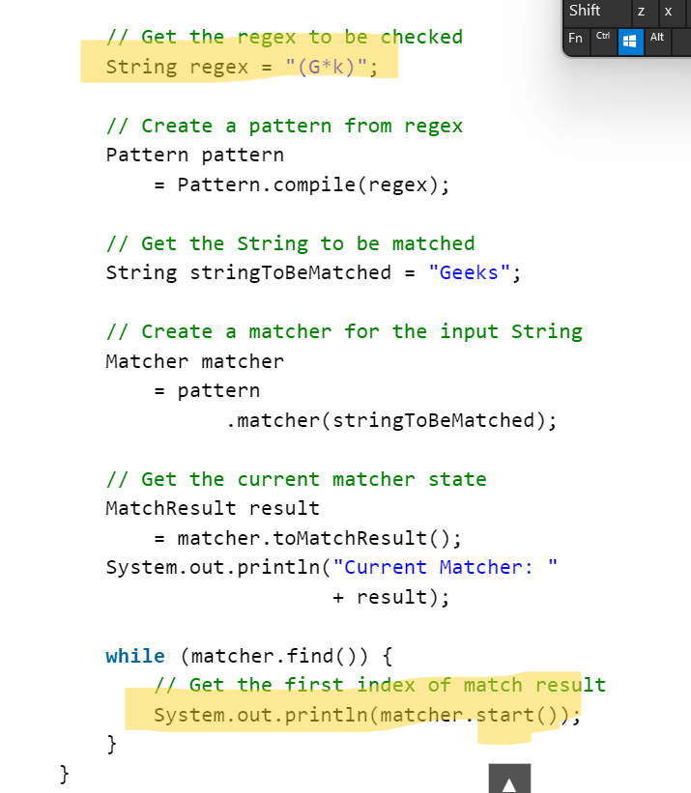
// returns the match index if matches pattern G*k
Output:Current Matcher: java.util.regex.Matcher[pattern=(G*k) region=0,5 lastmatch=]
3
Example 2:
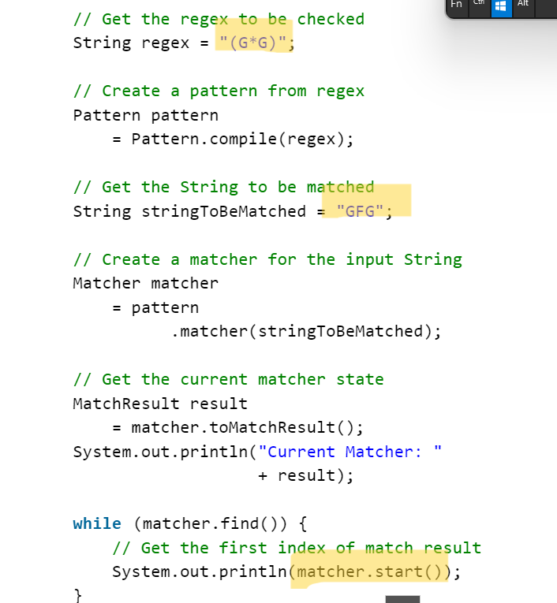
Output:
Current Matcher: java.util.regex.Matcher[pattern=(G*G) region=0,3 lastmatch=]
0
2
-----------------------------------------------------------------------------------------------------------
[6] int end(): returns the ending index of the matched subsequence.
//Will return where pattern end like here end will be 1 , 3
String regex = "(G*G)";
// Create a pattern from regex
Pattern pattern = Pattern.compile(regex);
// Get the String to be matched
String stringToBeMatched = "GFG"
// Create a matcher for the input String
Matcher matcher= pattern.matcher(stringToBeMatched);
// Get the current matcher state
MatchResult result = matcher.toMatchResult();
System.out.println("Current Matcher: "+ result);
while (matcher.find()) {
System.out.println(matcher.end());
}
[7] int groupCount() :returns the total number of the matched subsequence.
MatcherResult matcher = pattern.matcher(stringToBeMatched);
System.out.println(matcher.groupCount());
Pattern class : It is the compiled version of a regular expression. It is used to define a pattern for the regex engine.
[1] static Pattern compile(String regex) : compiles the given regex and returns the instance of the Pattern.
Like in above code we have used :
String regex = "(Geeks)";
// Create a pattern from regex
Pattern pattern = Pattern.compile(regex);
[2] Matcher matcher(CharSequence input) : creates a matcher that matches the given input with the pattern
String regex = "(G*G)";
// Create a pattern from regex
Pattern pattern = Pattern.compile(regex);
// Get the String to be matched
String stringToBeMatched = "GFG"
// Create a matcher for the input String
Matcher matcher= pattern.matcher(stringToBeMatched);
[3]static boolean matches(String regex, CharSequence input) : works as the combination of compile and matcher methods. It compiles the regular expression and matches the given input with the pattern.
import java.util.*;
import java.util.regex.*;
class HelloWorld {
public static void main(String[] args) {
String regex = "(.*)(for)(.*)";

String stringToBeMatched = "Geeks for Coder";
boolean matcher = Pattern.matches(regex , stringToBeMatched);
if(matcher){
System.out.println("Matcher found for regex");
}else{
System.out.println("No Matcher found for regex");
}
}
}

[4]
import java.util.*;
import java.util.regex.*;
class HelloWorld {
public static void main(String[] args) {
String regex = "for";
Pattern pattern = Pattern.compile(regex);
String stringToBeMatched = "Geeks for Coder";
// create limit to 2
// so it can applied at most limit - 1 time
int limit = 2;
//here regex will act as a seperator
// limit means size of array
// if nothing is mentoined it will work as required
// String [] array = pattern.split(stringToBeMatched,int limit);
String [] array = pattern.split(stringToBeMatched);
// print array
for (int i = 0; i < array.length; i++) {
System.out.println("array[" + i
+ "]=" + array[i]);
}
}
Output :
array[0]=Geeks
array[1]= Coder
Actual split method in string without Regex:
String str = "geekss@for@geekss";
String[] arrOfStr = str.split("@");
for (String a : arrOfStr)
System.out.println(a);
Regex Character classes
[1][abc] : a, b, or c (simple class)
This square-bracketed expression specifies the set of characters to match. In this case, it includes ‘a’, ‘b’, and ‘c’.
character class matches only a single character.
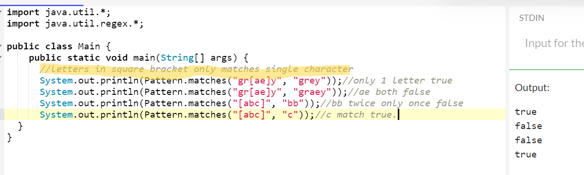
[2][^abc] : Any character except a, b, or c (negation)
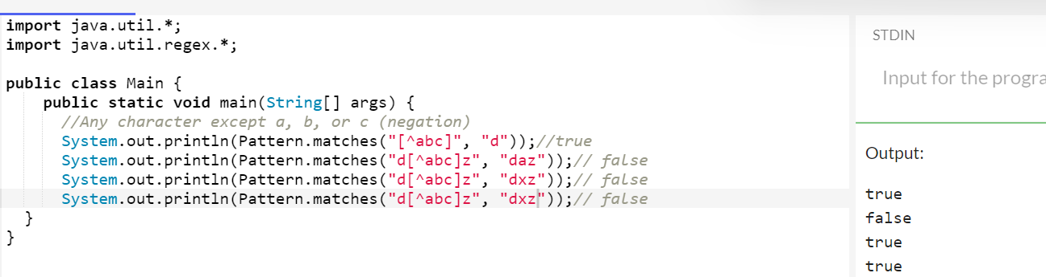
[3] [a-zA-Z] : a through z or A through Z, inclusive (range)
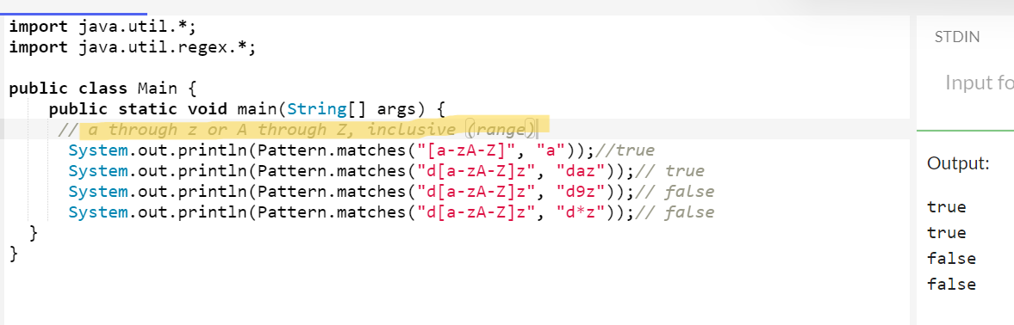
[4][a-d[m-p]] : represents a union of two ranges : a to d or from m to p
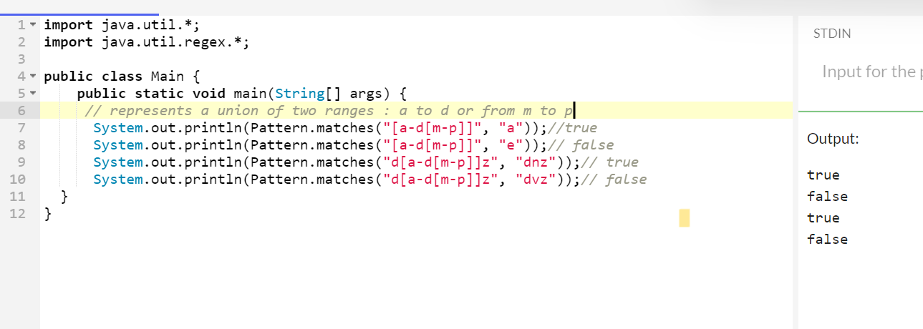
[5] [a-z&&[def]] : d, e, or f (intersection)
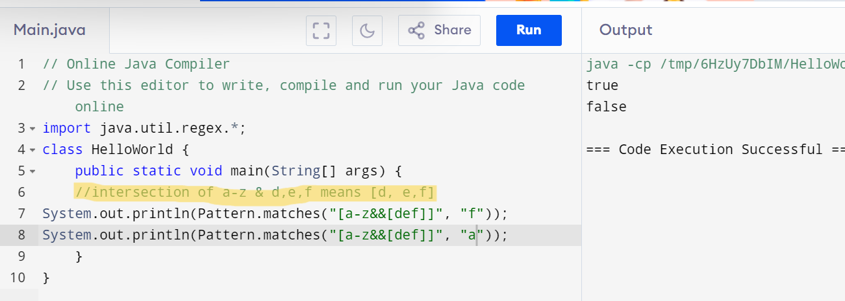
[6] [a-z&&[^bc]] : a through z, except for b and c: [ad-z] (subtraction)
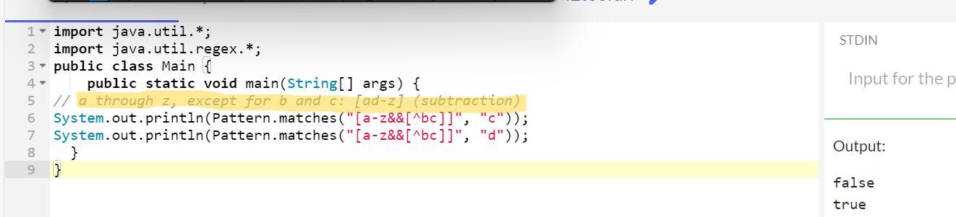
[7][a-z&&[^m-p]] : a through z, and not m through p:
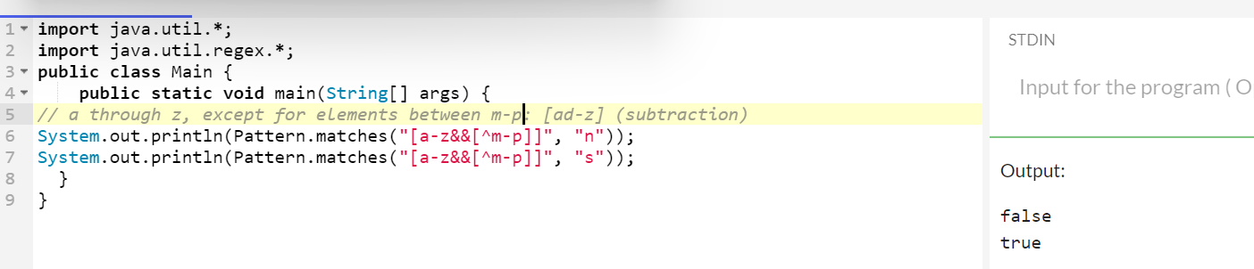

Regex Quantifiers :


