AIM-To find the solution of equation using simpson’s 1/3rd rule

THEORY-
Simpson’s Rule is a Numerical technique to find the definite integral of a function within a given interval.
The function is divided into many sub-intervals and each interval is approximated by a quadratic curve. And the area is then calculated to find the integral. The more is the number of sub-intervals used, the better is the approximation.
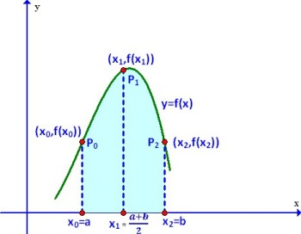

FORMULA USED-
∫_{b}ªf(x) dx=S2= h/3[f(a)+4f(a+b/2)+f(b)]

Where h = (b-a)/2
f(x) is called the integrand
a= lower limit of integration
b= upper limit of integration

ALGORITHM-
1.input Function f(x)
2.Read a,b,n
3.calculate h=(b-a)/n
4.sum=f(a)+f(a+nh)
5.for i=1 to i=n-1
sum+=4*f(a+ih)+2*f(a+(i+1)h);
6.result=sum*(h/3)
7.print result

CODE-
#include<iostream>
#include<cmath>
using namespace std;
float f(float x)
{
return sqrt(1+pow(x,3)); //Define the function f(x)
}

float simpson(float a, float b, int n)
{
float h, x[n+1], sum = 0;
int j;
h = (b-a)/n;
x[0] = a;
for(j=1; j<=n; j++)
{
x[j] = a + h*j;
}
for(j=1; j<=n/2; j++)
{
sum += f(x[2*j - 2]) + 4*f(x[2*j - 1]) + f(x[2*j]);
}
return sum*h/3;
}

int main()
{
int a,b,n;
a = 1;
b = 4;
n = 6;
cout<<"\nvalue of a="<<a;
cout<<"\nvalue of b="<<b;
cout<<"\nsub intervals n="<<n;
if (n%2 == 0)
cout<<"\nthe value of integral is "<<simpson(a,b,n)<<endl;
else
cout<<"n should be an even number";
return 0;
}
OUTPUT-

