Instruction For Windows GNUVERILOG

Software to Setup Before Run

- Install docker-desktop
- Install VcXsrv (display manager)

Procedure before running container

Docker-Desktop

Open the program and leave it running in the background
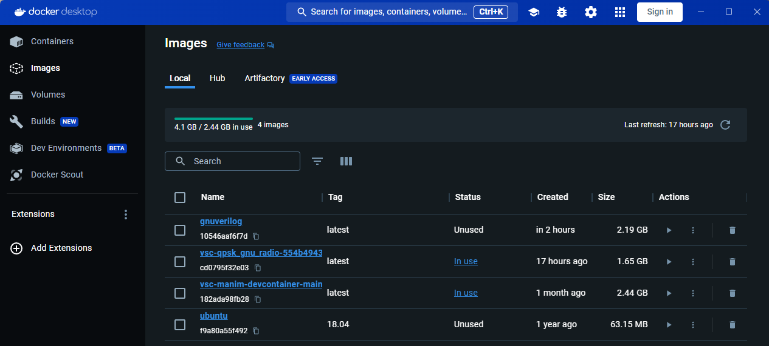

Xserver/XLaunch

Icon looks as follows


Below settings work fine
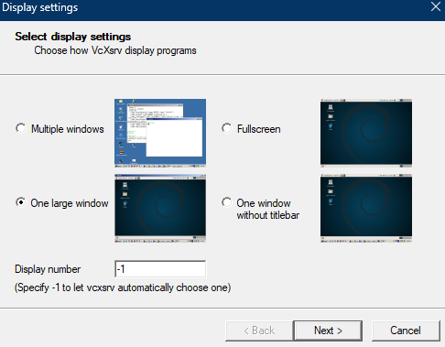
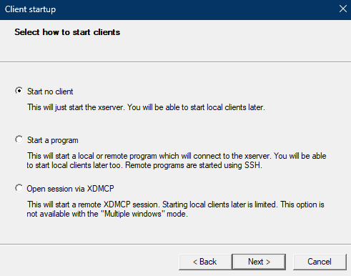
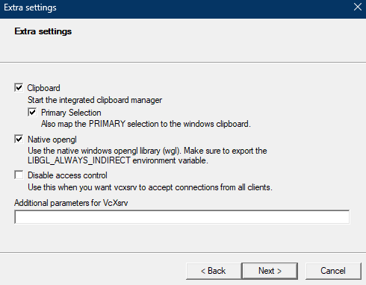
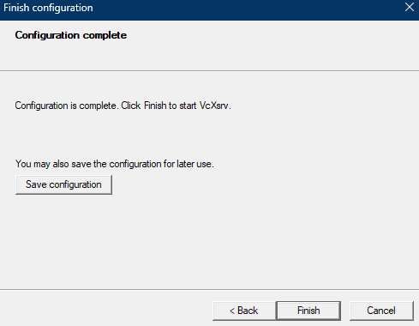

We are now done with all configurations,
Above steps need to be repeated every time new desktop session is opened

Commands in command prompt

Image with all configurations setups done in gnuverilog.tar
docker load -i .\gnuverilog.tar

(Optional) Can run to see if image was created
docker images

Example output
REPOSITORY TAG IMAGE ID CREATED SIZE
gnuverilog latest 10546aaf6f7d Less than a second ago 2.19GB

Run Container
docker run -it --rm -e DISPLAY=host.docker.internal:0 gnuverilog

You Should see something like this
root@6cd82717fae7:/#

