Question 1:
Relation R has eight attributes ABCDEFGH. Fields of R contain only atomic values. F = {CH →G, A → BC, B → CFH, E → A, F → EG} is a set of functional dependencies (FDs) so that F+ is exactly the set of FDs that hold for R. Find the candidate keys of relation R.
Solution:
We know that, if the closure of an attribute (or set of attributes) includes all the attributes of the relation, then that attribute (or set of attributes) is one of the candidate keys of the relation (table). To simplify, we would find the closure for left hand side attributes of all the functional
dependencies (we can skip redundant attributes).
Closure of A (A+):
Result = A
Result = ABC from A → BC
Result = ABCFH from B → CFH
Result = ABCEFGH from F → EG
Final result = ABCEFGH which is not ABCDEFGH i.e., result ≠ R. hence, A is not a candidate
key.
Closure of E (E+):
Result = E
Result = EA from E → A
If we know A, from the above derivation, final result would be ABCEFGH. And this is not
equal to R, hence E is not a candidate key.
At this stage, we need to observe one thing from the set of functional dependencies given. The
thing is, attribute D is not part of any functional dependencies. Hence, we need to include D
with other attributes. That means, whatever key we find, D should be a part of it.
Hence, we would try with D as a component attribute; if we follow the steps applied above; we would get the following;
Closure of AD (AD+) = R. Hence, AD is one of the candidate keys.
Closure of BD (BD+) = R. So BD is one of the candidate keys.
Closure of ED (ED+) = R. So, ED is one of the candidate keys.
Closure of FD (FD+) = R. Hence, FD is one of the candidate keys.
AD, BD, ED, and FD are the candidate keys of R.
Question 2:
Consider the relation scheme R = (E, F, G, H, I, J, K, L, M, N) and the set of functional dependencies {{E,F} → {G}, {F} → {I, J}, {E, H} → {K, L} → {M}, {K} → {M}, {L} → {N}} on R. What is the key for R?
Solution:
To find the key of a relation, we need to find the closure of attributes. If any attribute‛s or set of
attributes‛ closure gives all the attributes of the relation, then we would say that attribute/set of
attributes as the key for that relation.
To simplify this task or to avoid finding closure of all attributes, let us do find the closure for left hand side (LHS) attributes of the functional dependencies.
For the given question, attributes F, (E, F), (E, H), K, and L are the LHS attributes.
The closure of F, i.e., (F)+ = FIJ ≠ EFGHIJKLMN. Hence F is not a candidate key.
(EF)+ = EFGIJ ≠ EFGHIJKLMN. Hence EF is not a candidate key.
(EH)+ = EHKLMN ≠ EFGHIJKLMN. Hence EH is not a candidate key.
(K)+ = KM ≠ EFGHIJKLMN. Hence, K is not a candidate key.
We observed that the left side attributes of any FDs alone cannot form a key. Let us try with the
combination of two FDs LHS.
(EFH)+ = EFGHIJKLMN = R.
Hence, EFH is the key for this relation.
Derivation of EFH+:
Step 1: result = EFH
Step 2: result = EFGH from {E, F} → {G}
Step 3: result = EFGHIJ from {F} → {I, J}
Step 4: result = EFGHIJKLM from {E, H} → {K, L} → {M}
Step 5: result = EFGHIJKLMN from {L} → {N}
We have reached that the result = R. hence, EFH is the key.
Question 3:
Consider a relation Teacher with the attributes Teacher_Name, Gender, DOB, Subject_Handles, School_Name, and School_Location. Assume that Teacher is in 1NF. Answer the following questions;
a. Assume that there are set of functional dependencies in Teacher. If (Teacher_Name, DOB) is
the key for Teacher, is Teacher in 2NF?
CANNOT DETERMINE.
A table is in 2NF, if there is no partial key dependency. Here, the key for Teacher is a composite primary key. So, there are possibilities for partial key dependencies. We cannot determine whether this table is in 2NF or not as the given information is not enough.

b. If Teacher_Name is the key for Teacher, is Teacher in 2NF?
YES.
The key for Teacher is formed by a single column, ie., Teacher_Name. If all the attributes of Teacher can be determined uniquely by Teacher_Name, then only Teacher_Name attribute forms the key. And, there are no possibilities for partial key dependencies. Hence, Teacher is in 2NF.

c. (Teacher_Name, DOB) is the key for Teacher, all the other attributes depend on the whole key, and only other FD is "School_Name determines the School_Location uniquely". Is Teacher in 2NF?
YES.
As per the given information, there is no partial key dependency present. Hence, the table is in 2NF.
d. (Teacher_Name, DOB) combination is the key for Teacher, all the other attributes depend on
the whole key, and only other FD is "School_Name determines the School_Location uniquely". Is
Teacher in 3NF?
NO.
For a table in 3NF, it should be in 2NF and nonkey attribute dependencies (transitive dependencies) must not present. From the given information, it is clear that the table is in 2NF. Teacher is not in 3NF because of
the nonkey dependency School_Name → School_Location.
e. Assume a set of FDs in Teacher, and it is found that Teacher_Name is the key. If Teacher_Name
is the key for Teacher, is Teacher in 3NF?
CANNOT DETERMINE.
Only information given here is the key for Teacher. If we are given the set of functional
dependencies, then only we can decide. In this case we cannot determine.
Question 4:

For the following Student table instance, find all the possible functional dependencies that are held. Do not include trivial FDs.
[Schema Student (Regno, Name, DOB, Phone, Gender, Course_ID, Course_Name, Instructor_ID, Instructor_Name, Instructor_Office)]

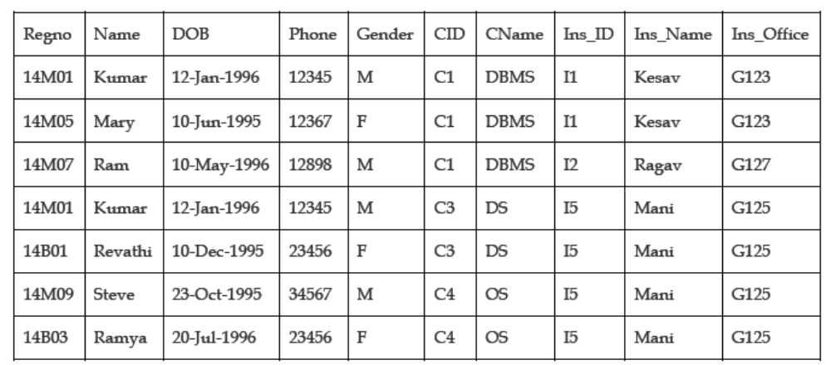
Solution:
Functional Dependency:
X → Y
X may be one or more attributes, and Y may be one or more attributes.
In this FD, X is the determinant set and Y is the dependent set.
We would read this as, “Y is dependent on X”, or “X determines the value of Y uniquely”
The following functional dependencies are held in Student;
Regno → Name
– Names are uniquely identified by a regno. In other words, for a given register number, there is exactly one name.
Regno → DOB
For any given register number in Student, there is exactly one DOB value.
Regno → Phone
Regno → Gender
You can write the above FDs collectively as follows;
Regno → Name, DOB, Phone, Gender

For any given register number of Student table, you would get unique name, DOB, phone, and gender values.
CID → CName
CName → CID

For the given instance, this FD is true. This FD may not be correct in some cases. For example, if suppose DBMS is offered for two different programs, say B.Tech and M.Tech with two different course IDs C1 and C10, then this FD does not hold in Student. You need to verify the semantics and the permitted values for a column carefully.

Ins_ID → Ins_Name, Ins_Office
Regno, CID → Name, DOB, Phone, Gender, CName
Regno and CID together, i.e., any combination of these two values can uniquely identify the
values of name, dob, phone, gender, and cname.

Regno, CID, Ins_ID → Name, DOB, Phone, Gender, CName, Ins_Name, Ins_Office
The combination of regno, cid and ins_id values can uniquely identify all the other attributes
of the table Student. Hence, the combination (Regno, CID, Ins_ID) is the key for Student.

Example of the functional dependencies (Not all) that are not holding on Student:
Phone → Regno
As per the given instance of Student, for a given phone value 23456, there are two students
with register numbers 14B01, and 14B03. Hence, this FD does not hold on Student.
CID → Ins_ID
CID C1 is taught by two instructors I1 and I2. Hence, this FD does not hold.
DOB → Regno, Name, Phone, Gender
Our Student instance does not contain duplicate values for the column DOB. But in reality,
there may be more than one student with the same DOB. Hence, we cannot use DOB as the
determiner.

Question 5:
The following relation schema is used to store information about the customers of a car service center.
Customer (Customer_ID, CName, CAddr, Phone, Customer_Visit_Date,
Service_Advisor_ID, SAName, SAPhone, No_of_Cars_Serviced, Service_Date)
A customer is identified with a unique Customer_ID, he can have only one phone number, and he may have visited the service center many times. There are more service advisors and each advisor services many cars on a given service date. Any service advisors can be reached at only one phone number.
Find the primary key for Customer.
Solution:
From the given information, we can derive the following set of functional dependencies;
Customer_ID → CName CAddr Phone
[as customer id is unique, every id is related to exactly one name, one address, and one phone]
The FDs that do not hold
Customer_ID → Customer_Visit_Date – This FD does not hold because a customer can visit many times. Hence, customer id cannot uniquely determine customer visit date.
Customer_ID → Service_Advisor_ID – This FD does not hold because a might have been attended by different advisors during each of his visit.
Service_Advisor_ID → Service_Date No_of_Cars_Serviced – This FD does not hold because a service advisor services every day with number of cars. Hence, we cannot uniquely determine the number of cars serviced or the service dates.
Service_Date → No_of_Cars_Serviced – This FD does not hold because on a given service date other service advisors may have serviced many cars as well.
Service_Advisor_ID → SAName SAPhone
[Service advisors name and phone can be uniquely determined by service advisor id]
Service_Advisor_ID Service_Date → No_of_Cars_Servicesd
[if we know the service date and the advisor id, we can uniquely determine the number of cars serviced on a data by an advisor]
Normally, it is enough to find the closure for the LHS (Left Hand Side) attributes of the FDs.
(Customer_ID)+ = Customer_ID, CName, CAddr, Phone
[(Customer_ID) does not derive all the attributes of customer]

(Service_Advisor_ID)+ = Service_Advisor_ID, SAName, SAPhone
[(Service_Advisor_ID) does not derive all the attributes of customer]

(Service_Advisor_ID, Service_Date)+ = Service_Advisor_ID, SAName, SAPhone,
Service_Date, No_of_Cars_Serviced
[(Service_Advisor_ID, Service_Date) does not derive all the attributes of customer]
(Customer_ID, Service_Advisor_ID, Service_Date)+ = Customer_ID, CName, CAddr, Phone, Service_Advisor_ID, SAName, SAPhone, Service_Date, No_of_Cars_Serviced
[(Customer_ID, Service_Advisor_ID, Service_Date) does not derive all the attributes of
customer.]
Here customer visit date is missing. And this attribute is not part of any FDs. Hence, we can include customer_visit_date attribute to the left hand side by assuming the trivial FD,
Customer_Visit_Date → Customer_Visit_Date.
Then we have,
(Customer_ID, Customer_Service_Date, Service_Advisor_ID, Service_Date)+ = Customer_ID, CName, CAddr, Phone, Customer_Service_Date, Service_Advisor_ID, SAName, SAPhone, Service_Date, No_of_Cars_Serviced
(Customer_ID, Customer_Service_Date, Service_Advisor_ID, Service_Date) derives all the
attributes of Customer. Hence, this combination forms the key for Customer.
Customer_ID Customer_Service_Date Service_Advisor_ID Service_Date → CName CAddr Phone SAName SAPhone No_of_Cars_Serviced This FD holds on Customer
(Customer_ID Customer_Service_Date Service_Advisor_ID Service_Date) is the key and it is a composite primary key.
Question 6:
Which of the following functional dependencies are satisfied by this relation? How?
(a) A → B
(b) A → CD
(c) AB → CD
(d) C → D
(e) B → A
(f) BD → AC
(g) AD → BC
(h) D → B
(i) D → C
(j) C → A
Solution:
Functional dependency – For a given Left Hand Side (LHS) value of an attribute (or set of attributes) of a functional dependency, there should be at most one Right Hand Side (RHS) value of an attribute (or set of attributes). Then we would say that the functional dependency holds on that relation.
In other words, if you execute the following query, we should always get only one student_name for a given reg_no.
SELECT Student_Name FROM Student WHERE Reg_No = 123;
Example:
REG_NO → STUDENT_NAME. This functional dependency means that there is at most one student name is related to one register number. This is correct.

STUDENT_NAME → REG_NO. This functional dependency means that there is at most one register number is related to a student name. This may not be true. Because, there may be more than one student with the same name.
(a) A → B – does not hold in relation R.
WHY? In the table R, we have 3 B values (1, 2 and 3) for a given A value (1).

(b) A → CD – holds in relation R.
WHY? In R, we have single C and D combination of values for every A value. You can observe the following from R.
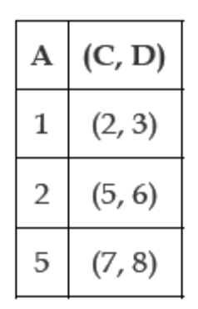
Also observe that whenever 1 comes as A value, (2, 3) is repeated. That means, this should be true for all records of R. whenever 1 is inserted as A value for any new record, there must be only one combination of C and D, (2, 3).

(c) AB → CD – holds in relation R.
WHY? In R there is one to one relationship between AB and CD, i.e., for a given A and B combination of values, there is unique C and D combination of values.

(d) C → D – holds in relation R.
WHY? In R there is one to one relationship between C and D values.
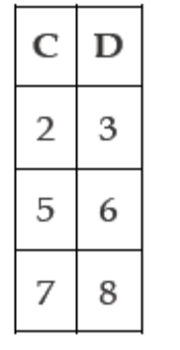
(e) B → A – holds in relation R.
WHY? In R there is one to one relationship between B and A values from B. that is, for a given B value,
there is only one associated A value.
(f) BD → AC – holds in relation R.
(g) AD → BC – does not hold in relation R.
WHY? In R, for a given A and D values (1, 3), there are more than one (3 values (
1, 2), (2, 2), (3, 2)) B and C values.
(h) D → B – does not hold in relation R.
WHY? In R, we have 3 different B values (1, 2, and 3) for a given D value (3).
(i) D → C – holds in relation R.
(j) → D – holds in relation R.

Question 7:
Consider the relation Treatment with the schema Treatment (doctorID, doctorName, patientID, diagnosis) and functional dependencies;
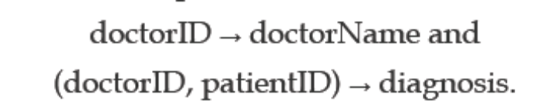
Describe different types of anomaly that can arise for this table with example records.
Answer:
Example:
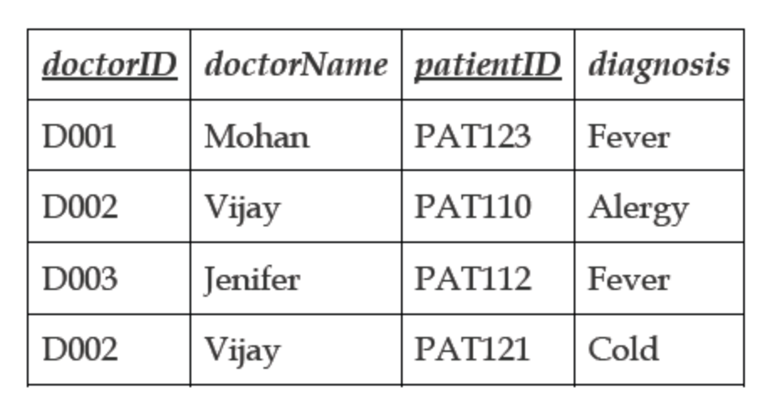

TREATMENT has two FDs. From the FDs, we can derive that the combination (doctorID,
patientID) is the primary key for TREATMENT.

Anomalies:
Insertion anomaly: The inability to store certain attributes’ values without the other attributes. If we are not able to insert a record into a relational table because of the absence of values for other attributes is called insertion anomaly.
For Treatment, we cannot insert the doctor information like doctorID and doctorName without any patient. That is, we need at least one patient to include the doctor information into the table. For example, if one more doctor Dr.Neeraj is appointed, we need to allocate at least one patient to insert Dr.Neeraj’s information. This inability is insertion anomaly.
Deletion anomaly: Deletion of values of certain attributes from any records (rows) will lead to lose of other attributes’ values of the same records. That means, we lose the complete information about an entity if we delete few values. This is called as deletion anomaly.
Deleting patients’ diagnosis could delete the name of their doctor. For example, Dr.Mohan has only one patient PAT123 registered for him. If we delete the patient PAT123, we need to delete Dr.Mohan’s details as well. This is the deletion anomaly present in the TREATMENT table.

Modification anomaly: Modification of certain values in a table may lead to change the values in more than one record if that particular value has duplicates. If we miss any one occurrence of that data, that leads to inconsistency of the table. This is called as modification anomaly.
A doctor may have more than one patient, so an update anomaly may result if a doctor’s name is changed for a given doctorID for only one patient. For example, in our table TREATMENT Dr.Vijay has two patients. Suppose that we need to change the doctor name from Vijay to Vijay Kumar. This change has to be done on two records. What if we change with second record and not changing with fourth record? If we do such thing, we are not able to find the exact name of the doctor of doctor ID D002. This stage is called as modification anomaly.

Question 8:
Consider a relation Movies_Screened with attributes Theatre_name, Movie, Day, Time, and Age_restriction. A sample table is given below;

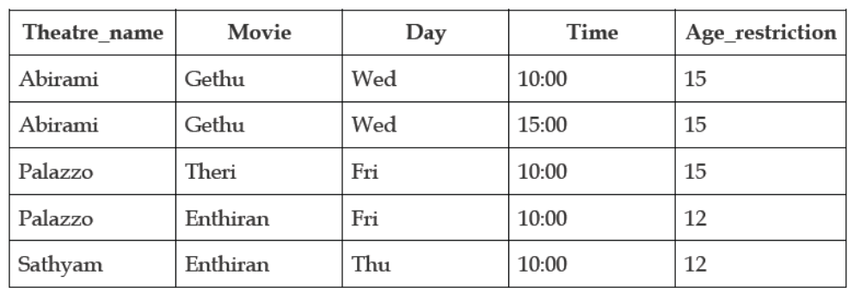

A theatre can screen more than one movie on the same day and time but on different screens. Age_restriction provides the minimum age limit to watch that particular movie as instructed by the central board of film certification. Does this relation satisfy 2NF conditions? Or, is Movies_Screened in 2NF?
Solution:
The properties to be satisfied for 2NF relations are;
Table should be in 1NF
All nonkey attributes must fully functionally dependent on the whole key (primary
key).

Is Movies_Screened in 1NF?
YES. All the attributes contain only atomic values. Hence, Movies_Screened is in 1NF.

Is Movies_Screened in 2NF?
To check this, first we need to find the key for Movies_Screened. To find the key we need the
possible functional dependencies that are held in the given table.
No attributes uniquely identify any other attributes in the given table.

For example,
Theatre_name → Movie – Not hold, because it is given that a theatre may show more than one movies on different screens.
Theatre_name → Day – Not hold, because it is given that a theatre may show more than one shows on the same day.

And so on. [Readers are requested to work on other attributes/attribute sets like this.]
Movie → Age_restriction – Holds, because the value of Age_restriction can be uniquely identified by the value of Movie.

Theatre_name, Movie, Day, Time → Age_restriction – Holds, because all these attributes Theatre_name, Movie, Day, and Time as a whole (together) uniquely determines the value of Age_restriction. Hence, this is the valid functional dependency.

From the above functional dependency, it is very clear that (Theatre_name, Movie, Day, Time) is the key for Movies_Screened table. It is a composite primary key.

For a table to be in 2NF, all nonkey attributes must fully functionally dependent on the whole key. In our table, Age_restriction is the only nonkey attribute. Also, it can be identified by the whole key and by Movie attribute. That means, the functional dependency
Movie → Age_restriction, shows partial dependency. Hence, the table Movies_Screened is not in 2NF.

Normalisation BCNF
BoyceCodd Normal Form (BCNF)
When a relation has more than one candidate key, anomalies may result even though the relation is in 3NF. 3NF does not deal satisfactorily with the case of a relation with
overlapping candidate keys i.e. composite candidate keys with at least one attribute in
common. BCNF is based on the concept of a determinant.

A determinant is any attribute (simple or composite) on which some other attribute is fully functionally dependent.
A relation is in BCNF is, and only if, every determinant is a candidate key.
Consider the following relation and determinants.

R(a,b,c,d)
a,c > b,d
a,d > b

Here, the first determinant suggests that the primary key of R could be changed from a,b to a,c. If this change was done all of the nonkey attributes present in R could still be determined, and therefore this change is legal. However, the second determinant indicates that a,d determines b, but a,d could not be the key of R as a,d does not determine all of the non key attributes of R (it does not determine c). We would say that the first determinate is a candidate key, but the second determinant is not a candidate key, and thus this relation is not in BCNF (but is in 3rd normal form).

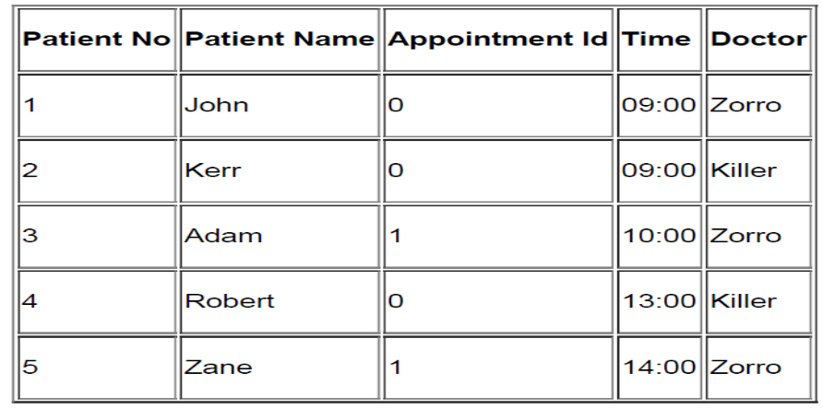
Lets consider the database extract shown above. This depicts a special dieting clinic where the each patient has 4 appointments. On the first they are weighed, the second they are exercised, the third their fat is removed by surgery, and on the fourth their mouth is stitched closed… Not all patients need all four appointments! If the Patient Name begins with a letter before “P” they get a morning appointment, otherwise they get an afternoon appointment. Appointment 1 is either 09:00 or 13:00, appointment 2 10:00 or14:00, and so on. From this (hopefully) make believe scenario

We can extract the following determinants:
DB(Patno,PatName,appNo,time,doctor)
Patno >PatName
Patno,appNo > Time,doctor
Time > appNo
Now we have to decide what the primary key of DB is going to be.
From the information we have, we could chose:
DB(Patno,PatName,appNo,time,doctor) (example 1a)
or
DB(Patno,PatName,appNo,time,doctor) (example 1b)

Example 1a
DB( Patno,PatName,appNo,time,doctor)
1NF Eliminate repeating groups.
None:
DB(Patno,PatName,appNo,time,doctor)

2NF Eliminate partial key dependencies
DB(Patno,appNo,time,doctor)
R1(Patno,PatName)
3NF Eliminate transitive dependencies
None: so just as 2NF

BCNF Every determinant is a candidate key
DB(Patno,appNo,time,doctor)
R1(Patno,PatName)

Go through all determinates where ALL of the left hand attributes are present in a relation and at least ONE of the right hand attributes are also present in the relation.
Patno > PatName
Patno is present in DB, but not PatName, so not relevant.
Patno,appNo > Time,doctor

All LHS present, and time and doctor also present, so relevant.
Is this a candidate key? Patno,appNo IS the key, so this is a candidate key. Thus this is OK for BCNF compliance.
Time > appNo

Time is present, and so is appNo, so relevant. Is this a candidate key. If it was then we could rewrite DB as:
DB(Patno,appNo,time,doctor)
This will not work, as you need both time and Patno together to form a unique key. Thus this determinate is not a candidate key, and therefore DB is not in BCNF. We need to fix this. BCNF: rewrite to

DB(Patno,time,doctor)
R1(Patno,PatName)
R2(time,appNo)
time is enough to work out the appointment number of a patient.
Now BCNF is satisfied, and the final relations shown are in BCNF.

Example 1b DB( Patno,PatName,appNo,time,doctor)
1NF Eliminate repeating groups.
None:
DB(Patno,PatName,appNo,time,doctor)

2NF Eliminate partial key dependencies
DB(Patno,time,doctor)
R1(Patno,PatName)
R2(time,appNo)

3NF Eliminate transitive dependencies
None: so just as 2NF

BCNF Every determinant is a candidate key
DB(Patno,time,doctor)
R1(Patno,PatName)
R2(time,appNo)

Go through all determinates where ALL of the left hand attributes are present in a relation and at least ONE of the right hand attributes are also present in the relation.
Patno > PatName
Patno is present in DB, but not PatName, so not relevant.
Patno,appNo > Time,doctor
Not all LHS present, so not relevant.

Time > appNo
Time is present, and so is appNo, so relevant. This is a candidate key. However, Time is currently the key for R2, so satisfies the rules for BCNF.

BCNF: as 3NF
DB(Patno,time,doctor)
R1(Patno,PatName)
R2(time,appNo)

This example has demonstrated three things:
BCNF is stronger than 3NF, relations that are in 3NF are not necessarily in BCNF
BCNF is needed in certain situations to obtain full understanding of the data model
there are several routes to take to arrive at the same set of relations in BCNF.
Unfortunately there are no rules as to which route will be the easiest one to take.

Example 2
Grade_report(StudNo,StudName,(Major,Adviser,
(CourseNo,Ctitle,InstrucName,InstructLocn,Grade)))
Functional dependencies
StudNo ‐> StudName
CourseNo ‐> Ctitle,InstrucName
InstrucName ‐> InstrucLocn
StudNo,CourseNo,Major ‐> Grade
StudNo,Major ‐> Advisor
Advisor ‐> Major

Unnormalised
Grade_report(StudNo,StudName,(Major,Advisor,
(CourseNo,Ctitle,InstrucName,InstructLocn,Grade)))

1NF Remove repeating groups
Student(StudNo,StudName)
StudMajor(StudNo,Major,Advisor)
StudCourse(StudNo,Major,CourseNo,
Ctitle,InstrucName,InstructLocn,Grade)

2NF Remove partial key dependencies
Student(StudNo,StudName)
StudMajor(StudNo,Major,Advisor)
StudCourse(StudNo,Major,CourseNo,Grade)
Course(CourseNo,Ctitle,InstrucName,InstructLocn)

3NF Remove transitive dependencies
Student(StudNo,StudName)
StudMajor(StudNo,Major,Advisor)
StudCourse(StudNo,Major,CourseNo,Grade)
Course(CourseNo,Ctitle,InstrucName)
Instructor(InstructName,InstructLocn)

BCNF Every determinant is a candidate key

Student : only determinant is StudNo

StudCourse: only determinant is StudNo,Major

Course: only determinant is CourseNo

Instructor: only determinant is InstrucName

StudMajor: the determinants are StudNo,Major, or Adviser
Only StudNo,Major is a candidate key.

BCNF
Student(StudNo,StudName)
StudCourse(StudNo,Major,CourseNo,Grade)
Course(CourseNo,Ctitle,InstrucName)
Instructor(InstructName,InstructLocn)
StudMajor(StudNo,Advisor)
Adviser(Adviser,Major)

Problems BCNF overcomes
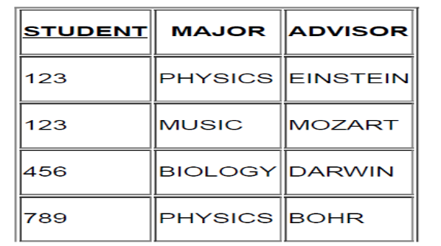
- If the record for student 456 is deleted we lose not only information on student 456 but also the fact that DARWIN advises in BIOLOGY
- we cannot record the fact that WATSON can advise on COMPUTING until we have a student majoring in COMPUTING to whom we can assign WATSON as an advisor.
In BCNF we have two tables:

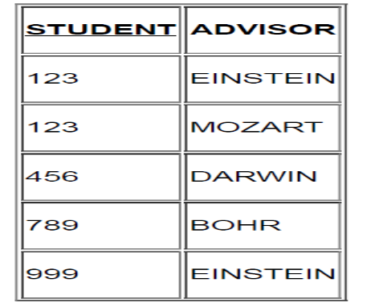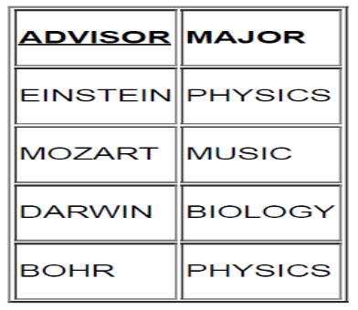

Normalisation Example
-Library
Consider the case of a simple video library. Each video has a title, director, and serial number. Customers have a name, address, and membership number. Assume only one copy of each video exists in the library. We are given:

video(title,director,serial)
customer(name,addr,memberno)
hire(memberno,serial,date)
title‐>director,serial
serial‐>title
serial‐>director
name,addr ‐> memberno
memberno ‐> name,addr
serial,date ‐> memberno
What normal form is this?

No repeating groups, so at least 1NF
2NF? There is a composite key in hire. Investigate further...
Can memberno in hire be found with just serial or just date.
NO. Therefore relation is in at least 2NF.
3NF? serial>director is a nonkey dependency. Therefore the relations are currently in 2NF.

Convert from 2NF to 3NF.
Rewrite
video(title,director,serial)
To
video(title,serial)
serial(serial,director)
Therefore the new relations become:
video(title,serial)
serial(serial,director)
customer(name,addr,memberno)
hire(memberno,serial,date)

In BCNF? Check if every determinant is a candidate key.
video(title,serial)
Determinants are:
title‐>director,serial Candidate key
serial‐>title Candidate key
video in BCNF
serial(serial,director)
Determinants are:
serial‐>director Candidate key
serial in BCNF
customer(name,addr,memberno)
Determinants are:
name,addr ‐> memberno Candidate key
memberno ‐> name,addr Candidate key
customer in BCNF
hire(memberno,serial,date)
Determinants are:
serial,date ‐> memberno
Candidate key hire in BCNF

Normalization exercises
Question 1:

The following relation schema can be used to register information on the repayments on
micro loans.
Repayment (borrower_id, name, address, loanamount, requestdate, repayment_date,
repayment_amount)
A borrower is identified with an unique borrower_id, and has only one address. Borrowers
can have multiple simultaneous loans, but they always have different request dates. The
borrower can make multiple repayments on the same day, but not more than one repayment
per loan per day.
a) State a key (candidate key) for Repayment.
b) Make the normalization to BCNF. Show the steps.

Answer a):
From the given information, we can derive the following set of functional dependencies;
Borrower_id → name [given: every borrower is identified with an unique id]
Borrower_id → address [given: each borrower has only one address]
Borrower_id, Requestdate → loanamount [given: more than one loan cannot be requested by a single borrower]
Borrower_id, requestdate, repayment_date → repayment_amount [given: a borrower can
make multiple repayments on a single day, but not on a single loan]
From the above set of FDs, it is evident that we can uniquely identify all the other attributes
of Repayment table, if we know the values of (borrower_id, requestdate, repayment_date).
That is,
Borrower_id, requestdate, repayment_date → name, address, loanamount, repayment_amount.
Hence, attributes (Borrower_id, requestdate, repayment_date) together forms a
candidate key.
Answer b):
Is the given relation Repayment is in 1NF?
Yes. It has a key. Hence, we can make unique identification of records.
Is the given relation is in 2NF?
No. We have the following partial key dependencies.
1. We can easily derive name and address of every borrower if we know the borrower_id
from the FDs Borrower_d → name, and Borrower_id → address.
2. We can derive the loanamount if we know borrower_id, and requestdate from the FD
Borrower_id, Requestdate → loanamount.
Hence, the relation Repayment is not in 2NF. To convert it into a 2NF relation, we can
decompose Repayment into the following relations;
Borrower (Borrower_id, Name, Address)
Borrower_loan (Borrower_id, Requestdate, Loanamount)
Repayment (Borrower_id, Requestdate, Repayment_date, Repayment_amount)
From the derived FDs, we know that all these tables are in 2NF.
Are these tables in 3NF?
Yes. There are no transitive dependencies present in the above tables’ set of functional
dependencies. Hence, we would say that all these tables are in 3NF.
Are these tables in BCNF?
Yes. There are no more than one candidate keys present in the above set of tables. Hence
the following decomposed tables are in Boyce‐Codd Normal Form.
Borrower (Borrower_id, Name, Address)
Borrower_loan (Borrower_id, Requestdate, Loanamount)
Repayment (Borrower_id, Requestdate, Repayment_date, Repayment_amount)
Question 2:
Let us assume a table User_Personal as given below;
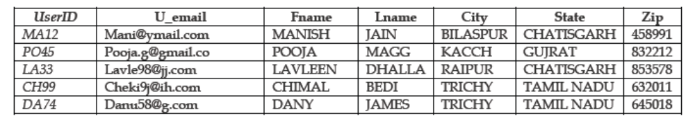

Is this table in First Normal Form?
Yes. All the attributes contain only atomic values.
Is this table in Second Normal Form?
To verify this property, we need to find all the functional dependencies which are holding in User_Personal table, and have to identify a Primary key.
Let us do that by using the sample data. This leads to the following set of FDs;
F = { UserID → U_email Fname Lname City State Zip,
Zip → City State,
City → Zip State }
As UserID attribute can uniquely determine all the other attributes, we can have UserID as the Primary key for
User_Personal table.

The next step is to check for the 2NF properties;
Property 1 – The table should be in 1NF.
Property 2 – There should not be any partial key dependencies.
Our table is in 1NF, hence property 1 is holding.

Primary key of our table is UserID and UserID is single simple attribute. As the key is not composite, there is
no chance for partial key dependency to hold. Hence property 2 is also holding.
User_Personal table is in 2NF.
Is User_Personal in 3NF?
To verify this we need to check the 3NF properties;
Property 1 – Table should be in 2NF.
Property 2 – There should not be any Transitive Dependencies in the table.
Table User_Personal is in 2NF, hence property 1 is satisfied.
User_Personal table holds the following Transitive dependency;
UserID → Zip, Zip → City State
Hence, property 2 is not satisfied and the table is not in 3NF.
Solution:
Decompose User_Personal. For this, we can use the functional dependencies
Zip → City State and UserID → U_email Fname Lname City State Zip.
As a result, we can have the following tables (primary keys are underlined);
User_Personal (UserID, U_email, Fname, Lname, Zip)
City (Zip, City, State)
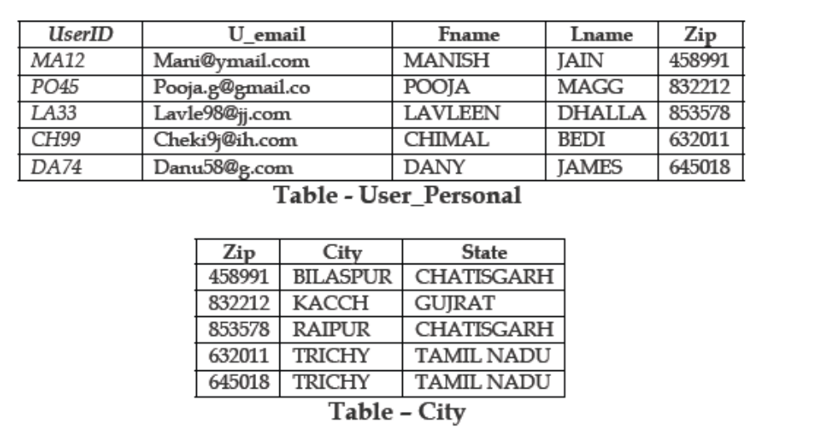
Both tables are in 3NF.
Hence, tables are normalized to Third Normal Form.

Exercise Set 3:
1. Consider the following relation schema R and set of Functional Dependencies F:
R(A,B,C,D,E), F = {AC → E, C → D, D → A}
One of the FDs contains an extraneous attribute that can be removed without changing the
dependencies implied by the above set. Explain which one.
Answer: Since the functional dependencies C → D and D → A imply C → A (transitive
dependency), the A in AC → E is extraneous. C alone can determine the other attributes.

2. For the following relation schema R and set of Functional Dependencies F:
R(A,B,C,D,E), F = {AC → E, B → D, E → A}
List all candidate keys.
Answer: From the given set F of functional dependencies, it is very evident that B and C
must be in the candidate key as they are not present in the Right Hand Side (RHS) of the
given set of FDs. Hence, at first we can check for BC as the candidate key as follows;
If you know B, then you know B and D through FD B → D. Along with this, if you know C, then you know BCD. That is, BC → BCD. B and C together cannot determine A and E, so BC cannot be a candidate key.
Then we can try with the attributes that are present in the LHS like B and C. First let us
take A. Then we have,
ABC → ABCDE. So, ABC is a candidate key.
Now we shall try with the other LHS attribute E. Then we have,
BCE → ABCDE. So, BCE is another candidate key.
Checking BCA and BCE, we see that both of them are candidate keys.

3. The relation schema given in question number 2 above is not in BCNF due to the reason
that it has two candidate keys. List one functional dependency that violates the rules for
BCNF.
Answer: E → A violates the rules. If we don‛t have a functional dependency like this, we have
only one candidate key, i.e, ABC.

Exercises set 4
1. Suppose that you are given a relation R = (A,B,C,D,E) with the following functional
dependencies: {CE → D,D → B,C → A}.
Find all candidate keys.
Answer: From the given set of functional dependencies, we can observe that only the
attributes C and E are present only on LHS. Hence, we can try with C and E attributes to
find candidate keys.
C alone cannot determine all the other attributes.
Hence, C → CA
E alone cannot determine all the other attributes.
Hence, E → E
C and E together can form a candidate key.
CE → ABCDE. Hence, CE is the only candidate key for the given relation R.

2. Suppose that you are given a relation R = (A,B,C,D,E) with the following functional
dependencies:
{BC → ADE, D → B}.
Find all candidate keys.
Answer: Let us start with LHS of given functional dependencies;
From D → B, D cannot uniquely determine the values of all the other attributes.
Hence, D alone cannot be a candidate key.
From BC → ADE, it is very clear that if you know values of B and C, you can
determine the values of attributes A, D, and E. Hence, BC → ABCDE is holding. So,
BC is one candidate key.
BC is one candidate key.
From D → B, if you know D then you know B. If you know C also, then you can determine all the other attributes. Hence, CD is another candidate key.
3. You are given the following set of functional dependencies for a relation R(A,B,C,D,E,F),
F = {AB → C, DC → AE, E → F}.
What are the keys of this relation?
Answer: From the given set of FDs F, it is very evident that we cannot have any one attribute as the key for R. Hence, we need to check with the different combination of attributes.
Let us try this example with the algorithm that is used for finding Attribute Closure.

Let us start with AB. Assume that the result is AB.
Result = AB;
From AB → C, (if you know A and B, then you would know C) Result = ABC.
We cannot move further. That is, AB can determine only A, B, and C. Hence, AB cannot be a
key.
Let us try with the other combination ABD.
Result = ABD;
From AB → C, Result = ABCD
From DC → AE, Result = ABCDE
From E → F, Result = ABCDEF.
At last, Result includes all the attributes of the relation R. Hence, ABD is one of the keys
for the relation R.
Let us try with the other combination BCD.
Result = BCD;
From DC → AE, Result = ABCDE
From E → F, Result = ABCDEF.
At last, Result includes all the attributes of the relation R. Hence, BCD is also one of the
keys for the relation R.

Exercise 6
Produce the Third Normal Form of this document by normalization.


A Sample Answer

0NF
ORDER(order#, customer#, name, address, orderdate(product#, description, quantity, unitprice))

1NF
ORDER(order#, customer#, name, address, orderdate)
ORDER_LINE(order#, product#, description, quantity, unitprice)

2NF
ORDER(order#, customer#, name, address, orderdate)
ORDER_LINE(order#, product#, quantity)
PRODUCT(product#, description, unitprice)

3NF
ORDER(order#, customer#, orderdate)
CUSTOMER(customer#, name, address)
ORDER_LINE(order#, product#, quantity)
PRODUCT(product#, description, unitprice)
Normalization solved exercise 7
Question 7:
Consider a relation R(A, B, C, D, E) with FD's AB → C, CD → E, C → A, C → D, D → B.
The possible candidate keys for R are AB, AD, C
(a) List all the functional dependencies that violate 3NF. If any, then decompose R accordingly.
(b) List all the FD's that violate BCNF. If any, then decompose R accordingly.
Solution (a):
To be in 3NF, the following points should not be violated by any of the FDs;
(i) R should be in 2NF;
According to the properties that are to be held for 2NF (No partial functional dependencies), all
the non-prime attributes (E is the only non-prime attribute in our case) depend on prime attributes (A, B, C, and D in our case) or keys as a whole. No partial dependencies found. Hence,
we would say that R is in 2NF.
(ii) Transitive functional dependencies of non-prime attributes on candidate keys are prohibited;
In the list of functional dependencies, we found no non-key dependencies. That is, no non-prime
attribute is functionally dependent on another non-prime attribute.
From points (i) and (ii), it is clear that there are no FDs that violate 3NF. Hence, we would say that R is in 3NF.
Solution (b):
R can be in BCNF if and only if R is in 3NF and every determinant is a candidate key.
From the solution (a), you would understand that R is in 3NF. But every determinant is not a candidate key. In the given set of FDs, D → B is the only functional dependency that violates this rule. That is, D is not a candidate key on its own. Hence, the relation R is not in BCNF.
To convert R into a BCNF relation, we need to decompose R using the FD D → B. Then we shall get the following relations R1 and R2;
R1 (D, B) and R2 (A, C, D, E)
Normalization solved exercise 8
Question:
Consider a relation R(A, B, C) with FD's AB → C, AC → B, BC → A.
Determine all the keys of relation R. Is the relation R in BCNF?
Solution:
From AB → C, we obtain that AB is one of the keys.
From AC → B, we obtain that AC is one of the keys.
From BC → A, we obtain that BC is one of the keys.
Every single FD given above, includes all the attributes of R. Hence, all the left hand side attributes form the key. And the keys are AB, AC, and BC.
Is R in BCNF?
Requirements: R should be in 2NF, 3NF, and every determinant must be a candidate key.
From the set of functional dependencies given, we observe the following;
No partial key dependencies. So, R is in 2NF.
No transitive dependencies. So, R is in 3NF.
Every determinant (AB, BC, AC) is a candidate key. Hence, R is in BCNF as well.
Normalization solved exercise 9
Question:
Consider a relation R(A, B, C, D) with FD's AB → C, AC → B, BC → A, B → D.
Determine all the keys of relation R. Is the relation R in BCNF?
Solution:
We can derive the values of C and D uniquely from the FDs AB → C, and B → D. And the closure of AB,
i.e., (AB)+ = ABCD. Hence, AB is one of the keys.
We can derive the values of B and D uniquely from the FDs AC → B, and B → D (Transitive FDs). (AC)+ = ABCD. Hence, AC is one of the keys.
We can derive the values of A and D uniquely from the FDs BC → A, and B → D. and the closure (BC)+ = ABCD. Hence, BC is one of the keys.
The keys are AB, AC, and BC.
Is R in BCNF?
Requirements: R should be in 2NF, 3NF, and every determinant must be a candidate key.
Partial key dependency is present – In the functional dependency B → D, the determinant B is not a key. But it is a part of the candidate keys AB and BC. If part of any candidate keys can uniquely identify another (or set of) non-key attribute, we call that as partial key dependency.
Hence, R is not in 2NF. We need to decompose R into the following relations so that we can make 2NF relations out of R;
R1(A, B, C) and R2(B, D).
R1 and R2 do not have partial key dependencies, and transitive dependencies. Hence, both are in 2NF and 3NF.
The determinants are the keys in both the relations. Hence, R1 and R2 are in BCNF.
Normalization solved exercise 10
Question:
Consider a relation R(A, B, C, D, E) with FDs AB → C, AC → B, BC → A, D → E.
Determine all the keys of relation R. Is the relation R in BCNF?
Solution:
The closure of AB, or AC, or BC is ABC. The attributes D and E are left alone. To include them we need to include the determinant D of D → E with other FDs determinants to form candidate keys as follows;
The closure of ABD, i.e., (ABD)+ = ABCDE. [Derived from AB → C and D → E]. This shows that ABD is one of the keys.
The closure of ACD, i.e., (ACD)+ = ABCDE. [Derived from AC → B and D → E]. This shows that ACD is one of the keys.
The closure of BCD, i.e., (BCD)+ = ABCDE. [Derived from BC → A and D → E]. This shows that BCD is one of the keys.
The candidate keys are ABD, ACD, and BCD.

Normalization
The relation R is in 1NF.
R is not in 2NF. Why?
2NF says “no partial functional dependencies”. In other words, all the non-key (nonprime)
attributes must fully functionally dependent on the key or whole key.
This is violated here. For example, if we say ABD as the key (because ABD determines
all the attributes of R uniquely), D determines the value of E which is a non-key
attribute. This means, D alone would be enough to uniquely determine E. This is called
as partial functional dependencies (or partial key dependency).
This happens with other candidate keys also.
The solution is to decompose R into two or more relations.
How to decompose into 2NF?
Follow these steps;
1. Create a separate relation for each partial dependency.
2. Remove the right hand side (RHS) attributes of partial dependency from the relation that is to be decomposed.
Apply these steps on R(A, B, C, D, E).
1. Create separate relation for partial dependency D → E. We will get R1 (D, E).
2. Remove RHS of D → E from R. We will get R2 (A, B, C, D).
As a result, we get R1 (D, E) and R2 (A, B, C, D).
R1 is in 2NF? Yes. R1 is in 2NF, 3NF, and BCNF. [Only one key and one non-key attributes]
R2 is in 2NF? The relation R2 (A, B, C, D) holds set of functional dependencies
AB → C, AC → B, BC→ A and an attribute D (We would write this as D → D, a trivial FD).
Key for R2 would be ABD, or ACD, or BCD. (It is because the closure of these attributes is ABCD).
And, R2 is in 2NF (no partial key dependency), in 3NF (no transitive dependency), and in BCNF (all determinants are keys).
Final BCNF relations are; R1 (D, E) and R2 (A, B, C, D).

Normalization Solved Exercise Set 11
Question:
Consider a relation R(A, B, C, D, E) with FD's AB → C, CD → E, C → A, C → D, D → B.
Determine all the keys of relation R. Do not list superkeys that are not a candidate key.
Solution:
Key 1:
From AB → C and C → D, we obtained AB → D. (as per Transitivity rule)
From AB → C and AB → D, we obtained AB → CD. (as per Union rule)
From AB → CD and CD → E, we obtained AB → E. (as per Transitivity rule)
From above points, we would know that the attributes AB together can identify all the other attributes of R uniquely. Hence, AB is one of the keys.
Key 2:
From C → A and C → B, we obtained C → AB. (as per Union rule)
From AB, we can obtain the rest of the attributes. (See the discussion in Key 1 above). Hence, C is one of the keys.
Key 3:
From D → B, we can get AD → AB. (as per Augmentation rule)
From AB, we can obtain the rest of the attributes. (See the discussion in Key 1 above). Hence AD is one of the keys.
The keys are AB, AD, and C.
Normalization solved exercise to find key 12
Question 12:
Consider a relation R (A, B, C, D) with FD's B → C, D → A. Determine all the keys of relation R.
Solution:
To find the key of a relation, we need to find the closure of attributes. If any attribute‛s or set of
attributes‛ closure gives all the attributes of the relation, then we would say that attribute/set of
attributes as the key for that relation.
To simplify this task or to avoid finding closure of all attributes, let us do find the closure for left hand side (LHS) attributes of the functional dependencies.
For the given question, attributes B and D are the LHS attributes.
The closure of B, (B)+ = BC from ≠ ABCD. Hence B is not a key.
The closure of D, (D)+ = DA ≠ ABCD. Hence D is not a key.
The closure of B and D together, i.e., (BD)+ = ABCD. All the attributes can be determined.
Hence, BD is a key (a composite key).
The key for R is (BD).

Class Exercise 13
Normalize User Views and Create a Final 3NF solution
Good News Grocers
User View 1 - Price Update List
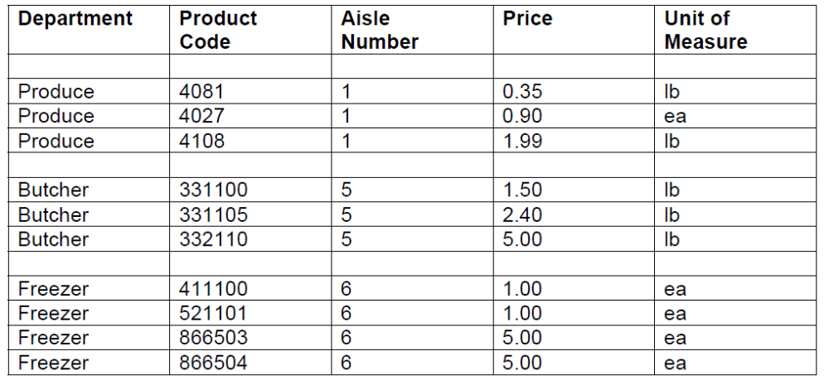
This report is used by the department managers to update the prices that are
displayed in the grocery store for these products.
UNF:
dept [dept, aisle_no (prod_code, , price, um) ]
1NF:
dept [dept_id, dept_name, aisle_no]
dept_product [dept, prod_code, price, um ]
2NF:
dept [dept_id, dept_name, aisle_no ]
product [prod_code, price, um, dept_id (FK) ]
3NF:
Note: 1. examing the relationship between department and product, we discover that
it is a 1:M, therefore we do not need the composite table, dept_product. So it is
eliminated and the foreign key placed in the product table.
2. it may be debatable whether department actually determines aisle number.
This may be true in a small grocery store but in a large grocery store, products
from a department may be found in multiple aisles. This should be discussed
with your database client to determine their exact needs.

Class Exercise
Normalize User Views and Create a Final 3NF solution

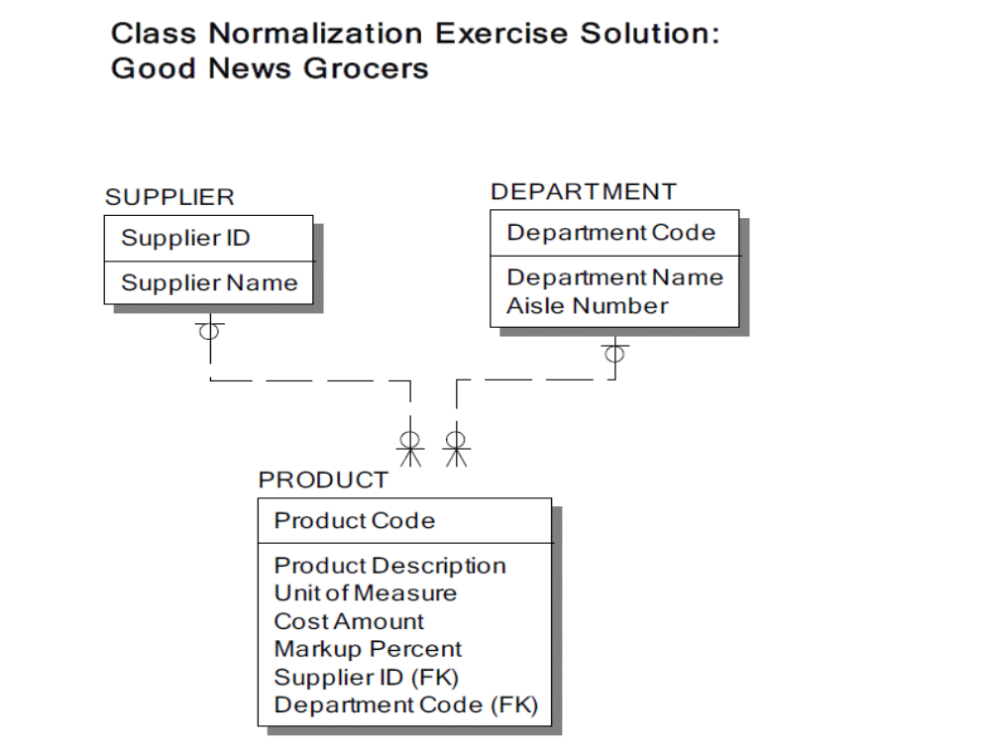

Class Exercise 14
Normalize User Views and Create a Final 3NF solution
Good News Grocers
User View 2: Product Cost Report
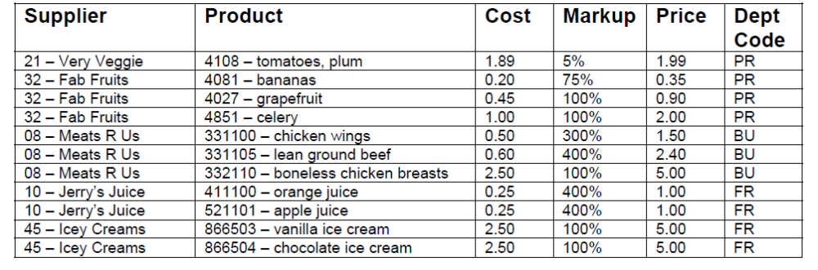This report is used by the grocery store manager to determine the final selling price of his products.
UNF:
supplier [supplier_id, supplier_name, (prod_code, prod_desc, cost, markup, dept_cd ) ]
1NF:
supplier [supplier_id, supplier_name]
supplier_product [supplier_id, prod_code, prod_desc, cost, markup, dept_cd ]
2NF:
supplier [supplier_id, supplier_name]
supplier_product [supplier_id, prod_code]
product [prod_code, prod_desc, cost, markup, dept_cd ]

note: if we were getting a product from more than 1 supplier, then the cost attribute would go into the supplier_product table.
3NF:
supplier [supplier_id, supplier_name]
product [prod_code, prod_desc, cost, markup, dept_cd, supplier_id (FK) ]
note: examing the relationship between supplier and product, we discover that it is a 1:M, therefore we do not need the composite table, supplier_product. So it is eliminated and the foreign key placed in the product table.

Class Exercise 15
Normalize User Views and Create a Final 3NF solution

View 1 solution:
3NF:
dept [dept_id, dept_name, aisle_no ]
product [prod_code, price, um, dept_id (FK) ]

View 2 Solution:
3NF:
supplier [supplier_id, supplier_name]
product [prod_code, prod_desc, cost, markup, dept_cd, supplier_id (FK) ]

Merged 3NF solution:
product [ prod_code, prod_desc, um, dept_cd (FK), supplier_id (FK), cost, markup ]
dept [ dept_cd, dept_name, aisle_no ]
supplier [ supplier_id, supplier_name ]

NOTE: although we took two different approaches to this question, we end up
with the same 3NF solution!

Normalize the table into 3NF
Normalization Exercise 16
Consider the relation PLAYER with relational schema PLAYER (Playerno, Playername, Team, Teamcolor, Coachno, Coachname,
Playerposition, Teamcaptain) and set of functional dependencies as follows;
F = {Playerno → Playername, Playerno → Playerposition, Playerno → Team, Coachno → Coachname, Team → Teamcolor, Team → Coachno, Team → Teamcaptain}
Answer the questions given below;
a) Is PLAYER in 2NF? If not, convert into 2NF.
b) Is PLAYER in 3NF? If not, convert into 3NF.
a) Is PLAYER in 2NF?
To answer this question, we need to find the key for PLAYER.
Let us find the closure for all the left hand side attributes of all the FDs of F.
(Playerno)+ = Playerno, Playername, Playerposition, Team, Teamcolor, Coachno, Teamcaptain, Coachname.
(Team)+ = Team, Teamcolor, Teamcaptain, Coachno, Coachname
(Coachno)+ = Coachno, Coachname
When we find closure, only Playerno can uniquely determine all the attributes of PLAYER. Hence,
Playerno is the only candidate key.
Question to think:
(Team, Playerno)+ = Playerno, Playername, Playerposition, Team, Teamcolor, Coachno, Teamcaptain, Coachname.
(Team, Playerno) combination, as given above can uniquely determine all the attributes of PLAYER. Hence, (Team, Playerno) can be a candidatekey?
NO.
Reason The proper subset of (Team, Playerno) is already a candidate key (Playerno).
As the key (Playerno) is single and simple attribute, there is no possibilities for partialkey dependencies. Hence, PLAYER is in 2NF.

b) Is PLAYER is in 3NF?
To answer this question, we need to check for nonkey dependencies or transitive dependencies. That is, we have to look for dependencies like the one follows;
Nonkey attribute(s) → Nonkey attribute(s)
From the given set of functional dependencies F, we could derive the following nonkey dependencies;
Team → Team, Teamcolor, Teamcaptain, Coachno, Coachname
Coachno→ Coachno, Coachname
Hence, PLAYER is not in 3NF.

Solution:
Decompose PLAYER into more tables based on the nonkey dependencies. Then we shall get the tables as follows;
PLAYER (Playerno, Playername, Playerposition, Team)
TEAM (Team, Teamcolor, Teamcaptain, Coachno, Coachname)

The key for PLAYER is Playerno, and all the others are nonkey attributes. Hence, PLAYER is in 2NF (no partial dependencies) and 3NF (no transitive dependencies).
The key for TEAM is Team. All the other attributes are nonkey attributes and depends on Teamno.
Hence, TEAM is in 2NF. TEAM has following transitive dependency;

Team → Coachno → Coachname.
Hence, TEAM is not in 3NF. To convert, decompose TEAM as follows;
TEAM (Team, Teamcolor, Teamcaptain, Coachno)
COACH (Coachno, Coachname)
Now, TEAM and COACH are both in 2NF and 3NF.

Final set of decomposed tables that are in 3NF are;
PLAYER (Playerno, Playername, Playerposition, Team)
TEAM (Team, Teamcolor, Teamcaptain, Coachno)
COACH (Coachno, Coachname)

