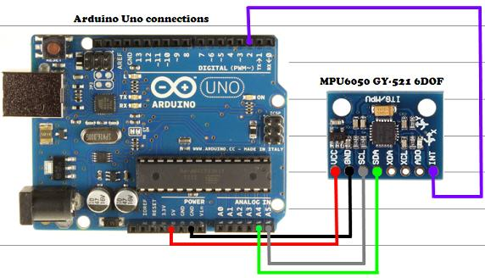

Cost:

Motors + ESC:

21.49*4

Arduino Uno

MPU6050

Turnigy 2200mAh 3S: 21.45

Frame: Hobby Kinf F330

Eclipse project copy:

Copy: .cproject, .project .settings (must, otherwise AVR includes don’t work properly)

Make sure the correct configuration is selected

Close Eclipse and Reopen

Wait for full command packet

57600 baudrate may be not enough with xbee communication

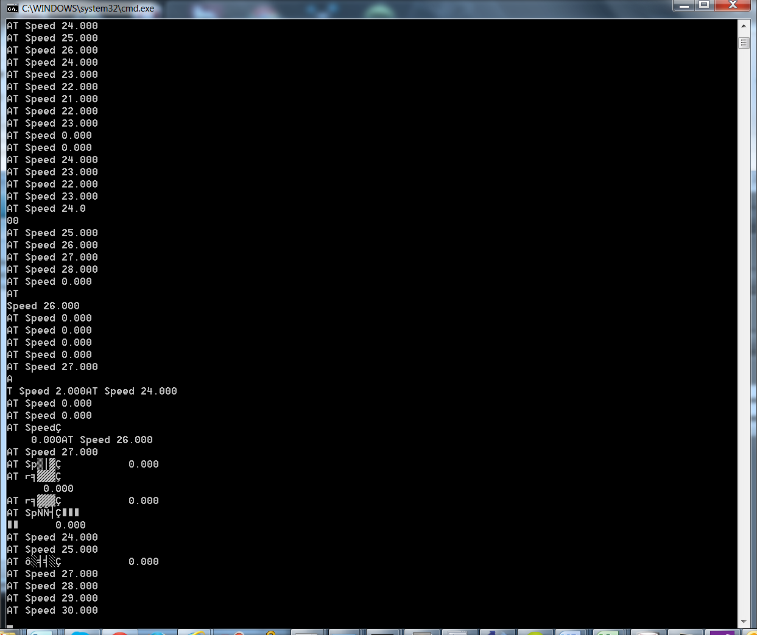

Software serial doesn’t work with 115200 baudrate

Hold reset button on the xbee to upload code while using hardware serial

Connecting arduino power jack to turnigy. Draws about 120 mA

On Arduino Mega, driving both the Xbee and the MPU6050 from the same 3.3 supply line leads to corrupt data from the MPU. This could be because of high current drawn by the Xbee radio. Solution: Use separate 5v->3.3v line for the MPU6050

Move to arduino mega as Iwas close to running out of program space on the Arduino Uno

Fixed deployment issues, replaced old avrdude.conf in winavr folder, fixed include paths for mega and recompiled libs Fixed timing issue with receiving commands. Must wait for all command characters to be received otherwise flush the serial port Added derivative to the pid controller, fixed a bug in the proportional part Added ability to change set point and smoothly transition to the new set point Reorganized the user interface by adding per axis pid controllers Experimented with using serial port1/2

1/7/2015

Added ArrowPad for changing setpoint

Pitch/Roll setpoints can be configured independently

Changed commands mechanism to resend a command until a repeat count is reached if an acknowledgement is not received. This ensures that the state of the quadcopter (PID parameters, speed, setpoints are set up properly) is consistent on startup

1/29/2015

Talk about write/writemicroseconds, servo refresh frequency (default 50hz)

**#define** REFRESH_INTERVAL 5000 // minumim time to refresh servos in microseconds

**#define** SERVOS_PER_TIMER 1

2/23/2015

Quadcopter starts sending partially incorrect data after about 30 min. Could be some variable overflow.. reseting doesn’t solve the issue, power to the board needs to be cut off.

3/16/2015

Partially incorrect data issue resolved by doing onboard sensor fusion

Note that we must use scaled angular velocities and accelerations for PID loop After the scale adjustment is applied, the resulting values are in physical units (degrees/sec etc)and independent of gyro settings such as gyro/accel range etc. If unscaled values are used, the magnitude of the unscaled values will be different and PID coefficients set for a certain scale will likely not work.

Calculating the offsets for the gyro is very important. Make sure to wait for a time duration > sampling interval before collecting next data sample for calculating offsets

$ git commit -m 'Added IMU offset calculation routine. Offset calculation is very important to ensure that gyro/accel v

alues don't drift over time. Added a textfied in the controller app to show any exceptions received and emit a beep sou

nd when an exception is received. Using scaled angular velocities/accelerations as input to the PID loop. This insures

that meaurements used in the PID are in physical units, independent of IMU init params such as gyro/accel range.'

"C:\github\stingray-public-platforms\windows_engine_vs2012.sln" (Build target) (1) ->  
"C:\github\stingray-public-platforms\plugins\scaleformstudio_plugin\scaleformstudio_plugin\scaleformstudio_plugi  
n_windows_vs2012.vcxproj" (default target) (14) ->  
(ClCompile target) ->  
  s2d_log.cpp(1): fatal error C1083: Cannot open include file: 's2d_log.h': No such file or directory [C:\github  
\stingray-public-platforms\plugins\scaleformstudio_plugin\scaleformstudio_plugin\scaleformstudio_plugin_windows_  
vs2012.vcxproj]  
  if_s2d.cpp(1): fatal error C1083: Cannot open include file: 'if_S2D.h': No such file or directory [C:\github\s  
tingray-public-platforms\plugins\scaleformstudio_plugin\scaleformstudio_plugin\scaleformstudio_plugin_windows_vs  
2012.vcxproj]  
  s2d_plugin.cpp(1): fatal error C1083: Cannot open include file: 's2d_plugin.h': No such file or directory [C:\  
github\stingray-public-platforms\plugins\scaleformstudio_plugin\scaleformstudio_plugin\scaleformstudio_plugin_wi  
ndows_vs2012.vcxproj]  
  c:\github\stingray-public-platforms\plugins\scaleformstudio_plugin\scaleformstudio_plugin\s2d_system.h(10): fa  
tal error C1083: Cannot open include file: 'plugin_foundation/exception_handling.h': No such file or directory (  
s2d_messages.cpp) [C:\github\stingray-public-platforms\plugins\scaleformstudio_plugin\scaleformstudio_plugin\sca  
leformstudio_plugin_windows_vs2012.vcxproj]  
  c:\github\stingray-public-platforms\plugins\scaleformstudio_plugin\scaleformstudio_plugin\s2d_system.h(10): fa  
tal error C1083: Cannot open include file: 'plugin_foundation/exception_handling.h': No such file or directory (  
s2d_system.cpp) [C:\github\stingray-public-platforms\plugins\scaleformstudio_plugin\scaleformstudio_plugin\scale  
formstudio_plugin_windows_vs2012.vcxproj]

* Don’t reset while motors are powered on, escs will get random input leading to disaster
* Xbee must only be powered by the regulated power supply on the arduino, otherwise unpredictable behavior