**Java Installation Tutorial Mac OSX**

This is a step by step tutorial for installing Java and Text IDE and Eclipse IDE on your system. It includes details for Mac OS X.

First check if your PC/Laptop satisfies the system requirements for Java 7.0, 8.0

Go to this link <http://java.com/en/download/help/sysreq.xml>

Important: Please create Oracle website account before beginning the tutorial.

https://login.oracle.com/mysso/signon.jsp

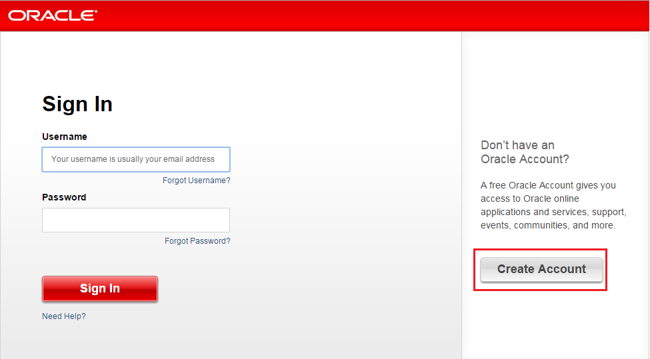

You also will need the following software’s/tools:

* Linux/Windows/Mac OS X operating system.
* Java JDK
* JRE
* Microsoft Notepad or any other text editor or IDE like Eclipse/Netbeans

Installing the Java Development Kit (JDK) – Mac OS X

When you download the Java Development Kit (JDK), the associated Java Runtime Environment (JRE) is installed at the same time. The JavaFX SDK and Runtime are also installed and integrated into the standard JDK directory structure.

Depending on your processor, the downloaded file has one of the following names:

http://www.oracle.com/technetwork/java/javase/downloads/jdk8-downloads-2133151.html

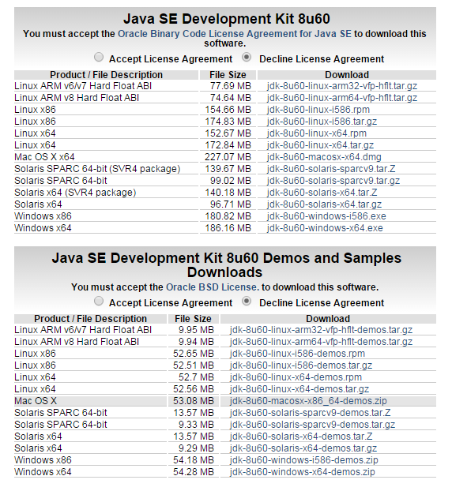

* jdk-7u<version>-macosx-amd64.dmg
* jdk-7u<version>-macosx-x64.dmg

Where **<version>** is 6 or later.

1. Download the file. Before the file can be downloaded, you must accept the license agreement.

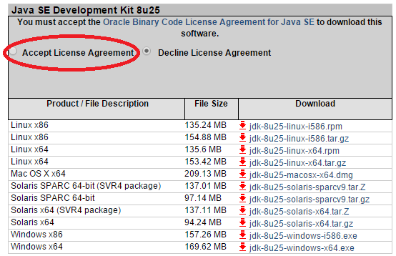

2. From either the Downloads window of the browser, or from the file browser, double click the .dmg file to launch it.

3. A Finder window appears containing an icon of an open box and the name of the .pkg file Double click the package icon to launch the **Install** app.

4. The Install app displays the **Introduction** window. Click **Continue**.

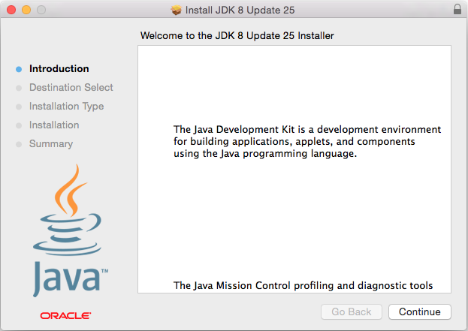

4a. Note that, in some cases, a **Destination Select** window appears. This is a bug, as there is only one option available. If you see this window, select **Install for all users of this computer** to enable the continue button. Click **Continue**.

5. The **Installation Type** window appears. Click **Install**.

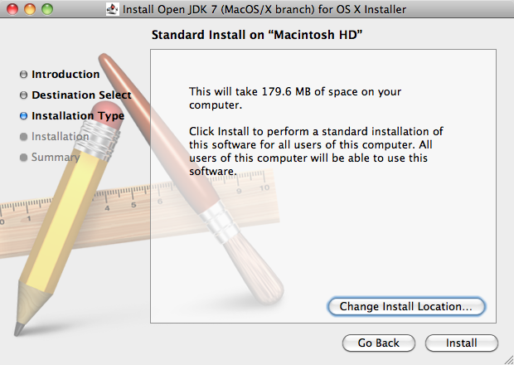

6. A window appears which says "Installer is trying to install new software. Type your password to allow this." Enter the Administrator login and password and click **Install Software**.

7. The software is installed and a confirmation window appears. Click the [ReadMe](http://www.oracle.com/technetwork/java/javase/downloads/jdk-for-mac-readme-1564562.html) for more information about the installation.

After the software is installed, delete the dmg file if you want to save disk space.

## Determining the Default Version of the JDK

A: If you have not yet installed Apple's Java Mac OS X 2012-006 update, then you are still using a version of Apple Java 6 that includes the plug-in and the Java Preferences app. See [Note for Users of Macs that Include Apple Java 6 Plug-in](http://docs.oracle.com/javase/7/docs/webnotes/install/mac/mac-preferences.html).

There can be multiple JDKs installed on a system – as many as you wish.

When launching a Java application through the command line, the system uses the default JDK. It is possible for the version of the JRE to be different than the version of the JDK.

You can determine which version of the JDK is the default by typing java -version in a **Terminal** window. If the installed version is 7u6, you will see a string that includes the text 1.7.0_06. For example:

% java -version

java version "1.7.0_06-ea"

Java(TM) SE Runtime Environment (build 1.7.0_06-ea-b13)

Java HotSpot(TM) 64-Bit Server VM (build 23.2-b04, mixed mode)

To run a different version of Java, either specify the full path, or use the java_home tool:

/usr/libexec/java_home -v 1.7.0_06 --exec javac -version

For more information, see the java_home(1) man page.

## Uninstalling the JDK

To uninstall the JDK, you must have Administrator privileges and execute the remove command either as root or by using the sudo(8) tool.

Navigate to /Library/Java/JavaVirtualMachines and remove the directory whose name matches the following format:*

Installing the Java Runtime Environment (JRE) Mac OS X

Depending on your processor, the downloaded file has one of the following names, where version is the update number:

http://www.oracle.com/technetwork/java/javase/downloads/jre8-downloads-2133155.html

* jre-8uversion-macosx-amd64.dmg
* jre-8uversion-macosx-x64.dmg

## 

## Installing JRE Version Prior to 8u40 or 8u45 and Later

If you are installing a version of the JRE prior to 8u40, or 8u45 and later, then follow these steps:

1. Download the file.

Before the file can be downloaded, you must accept the license agreement.

1. From either the Downloads window of the browser, or from the file browser, double click the file .dmg to launch it.

A Finder window appears containing an icon of an open box and the name of the .pkg file.

1. Double click the package icon to launch the Install app.

The Install app displays the Introduction window.

1. Click **Continue**.

The Installation Type window appears.

1. Click **Install**.

A window appears that says "Installer is trying to install new software. Type your password to allow this."

1. Enter the Administrator login and password and click **Install Software**.

The software is installed and a confirmation window appears.

1. After the software is installed, delete the .dmg file if you want to save disk space.

## Installing JRE 8u40

If you are installing JRE 8u40, then follow these steps:

1. Download the file.

Before the file can be downloaded, you must accept the license agreement.

1. From either the Downloads window of the browser, or from the file browser, double click the file .dmg to launch it.

A Finder window appears containing an icon of an open box and the name of the .app file.

1. Double click the package icon to launch the Install app.

A window appears that says, "Java 8 Update 40 is trying to install a new helper tool. Type your password to allow this."

Enter the Administrator login name and password and then click **Install Helper**.

The Install app then displays the Introduction window.

1. Click **Next**.

Oracle has partnered with companies that offer various products. The installer may present you with the option to install these programs when you install Java. Specify if you want these programs installed and then click **Next**.

An Installation Progress window is displayed. Once the software is installed, a confirmation window appears and then an applet is launched to verify the version of Java installed.

1. Delete the .dmg file if you want to save disk space.

## Determining the Installed Version of the JRE

If you have not yet installed Apple's Java OS X 2012-006 update, then you are still using a version of Apple Java 6 that includes the plug-in and the Java Preferences app. See ["Note for Users of OS X that Include Apple Java 6 Plug-in"](https://docs.oracle.com/javase/8/docs/technotes/guides/install/mac_preferences.html" \l "BABHEJEC).

Only one JRE can be installed. Installing a JRE removes the previously installed JRE. The JRE version used by the system can be determined in one of two ways:

* From System Preferences click the Java icon from the **Other** category. This launches the Java Control Panel. **Click About**.
* Type the following in a Terminal window (note escaped space character, ignore line break):
* % /Library/Internet\ Plug-Ins/JavaAppletPlugin.plugin/Contents/Home/bin/java -version

The system will not install a JRE that has a lower version than the current version. If you want to install a lower version, first uninstall the existing version.

## Uninstalling the JRE

To uninstall the JRE, you must have Administrator privileges and execute the remove commands either as root or by using the sudo(8) tool.

Remove one directory and one file (a symlink), as follows:

* Navigate to /Library/Internet Plug-Ins and remove the JavaAppletPlugin.plugin directory.
* Navigate to /Library/PreferencePanes and remove JavaControlPanel.prefpane.

Do not attempt to uninstall Java by removing the Java tools from /usr/bin. This directory is part of the system software and any changes will be reset by Apple the next time you perform an update of the OS.

Setting up Java Environment Variables Mac OSX

## 1. Mac OSX 10.5 or later

In Mac OSX 10.5 or later, Apple recommends to set the $JAVA_HOME variable to /usr/libexec/java_home, just export$JAVA_HOME in file ~/. bash_profile or ~/.profile.

$ vim .bash_profile

export JAVA_HOME=$(/usr/libexec/java_home)

$ source .bash_profile

$ echo $JAVA_HOME

/Library/Java/JavaVirtualMachines/1.7.0.jdk/Contents/Home

## 2. Older Mac OSX

For older Mac OSX, the /usr/libexec/java_home doesn’t exists, so, you should set JAVA_HOME to the fixed path :

$ vim .bash_profile

export JAVA_HOME=/System/Library/Java/JavaVirtualMachines/1.6.0.jdk/Contents/Home

$ source .bash_profile

$ echo $JAVA_HOME

/System/Library/Java/JavaVirtualMachines/1.6.0.jdk/Contents/Home

Installing text based IDE Mac OSX

There is no shortage of options for text editors geared towards developers on the Mac, but TextMate is one of the best. It wins out thanks to its massive programming language syntax support, helpful code snippets, expandability, and integration with the OS X terminal.

You can download TextMate from

http://macromates.com/

Installing the Eclipse Mac OSX

**Step 1**

Go to <http://www.eclipse.org/downloads/> to download a copy of eclipse. The page will look like this:

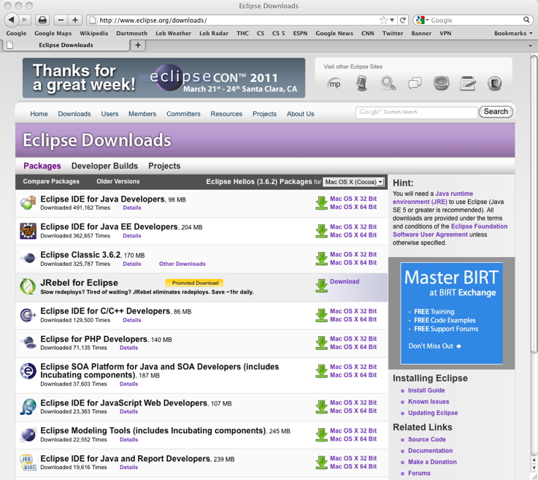

The first item listed is "Eclipse IDE for Java Developers (98 MB)." On the right is a green, downward-pointing arrow. Next to that are links labeled "Mac OS X 32 Bit" and "Mac OS X 64 Bit." Click on the "Mac OS X 32 Bit" link. (Even if you have nice, new 64-bit Mac, it should run the 32-bit version just fine.)

**Step 2**

You will see a window like this:

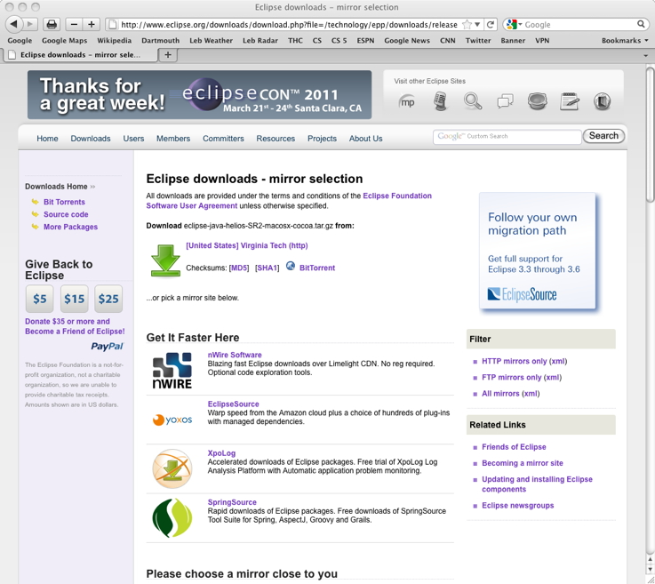

(The location next to the green, downward-pointing arrow might not be Virginia Tech, but that's OK. And the "Get It Faster Here" locations might be different, but that doesn't matter, either.) Click on the green, downward pointing arrow. A download of eclipse-java-helios-SR2-macosx-cocoa.tar.gz will start. If you first get a window like this

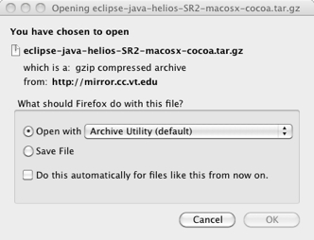

just click "OK" so that the downloaded file opens with Archive Utility.

**Step 3**

The download will go to your Downloads folder. You will normally have an icon for the Downloads folder on the right-hand side of the dock. Find **eclipse-java-helios-SR2-macosx-cocoa.tar.gz** in your Downloads folder, and drag it to the Desktop. Then double-click it. You will see a folder named "eclipse."

**Step 4**

Drag the "**eclipse**" folder into your Applications folder. The easiest way to do so is to open a new window in the Finder and click on Applications in the list you get on the left-hand side. Then drag the "eclipse" folder in with the other applications. Make sure that you do not drag it into a folder that's already within Applications. In other words, when you're done, the Applications folder should have directly within it a folder named "eclipse."

**Step 5**

(This step is not required, but it's strongly recommended.) Double click the "eclipse" folder. You'll see an application named "**Eclipse**"; it has a purple icon with white horizontal stripes. Drag it into your dock. Now you will be able to launch Eclipse by clicking on the icon in the dock.

**Step 6**

You may now drag **eclipse-java-helios-SR2-macosx-cocoa.tar.gz** to the Trash. Empty the Trash whenever you wish.

**Step 7**

When you launch Eclipse for the first time, you'll be asked "**'Eclipse'** is an application downloaded from the Internet. Are you sure you want to open it?" Click "**Open**."

**Step 8**

You'll see something like the following window:

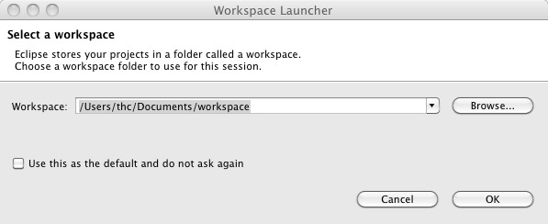

Of course, the workspace name will have your user name in place of "thc." You can choose whatever place you want for your workspace, but it's easiest to just use the default you're given. I recommend that you just click the checkbox next to "Use this as the default and do not ask again" and then click "OK."

**Step 9**

You'll then see the following screen:

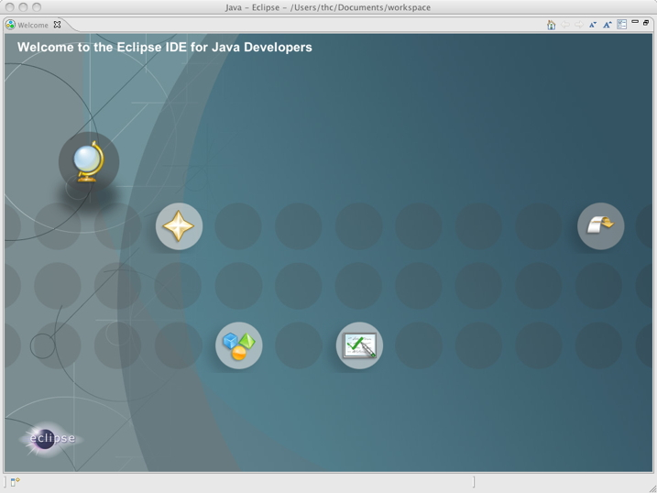

Click on the folded-over arrow on the right. You won't see this screen again, even if you quit Eclipse and relaunch it.

**Step 10**

Now you'll see the following screen:

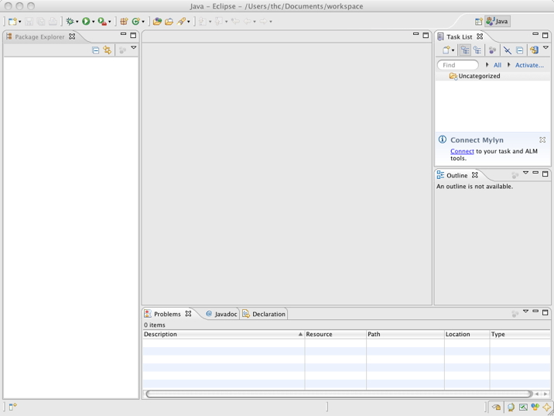

Lots of buttons and panes, but nothing of consequence. You have now installed Eclipse!

Other Java IDE for Mac OSX

Java development on any platform often benefits from the use of an Integrated Development Environment (IDE), which provides a more fluid workflow between writing, compiling, running, debugging, and packaging Java code than a simple text editor and the command line. Different IDEs offer unique features and are often suited for different kinds of Java development. These IDEs are industry leaders and offer substantial support for OS X:

* Netbeans IDE ([http://www.netbeans.org](http://www.netbeans.org/)) is a free download.
* Jetbrains IntelliJ IDEA (<http://www.jetbrains.com/idea/>) requires a license for continued use after a trial period.
* Xcode (<http://developer.apple.com/tools/xcode/>) is a free download with a free account from the Apple Developer Connection.

If you are developing a JNI library or intend to have your application communicate with Cocoa, you should plan to use the Xcode Tools for those portions of your development. For more information on JNI development, see [JNI](https://developer.apple.com/library/mac/documentation/Java/Conceptual/Java14Development/05-CoreJavaAPIs/CoreJavaAPIs.html#//apple_ref/doc/uid/TP40001902-210780).