**Java Installation Tutorial Windows**

This is a step by step tutorial for installing Java and TextPad/Notepad/ Eclipse IDE on your system. It includes details for Windows OS.

First check if your PC/Laptop satisfies the system requirements for Java 7.0, 8.0

Go to this link <http://java.com/en/download/help/sysreq.xml>

Important: Please create Oracle website account before beginning the tutorial.

https://login.oracle.com/mysso/signon.jsp

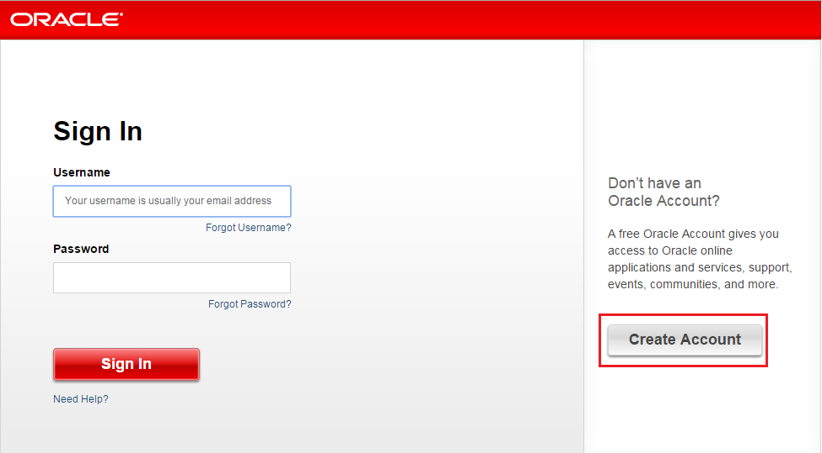

You also will need the following software’s/tools:

* Linux/Windows/Mac OS X operating system.
* Java JDK
* JRE
* Microsoft Notepad or any other text editor or IDE like Eclipse/Netbeans

Installing the Java Development Kit (JDK) – Windows OS

For Windows systems, the JDK may be obtained from Oracle Corporation’s website using the following URL:

<http://www.oracle.com/technetwork/java/javase/downloads/index.html>

Assuming that a suitable JDK is not already installed on your system, download the latest JDK package that matches the destination computer system. Once downloaded, launch the installation executable and follow the on screen instructions to complete the installation process.

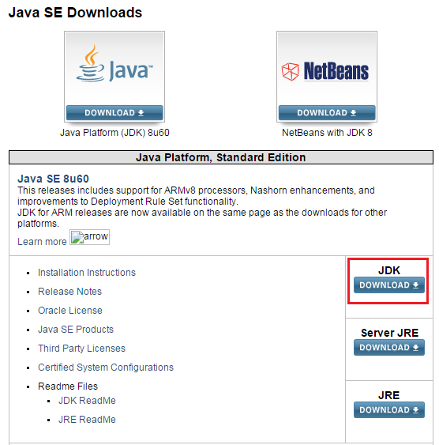

### Running the JDK Installer

You must have administrative permissions in order to install the JDK on Microsoft Windows.

The file jdk-8version-windows-i586-i.exe is the JDK installer for 32-bit systems. The file jdk-8version-windows-x64.exe is the JDK installer for 64-bit systems. If you downloaded either file instead of running it directly from the web site, double-click the installer's icon. Then, follow the instructions the installer provides. When finished with the installation, you can delete the downloaded file to recover disk space.

To check your OS version right click on “**MyComputer**” and then select “**Properties**”.

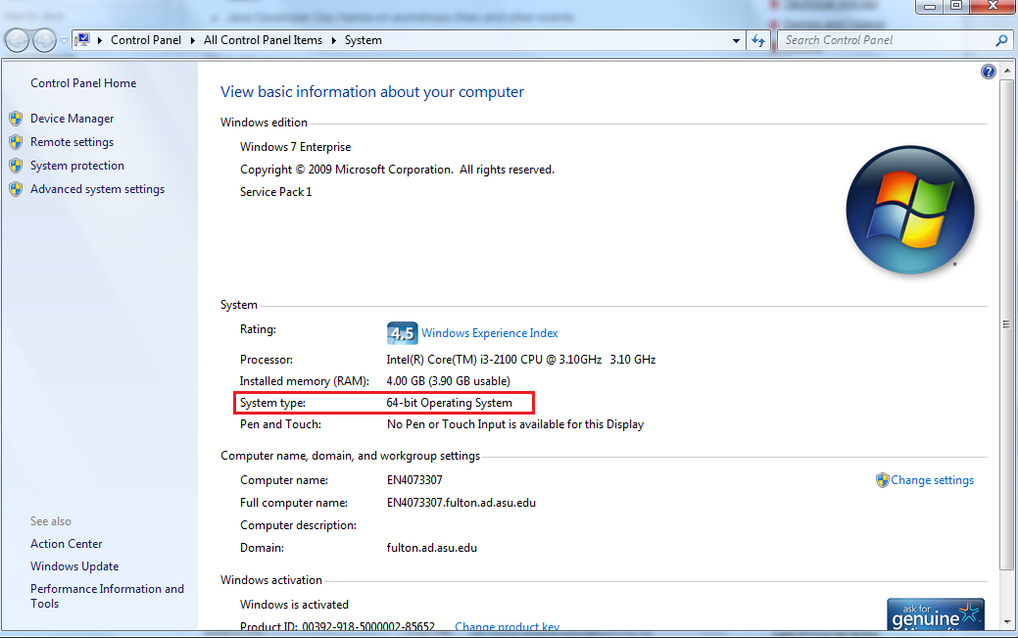

### Updating the PATH Environment Variable

If you do not set the PATH variable, you need to specify the full path to the executable file every time you run it, such as:

C:\> "C:\Program Files\Java\jdk1.8.0\bin\javac" MyClass.java

It is useful to set the PATH variable permanently so it will persist after rebooting.

To set the PATH variable permanently, add the full path of the jdk1.8.0\bin directory to the PATH variable. Typically, this full path looks something like C:\Program Files\Java\jdk1.8.0\bin. Set the PATH variable as follows on Microsoft Windows:

1. Click **Start**, then **Control Panel**, then **System**.
2. Click **Advanced**, then **Environment Variables**.
3. Add the location of the bin folder of the JDK installation to the PATH variable in **System Variables**. The following is a typical value for the PATH variable:
4. C:\WINDOWS\system32;C:\WINDOWS;C:\Program Files\Java\jdk1.8.0\bin

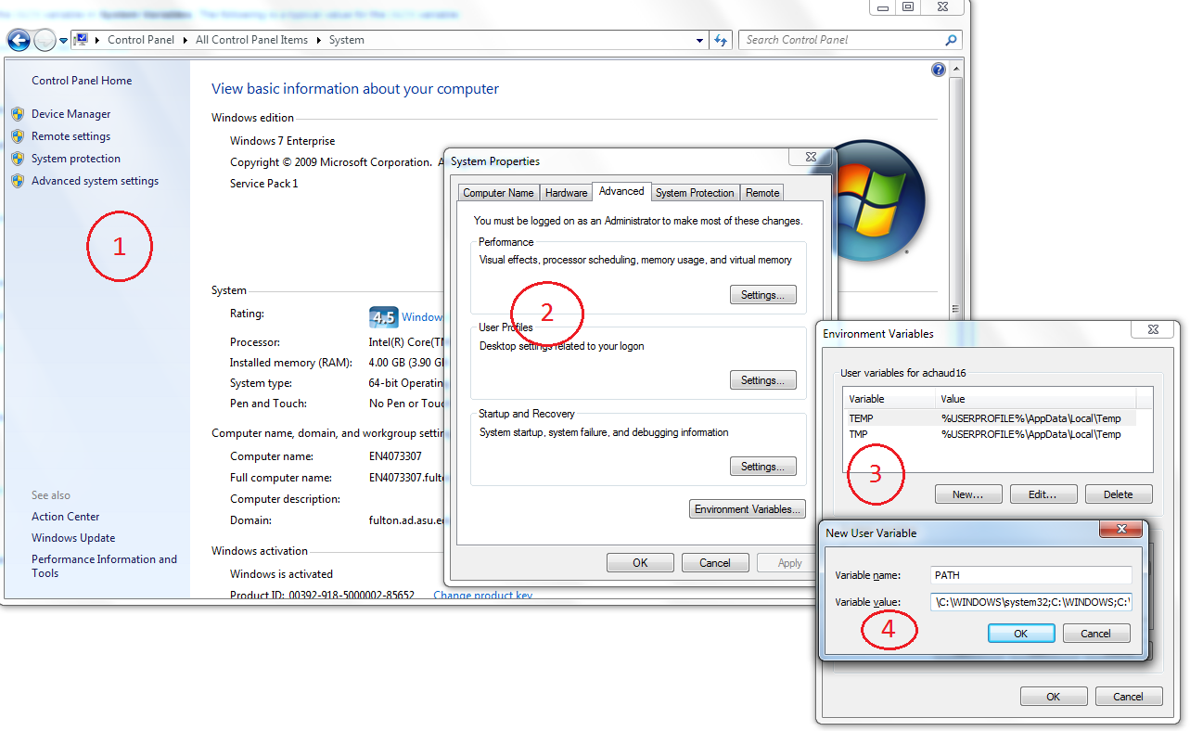

Note:

* The PATH environment variable is a series of directories separated by semicolons (;) and is not case-sensitive. Microsoft Windows looks for programs in the PATH directories in order, from left to right.
* You should only have one bin directory for a JDK in the path at a time. Those following the first instance are ignored.
* If you are not sure where to add the JDK path, append it.
* The new path takes effect in each new command window you open after setting the PATH variable.

### Starting to Use the JDK

Use the **Java** item in the Windows **Start** menu to get access to essential Java information and functions, including help, API documentation, the Java Control Panel, checking for updates, and Java Mission Control.

If you are new to developing and running programs in the Java programming language, see <http://docs.oracle.com/javase/tutorial> for some guidance. Note especially the tutorial trails under the heading *Trails Covering the Basics*.

You can also download the JDK documentation from <http://www.oracle.com/technetwork/java/javase/downloads/index-jsp-138363.html> page.

## Uninstalling the JDK

To uninstall the JDK, use the "Add/Remove Programs" utility in the Microsoft Windows Control Panel.

Installing the Java Runtime Environment (JRE) Windows OS

### Downloading the Installer

You have a choice of the following kinds of JRE installers that you can download:

http://www.oracle.com/technetwork/java/javase/downloads/jre8-downloads-2133155.html

* Windows x86 Online: jre-8version-windows-i586-iftw.exe (The letters iftw mean "install from the web.")
* Windows x86 Offline: jre-8version-windows-i586.exe
* Windows x64: jre-8version-windows-x64.exe

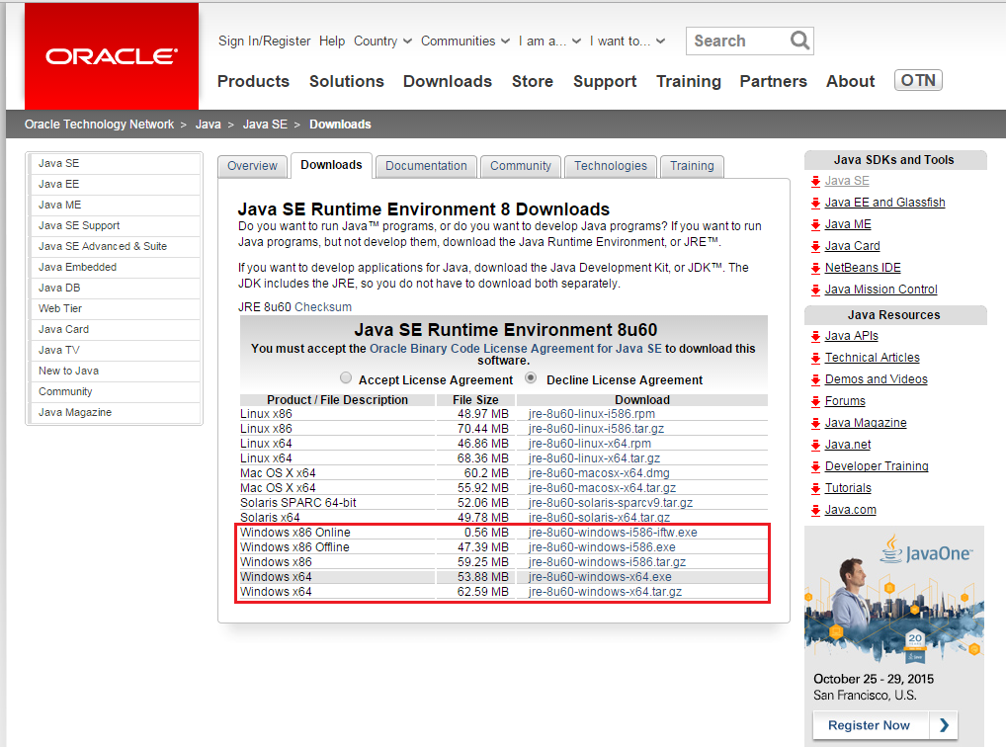

### Running the Installer

If you saved the JRE installer to your computer, run the installer by double-clicking it. Follow the instructions the installer provides. The installer notifies you if Java content is disabled in web browsers, and provides instructions for enabling it.

If you previously chose to hide some of the security prompts for applets and Java Web Start applications, the installer provides an option for restoring the prompts. When you are finished with the installation, you can delete the downloaded file to recover disk space.

#### Set the JAVA_HOME System Variable

These steps verify that the **JAVA_HOME** system environment variable points to the JRE that you installed, or creates the variable if absent.

1. On the desktop right-click **My Computer** and then click **Properties**.
2. Click the **Advanced** tab, and then click **Environment Variables**.
3. Under **System Variables**, look for the **JAVA_HOME** system variable. The **JAVA_HOME** path should point to the location that you recorded when you installed the JRE.
4. Do one of the following:
   * If you see the **JAVA_HOME** system variable and it points to the correct location, leave the **Environment Variables** dialog box open
   * If a **JAVA_HOME** system variable does not exist, or if it points to the wrong location, continue to the next step.
5. Under **System Variables**, do one of the following:
   * Click **New** to create a **JAVA_HOME** variable.
   * Select the existing **JAVA_HOME** variable and then click **Edit**. This opens a dialog box to edit this variable.
6. In the **Variable Name** box, type **JAVA_HOME** in capital letters.
7. In the **Variable Value** box, type the correct path to the JRE.
8. Click **OK** to set the path and close the dialog box.

## Uninstalling the JRE

To uninstall the JRE, use the Java Uninstall tool, which you can access in the following ways:

* If the JRE is version 8u20 or later, uninstall it with the "Add/Remove Programs" utility in the Microsoft Windows Control Panel. The Java Removal Tool is integrated with the uninstallation process, and it will guide you through the removal of older JREs.
* Use the online Java Uninstall tool:

<https://www.java.com/en/download/uninstallapplet.jsp>

The Java Uninstall tool helps you improve your computer security by simplifying the process of finding and uninstalling older versions of Java. The Uninstall tool shows you a list of the Java versions on your computer and then removes those that are out-of-date.

Installing the TextPad / Notepad IDE Windows

#### 1.1  Using TextPad for Java Programming (on Windows)

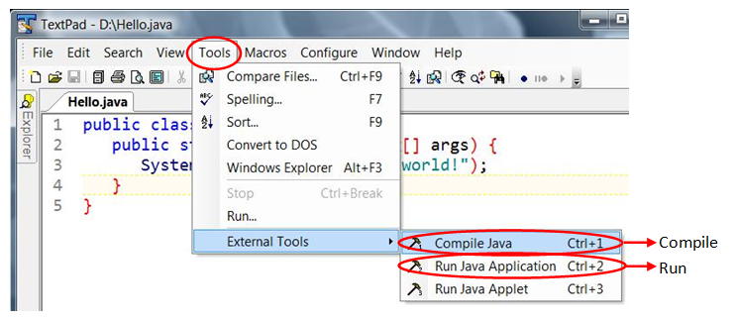

TextPad (@ [www.textpad.com](http://www.textpad.com/)) is an excellent programming text editor for writing toy Java programs. It can be configured to couple with the JDK, hence, bypassing the CMD shell.

From the TextPad editor, you can invoke the JDK compiler/runtime directly via "Tools" menu ⇒ External Tools ⇒ "Compile Java" or "Run Java Application". Take note of the keyboard shortcuts - Ctrl+1 for compile and Ctrl+2 for run.

If you cannot find these commands in the "Tools" menu, goto "Configure" ⇒ Preferences... ⇒ Tools ⇒ Add ⇒ JDK Commands.

#### 1.2  Using NotePad++ for Java Programming (on Windows)

Notepad++ (@ [http://notepad-plus-plus.org](http://notepad-plus-plus.org/)) is a free and open-source programming editor.

You can use NotePad++ to write your Java source code. But you need to use CMD shell to compile and run the Java program.

Installing the Eclipse Windows

##### **Step 0: Install JDK**

To use Eclipse for Java programming, you need to first install Java Development Kit (JDK).Steps to install JDK are described above.

##### **Step 1: Download**

Download Eclipse from [http://www.eclipse.org/downloads](http://www.eclipse.org/downloads/). For beginners, choose "Eclipse IDE for Java Developers" (32-bit or 64-bit) (e.g., "eclipse-java-luna-SR1a-win32-x86_64.zip"). Check your OS version from the steps described above.

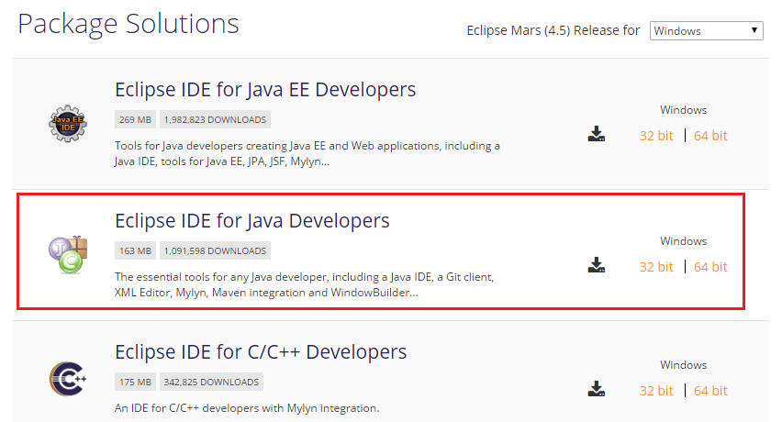

##### **Step 2: Unzip**

To install Eclipse, simply unzip the downloaded file into a directory of your choice (e.g., "d:\myproject").

There is no need to run any installer. Moreover, you can simply delete the entire Eclipse directory when it is no longer needed (without running any un-installer). You are free to move or rename the directory. You can install (unzip) multiple copies of Eclipse in the same machine.

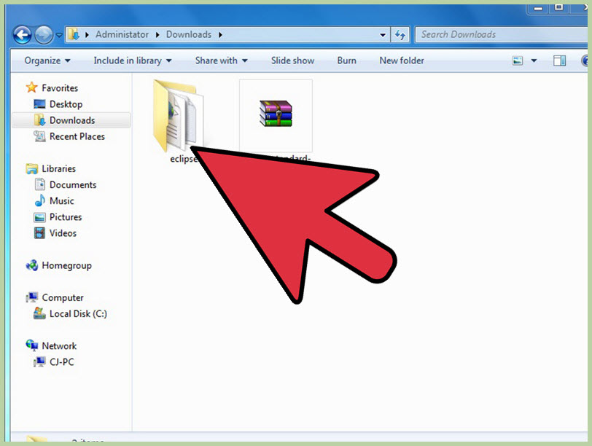

##### **Step 3: Launch Eclipse**

Start Eclipse by running "eclipse.exe" in the Eclipse installed directory. You may want to extract the archive to the root of C:\ drive, thus creating the folder “C:\eclipse”, or just moved the extracted eclipse folder to the root of C:\ drive if you extracted it already. Since Eclipse does not have any installer, there will be a file inside the Eclipse folder named eclipse.exe ( ). You can double click on the file to run Eclipse.

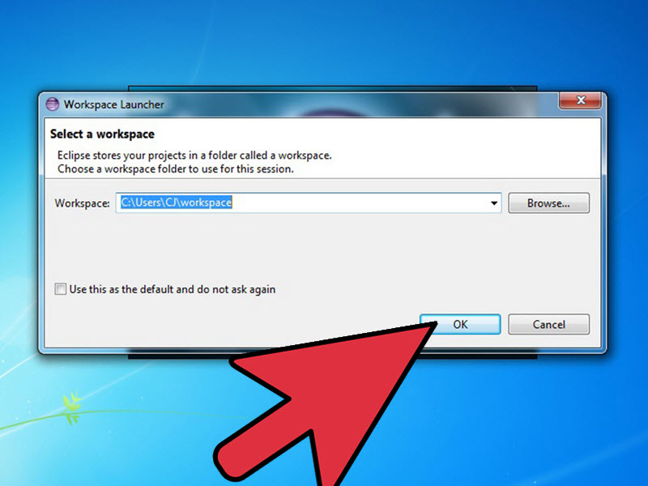

**Step 4**

Choose an appropriate directory for your workspace (i.e., where you would like to save your files). If the "Welcome" screen shows up, close it by clicking the "close" button.

**Step 5**

**Now that you have finished installing Eclipse, restart your computer.** Restarting your computer refreshes system memory and allows registration or configuration changes made by installers and uninstallers to take effect.