1. Declare a new global variable for the new system in unixinstall.sh This variable should be unique. The current variables are:

#global variables for all supported Unix systems

export osUbuntu="ubuntu"

export osDebian="debian"

export osFedora="fedora"

export osSuse="suse"

export osMandriva="mandriva"

2. When the installer runs unixinstall.sh, the first parameter is the name of OS in the above global variable.

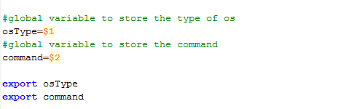

3. In the shell functions of the form getXXXName or installXXX, where XXX is the name of an XSB package, add a case for the new operating system. For instance:

installLibxmldev()

{

getXmlName

case "$osType" in

"$osUbuntu")

if dpkg -l | grep -q $xmlName ; then

echo "\n$xmlName - package already installed."

else

echo $password | sudo -S apt-get install -y $xmlName

fi ;;

"$osDebian")

if dpkg -l | grep -q $xmlName ; then

echo "\n$xmlName - package already installed."

else

echo $password | sudo -S apt-get install -y $xmlName

fi ;;

"$osFedora")

if rpm -q $xmlName ; then

echo ""

echo "$xmlName - package already installed."

else

echo $password | sudo -S yum install -y $xmlName

fi ;;

"$osSuse")

if rpm -q $xmlName | grep "is not installed" ; then

echo $password | sudo -S zypper install -y $xmlName

else

echo "$xmlName - package already installed."

fi ;;

"$osMandriva")

echo $password | sudo -S urpmi --auto $xmlName ;;

esac

}

4. Finally, make a change in the Java source code in property files.

In the “installer” folder, add a new line in “system.properties” for the new OS. For instance :

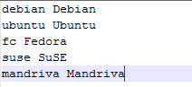

The left ***key*** is the name you defined for global variables in unixinstall.sh. The value on the right it the name of OS you want to display on the panel.

The **key** must be the value that in output by “cat /proc/version”. The key should be able to uniquely identify the new operating system type.