**Module-3: Docker – I Assignment – 5**

You have been asked to:

● Create a sample HTML file

● Use the Dockerfile from the previous task

● Replace this sample HTML file inside the docker container with the default page

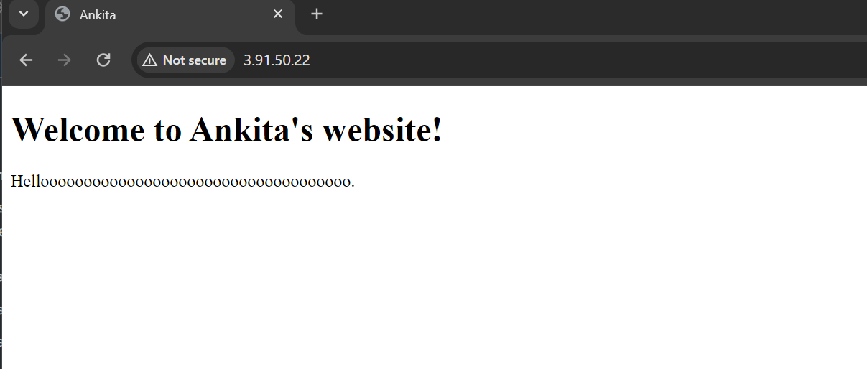

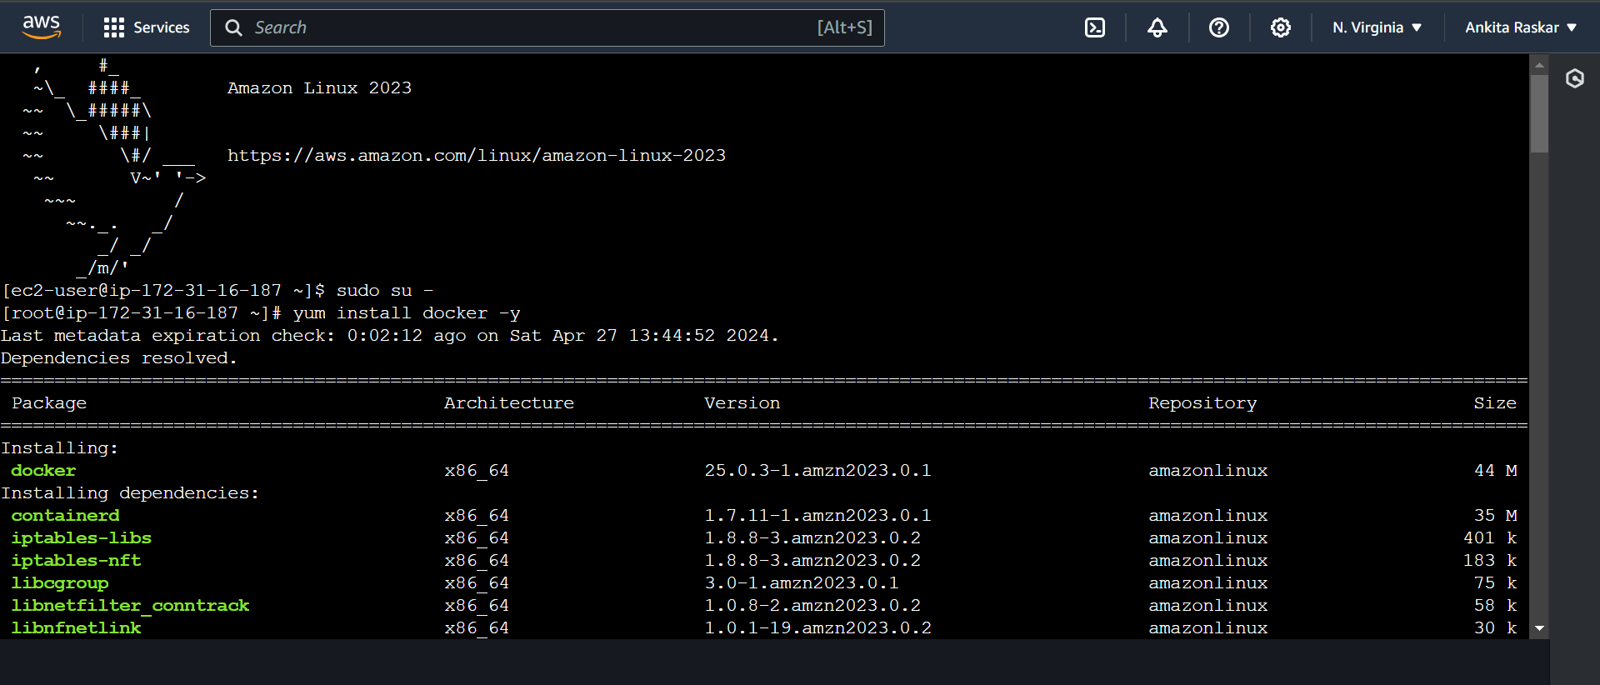

[ec2-user@ip-172-31-16-187 ~]$ sudo su -

[root@ip-172-31-16-187 ~]# yum install docker -y

Complete!

[root@ip-172-31-16-187 ~]# vi index.html

[root@ip-172-31-16-187 ~]# vi Dockerfile

[root@ip-172-31-16-187 ~]# docker build -t my-apache-image .

ERROR: Cannot connect to the Docker daemon at unix:///var/run/docker.sock. Is the docker daemon running?

[root@ip-172-31-16-187 ~]# systemctl status docker

○ docker.service - Docker Application Container Engine

Loaded: loaded (/usr/lib/systemd/system/docker.service; disabled; preset: disabled)

Active: inactive (dead)

TriggeredBy: ○ docker.socket

Docs: https://docs.docker.com

[root@ip-172-31-16-187 ~]# systemctl start docker

[root@ip-172-31-16-187 ~]# systemctl status docker

● docker.service - Docker Application Container Engine

Loaded: loaded (/usr/lib/systemd/system/docker.service; disabled; preset: disabled)

Active: active (running) since Sat 2024-04-27 13:53:31 UTC; 38s ago

TriggeredBy: ● docker.socket

Docs: https://docs.docker.com

Process: 26980 ExecStartPre=/bin/mkdir -p /run/docker (code=exited, status=0/SUCCESS)

Process: 26981 ExecStartPre=/usr/libexec/docker/docker-setup-runtimes.sh (code=exited, status=0/SUCCESS)

Main PID: 26982 (dockerd)

Tasks: 8

Memory: 31.9M

CPU: 326ms

CGroup: /system.slice/docker.service

└─26982 /usr/bin/dockerd -H fd:// --containerd=/run/containerd/containerd.sock --default-ulimit nofile=32768:65536

Apr 27 13:53:30 ip-172-31-16-187.ec2.internal systemd[1]: Starting docker.service - Docker Application Container Engine...

Apr 27 13:53:30 ip-172-31-16-187.ec2.internal dockerd[26982]: time="2024-04-27T13:53:30.636138416Z" level=info msg="Starting up"

Apr 27 13:53:30 ip-172-31-16-187.ec2.internal dockerd[26982]: time="2024-04-27T13:53:30.699553584Z" level=info msg="Loading containers: star>

Apr 27 13:53:31 ip-172-31-16-187.ec2.internal dockerd[26982]: time="2024-04-27T13:53:31.090398970Z" level=info msg="Loading containers: done>

Apr 27 13:53:31 ip-172-31-16-187.ec2.internal dockerd[26982]: time="2024-04-27T13:53:31.114804408Z" level=info msg="Docker daemon" commit=f4>

lines 1-19

^C

[root@ip-172-31-16-187 ~]# docker build -t my-apache-image .

[+] Building 18.0s (8/8) FINISHED docker:default

=> [internal] load build definition from Dockerfile 0.0s

=> => transferring dockerfile: 413B 0.0s

=> [internal] load metadata for docker.io/library/ubuntu:latest 0.4s

=> [internal] load .dockerignore 0.0s

=> => transferring context: 2B 0.0s

=> [1/3] FROM docker.io/library/ubuntu:latest@sha256:562456a05a0dbd62a671c1854868862a4687bf979a96d48ae8e766642cd911e8 2.2s

=> => resolve docker.io/library/ubuntu:latest@sha256:562456a05a0dbd62a671c1854868862a4687bf979a96d48ae8e766642cd911e8 0.0s

=> => sha256:562456a05a0dbd62a671c1854868862a4687bf979a96d48ae8e766642cd911e8 1.13kB / 1.13kB 0.0s

=> => sha256:28a2b328825ac02db5c29d9356bfba80ba6c4b6ebfcac5a91a4656fa3453775a 424B / 424B 0.0s

=> => sha256:de52d803b2245ea6d6b4235e43533dc5a70ea3837c0db840603d0b828d42266c 2.30kB / 2.30kB 0.0s

=> => sha256:fdcaa7e87498b7e172f808aa62dfb30c533563cb3e474262835357118da1f260 28.86MB / 28.86MB 0.4s

=> => extracting sha256:fdcaa7e87498b7e172f808aa62dfb30c533563cb3e474262835357118da1f260 1.7s

=> [internal] load build context 0.0s

=> => transferring context: 394B 0.0s

=> [2/3] RUN apt-get update && apt-get install -y apache2 && apt-get clean 13.3s

=> [3/3] COPY index.html /var/www/html/index.html 0.1s

=> exporting to image 1.9s

=> => exporting layers 1.9s

=> => writing image sha256:eaf9959bf42cb81a46ed48216d56afa1d242d3d2fb7df2959aac47d3e170cc71 0.0s

=> => naming to docker.io/library/my-apache-image 0.0s

[root@ip-172-31-16-187 ~]# docker images

REPOSITORY TAG IMAGE ID CREATED SIZE

my-apache-image latest eaf9959bf42c About a minute ago 220MB

[root@ip-172-31-16-187 ~]# docker run -d -p 80:80 my-apache-image

426a5fddce446cfefe4176b77b96368b059534c23073996c92196ce3c58d862c

[root@ip-172-31-16-187 ~]# docker ps

CONTAINER ID IMAGE COMMAND CREATED STATUS PORTS NAMES

426a5fddce44 my-apache-image "apache2ctl -D FOREG…" 6 seconds ago Up 5 seconds 0.0.0.0:80->80/tcp, :::80->80/tcp suspicious_kapitsa

[root@ip-172-31-16-187 ~]#