**Module-4: Docker - II: Assignment - 1**

You have been asked to:

● Launch the Apache2 container created in previous module

● Create a Docker volume on /var/www/html Please submit the commands, in order to complete this assignment

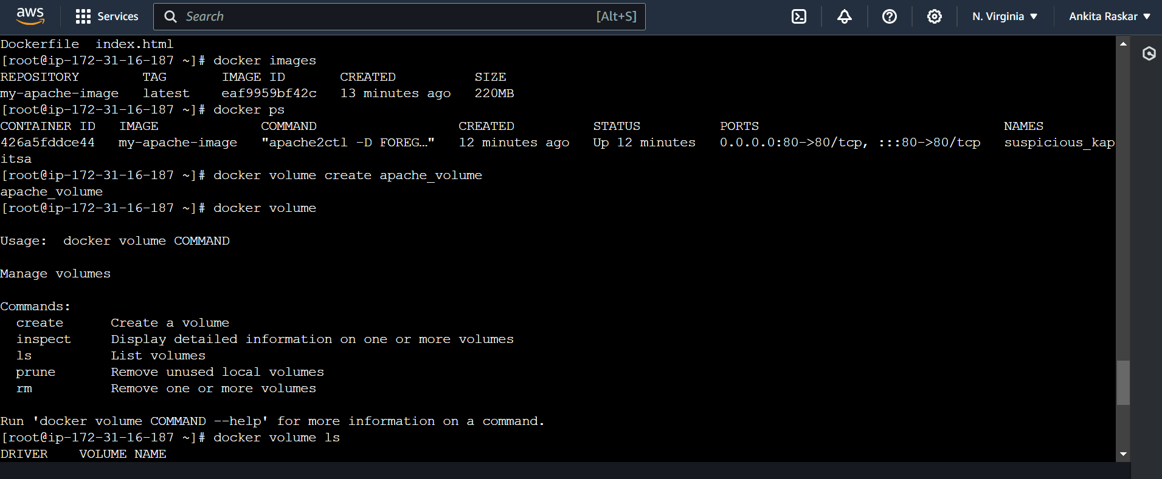

[root@ip-172-31-16-187 ~]# ls

Dockerfile index.html

[root@ip-172-31-16-187 ~]# docker images

REPOSITORY TAG IMAGE ID CREATED SIZE

my-apache-image latest eaf9959bf42c 13 minutes ago 220MB

[root@ip-172-31-16-187 ~]# docker ps

CONTAINER ID IMAGE COMMAND CREATED STATUS PORTS NAMES

426a5fddce44 my-apache-image "apache2ctl -D FOREG…" 12 minutes ago Up 12 minutes 0.0.0.0:80->80/tcp, :::80->80/tcp suspicious_kapitsa

[root@ip-172-31-16-187 ~]# docker volume create apache_volume

apache_volume

[root@ip-172-31-16-187 ~]# docker volume

Usage: docker volume COMMAND

Manage volumes

Commands:

create Create a volume

inspect Display detailed information on one or more volumes

ls List volumes

prune Remove unused local volumes

rm Remove one or more volumes

Run 'docker volume COMMAND --help' for more information on a command.

[root@ip-172-31-16-187 ~]# docker volume ls

DRIVER VOLUME NAME

local apache_volume

[root@ip-172-31-16-187 ~]# docker run -d -p 80:80 -v apache_volume:/var/www/html my-apache-image

acfec0c0a5872204a4d5e4303c39221233d9990acae3a51c1797bdef9d04e260

docker: Error response from daemon: driver failed programming external connectivity on endpoint elegant_lederberg (1c60ab20084796a93dd923800eb1c2d638c77e15089e434a270d2b3729768533): Bind for 0.0.0.0:80 failed: port is already allocated.

[root@ip-172-31-16-187 ~]# docker ps

CONTAINER ID IMAGE COMMAND CREATED STATUS PORTS NAMES

426a5fddce44 my-apache-image "apache2ctl -D FOREG…" 13 minutes ago Up 13 minutes 0.0.0.0:80->80/tcp, :::80->80/tcp suspicious_kapitsa

[root@ip-172-31-16-187 ~]# docker rm 426a5fddce44

Error response from daemon: cannot remove container "/suspicious_kapitsa": container is running: stop the container before removing or force remove

[root@ip-172-31-16-187 ~]# docker stop 426a5fddce44

426a5fddce44

[root@ip-172-31-16-187 ~]# docker ps

CONTAINER ID IMAGE COMMAND CREATED STATUS PORTS NAMES

[root@ip-172-31-16-187 ~]# docker rm 426a5fddce44

426a5fddce44

[root@ip-172-31-16-187 ~]# docker run -d -p 80:80 -v apache_volume:/var/www/html my-apache-image

34d2710960427fdf455bd4120017aba8e18610fe5c86a2dae35815e76fe090dc

[root@ip-172-31-16-187 ~]# docker ps

CONTAINER ID IMAGE COMMAND CREATED STATUS PORTS NAMES

34d271096042 my-apache-image "apache2ctl -D FOREG…" 12 seconds ago Up 12 seconds 0.0.0.0:80->80/tcp, :::80->80/tcp goofy_hamilton

[root@ip-172-31-16-187 ~]#