**Module-4: Docker - II: Assignment - 2**

You have been asked to:

● Use the apache2 container created in previous module

● Create a bind mount on /var/www/html to replace html files dynamically Submit the commands, to complete the assignment

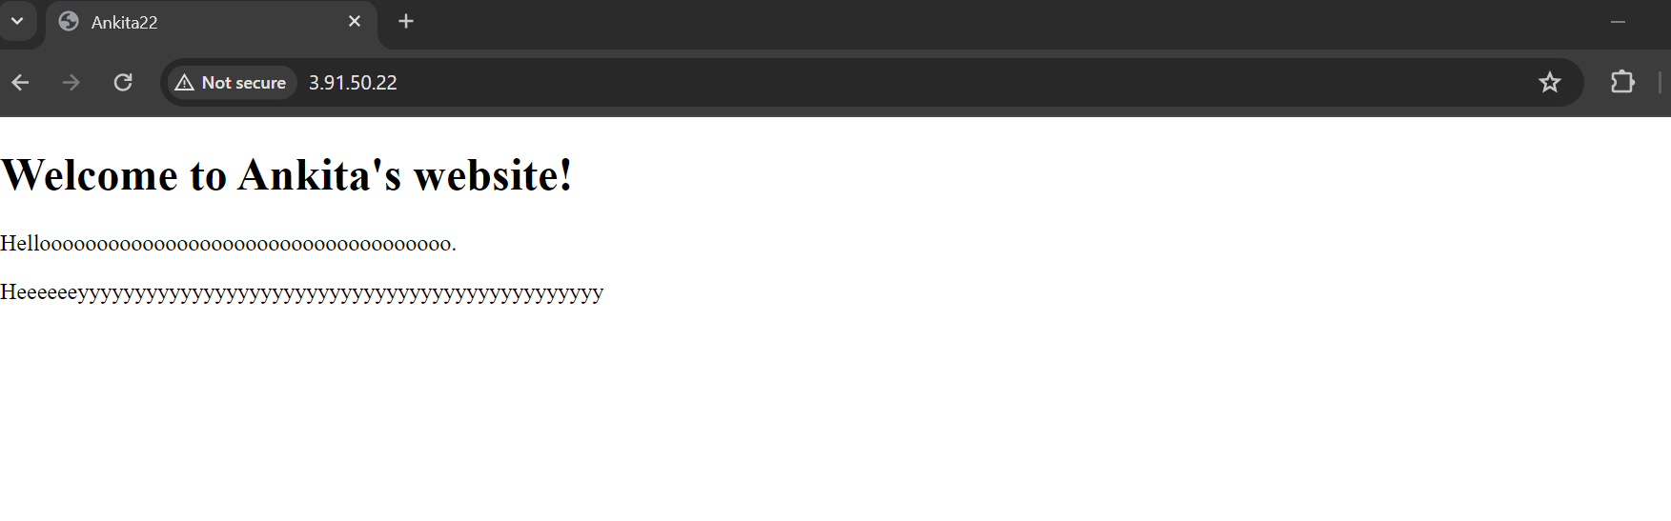

[root@ip-172-31-16-187 ~]# docker os

docker: 'os' is not a docker command.

See 'docker --help'

[root@ip-172-31-16-187 ~]# docker ps

CONTAINER ID IMAGE COMMAND CREATED STATUS PORTS NAMES

34d271096042 my-apache-image "apache2ctl -D FOREG…" 9 minutes ago Up 9 minutes 0.0.0.0:80->80/tcp, :::80->80/tcp goofy_hamilton

[root@ip-172-31-16-187 ~]# docker stop 34d271096042

34d271096042

[root@ip-172-31-16-187 ~]# docker rm 34d271096042

34d271096042

[root@ip-172-31-16-187 ~]# docker ps

CONTAINER ID IMAGE COMMAND CREATED STATUS PORTS NAMES

[root@ip-172-31-16-187 ~]# ls

Dockerfile index.html

[root@ip-172-31-16-187 ~]# mkdir html_file

[root@ip-172-31-16-187 ~]# mv index.html html_file

[root@ip-172-31-16-187 ~]# ls

Dockerfile html_file

[root@ip-172-31-16-187 ~]# cd html_file

[root@ip-172-31-16-187 html_file]# ls

index.html

[root@ip-172-31-16-187 html_file]# pwd

/root/html_file

[root@ip-172-31-16-187 html_file]# cd

[root@ip-172-31-16-187 ~]# docker run -d -p 80:80 -v /root/html_file:/var/www/html my-apache-image

68f9219591f286048f2262a7eab9d70ff7600fe032950650bf00d265adf7604a

[root@ip-172-31-16-187 ~]# docker ps

CONTAINER ID IMAGE COMMAND CREATED STATUS PORTS NAMES

68f9219591f2 my-apache-image "apache2ctl -D FOREG…" 7 seconds ago Up 6 seconds 0.0.0.0:80->80/tcp, :::80->80/tcp tender_galois

[root@ip-172-31-16-187 ~]# cd html_file

[root@ip-172-31-16-187 html_file]# ls

index.html

[root@ip-172-31-16-187 html_file]# vi index.html

[root@ip-172-31-16-187 html_file]# vi index.html