**A**

**Project Report**

**is**

**Submitted to the completion of Epam-COE-DevOPS**

**Training Program**

**PROJECT-2**



**Submitted By:**

**Mr. Ankur Bhardwaj**

**Junior Software Engineer-Epam Hyderabad**

**PROJECT-2**

**Following is the documentation of project that covers following objectives:**

* Infrastructure as Code Using Terraform (Modules)

1. **Total Files in the Terraform with access:**

1. **Terraform init**

1. Terraform Apply

1. Instance Launced

1. VPC’s

1. Subnets

1. Route Tables

1. Internet Gateways

1. Test Page

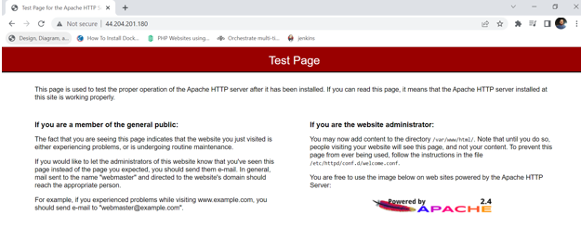

https://github.com/ankurbhardwajkiet/Terraform.git