Logging

Logging is the process of recording run-time actions as they happen in real-time.

Helps us to understand the failures and performance bottlenecks of the application.

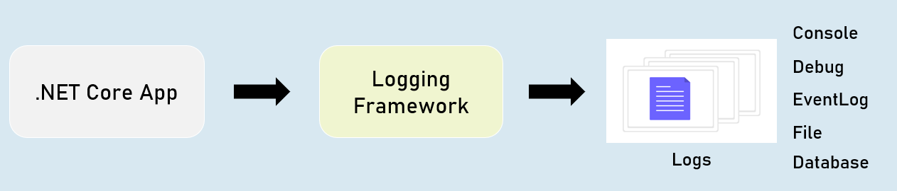

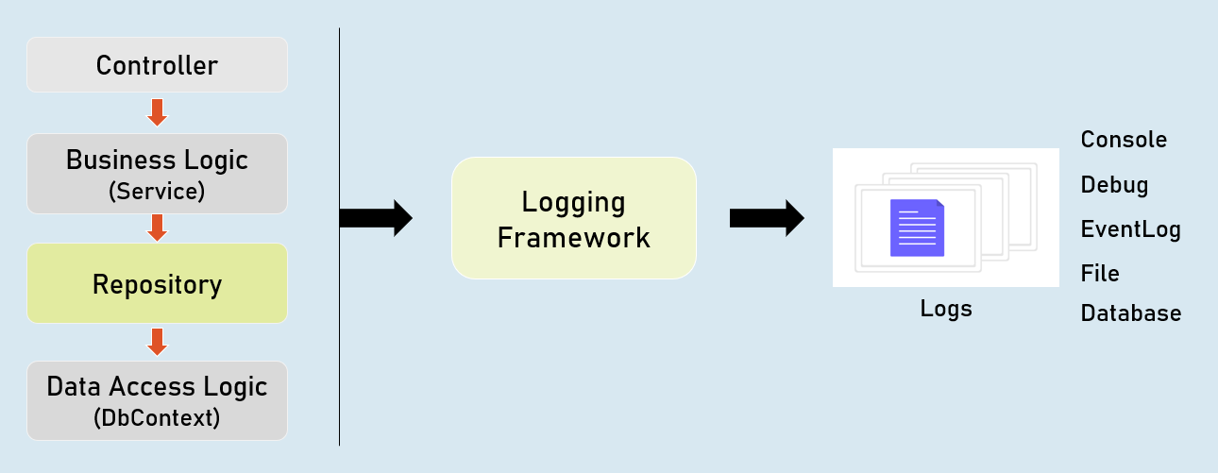

ILogger

**Debug**

ILogger.LogDebug("log_message");

Logs that provide details & values of variables for debugging purpose.

**Information**

ILogger.LogInformation("log_message");

Logs that track the general flow of the application execution.

**Warning**

ILogger.LogWarning("log_message");

Logs that highlight an abnormal or unexpected event.

**Error**

ILogger.LogError("log_message");

Logs to indicate that flow of execution is stopped due to a failure.

**Critical**

ILogger.LogCritical("log_message");

Logs to indicate an unrecoverable application crash.

Logging Configuration

appsettings.json

{

"Logging": {

"LogLevel": {

"Default": "Debug | Information | Warning | Error| Critical"

"Microsoft.AspNetCore": "Debug | Information | Warning | Error | Critical"

}

}

}

Controller and other classes

using Microsoft.AspNetCore.Mvc;

using Microsoft.Extensions.Logging;

public class ControllerName : Controller

{

private readonly ILogger<ClassName> _logger;

public ControllerName(ILogger<ClassName> logger)

{

_logger = logger;

}

}

**Logging Providers**

Logging provider specifies where to store / display logs.

The built-in logging providers in asp.net core doesn't support file / database logging providers.

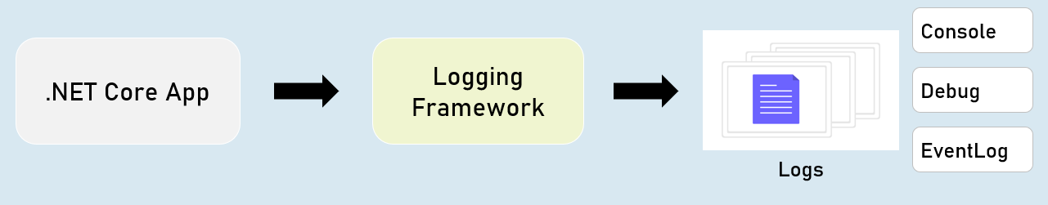

in Program.cs:

builder.Host.ConfigureLogging(logging =>

{

logging.ClearProviders();

logging.AddConsole();

logging.AddDebug();

logging.AddEventLog();

});

HTTP Logging

Logs details all HTTP requests and responses.

You need to set a value of "HttpLoggingFields" enum to set specify desired details.

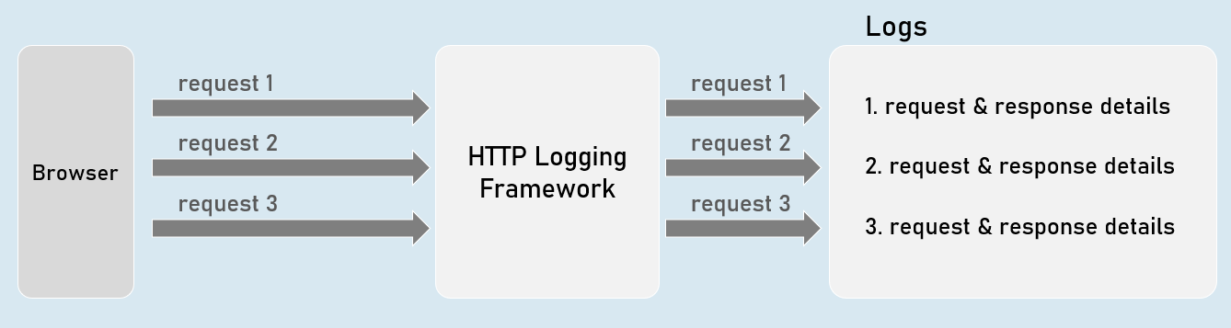

HTTP Logging Options

**"HttpLoggingFields" enum:**

**RequestMethod**

Method of request. Eg: GET

**RequestPath**

Path of request. Eg: /home/index

**RequestProtocol**

Protocol of request. Eg: HTTP/1.1

**RequestScheme**

Protocol Scheme of request. Eg: http

**RequestQuery**

Query string Scheme of request. Eg: ?id=1

**RequestHeaders**

Headers of request. Eg: Connection: keep-alive

**RequestPropertiesAndHeaders**

Includes all of above (default)

**RequestBody**

Entire request body. [has performance drawbacks; not recommended]

**Request**

Includes all of above

**"HttpLoggingFields" enum**

**ResponseStatusCode**

Status code of response. Eg: 200

**ResponseHeaders**

Headers of response. Eg: Content-Length: 20

**ResponsePropertiesAndHeaders**

Includes all of above (default)

**ResponseBody**

Entire response body. [has performance drawbacks; not recommended]

**Response**

Includes all of above

**All**

Includes all from request and response

**HTTP Logging Options**

Program.cs:

builder.Serices.AddHttpLogging(options =>

{

options.LoggingFields = Microsoft.AspNetCore.HttpLogging.HttpLoggingFields.YourOption;

});

Serilog

Serilog is a structured logging library for Asp.Net Core.

Supports variety of logging destinations, referred as "Sinks" - starts with Console, Azure, DataDog, ElasticSearch, Amazon CloudWatch, Email and Seq.

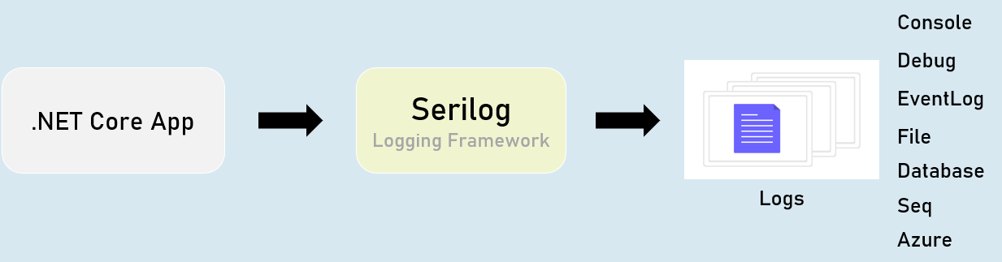

Serilog - Configuration

appsettings.json

{

"Serilog": {

"Using": [

"Serilog.Sinks.YourSinkHere"

],

"MinimumLevel": "Debug | Information | Warning | Error | Critical",

"WriteTo": [

{

"Name": "YourSinkHere",

"Args": "YourArguments"

}

]

}

}

**Serilog - Options**

Program.cs:

builder.Host.UseSerilog(HostBuilderContext context,

IServiceProvider services, LoggerConfiguration configuration) =>

{

configuration

.ReadFrom.Configuration(context.Configuration) //read configuration settings from built-in IConfiguration

.ReadFrom.Services(services); //read services from built-in IServiceProvider

});

Serilog - File Sink

The "Serilog.Sinks.File" logs into a specified file.

You can configure the filename, rolling interval, file size limit etc., using configuration settings.

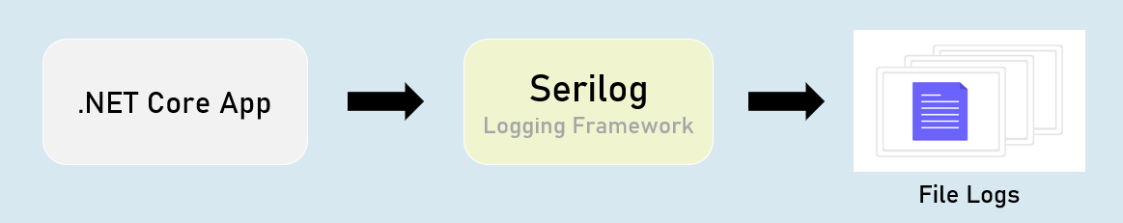

Serilog - "File Sink" Configuration

**appsettings.json**

1. {
2. "Serilog": {
3. "Using": [ "Serilog.Sinks.File" ],
4. "MinimumLevel": "Debug | Information | Warning | Error | Critical",
5. "WriteTo": [
6. {
7. "Name": "File",
8. "Args": [
9. "path": "folder/filename.ext",
10. "rollingInterval": "Minute | Hour | Day | Month | Year | Infinite",
11. ]
12. }
13. ]
14. }
15. }

Serilog - Database Sink

The "Serilog.Sinks.MSSqlServer" logs into a specified SQL Server database.

You can configure the connection string using configuration settings.

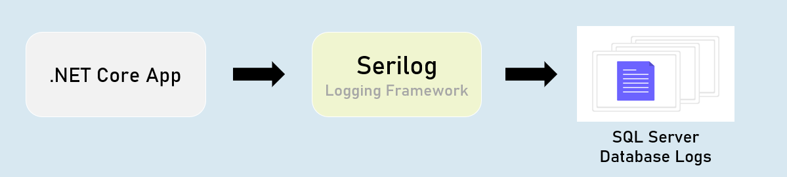

**Serilog - 'MSSqlServer' Sink Configuration**

**appsettings.json**

1. {
2. "Serilog": {
3. "Using": [ "Serilog.Sinks.MSSqlServer" ],
4. "MinimumLevel": "Debug | Information | Warning | Error | Critical",
5. "WriteTo": [
6. {
7. "Name": "MSSqlServer",
8. "Args": [
9. "connectionString": "your_connection_string_here",
10. "tableName": "table_name",
11. ]
12. }
13. ]
14. }
15. }

Serilog - Seq Sink

The "Serilog.Sinks.Seq" is a real-time search and analysis server for structured application log data.

Seq server can run on Windows, Linux or Docker.

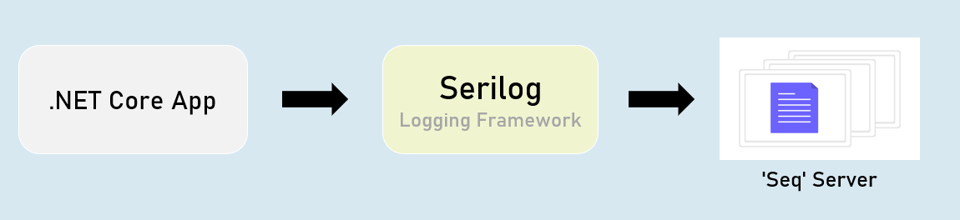

**Serilog - 'Seq' Sink - Configuration**

**appsettings.json**

1. {
2. "Serilog": {
3. "Using": [ "Serilog.Sinks.Seq" ],
4. "MinimumLevel": "Debug | Information | Warning | Error | Critical",
5. "WriteTo": [
6. {
7. "Name": "Seq",
8. "Args": [
9. "serverUrl": "http://localhost:5341"
10. ]
11. }
12. ]
13. }
14. }

Serilog - RequestId

"RequestId" is the unique number (guid) of each individual requests, used to identify to which request the log belongs to.

RequestId is "TraceIdentifier" internally, that is generated by Asp.Net Core.

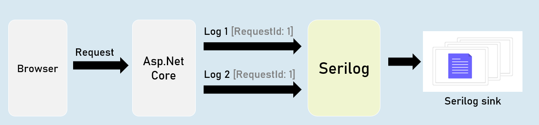

Serilog - Enrichers

Enrichers are additional details that are added to LogContext; so they're stored in logs.

Eg: MachineName[or]Custom Properties.

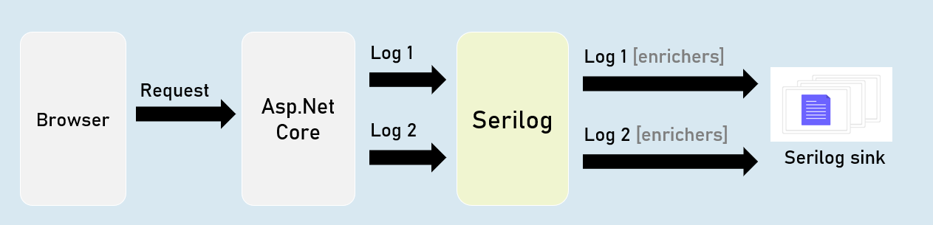

Serilog - IDiagnosticContext

Diagnostic context allows you to add additional enrichment properties to the context; and all those properties are logged at once in the final "log completion event" of the request.

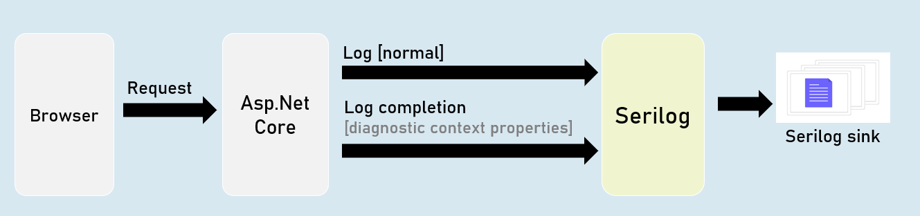

Serilog Timings

"SerilogTimings" package records timing of a piece of your soure code, indicating how much time taken for executing it.

**Filters**

Filters are the code blocks that execute before / after specific stages in "Filter Pipeline".

Filters perform specific tasks such as authorization, caching, exeption handling etc.

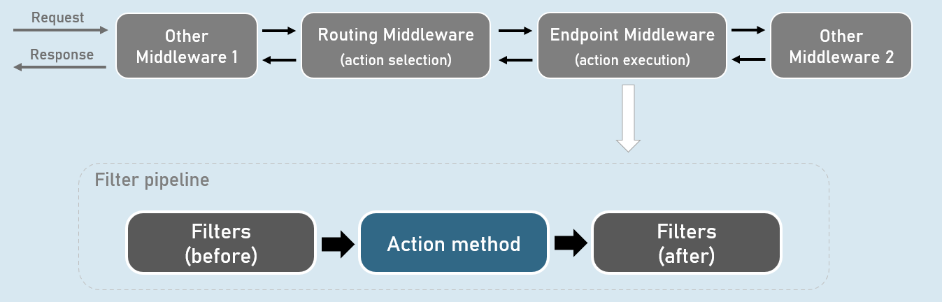

**Filter Pipeline**

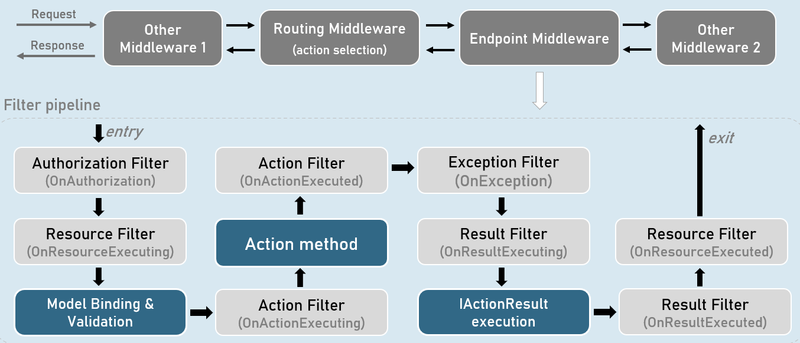

**Overview of Types of Filters**

**Authorization Filter**

Determines whether the user is authorized to access the action method.

**Resource Filter**

Invoking custom model binder explicitly

Caching the response.

**Action Filter**

Manipulating & validating the action method parameters.

Manipulating the ViewData.

Overriding the IActionResult provided by action method.

**Exception Filter**

Handling unhandled exception that occur in model binding, action filters or action methods.

**Result Filter**

Preventing IActionResult from execution.

Adding last-moment changes to response (such as adding response headers).

**Action Filter**

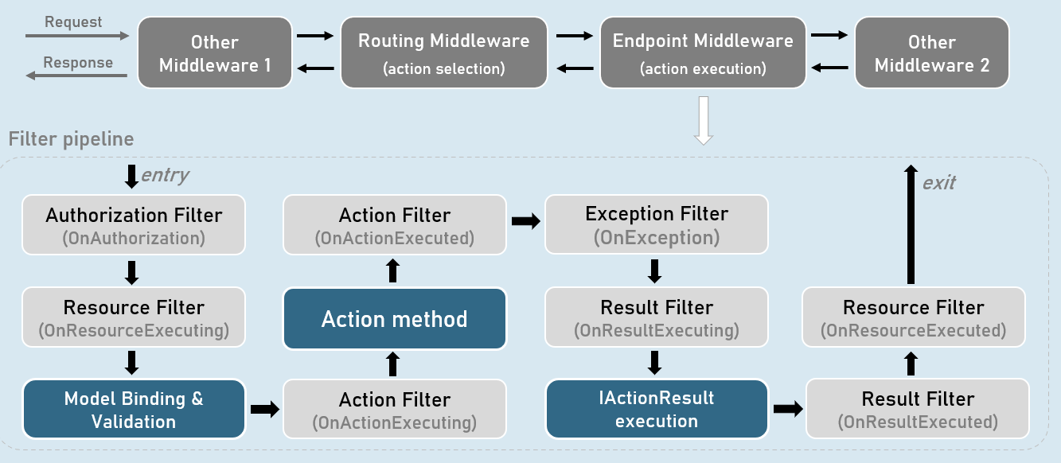

**When it runs**

Runs immediately before and after an action method executes.

**'OnActionExecuting' method**

It can access the action method parameters, read them & do necessary manipulations on them.

It can validate action method parameters.

It can short-circuit the action (prevent action method from execution) and return a different IActionResult.

**'OnActionExecuted' method**

It can manipulate the ViewData.

It can change the result returned from the action method.

**Filter Arguments**

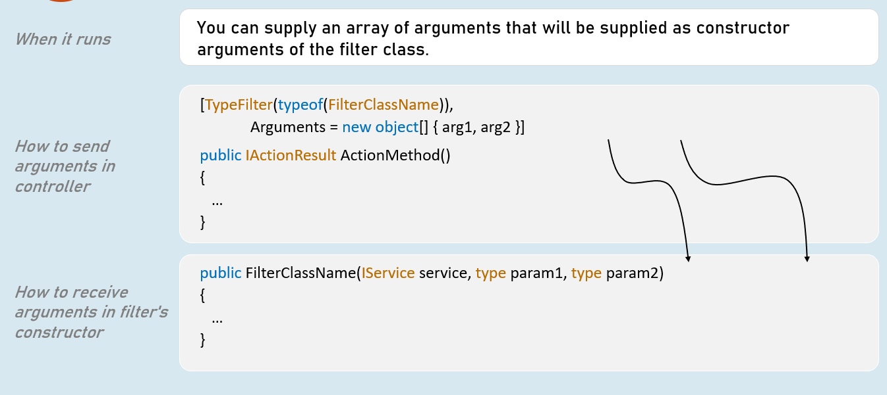

**Global Filters**

**Filter Scopes**

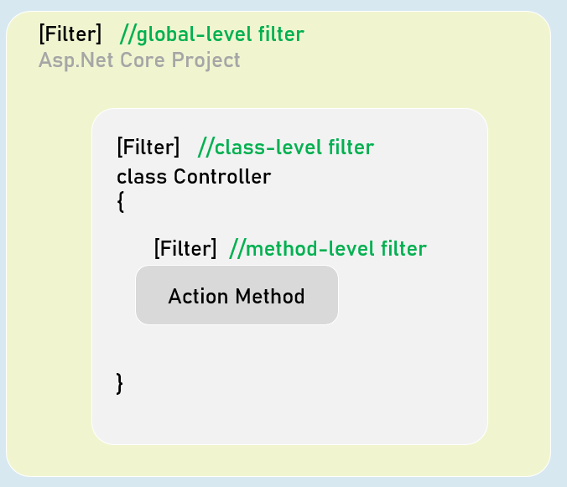

**What are global filters?**

Global filters are applied to all action methods of all controllers in the project.

**How to add global filters in Program.cs?**

builder.Services.AddControllersWithViews(options => {

options.Filters.Add<FilterClassName>(); //add by type

//or

options.Filters.Add(new FilterClassName()); //add filter instance

});

#### Default Order of Filter Execution

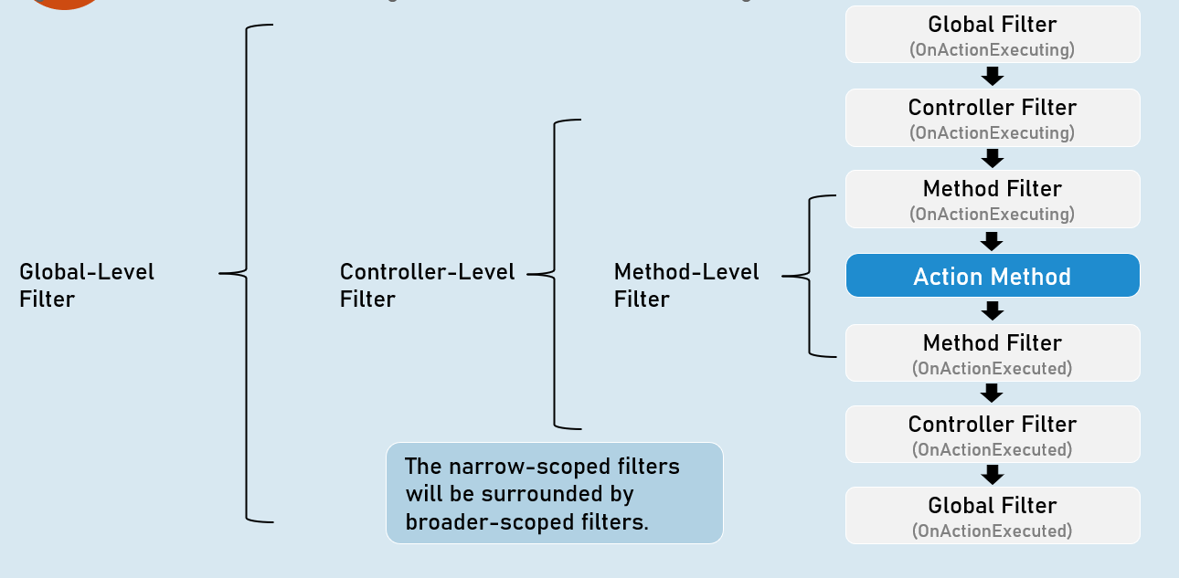

#### Custom Order of Filters

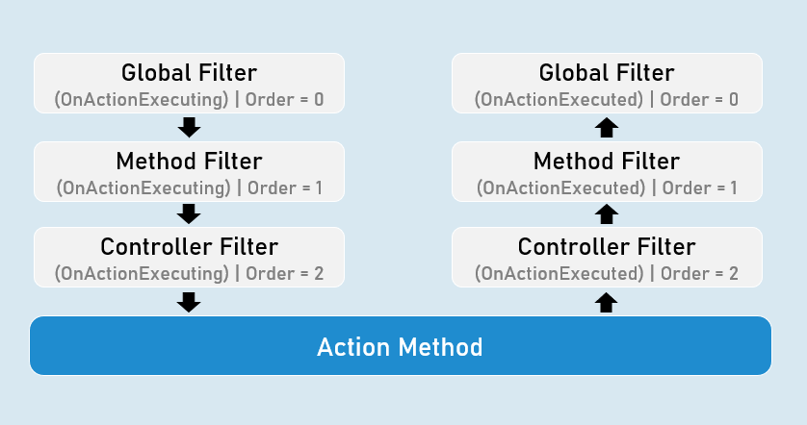

#### IOrderedFilter

**Example**

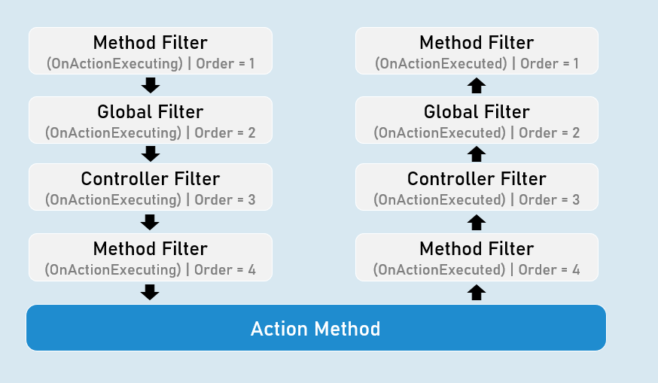

IOrderedFilter

**Action filter with IOrderedFilter**

public class FilterClassName : IActionFilter, IOrderedFilter

{

public int Order { get; set; } //Defines sequence of execution

public FilterClassName(int order)

{

Order = order;

}

public void OnActionExecuting(ActionExecutingContext context)

{

//TO DO: before logic here

}

public void OnActionExecuted(ActionExecutedContext context)

{

//TO DO: after logic here

}

}

Async Filters

**Asynchronous Action Filter**

public class FilterClassName : IAsyncActionFilter, IOrderedFilter

{

public int Order { get; set; } //Defines sequence of execution

public FilterClassName(int order)

{

Order = order;

}

public async Task OnActionExecutionAsync(ActionExecutingContext context, ActionExecutionDelegate next)

{

//TO DO: before logic here

await next();

//TO DO: after logic here

}

}

Short-circuiting Filters

**Action Filters**

**When it runs**

Runs immediately before and after an action method executes.

**'OnActionExecuting' method**

It can access the action method parameters, read them & do necessary manipulations on them.

It can validate action method parameters.

It can short-circuit the action (prevent action method from execution) and return a different IActionResult.

**'OnActionExecuted' method**

It can manipulate the ViewData.

It can change the result returned from the action method.

It can throw exceptions to either return the exception to the exception filter (if exists); or return the error response to the browser.

Short-Circuiting Action Filter

public class FilterClassName : IAsyncActionFilter, IOrderedFilter

{

public int Order { get; set; } //Defines sequence of execution

public FilterClassName(int order)

{

Order = order;

}

public async Task OnActionExecutionAsync(ActionExecutingContext context, ActionExecutionDelegate next)

{

//TO DO: before logic here

context.Result = some_action_result; //you can return any type of IActionResult

//Not calling next(). So it leads remaining filters & action method short-circuited.

}

}

Short-Circuiting (exit) the filters

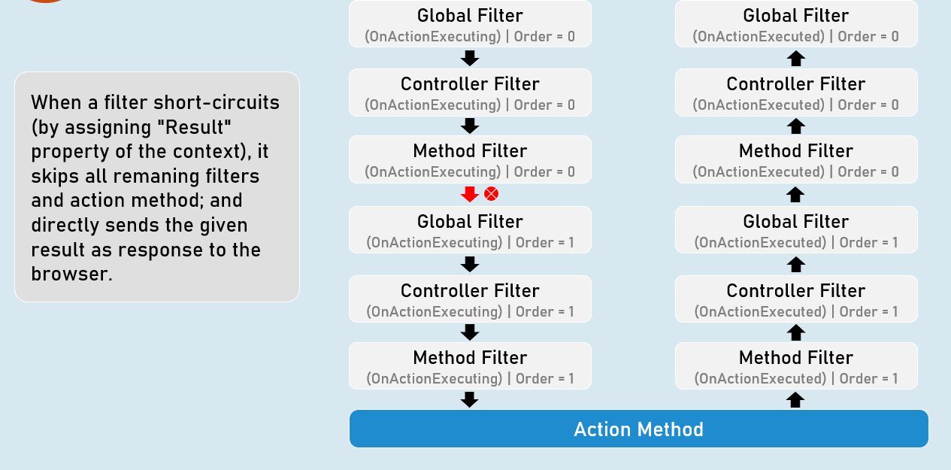

Result Filter

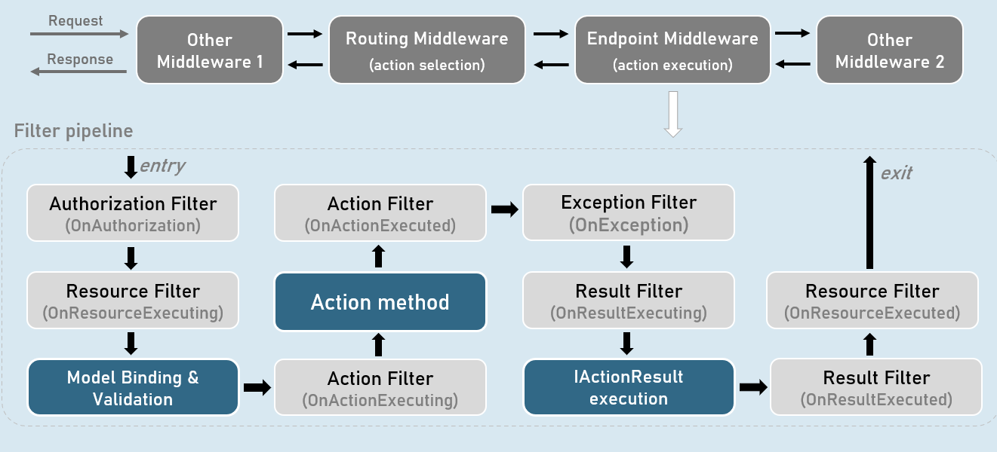

**When it runs**

Runs immediately before and after an IActionResult executes.

It can access the IActionResult returned by the action method.

**'OnResultExecuting' method**

It can continue executing the IActionResult normally, by not assigning "Result" property of the context.

It can short-circuit the action (prevent IActionResult from execution) and return a different IActionResult.

**'OnResultExecuted' method**

It can manipulate the last-moment changes in the response, such as adding necessary response headers.

It should not throw exceptions because, exceptions raised in result filters would not be caught by the exception filter.

**Synchronous Result Filter**

public class FilterClassName : IResultFilter, IOrderedFilter

{

public int Order { get; set; } //Defines sequence of execution

public FilterClassName(int order)

{

Order = order;

}

public void OnResultExecuting(ResultExecutingContext context)

{

//TO DO: before logic here

}

public void OnResultExecuted(ResultExecutedContext context)

{

//TO DO: after logic here

}

}

**Asynchronous Result Filter**

public class FilterClassName : IAsyncResultFilter, IOrderedFilter

{

public int Order { get; set; } //Defines sequence of execution

public FilterClassName(int order)

{

Order = order;

}

public async Task OnResultExecutionAsync(ResultExecutingContext context, ResultExecutionDelegate next)

{

//TO DO: before logic here

await next();

//TO DO: after logic here

}

}

Resource Filter

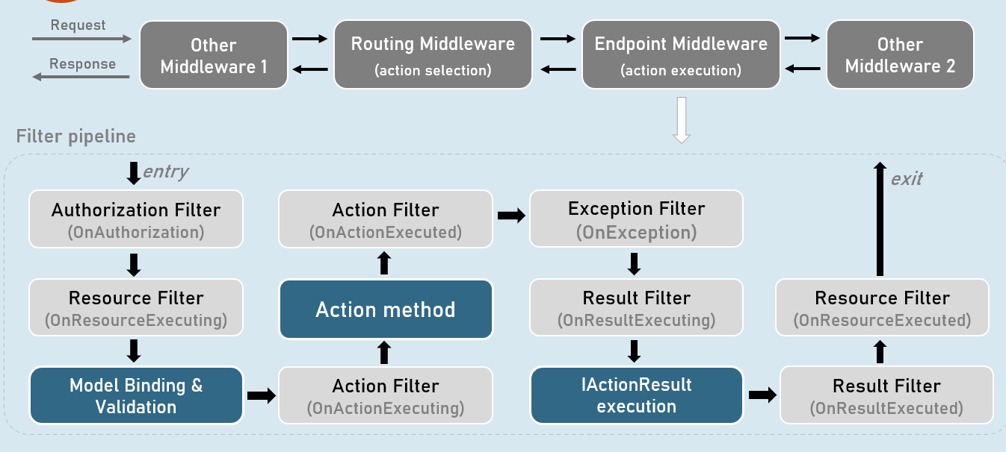

**When it runs**

Runs immediately after Authorize Filter and after Result Filter executes.

**'OnResourceExecuting' method**

It can do some work before model binding. Eg: Adding metrics to an action method.

It can change the way how model binding works (invoking a custom model binder explicitly).

It can short-circuit the action (prevent IActionResult from execution) and return a different IActionResult.

Eg: Short-circuit if an unsupported content type is requested.

**'OnResourceExecuted' method**

It can read the response body and store it in cache.

**Synchronous Resource Filter**

public class FilterClassName : IResourceFilter, IOrderedFilter

{

public int Order { get; set; } //Defines sequence of execution

public FilterClassName(int order)

{

Order = order;

}

public void OnResourceExecuting(ResourceExecutingContext context)

{

//TO DO: before logic here

}

public void OnResourceExecuted(ResourceExecutedContext context)

{

//TO DO: after logic here

}

}

**Asynchronous Resource Filter**

public class FilterClassName : IAsyncResourceFilter, IOrderedFilter

{

public int Order { get; set; } //Defines sequence of execution

public FilterClassName(int order)

{

Order = order;

}

public async Task OnResourceExecutionAsync(ResourceExecutingContext context, ResourceExecutionDelegate next)

{

//TO DO: before logic here

await next();

//TO DO: after logic here

}

}

Authorization Filter

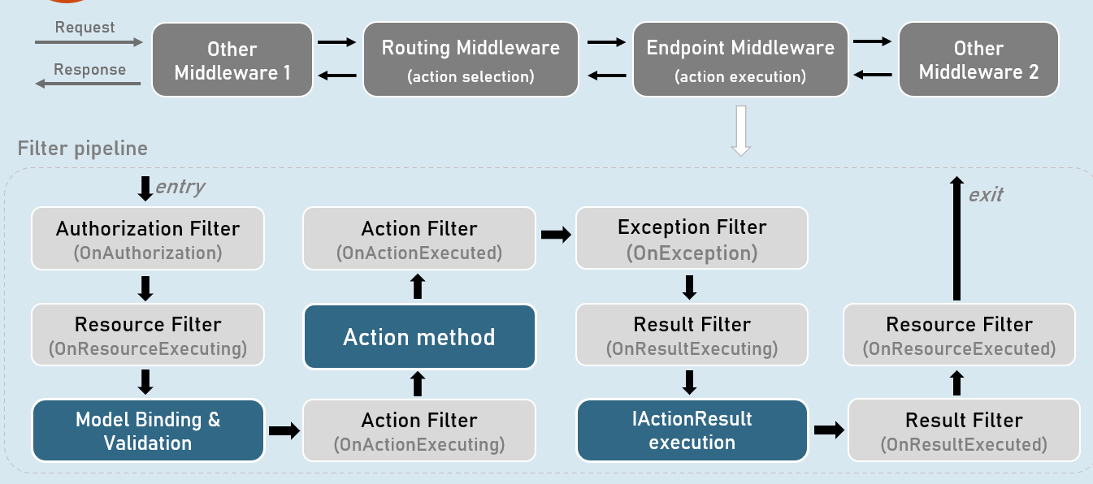

**Authorization Filters**

Runs before any other filters in the filter pipeline.

'OnAuthorize' method

Determines whether the user is authorized for the request.

Short-circuits the pipeline if the request is NOT authorized.

Don't throw exceptions in OnAuthorize method, as they will not be handled by exception filters.

**Synchronous Authorization Filter**

public class FilterClassName : IAuthorizationFilter

{

public void OnAuthorization(AuthorizationFilterContext context)

{

//TO DO: authorization logic here

}

}

**Asynchronous Authorization Filter**

public class FilterClassName : IAsyncAuthorizationFilter

{

public async Task OnAuthorizationAsync(AuthorizationFilterContext context)

{

//TO DO: authorization logic here

}

}

Exception Filter

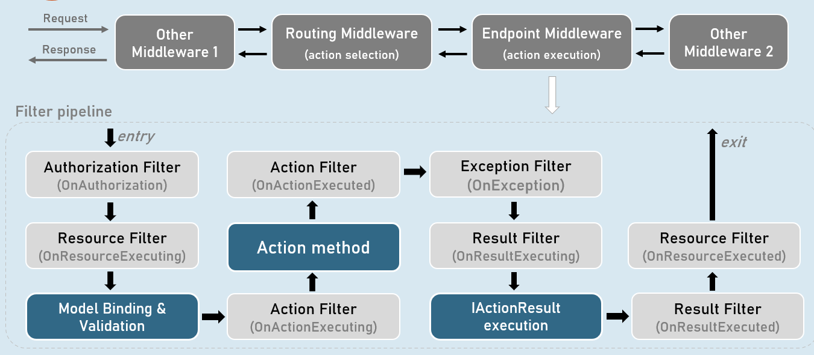

**When it runs**

Runs when an exception is raised during the filter pipeline.

**'OnException method**

Handles unhandled exceptions that occur in controller creation, model binding, action filters or action methods.

Doesn't handle the unhandled exceptions that occur in authorization filters, resource filters, result filters or IActionResult execution.

Recommended to be used only when you want a different error handling and generate different result for specific controllers; otherwise, ErrorHandlingMiddleware is recommended over Exception Filters.

**Synchronous Exception Filter**

public class FilterClassName : IAsyncExceptionFilter

{

public async Task OnExceptionAsync(ExceptionFilterContext context)

{

//TO DO: exception handling logic here, as follows

context.Result = some_action_result;

//or

context.ExceptionHandled = true;

return Task.CompletedTask;

}

}

**Asynchronous Exception Filter**

public class FilterClassName : IAsyncExceptionFilter

{

public async Task OnExceptionAsync(ExceptionFilterContext context)

{

//TO DO: exception handling logic here, as follows

context.Result = some_action_result;

//or

context.ExceptionHandled = true;

return Task.CompletedTask;

}

}

Impact of Short-Circuiting

**Short-circuiting Authorization Filter**

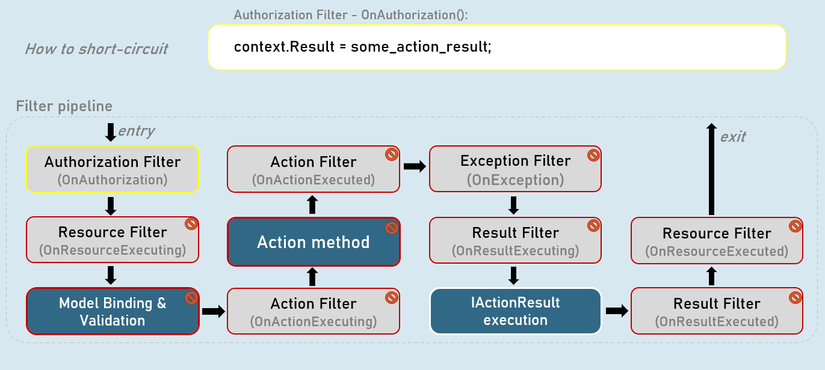

**Short-circuiting Resource Filter**

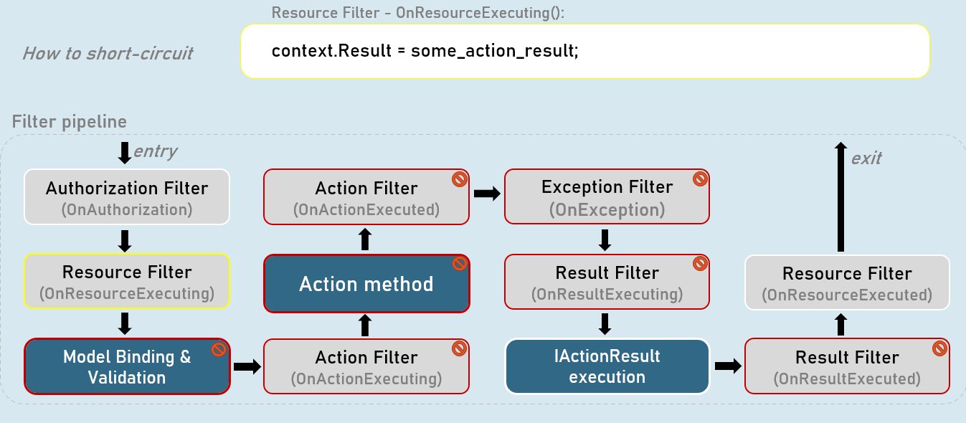

**Short-circuiting Action Filter**

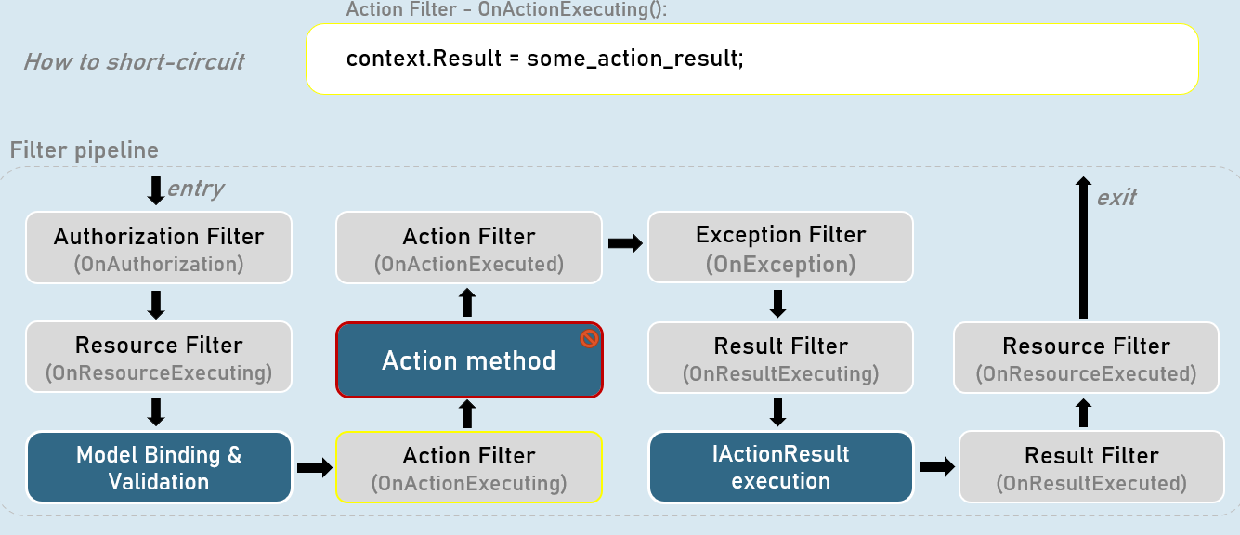

**Short-circuiting Exception Filter**

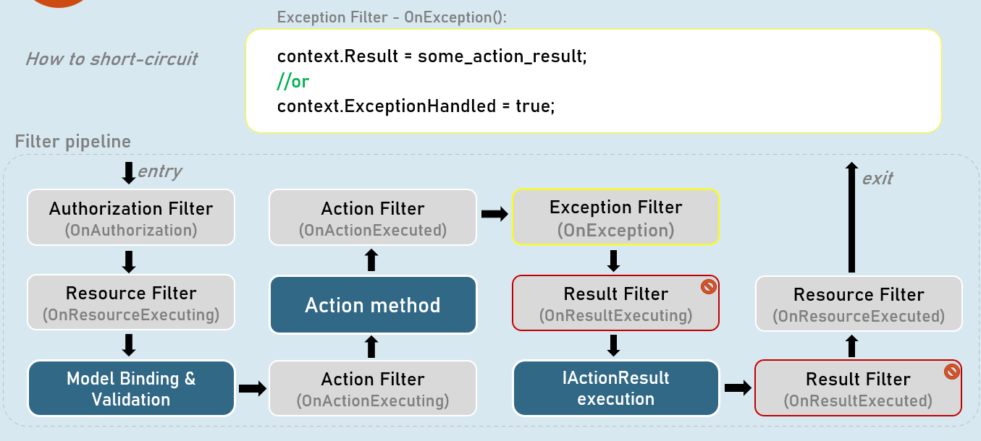

**Short-circuiting Result Filter**

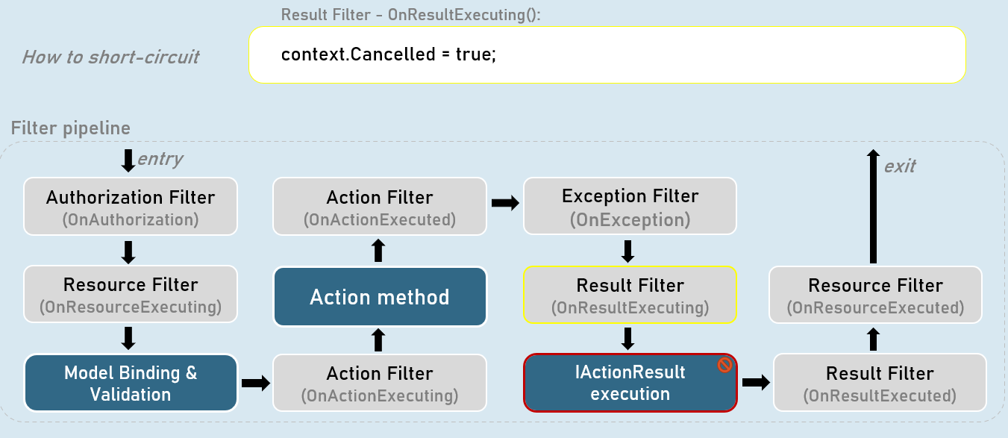

**Short-circuiting the filters**

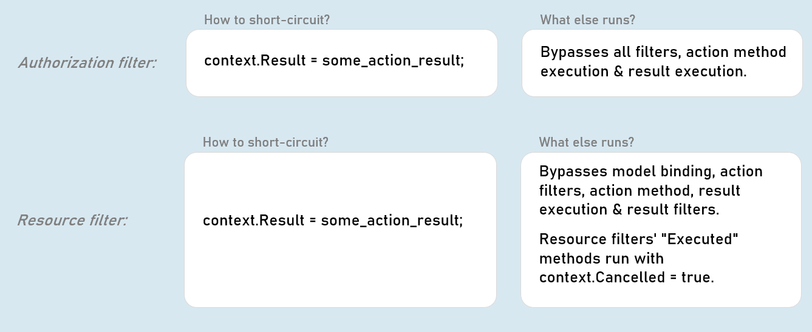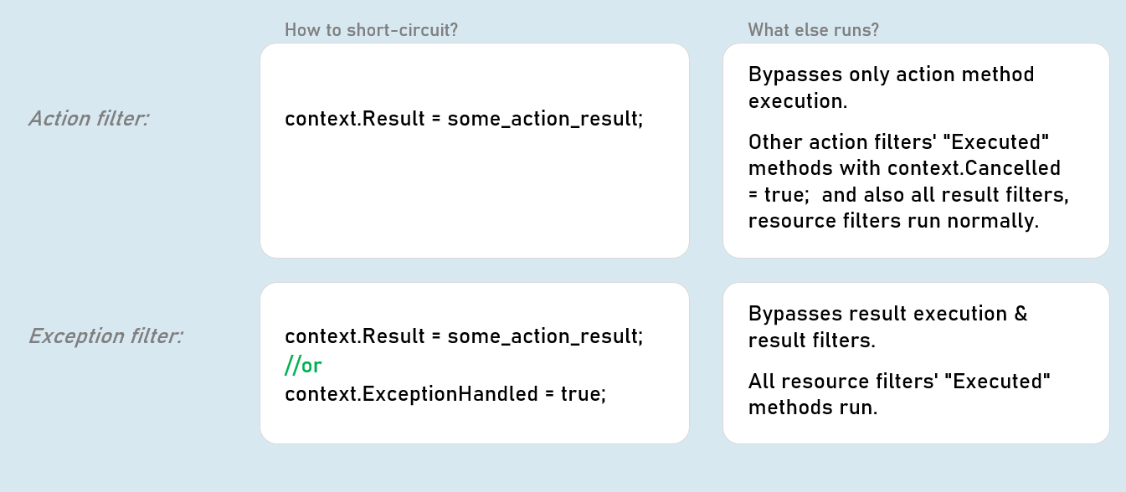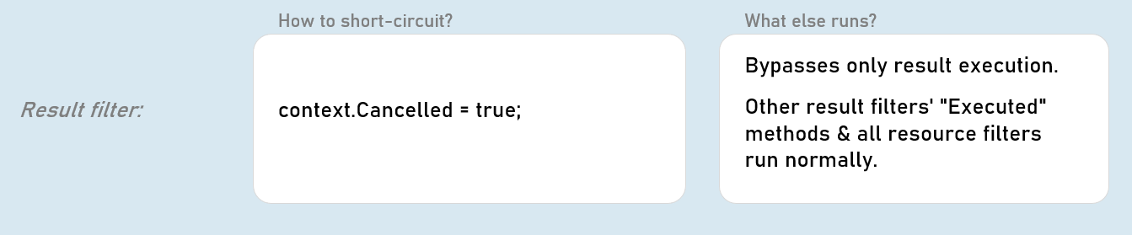

AlwaysRun Result Filter

**Short-circuiting Authorization Filter**

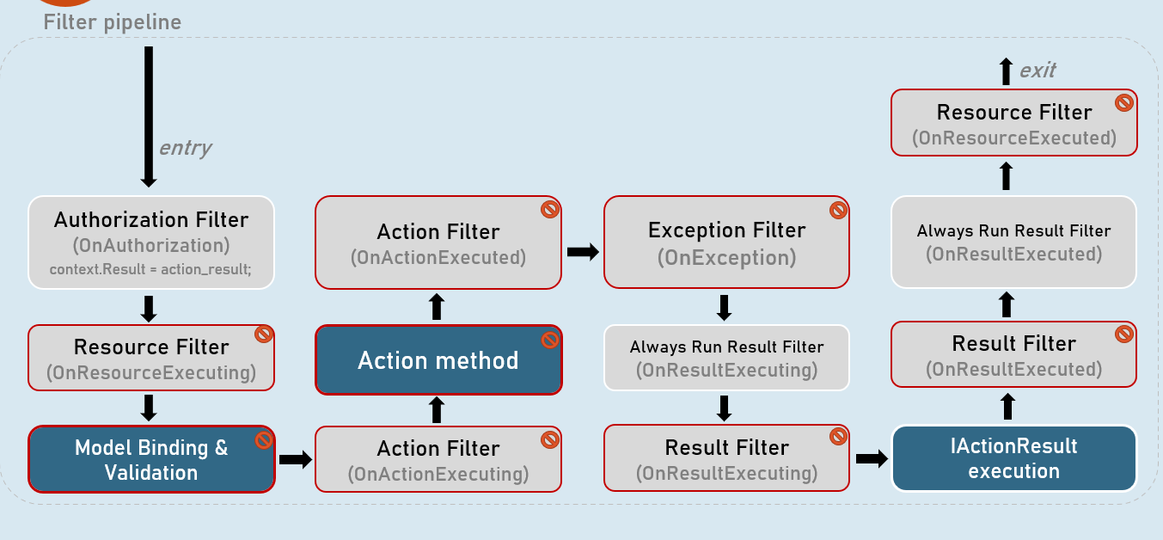

**Short-circuiting Resource Filter**

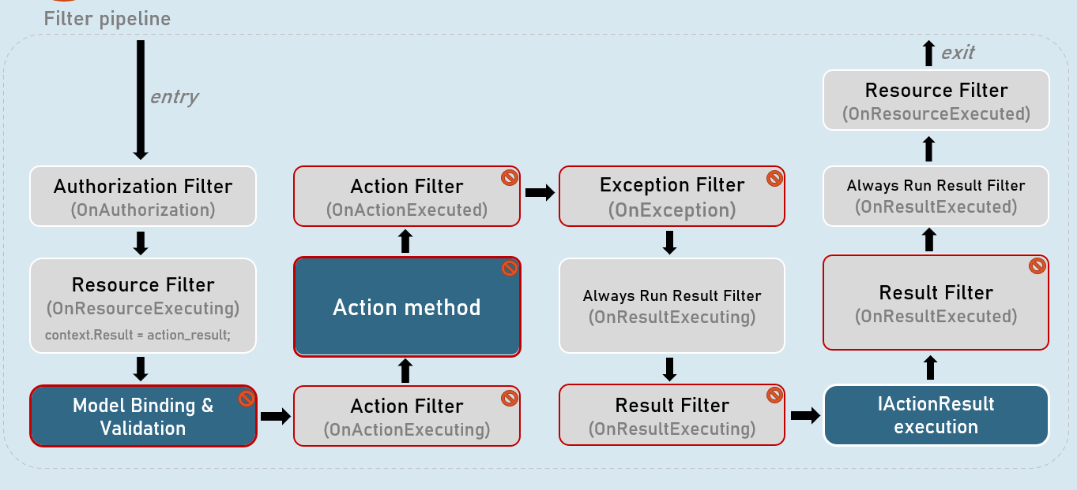

**Short-circuiting Action Filter**

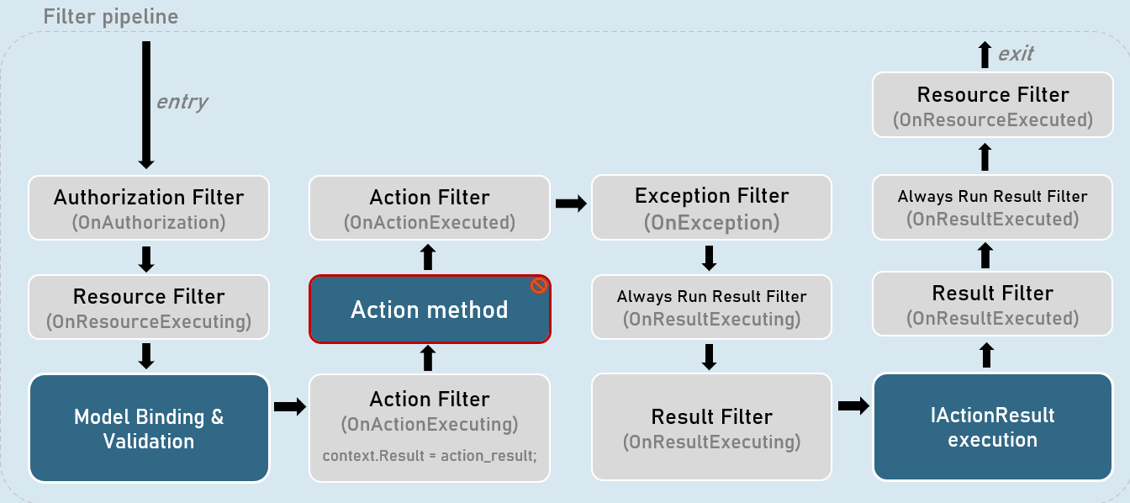

**Short-circuiting Exception Filter**

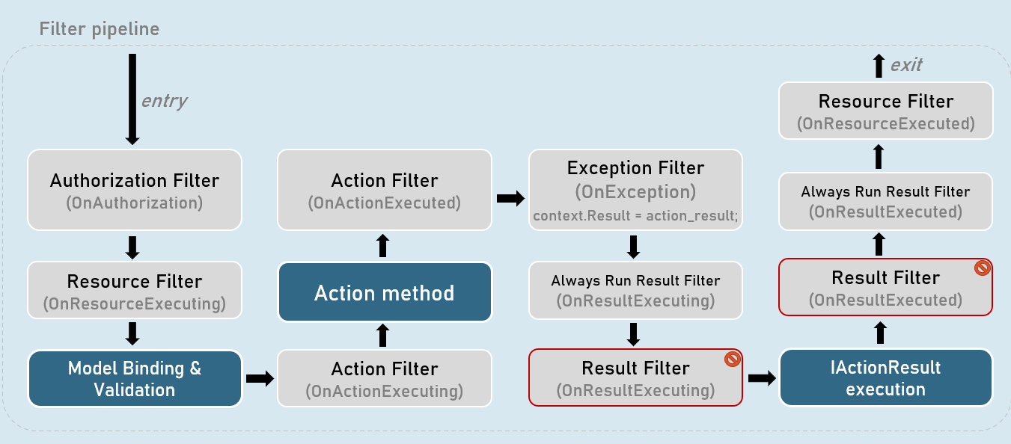

**Short-circuiting Result Filter**

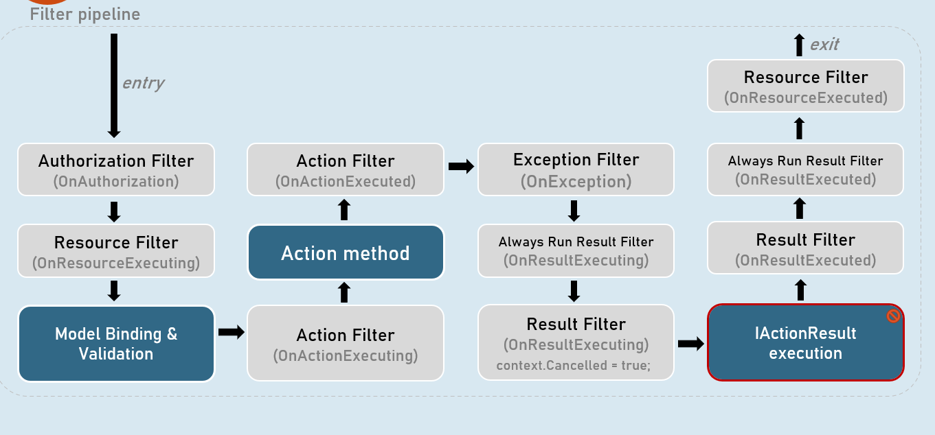

**When AlwaysRunResultFilter runs**

Runs immediately before and after result filters.

**Result filters:**

Doesn't execute when authorization filter, resource filter or exception filter short-circuits.

**AlwaysRunResult filter:**

Execute always even when authorization filter, resource filter or exception filter short-circuits.

**'OnResultExecuting' method**

Same as Result filter

**'OnResultExecuted' method**

Same as Result filter

**Synchronous Always Run Result Filter**

public class FilterClassName : IAlwaysRunResultFilter

{

public void OnResultExecuting(ResultExecutingContext context)

{

//TO DO: before logic here

}

public void OnResultExecuted(ResultExecutedContext context)

{

//TO DO: after logic here

}

}

**Asynchronous Always Run Result Filter**

public class FilterClassName : IAsyncAlwaysRunResultFilter

{

public async Task OnResultExecutionAsync(ResultExecutingContext context, ResultExecutionDelegate next)

{

//TO DO: before logic here

await next();

//TO DO: after logic here

}

}

Filter Overrides

[TypeFilter(typeof(FilterClassName))] //filter applied at controller level

public class ControllerName : Controller

{

public IActionResult Action1() //requirement: The filter SHOULD execute

{

}

public IActionResult Action2() //requirement: The filter SHOULD NOT execute. But how??

{

}

}

**Attribute to be applied to desired action method**

public class SkipFilterAttribute : Attribute, IFilterMetadata

{

}

**Action method**

[SkipFilter]

public IActionResult ActionMethod()

{

}

**Filter that respects 'SkipFilterAttribute'**

public class FilterClassName : IActionFilter //or any other filter interface

{

public void OnActionExecuting(ActionExecutingContext context)

{

//get list of filters applied to the current working action method

if (context.Filters.OfType<SkipResultFilter>().Any())

{

return;

}

//TO DO: before logic here

}

public void OnActionExecuted(ActionExecutedContext context)

{

//TO DO: after logic here

}

}

It skips execution of code of a filter, for specific action methods.

[ServiceFilter]

**Common purpose**

Both are used to apply a filter a controller or action method.

**Type Filter Attribute**

//can supply arguments to filter

[TypeFilter(typeof(FilterClassName), Arguments = new object[] { arg1, arg2 })]

public IActionResult ActionMethod()

{ …}

**Service Filter Attribute**

//can't supply arguments to filter

[ServiceFilter(typeof(FilterClassName))]

public IActionResult ActionMethod()

{ …}

**Type Filter**

Can supply arguments to the filter.

Filter instances are created by using Microsoft.Extensions.DependencyInjection. ObjectFactory.

They're NOT created using DI (Dependency Injection).

The lifetime of filter instances is by default transient (a new filter instance gets created every time when it is invoked).

But optionally, you can re-use the same instance of filter class across multiple requests, by setting a property called TypeFilterAttribute.IsReusable to 'true'.

Filter classes NEED NOT be registered (added) to the IoC container.

Filter classes CAN inject services using both constructor injection or method injection.

**Service Filter**

Can't supply arguments to the filter.

Filter instances are created by using ServiceProvider (using DI).

The lifetime of filter instances is the actual lifetime of the filter class added in the IoC container.

Eg: If the filter class is added to the IoC container with AddScoped() method, then its instances are scoped.

Filter class SHOULD be registered (added) to the IoC container, much like any other service.

Filter classes CAN inject services using both constructor injection or method injection.

**Filter attribtute classes**

**IActionFilter [vs] ActionFilterAttribute**

**[versus]**

**Action filter that implements 'IActionFilter'**

public class FilterClassName : IActionFilter, IOrderedFilter

{

//supports constructor DI

}

**Action filter that inherits 'ActionFilterAttribute'**

public class FilterClassName : ActionFilterAttribute

{ //doesn't support constructor DI}

**Filter interfaces:**

IAuthorizationFilter

IResourceFilter

IActionFilter

IExceptionFilter

IResultFilter

IAsyncAuthorizationFilter

IAsyncResourceFilter

IAsyncActionFilter

IAsyncExceptionFilter

IAsyncResultFilter

**Filter attributes:**

ActionFilterAttribute

ExceptionFilterAttribute

ResultFilterAttribute

**Action filter that implements 'IActionFilter'**

public class FilterClassName : IActionFilter, IOrderedFilter

{

public int Order { get; set; }

public FilterClassName(IService service, type arg)

{}

public void OnActionExecuting(ActionExecutingContext context)

{}

public void OnActionExecuted(ActionExecutedContext context)

{}

}

[TypeFilter(typeof(FilterClassName),

Arguments = new object[] { arg1, … })]

**Action filter that inherits 'ActionFilterAttribute'**

public class FilterClassName : ActionFilterAttribute

{

public FilterClassName(type arg)

{}

public override void OnActionExecuting(ActionExecutingContext context)

{

}

public override void OnActionExecuted(ActionExecutedContext context)

{

}

}

[FilterClassName(arg1, … )]

**Internal definitions of IActionFilter and ActionFilterAttribute**

**IActionFilter**

namespace Microsoft.AspNetCore.Mvc.Filters

{

public interface IActionFilter : IFilterMetadata

{

void OnActionExecuting(ActionExecutingContext context);

void OnActionExecuted(ActionExecutedContext context);

}

}

**ActionFilterAttribute**

namespace Microsoft.AspNetCore.Mvc.Filters

{

public class ActionFilterAttribute : Attribute, IActionFilter, IAsyncActionFilter, IOrderedFilter, IResultFilter, IAsyncResultFilter

{

public virtual void OnActionExecuting(ActionExecutingContext context) { }

public virtual void OnActionExecuted(ActionExecutedContext context) { }

public virtual void OnResultExecuting(ActionExecutingContext context) { }

public virtual void OnResultExecuted(ActionExecutedContext context) { }

public virtual Task OnActionExecutionAsync(ActionExecutingContext context, ActionExecutionDelegate next) { }

public virtual Task OnResultExecutionAsync(ResultExecutingContext context, ResultExecutionDelegate next) { }

public int Order { get; set; }

}

}

**Filter interface [vs] FilterAttribute class**

**Filter interface [such as IActionFilter, IResultFilter etc.]**

Filter class MUST implement all methods - both "Executing" and "Executed" methods.

Filter class CAN have DI with either constructor injection or method injection.

Doesn't implement "Attribute" class.

Filter should be applied to controller or action methods by using [ServiceFilter] or [TypeFilter] attributes; otherwise can be applied as global filter in the Program.cs.

Eg: [TypeFilter(typeof(FilterClassName))] //lengthy

Filter class can receive arguments only through constructor parameters; but only with [TypeFilter] attribute; not with [ServiceFilter] attribute.

**FilterAttribute class [such as ActionFilterAttribute etc.]**

Filter class MAY override desired (either or both methods - "Executing" and "Executed") methods.

Filter class CAN'T have DI with neither constructor injection nor method injection.

FilterAttribute class [such as ActionFilterAttribute etc.]

Filter can be applied to controller or action methods by directly using the filter class name itself (without using [ServiceFilter] or [TypeFilter] attributes); otherwise can be applied as global filter in the Program.cs.

Eg: [FilterClassName] //simple

Filter class can receive arguments either through constructor parameters or filter class's properties.

IFilterFactory

**Filter factory that inherits 'IFilterFactory'**

public class FilterClassNameAttribute : Attribute,

IFilterFactory

{

public type Prop1 { get; set; }

public FilterClassName(type arg1, type arg2)

{

this.Prop1 = arg1; this.Prop2 = arg2;

}

public IFilterMetadata CreateInstance(IServiceProvider serviceProvider)

{

FilterClassName filter = serviceProvider.GetRequiredService<FilterClassName>(); //instantiate the filter

filter.Property1 = Prop1;

…

return filter;

}

}

[FilterClassName(arg1, arg2, … )]

**Action filter that inherits 'ActionFilterAttribute'**

public class FilterClassName : ActionFilterAttribute

{

public FilterClassName(type arg1, type arg2)

{

}

public override void OnActionExecuting(ActionExecutingContext context)

{

}

public override void OnActionExecuted(ActionExecutedContext context)

{

}

}

[FilterClassName(arg1, arg2, … )]

**IFilterFactory**

1. namespace Microsoft.AspNetCore.Mvc.Filters
2. {
3. public interface IFilterFactory : IFilterMetadata
4. {
5. IFilterMetadata CreateInstance(IServiceProvider serviceProvider);
6. bool IsReusable { get; }
7. }
8. }

**FilterAttribute class [such as ActionFilterAttribute etc.]**

Filter CAN be applied as an attribute to the controller or action method. Eg: [FilterClassName]

Filter class CAN'T have DI with neither constructor injection nor method injection.

Filter class CAN receive arguments either through constructor parameters or filter class's properties.

**IFilterFactory**

Filter CAN be applied as an attribute to the controller or action method. Eg: [FilterClassName]

Filter class CAN have DI with either constructor injection or method injection.

Filter class CAN receive arguments only through filter class's properties, if it is instantiated through ServiceProvider (using DI).

Alternatively, if you don't need to inject services using DI in the filter class; you can instantiate the filter class with 'new' keyword, in the CreateInstance() method of IFilterFactory; then the filter class can receive arguments either as constructor parameters or properties.

Filters [vs] Middleware

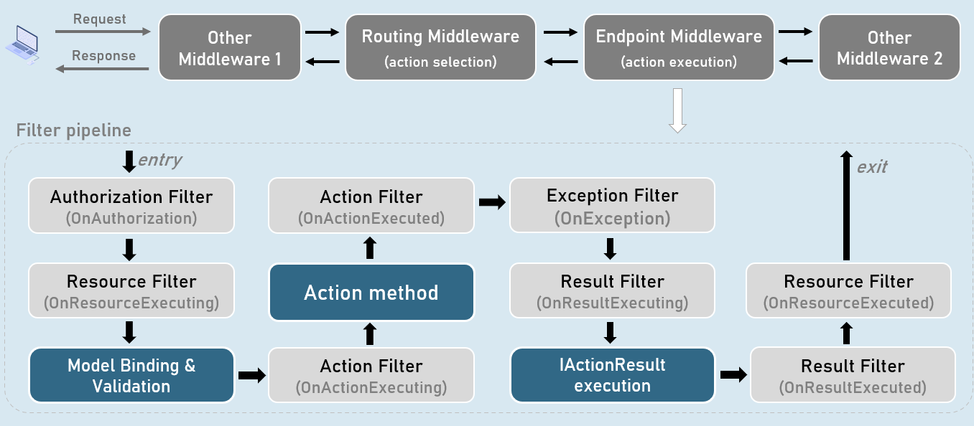

**Middleware**

Middleware pipeline is a superset of Filter pipeline, which contains the full-set of all middlewares added to the ApplicationBuilder in the application's startup code (Program.cs).

Middleware pipeline execute for all requests.

Middleware handles application-level functionality such as Logging, HTTPS redirection, Performance profiling, Exception handling, Static files, Authentication etc., by accessing low-level abstractions such as HttpContext.

**Filter**

Filter pipeline is a subset of Middleware pipeline which executes under "EndPoint Middleware".

In addition, filter pipeline executes for requests that reach "EndPoint Middleware".

Filters handle MVC-specific functionality such as manipulating or accessing ViewData, ViewBag, ModleState, Action result, Action parameters etc.

**Middleware Pipeline**

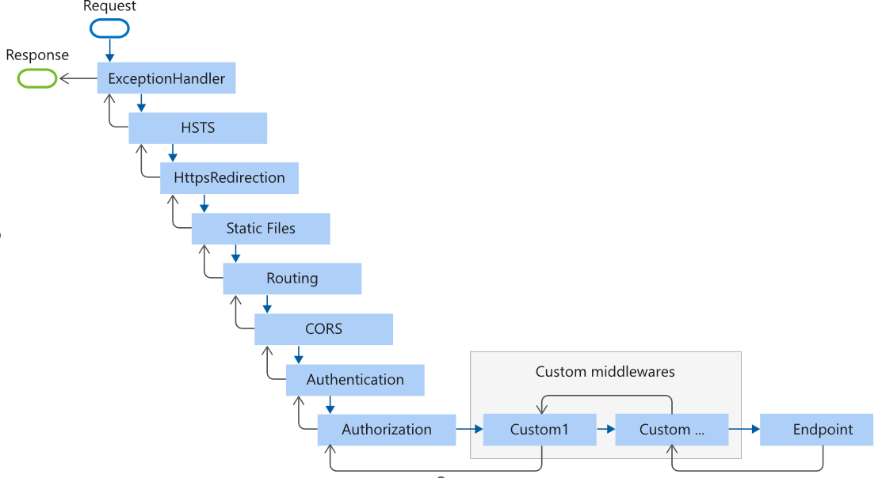

Exception Handling Middleware

Handles all errors occurred in filter pipeline (including model binding, controllers and filters).

Should be added to the application pipeline, before RoutingMiddleware.

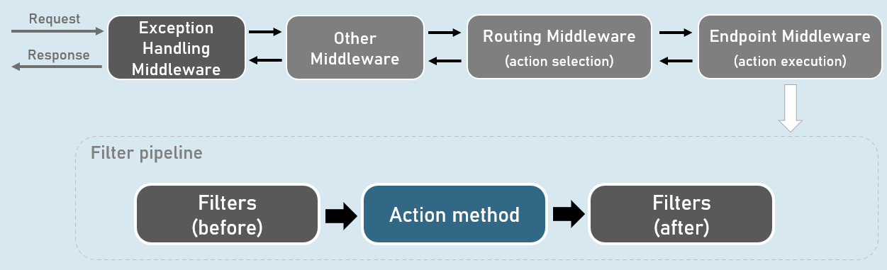

**Custom Exception Handling Middleware**

public class ExceptionHandlingMiddleware

{

private readonly RequestDelegate _next; //Stores reference of subsequent middleware

public ExceptionHandlingMiddleware(RequestDelegate next)

{

_next = next;

}

public async Task InvokeAsync(HttpContext context)

{

try

{

await _next(context);

}

catch(Exception ex)

{

…

}

}

}

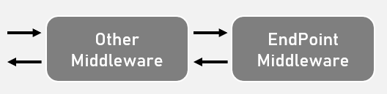

**Custom Exceptions**

A custom exception class is an exception class that inherits from System.Exception class & represents a domain-specific excpetion

Used to represent the domain-specific errors stand-out of system-related (.NET) related exceptions.

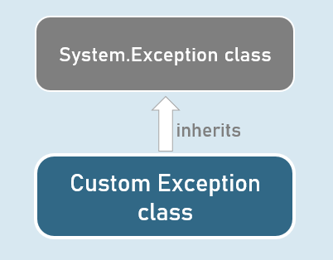

**Custom Exception class**

public class CustomException : Exception

{

public CustomException() : base()

{

}

public CustomException(string? message) : base(message)

{

}

public CustomException(string? message, Exception? innerException) : base(message, innerException)

{

}

}

**UseExceptionHandler()**

The built-in UseExceptionHandler() middleware redirects to the specified route path, when an unhandled exception occurs during the application execution.

Can be used as an alternative to custom exception handling middleware.

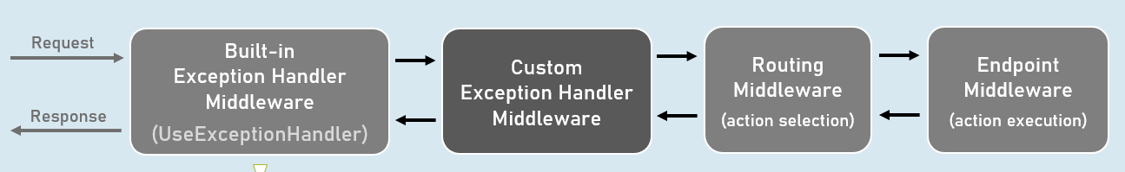

Catches and logs unhandled exceptions.

Re-executes the request in an alternative pipeline using the specified route path.