**Overview of Minimal API**

- It is a Microsoft's API that is used to create HTTP services (or HTTP APIs) with minimal dependencies on packages.

- Alternative to Web API Controllers. Mainly used to create HTTP services or Microservices.

**REST API (Representational State Transfer)**

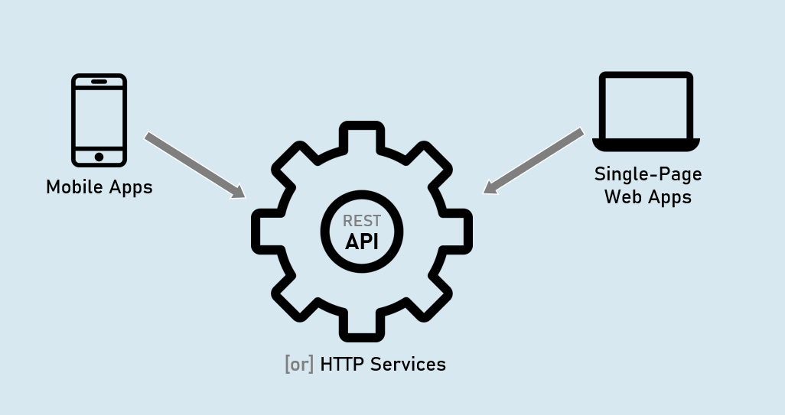

**MVC Controller (Microsoft.AspNetCore.Mvc.Controller)**

Full support for model binding and model validation.

Full support for views.

Full support for filters & filter pipeline.

**API Controller (Microsoft.AspNetCore.Mvc.ApiControllerAttribute)**

Full support for model binding and model validation.

No support for views.

Full support for filters & filter pipeline.

**Minimal API**(IApplicationBuilder.Map* Methods)

Limited support for custom model binding and custom model validation (needs to improve).

No support for views.

No support for filters & filter pipeline; but supports "Endpoint Filters" alternatively.

Routing in Minimal API

**1. MapGet()**

Creates an endpoint that receives HTTP GET request.

app.MapGet("/route", async (HttpContext context) => {

await context.Response.WriteAsync("your response");

});

**2. MapPost()**

Creates an endpoint that receives HTTP DELETE request.

app.MapDelete("/route", async (HttpContext context) => {

await context.Response.WriteAsync("your response");

});

**3. MapPut()**

Creates an endpoint that receives HTTP PUT request.

app.MapPut("/route", async (HttpContext context) => {

await context.Response.WriteAsync("your response");

});

**4. MapDelete()**

Creates an endpoint that receives HTTP DELETE request.

app.MapDelete("/route", async (HttpContext context) => {

await context.Response.WriteAsync("your response");

});

Route Parameters in Minimal API

Route parameters can be created as you were creating them in UseEndpoints() or in MVC controllers.

app.MapGet("/route/{parameter}", async (HttpContext context) => {

await context.Response.WriteAsync("your response");

});

Route Constraints in Minimal API

Route constraints can be used as you were using them in UseEndpoints() or in MVC controllers.

app.MapGet("/route/{parameter:constraint}", async (HttpContext context) => {

await context.Response.WriteAsync("your response");

});

Eg: int, bool, datetime, decimal, double, float, guid, long, Minlength, maxlength, length, min, max, range, alpha, regex, required

Map Groups in Minimal API

A map group (or route group) is a set of endpoints with a common prefix.

A map group is a collection of endpoints created with Map* methods such as MapGet(), MapPost() etc.

**MapGet()**

Creates an endpoint that receives HTTP GET request.

var mapGroup = app.MapGroup("/route-prefix");

mapGroup.MapGet(…);

mapGroup.MapPost(..);

IResult

The Microsoft.AspNetCore.Http.IResult is the base interface that is implemented by different result types such as Ok, Json, BadRequest etc., which can be returned by endpoints in minimal API.

Results.Ok( )

Results.Json( )

Results.Text( )

Results.File( )

Results.BadRequest( )

Results.NotFound( )

Results.Unauthorized( )

Results.ValidationProblem( )

IResult Implementations

**1. Results.Ok**

Response Content-type: application/json [or] text/plain

Response Status Code: 200

return Results.Ok(response_object); //can be a string or model

**2. Results.Json**

Response Content-type: application/json

Response Status Code: 200

return Results.Json(response_object); //should be a model

**3. Results.Text**

Response Content-type: text/plain

Response Status Code: 200

return Results.Text(response_string); //should be a string

**4. Results.File**

Response Content-type: application/octet-stream

Response Status Code: 200

return Results.File(stream_object); //should be 'System.IO.Stream' type

**5. Results.BadRequest**

Response Content-type: N/A

Response Status Code: 400

return Results.BadRequest(response_object); //can be a string or model

**6. Results.NotFound**

Response Content-type: N/A

Response Status Code: 404

return Results.NotFound(response_object); //can be a string or model

**7. Results.Unauthorized**

Response Content-type: N/A

Response Status Code: 401

return Results.Unauthorized(response_object); //can be a string or model

**8. Results.ValidationProblem**

Response Content-type: application/json

Response Status Code: 400

return Results.ValidationProblem(response_object); //automatically creates JSON with validation errors

Endpoint Filter

EndPoint Filters execute much like 'action filters' i.e., 'before' and 'after' the execution of minimal API endpoint.

They are mainly used to validate parameters of the endpoint.

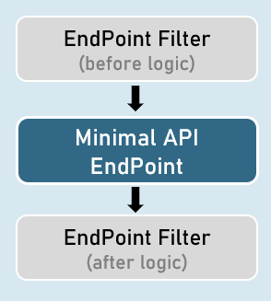

**Creating an Endpoint Filter**

Endpoint filters can be registered by providing a Delegate that takes a EndpointFilterInvocationContext and returns a EndpointFilterDelegate.

app.MapGet("/route", () => {

//your endpoint code here

})

.AddEndpointFilter(async (context, next) => {

//before logic

var result = await next(context); //calls subsequent filter or endpoint

//after logic

return result;

});

IEndpointFilter

Creating an Endpoint Filter by implementing IEndpointFilter interface

The InvokeAsync() method takes a EndpointFilterInvocationContext and returns a EndpointFilterDelegate.

class CustomEndpointFilter : IEndpointFilter

{

public async ValueTask<object?> InvokeAsync(EndpointFilterInvocationContext context, EndpointFilterDelegate next)

{

//before logic

var result = await next(context); //calls subsequent filter or endpoint

//after logic

return result;

}

}