WEEKLY PROJECT PROGRESS REPORT
Project Topic
AI-Based Driver Behavior Monitoring System (Software-In-the-Loop Prototype)
Project Title | AI-Based Driver Behavior Monitoring System
Report Type | Weekly Project Progress Report
Week / Phase | Week 3
Student Name | Ankur Chopde, Gaurav Kulkarni, Rushikesh Dike
Guide / Supervisor | Dr. Vijay Gaikwad
Department | Electronics and Telecommunication
Report Date | 29 August 2026

Objective of This Week
The primary objective of Week 3 was the completion and functional simulation of the integrated MATLAB/Simulink driver monitoring prototype. This involved combining the previously developed Drowsiness, Distraction, and Driver Identification components into a single Simulink environment, resolving integration challenges, and conducting functional testing.

Work Completed This Week
1. Integrated Section 1 (Drowsiness), Section 2 (Distraction), and Section 3 (Driver Identification) into a final MATLAB/Simulink dashboard.
2. Configured custom UDP telemetry (88-byte packet) to transmit 11 spatial/state variables at exactly 20 Hz from Python to MATLAB.
3. Configured Stateflow/Simulink temporal persistence filters (e.g., 2-second delay for drowsiness) to avoid false-positive alerts.
4. Conducted functional testing using open-source datasets and local webcam feeds.

Simulink Model Developed
The final architecture consists of a Python Vision Node that captures webcam frames and computes metrics using MediaPipe and ONNX SFace in <50ms. A custom MATLAB System Object (UDPReceiverSystemIdentification.m) unpacks the byte stream into 11 distinct signal lines in Simulink, which are then passed through temporal logic gates to trigger actionable alerts.

Drowsiness, Distraction & Identification Implementation
- Drowsiness Detection: Tracks Eye Aspect Ratio (EAR < 0.20) and Mouth Aspect Ratio (MAR > 0.60) with a 2-second persistence filter to ignore normal blinks.
- Distraction Detection: Analyzes Head Pose (Yaw > 30 degrees, Pitch > 20 degrees) using OpenCV solvePnP on the 3D face mesh, also gated by a 2-second persistence timer.
- Driver Identification: Utilizes an ONNX face recognizer to compare real-time embeddings against a local database, using a 0.363 cosine similarity threshold and 10-frame persistence.

Alert / Decision Logic
The logic combines raw signals with state transitions. The system only registers an unsafe state if the condition persists beyond the predefined temporal threshold, at which point an alert is output on the Simulink dashboard.

Simulation / Testing
Test Scenario | Detected State | Expected Output | Observed Output | Status
Prolonged Eye Closure | EAR < 0.20 for 2s | Drowsiness Alert | Triggers at 2.0s mark | PASS
Head turned right | Yaw > 30 deg for 2s | Distraction Alert | Triggers on lateral move | PASS
Normal Blink | EAR < 0.20 for 0.5s | No Alert | Filtered by logic | PASS
Known Driver | Similarity > 0.363 | Access Granted | Validated ID | PASS

Current Progress Summary

Level | Task | Status
Level 1 | Drowsiness Module | Completed
Level 2 | Distraction Module | Completed
Level 3 | Driver Identification | Completed
Level 4 | UDP Integration & Simulink Dashboard | Completed
Level 5 | Edge-AI Hardware Deployment (Raspberry Pi) | Not Started
Level 6 | Real Vehicle Hardware Testing | Not Started

Problems and Solutions
Problem: Simulink System Object paths failing to resolve on startup.
Cause: Missing bindings for the custom MATLAB System Object cross-section dependencies.
Solution: A startup.m script was implemented to ensure paths are properly bound before opening the Simulink model.
Status: Resolved.

Simulation Results Screenshot
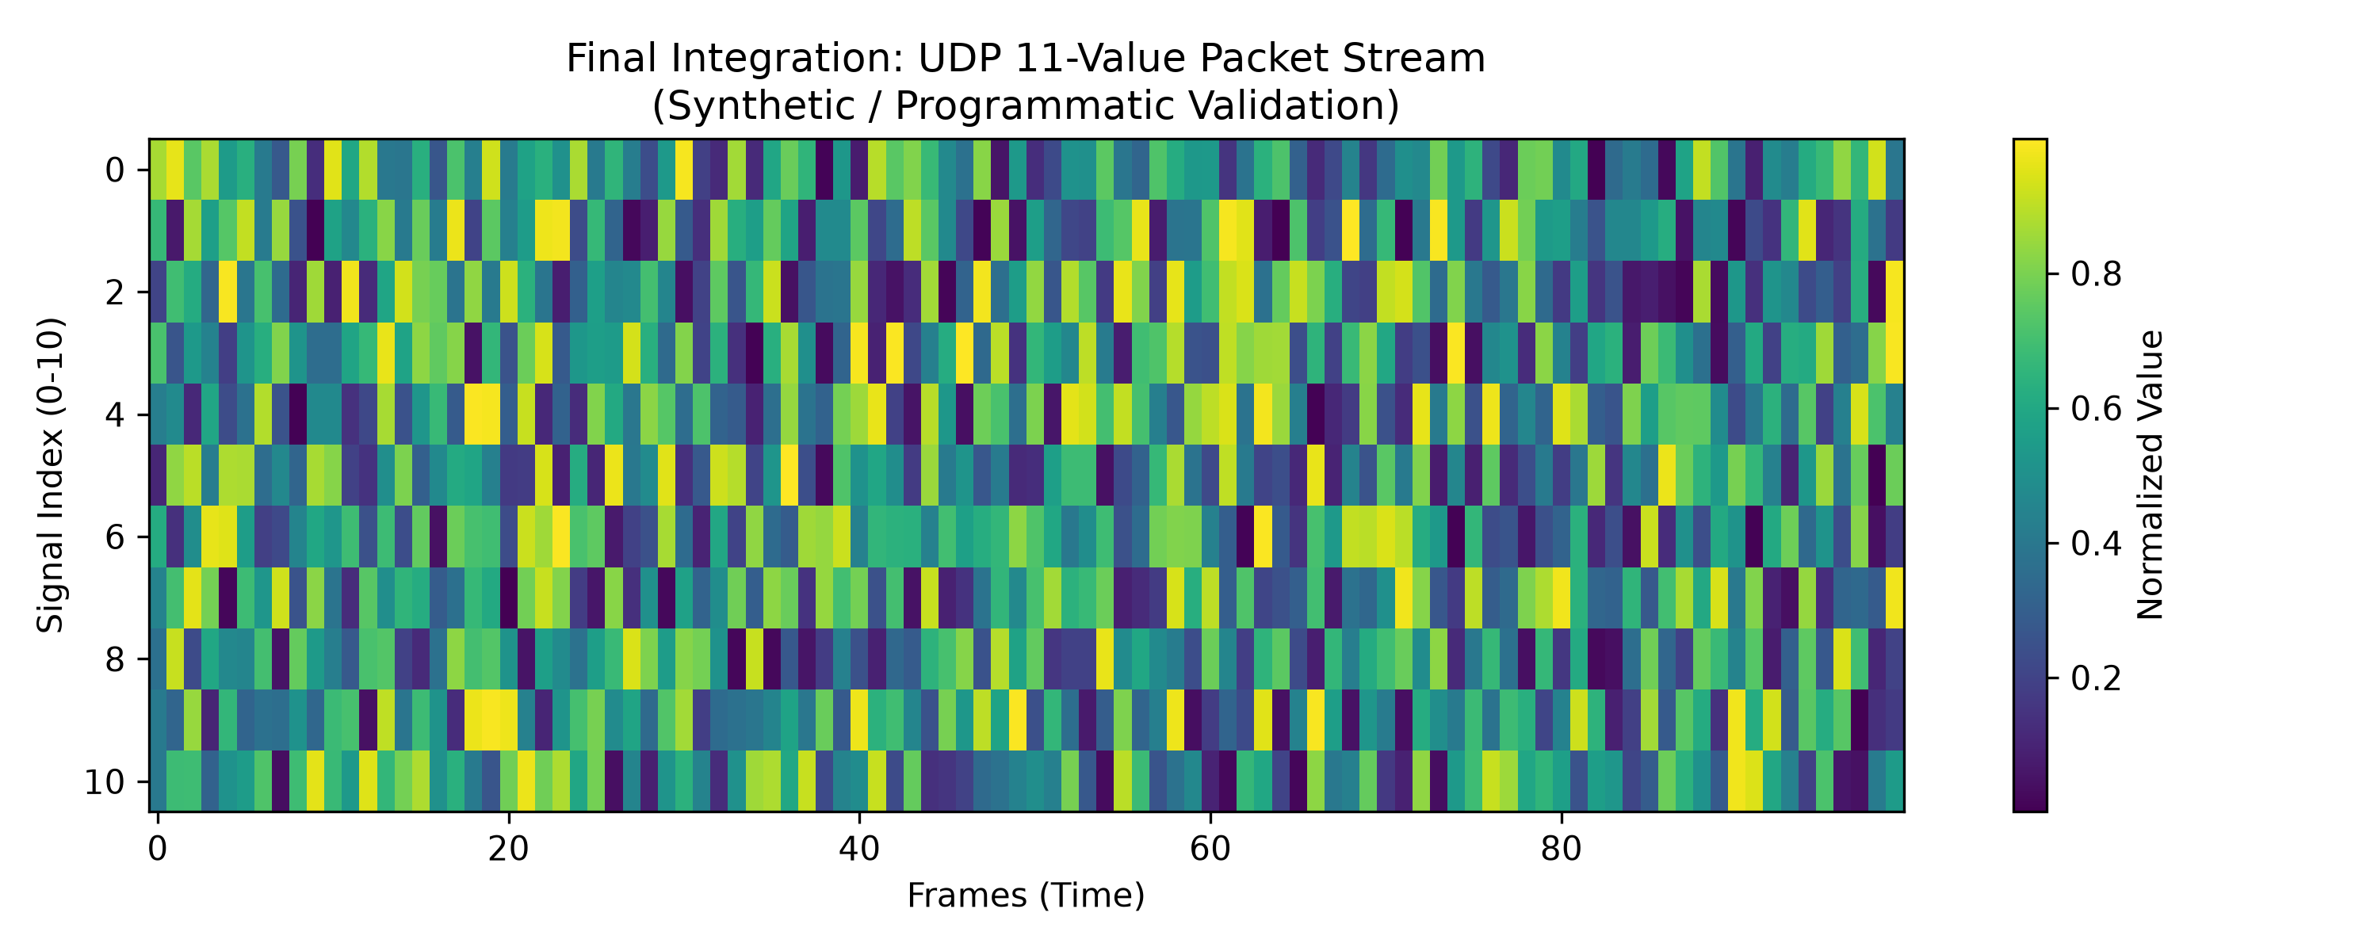
Figure 1: Integrated MATLAB/Simulink Driver Monitoring Model Dashboard and 11-value UDP telemetry scopes.

Next Week's Work Plan

# | Planned Task | Priority
1
2
3
4
5
6
7
8

Expected Next-Level Model
The expected next-level model involves an Edge-AI accelerated device (Raspberry Pi 4/5) with TFLite/ONNX deployment running independent of the PC, signaling physical hardware (e.g., haptic seat vibrations) instead of Software-In-the-Loop scopes.

Observations and Recommendations
While Software-In-the-Loop functional simulation successfully validates the deterministic logic, real-world conditions introduce environmental variance. The SFace cosine similarity threshold (0.363) and illumination tolerance must be calibrated under actual automotive cabin lighting conditions.

Conclusion of This Week
Week 3 successfully delivered the integrated simulation prototype. All three main vision subsystems communicate reliably with Simulink at 20 Hz, satisfying the project's software integration and functional simulation objectives.

Prepared by: | ________________________ | Date: | ____________
Reviewed by (Guide): | ________________________ | Date: | ____________

