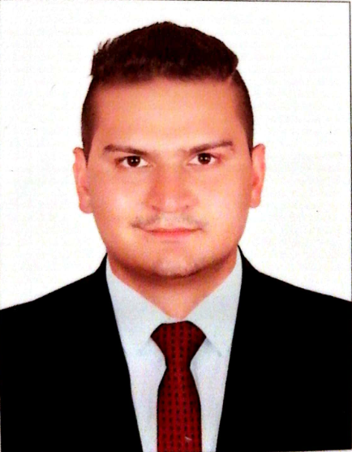  DEEPAK GUSAIN  Captain,  The Cove Rotana Resort  Ras Al Khaima,  UAE.  Phone  +971501861127  Skype:  deepakgusain2429@gmail.com  Email: deepakgusain2424@gmail.com  Personal Data  Date of Birth:  October 07,1992  Nationality:  Indian  Language:  English- Fluent  Hindi-Native Language  Passport Details  Passport No:K6478484  Date of Issue: 27/07/2012  Date of Expiry:26-07-2022  Place of issue: Dehradun, Uttarakhand, India | CURRICULUM VITAE  Experience Five years + Bar Hospitality Industry  OBJECTIVE  To be an absolute professional who symbolizes the ‘sprit’ of service in Hospitality Industry  with ultimate professionalism, hard work and dedication.  EXPERIENCE  Worked as Restaurant Captain at The Cove Rotana Resort, Ras –al-Khaimah, (UAE).  -From May 2017 to Present  -Restaurant Incharge (All day dinning ).  Worked as Bartender at The Cove Rotana Resort, Ras –al-Khaimah ,(UAE ).  From April 2016 to May 2017.  Worked as Guest service associate at The Cove Rotana Resort, Ras –al-Khaimah,( UAE)  From July 2015 to April 2016  Worked as Guest service associate at J.W MARRIOTT, Chandigarh(INDIA)  From July 2013 to June 2015.  Internship at ITC Mughal the Luxury Collection Hotel , Agra (INDIA)  From October 2011 to April 2012.  ACADEMICS  - 2010-2013: Degree In Hotel Management and Catering Technology  In Chitkara University ,Chandigarh , India  ACHIEVEMENTS  - Department Trainer(DT) August 24, 2017,  - Destination Leadership, July 12, 2019  - Food Safety in Catering, March 26 ,2016  - Employee of the month, April 2015,  - Employee of the month, July 2016,
TRAINING AND SKILLS
- Cashiering
- Payroll
- Computer Literate- MS word, Excel, Power point
- Oasys
- Micros
- Wines and Bar Services
- Bayan

REFRENCE :1)

NAME : Shekhar Shubhendu
DESIGNATION: Restaurant Manager
CONTACT NO: +971-503681024

REFRENCE :2)
NAME : Mr. Mahmoud Rateb
DESIGNATION: Speciality Outlet Manager
CONTACT .NO:+971-566447463

ABOUT MYSELF
Optimistic, self confident, committed and responsible. Always explore and utilize professionalism and have a positive attitude towards everything. Good team worker, Co-operative & Willing to shoulder responsibilities

I hereby declare that the information furnished above is true to the best of my knowledge.

Deepak Gusain 25-04-2021
___________________________________

