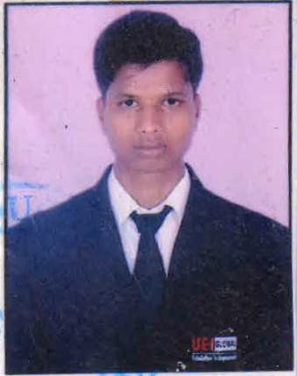CURRICULUM-VITAE.

***PUNEET KUMAR***

***Address:-VILLAGE – KUSAILA DISTRICT SITAPUR PIN CODE-261141***

***Contact:- 9794740775 ,7317243999***

***E-mail:- [puneetvishwakarma75@gmail.com](mailto:puneetvishwakarma75@gmail.com)***

***CARRER OBJECTIVE***

* *To achieve a trustworthy position in the organization from where I can contribute in the development of the organization and my individual goals with developing my skills.*

***ACADEMIC QUALIFICATION***

* *Graduation complete in hotel managment in year 2018 from UEI Global Lko*
  + *Intermediate from UP Board Passed 2015.*
* *High School from UP Board Passed 2013*

***PROFESSIONAL QULIFICATION***

* *B HM completed from UEI Global institute of Hotel Management Lucknow.*
* *Basic*
  + *Knowledge of Computer.*
  + *NCC (A) certificate .*

***EXPERIENCE***

* *1 Year Experience in ODC in Taj Hotel Lucknow.*
* *Industrial Traning Pride Plaza Hotel Ahmbadabad 6 month year 2016*
* *Job Traning sarover Portico Hotel Lucknow 6 month year 2017*
* *G S A master Chef Pankaj Bhadouria Restaurant Cafe By Defult 1 year Experience2018*

### Sr. G S A Clark premier hotel Kota Rajsthan 1 year 6 month Experience year 2019

### L2 Barbeque Nation Hospitality LTD One Year Experience year 2020 currently working

***HOBBIES***

* + *Swimming and traveling.*
  + *playing chess*

***STRENGTH***

* *Believe in Team Work*
* *Positive attitude*
* *Adjust in any work Environment.*

***PERSONAL DETAILS***

* ***Date of birth :*** *15/03/1998*
* ***Father Nam :*** *Mr. Shri krishna*
* ***Marital Status :*** *Unmarried.*
* ***Sex :*** *Male.*
* ***Nationality :*** *Indian.*
* ***Religion :*** *Hindu.*
* ***Language :*** *Hindi &English.*

***AIM***

* *To be a person who can lead professional life with full confidence and self respect.*

***DECLARATION***

* *I hereby declare that the above information and particulars are true and correct to the best of my knowledge and belief.*

### REFERENCE

***Mr. Amit Kumar***

***UEI Global Acadmic Director.***

# Date :

***Place : (PUNEET KUMAR)***