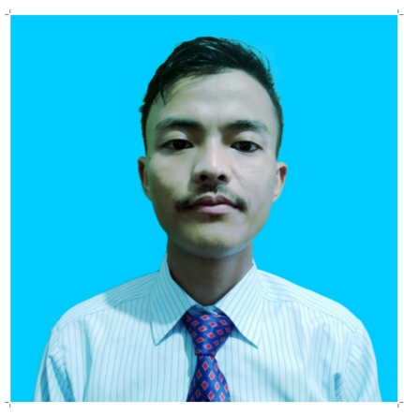

**Pawal Thapa**

**Date of Birth : 09th october** 1994

**Address : Gielle tea estate ward 6**

**District :**  Darjeeling

West Bengal 734226

**Contact No :** +917908942352,+919986629464

**Email : pwlthapa1@gmail.com**

Area of Interest: Food & Beverage Service

Career Objective

* An enthusiastic individual looking for a guest service associate position in your organisation. Offering friendly and neat personality, exceptional ability "to think on my feet" and offer good knowledge of the food and beverage service to provide excellence in hospitality service.

Educational History

* Diploma in Hospitality Management from Donbosco technical institute of kalimpong
* Passed 12th Standard from W.B.C.H.S.E in 2013
* Passed 10th Standard from W.B.B.S.E in2011

Professional Experience

* **RADISSON BLU BENGALURU KARNATAKA INDIA (09 DECEMBER 2019 TO 30th APRIL 2020)**

* **JW MARRIOTT MUSSOORIE WALNUT GROVE AND RESORT (05 JUNE 2017 TO 01 JULY 2019 INDIA)**

**F&B Service As G.S.A**

* Responsible for the setup of an area for the busy in-room dining service as per the standards .
* Responsible for the setup of the restuarant as per the standard.
* Ensuring cleaning and maintenance of the required appliances of the resturant before the operation.
* Maintaing daily inventory of required cutlery and crockery with proper handover.
* Upselling of signature dish.
* Monitoring the stock and consumption of different beverages and food to control the cost and monitoring the expiry date of non alcoholic beverage and other product to follow the first in and first out method.
* Taking feedback from the guest to ensure their satisfactions.
* Responsible for the closing procedure of the restuarant and as well as in-room dining in terms of cleanliness and billing.

* **Accord Puducherry (INDIA)**

**F&B Service As GDA (29th sep 2015 to 04 oct 2016)**

* Responsible for setup of an area of the restuarant as per the standard .
* Taking customer order and delivering food and beverages on the table.
* Guest voice updates.
* Menu recommendation.
* Updates of monthly inventory.
* Responsible for the closing of the restuarant in terms of cleanliness and billing.
* Undergone task force at Marriott hotel and resorts kochin for 1 month.
* undergone task force at Marriott hotel and resorts jaiselmer for 3 month.

Computer Skills

* Knowledge of M.S. Office and Internet
* Good knowledge of Micros System and IDS System

Key Skills

* Ability to work under the pressure.
* Patience.
* Problem solving.
* To be patient and diplomatic when dealing with complaints.
* Engaged customers in a sincere and friendly manner.

Language Ability

* English : Excellent
* Hindi : Excellent
* Nepali : Excellent

**Hobbies**

* Playing guitar & Travelling.
* Swimming & listening music.

**Strength**

* Multi task.
* Positive attitude.
* Reliable.
* Sell to customer needs.

Personal Details

C/o : Pawal Thapa

Date of birth. : 09TH October1994

Nationality : Indian

Marital Status : Unmarried

**Declaration**

I hereby declare that all the above furnished information is true to the best of my knowledge.

DATE: 04th Sep 2021

PLACE: Darjeeling (PawalThapa)