**PRACTICAL EXAM QUESTIONS JULY 2023**

**COURSE MCA**

**SEMESTER 1**

**SUBJECT CODE V20PC102**

**OPERATING SYSTEM LAB**

ENROLLMENT NUMBER – EC2332251010074  
NAME OF THE STUDENT – ANKUR CHAUDHARY  
DATE – 12-07-2023  
SUBJECT CODE- V20PC102SUBJECT NAME - PROGRAMMING IN JAVACOURSE NAME – MCA

**NAME OF THE PROGRAM:**

**1. Write the steps for installing windows in a virtual machine/workstation.**

**AIM OF THE PROGRAM: installing windows in a virtual machine/workstation.**

**PROCEDURE:**

The steps for installing Windows in a virtual machine are similar for each software, but we may have some differences in the interface and options. Here is a general overview of the steps:

1. Download the Windows ISO file from the [Windows 10 download page](https://www.petri.com/how-to-install-windows-10-in-a-virtual-machine) or use the Media Creation Tool to create one.
2. Launch the virtual machine software and create a new virtual machine. Give it a name and choose a location for the files.
3. Select the generation or type of the virtual machine. For Windows 10, choose Generation 2 or Microsoft Windows.
4. Allocate RAM and disk space for the virtual machine. The minimum requirements for Windows 10 are 2 GB of RAM and 20 GB of disk space, but we can increase them if we have enough resources on our host machine.
5. Select a virtual network adapter for the virtual machine. This will allow it to connect to the internet and our local network.
6. Locate the Windows ISO file and attach it to the virtual machine as a bootable image file.
7. Start the virtual machine and follow the instructions to install Windows 10 on it.
8. Install any additional drivers or tools that are required by the virtual machine software, such as VirtualBox Guest Additions or VMware Tools.

**RESULT:** The windows get installed in virtual machine in our system.

**HERE IS THE EXAMPLE OF INSTALLING WINDOWS 11 IN VMWARE**

**Install Windows 11 on VMware**

Since Windows 11 is still a new operating system, installing it on VMWare Workstation Player requires minor workarounds, such as editing VM settings to match Windows 11 requirements.

However, the process is straightforward and consists of three steps:

1. Creating a Windows 11 virtual machine.
2. Configuring the VM.
3. Installing Windows 11 on the VM.

**Step 1: Create Windows 11 Virtual Machine**

To create a Windows 11 virtual machine, launch VMWare Workstation Player and:

1. Select **Create a New Virtual Machine** in the main window.

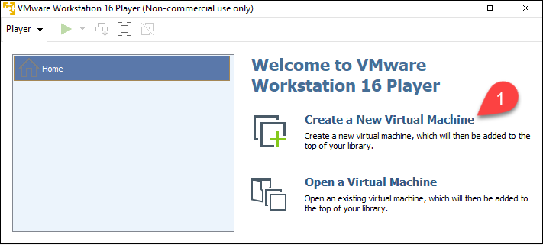

The *New Virtual Machine Wizard* starts.

2. Select the **Installer disc image file (iso)** option.

3. Click **Browse** and locate your Windows 11 ISO file.

4. Select **Next**.

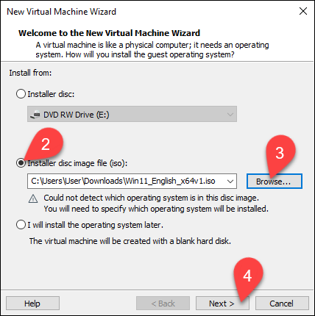

The *Select a Guest Operating System* window loads.

5. Select **Microsoft Windows** in the *Guest operating system* section.

6. Pick **Windows 10 and later x64** from the dropdown list.

7. Select **Next**.

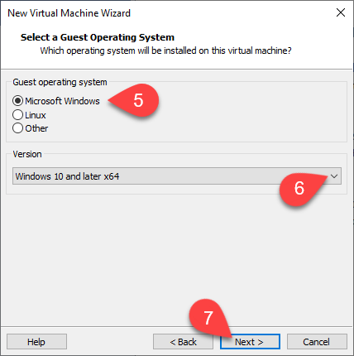

The *Name the Virtual Machine* window appears.

8. Type the name for the virtual machine. The example VM is named *Windows11*.

9. Click Browse to **choose the location** of the VM. Skip this step to use the tool's default location.

10. Select **Next**.

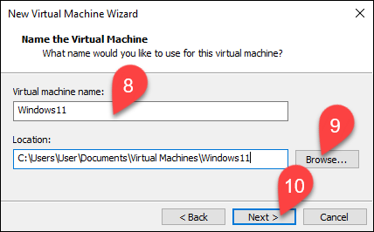

The *Specify Disk Capacity* window appears.

11. Choose the maximum disk size in gigabytes. Assign 60 gigabytes or more for the Windows 11 VM.

12. Select **Store virtual disk as a single file** option.

13. Select **Next**.

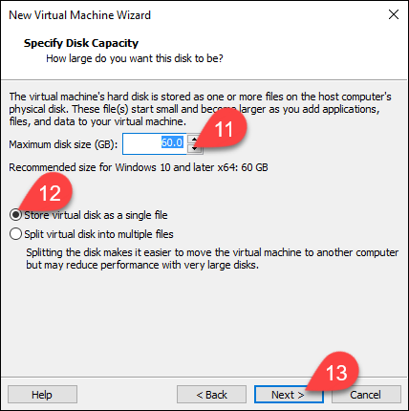

In the *Ready to Create Virtual Machine* window, you can see all the VM settings.

14. Select **Finish** to create your Windows 11 VM.

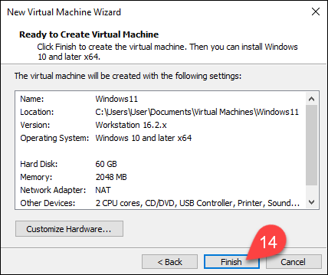

**Step 2: Modify and Start Windows 11 Virtual Machine**

Since the virtual machine has been created with *Windows 10 and later x64* settings, edit the VM to satisfy Windows 11 minimum requirements.

1. Select your VM in the list on the left side of the window.

2. Select **Edit virtual machine settings**.

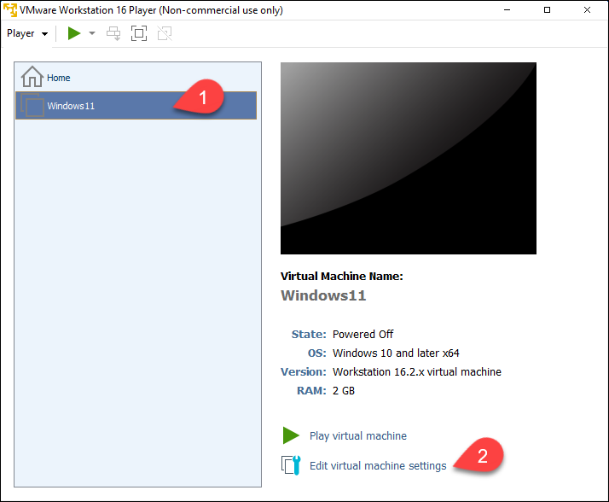

The *Virtual Machine Settings* window opens.

3. The menu on the left side contains the VM's virtual devices. Select the device you want to adjust.

4. Change the device settings in the section on the right side of the window.

**Note**: To satisfy Windows 11 requirements, set at least 4 GB of memory and two processor cores.

5. Select **OK** when you finish setting up your VM.

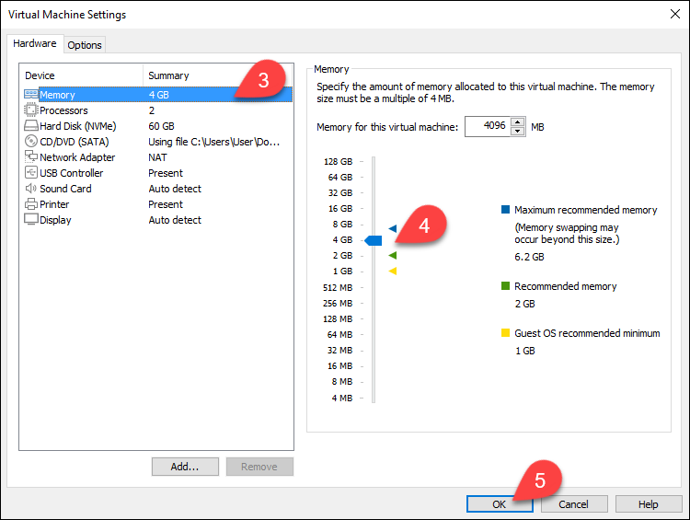

6. Select **Play virtual machine** in the main VMWare Workstation Player window.

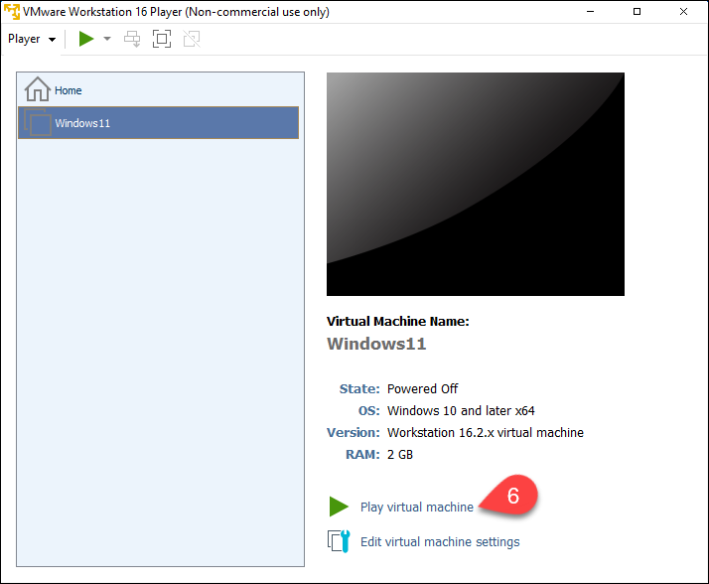

The VM window opens.

7. Press any key while in the VM window to boot the ISO file.

**Step 3: Install Windows 11**

The Windows 11 installation process inside the VMWare Workstation Player is the same as installing Windows 11 directly on the hardware.

1. Pick the language of the installation, the time and currency format, and the input method from the dropdown menu.

2. Select **Next**.

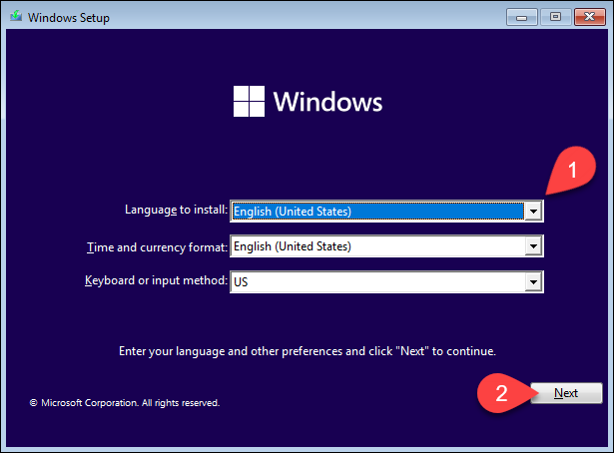

3. Click **Install now**.

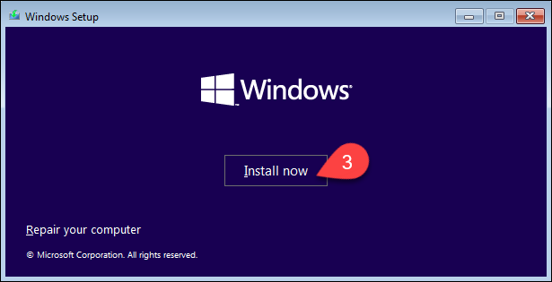

The *Activate Windows* window appears.

4. Enter the product key in the box, or click **I don't have a product key**. Choosing **I don't have a product key** takes you to the next window.

5. Select **Next**.

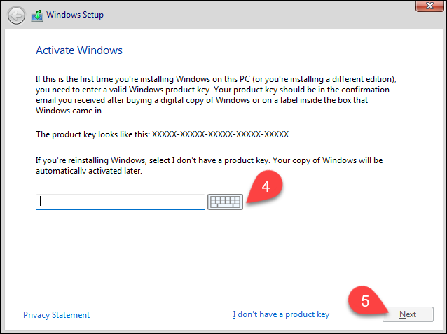

The window with a list of operating system versions appears.

6. Pick the Windows 11 version you want to install.

7. Select **Next**.

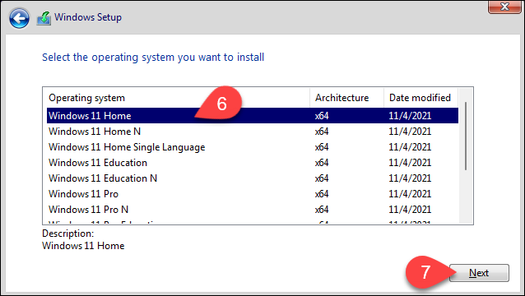

The *Applicable notices and license terms* window opens.

8. Select the checkbox to accept the Microsoft Software License Terms.

9. Select **Next**.

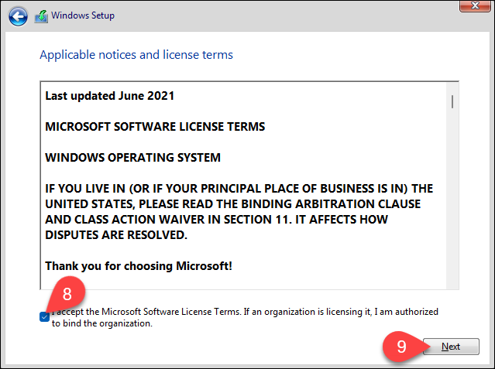

The following window contains installation options.

10. Choose **Custom: Install Windows only (advanced)** option.

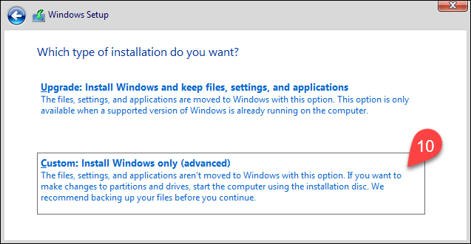

The window with partition information appears.

11. Select **New** to create a new partition.

12. Pick the size of the partition. Windows uses the entire unallocated space if you do not specify the size.

13. Select **Apply** to let Windows create the partitions.

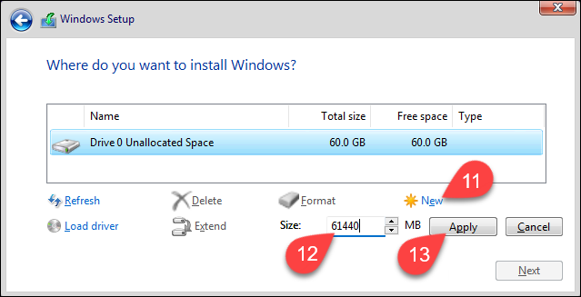

When Windows finishes creating the partitions, the complete partition list appears.

14. Pick the partition marked as *Primary* from the partition list.

15. Select **Next**.

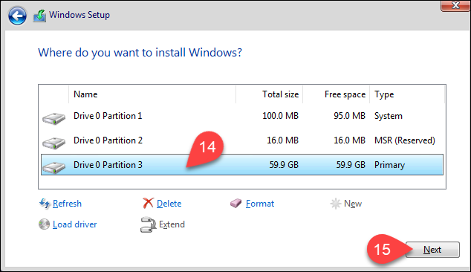

The Windows 11 installation starts. Follow the installation progress in the *Installing Windows* window.

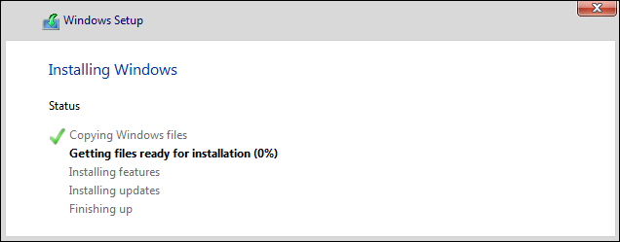

**(Optional) Bypass the TPM Check**

If your machine does not meet minimal requirements for Windows 11 installation, the *This PC can't run Windows 11 message* appears instead of the *Applicable notices a*nd license terms window.

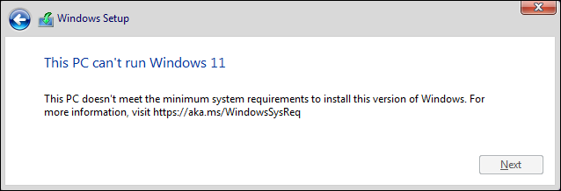

If you still wish to test Windows 11 on the same machine, you can override the Trust Platform Module (TPM) check preventing you from continuing with the installation.

To do so:

1. Press **Shift + F10** to open the command prompt.

**Note**: On some keyboards, you have to press **Shift + Fn + F10**.

The command prompt opens.

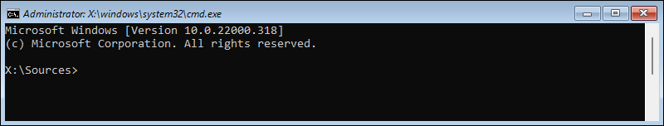

2. Open the Registry Editor by typing:

regedit

Press **Enter**to confirm. The Registry Editor appears.

3. In the navigation menu on the left side of the window, go to **HKEY_LOCAL_MACHINE>SYSTEM>Setup**. Right-click **Setup**, hover over the **New** option in the context menu, and select **Key** from the sub-menu.

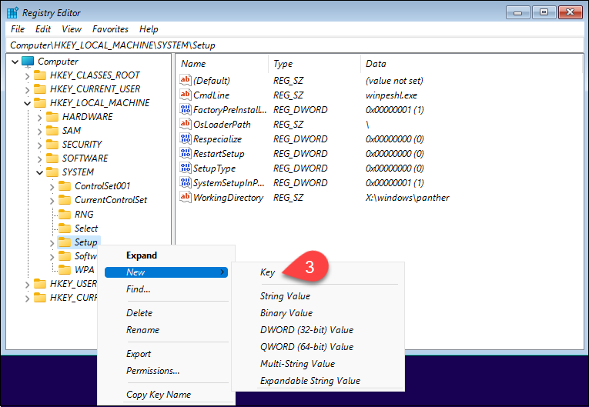

When prompted, name the key *LabConfig*.

4. Right-click the newly created **LabConfig** item in the navigation menu on the left side of the window. Hover over the **New** option in the context menu, and select **DWORD (32-bit) Value** item.

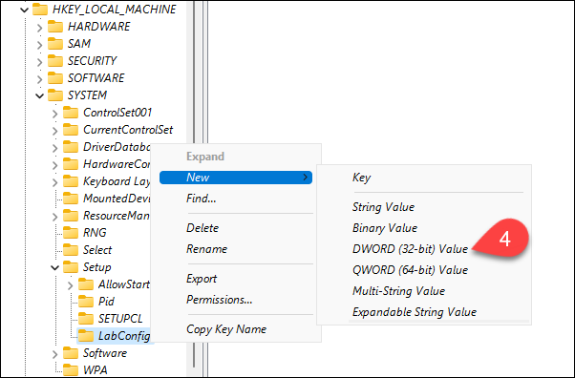

When prompted, name the item *BypassTPMCheck*.

5. Right-click **BypassTPMCheck** value in the main window list. Select **Modify** in the context menu.

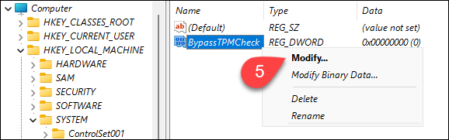

6. In the *Edit DWORD (32-bit) Value*dialogue box, change the *Value data* from **0** to **1**.

7. Select **OK**.

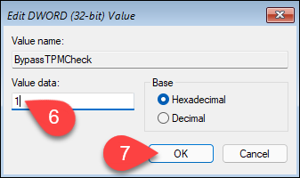

8. Close the Registry Editor.

9. Click the back arrow to go back to the installation process.

