**PRACTICAL EXAM QUESTIONS JULY 2023**

**COURSE MCA**

**SEMESTER 1**

**SUBJECT CODE V20PCA103**

**DATABASE TECHNOLOGY LAB**

ENROLLMENT NUMBER – EC2332251010074  
NAME OF THE STUDENT – ANKUR CHAUDHARY  
DATE – 13-07-2023  
SUBJECT CODE- V20PCA103SUBJECT NAME – DATABASE TECHNOLOGYCOURSE NAME – MCA

**NAME OF THE PROGRAM:**

**Q1)Employee table contains the information of employee_id ,first_name,last_name,email,phone_number,hire_date,job_id,Salary,comission_pct,manager_id,department_id .**

**(1) create the table and insert the value inside the table**

**(2)Display the salary information whose salary is greater than 50000**

**(3)create and query to display the last name,job code, hire date, and employee number for each employee.**

**(4) Set the primary key as employee_id**

**(5)Display the deparment_id in Ascending order**

**AIM:**

**Write a program to create a table in sql format.**

**Procedure for program:**

**1. start the program.**

**2. write the syntax for creating the table.**

**3. then run the program.**

**Program:**

**1. create the table and insert the value inside the table.**

CREATE TABLE employee (

employee_id INT PRIMARY KEY,

first_name VARCHAR(50),

last_name VARCHAR(50),

email VARCHAR(100),

phone_number VARCHAR(20),

hire_date DATE,

job_id VARCHAR(10),

salary DECIMAL(10,2),

commission_pct DECIMAL(4,2),

manager_id INT,

department_id INT

);

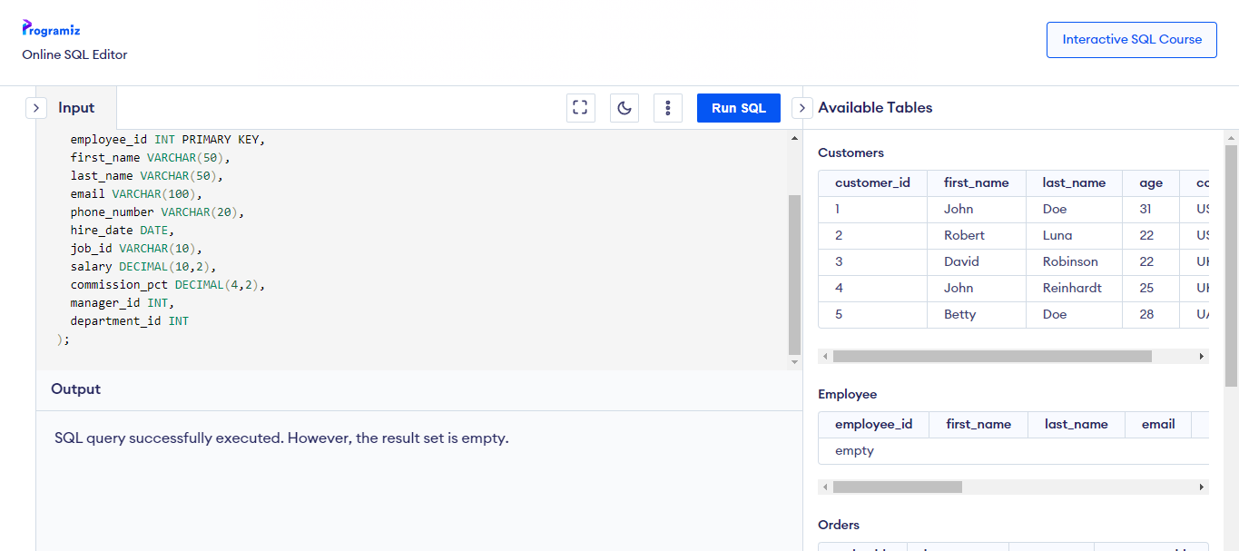

INSERT INTO employee (

employee_id,

first_name,

last_name,

email,

phone_number,

hire_date,

job_id,

salary,

commission_pct,

manager_id,

department_id

)

VALUES (

100,

'Steven',

'King',

'steven.king@company.com',

'515.123.4567',

'2003-06-17',

'AD_PRES',

24000.00,

NULL,

NULL,

90

);

INSERT INTO employee (

employee_id,

first_name,

last_name,

email,

phone_number,

hire_date,

job_id,

salary,

commission_pct,

manager_id,

department_id

)

VALUES (

101,

'john',

'smith',

'john.smith@company.com',

'515.123.4570',

'2008-06-16',

'AD_PRES',

67000.00,

NULL,

NULL,

97

);

INSERT INTO employee (

employee_id,

first_name,

last_name,

email,

phone_number,

hire_date,

job_id,

salary,

commission_pct,

manager_id,

department_id

)

VALUES (

103,

'andrew',

'smith',

'andrew.smith@company.com',

'515.123.4576',

'2007-06-19',

'AD_PRES',

45000.00,

NULL,

NULL,

95

);

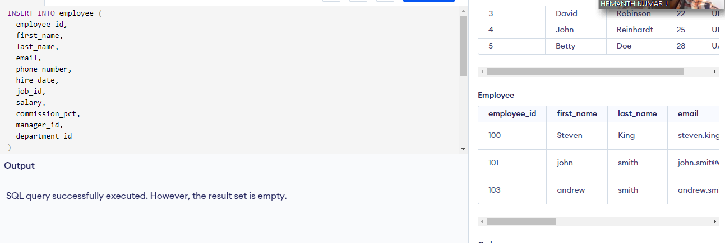

**(3)create and query to display the last name,job code, hire date, and employee number for each employee.**

SELECT job_id, last_name, hire_date, phone_number FROM employee;

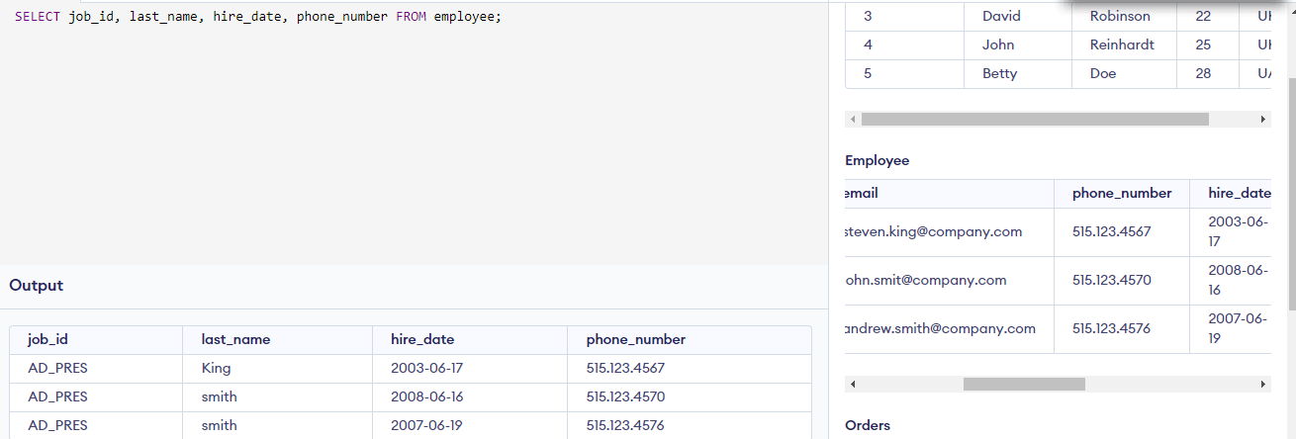

**(5)Display the deparment_id in Ascending order**

SELECT department_id FROM employee ORDER BY department_id ASC;

