

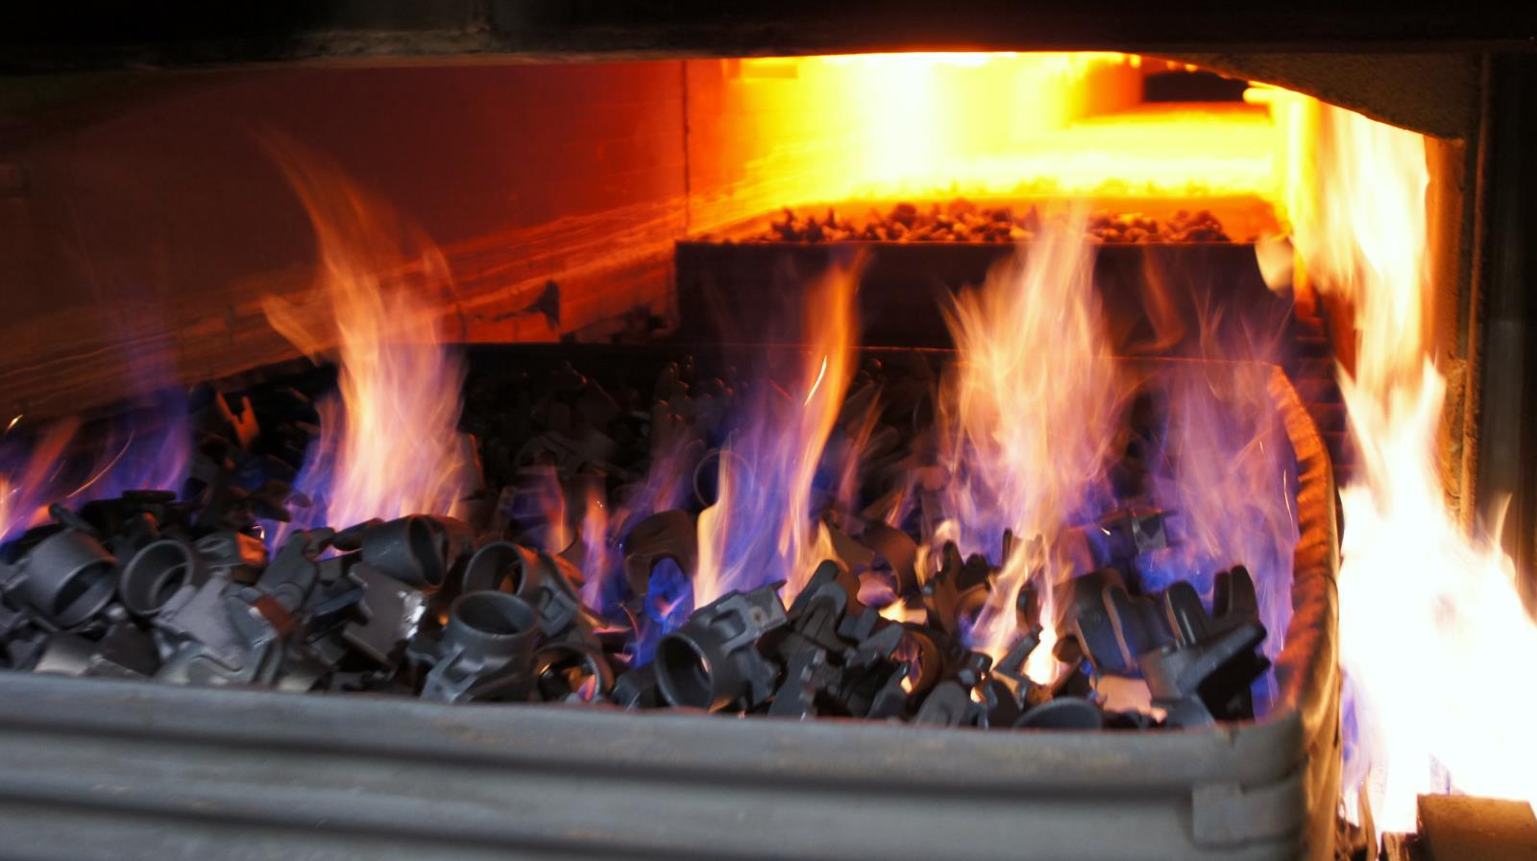

**[[](https://bluewaterthermal.com/aerospace-heat-treating-services-aircraft-approved-vendor/)](https://bluewaterthermal.com/aerospace-heat-treating-services-aircraft-approved-vendor/)**

**[AEROSPACE](https://bluewaterthermal.com/aerospace-heat-treating-services-aircraft-approved-vendor/)**

**[[](https://bluewaterthermal.com/farming-agriculture-equipment-coatings/)](https://bluewaterthermal.com/farming-agriculture-equipment-coatings/)**

**[AGRICULTURE](https://bluewaterthermal.com/farming-agriculture-equipment-coatings/)**

**[[](https://bluewaterthermal.com/automotive-heat-treatment/)](https://bluewaterthermal.com/automotive-heat-treatment/)**

**[AUTOMOTIVE](https://bluewaterthermal.com/automotive-heat-treatment/)**

**[[](https://bluewaterthermal.com/heat-treatments-and-brazing-for-oil-refinement-and-energy/)](https://bluewaterthermal.com/heat-treatments-and-brazing-for-oil-refinement-and-energy/)**

**[ENERGY](https://bluewaterthermal.com/heat-treatments-and-brazing-for-oil-refinement-and-energy/)**

NORMALIZING HEAT TREATMENT

**Normalizing Heat Treatment** services for metal and metal components.

The functions of normalizing may overlap with or easily be confused with those of [annealing](https://bluewaterthermal.com/annealing/), [hardening](https://bluewaterthermal.com/harden-temper/), and [stress relieving](https://bluewaterthermal.com/stress-relieve/); however, they are not interchangeable, and the final use of the product must be considered when determining which method to use. Normalization may increase or decrease the strength and hardness of metal in a given product form, depending on the thermal and mechanical history of the product.

Normalizing is a high-temperature austenitizing heating cycle followed by cooling in still or agitated air that is performed for a variety of reasons but primarily is performed to homogenize the microstructure and remove any segregation or non-uniformities that may exist at the microscopic level.

Normalizing Process Overview

Normalizing heat treatment helps to remove impurities and improve ductility and toughness. During the normalizing process, material is heated to between 750-980 °C (1320-1796 °F). The exact heat applied for treatment will vary and is determined based on the amount of carbon content in the metal.

Depending on the mechanical properties required, normalizing may be substituted for conventional hardening when the size or shape of the part is such that liquid quenching might result in cracking, distortion, or excessive dimensional changes. Thus, pieces that are of complex shape or that incorporate sharp changes in the section may be normalized and tempered, provided that the properties obtained are acceptable.

***THE COOLING PROCESS:***

After heating, material is cooled to room temperature. The rate of cooling significantly influences both the amount of pearlite and the size and spacing of the pearlite lamellae. At higher cooling rates, more pearlite forms, and the lamellae are finer and more closely spaced. Both the increased amount of pearlite and the greater fineness of the pearlite result in higher strength and higher hardness. Conversely, lower cooling rates result in softer parts.

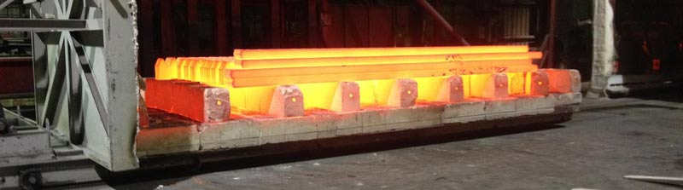

The Outcome

Normalizing will typically produce a uniform pearlitic structure in combination with either ferrite grains or grain-boundary carbides present depending on the base material’s carbon content.

Improved machinability, grain-structure refinement, homogenization, and reduction of residual stresses are the primary reasons that normalizing is performed. Homogenization of castings by normalizing may be done to break up or refine the as-cast dendritic structure and facilitate a more uniform response to subsequent hardening. Similarly, for wrought metals, normalization can help reduce banded grain structure due to hot rolling, as well as large grain size or mixed large and small grain size due to forging practice.

Differentiating Normalizing from Annealing and Stress Relief

While the general process of normalizing mirrors that of annealing and stress relief, there are significant differences in both the process and the final product. The normalizing process requires more intense heating than both annealing and stress relief, but the cooling process is significantly faster. For this reason, normalizing is typically a less expensive process than annealing or stress relief.

The shorter cooling time in the normalizing process produces metal that is less ductile and has a higher hardness value than the annealing process. The stress relief process uses heat treatment to reduce, as the name suggests, stresses caused by rolling or cutting, but is not heated enough to produce any significant changes to the material properties as with the normalizing and annealing processes.

Materials Suitable for Normalizing

* Aluminum
* Brass
* Copper
* Iron alloys
* Nickel alloys
* Steel

Applications for Normalizing

Normalizing has broad practical applications across industries, including:

* Aerospace
* Agriculture
* Automotive
* Energy
* Heavy Equipment

In general, it is the best practice to use normalizing in circumstances when manufacturing activities are expected to place considerable stress on the material or in situations where dimensional stability is vital to the product.

[Capabilities Overview](https://bluewaterthermal.com/capabilities/)

Contact Us

**at one of these locations for information or a quote.**

* [Benton Harbor, MI](https://bluewaterthermal.com/locations-benton-harbor-plant-back-and-continuous-mesh-belt-treatments/)
* [Chicago Plant 1, IL](https://bluewaterthermal.com/locations-chicago-plant-one-casting-heat-treatment-heat-treatment-forging/)
* [Chicago Plant 2, IL](https://bluewaterthermal.com/locations-chicago-plant-two-continuous-heat-treatment-annealing-services/)
* [Chicago Plant 3, IL](https://bluewaterthermal.com/locations-chicago-plant-3-continuous-mesh-belt-hardening-carburizing/)
* [Coldwater, MI](https://bluewaterthermal.com/locations-coldwater-mi-plant-continuous-mesh-belt-brazing-and-annealing/)
* [Rockford, IL](https://bluewaterthermal.com/locations-rockford-il-plant-heat-treating-services/)
* [Saint Marys, PA](https://bluewaterthermal.com/locations-saint-marys-plant-heat-treatments-continuous-mesh-belt-furnaces-treatments/)
* [South Bend, IN](https://bluewaterthermal.com/locations-south-bend-plant-batch-furnace-and-vacuum-furnace-heat-treatments/)
* [Southwest Heat Treat](https://bluewaterthermal.com/locations-southwest-plant-heat-treatment-of-metals-for-oil-gas-industry/)

**RELATED CASE STUDIES**

[[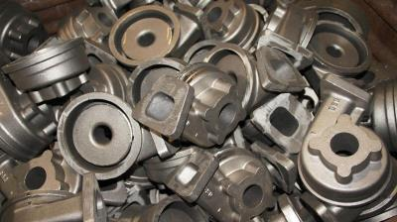](https://bluewaterthermal.com/heat-treatment-castings/)](https://bluewaterthermal.com/heat-treatment-castings/)

**[VIEW CASE STUDY](https://bluewaterthermal.com/heat-treatment-castings/)**

**[Heat Treatment of Castings for Pump Housings, Turbochargers, and Valve Bodies](https://bluewaterthermal.com/heat-treatment-castings/)**

[**Solutions Overview**](https://bluewaterthermal.com/metal-heat-treating-solutions-and-services/)

We provide a comprehensive list of services that can be combined to provide a perfect process for your components.

[**Our Locations**](https://bluewaterthermal.com/locations/)

North America's thermal processing specialists are ready to serve you from our multiple locations.

[**Senior Leadership**](https://bluewaterthermal.com/leadership/)

Meet Bluewater's leadership team.

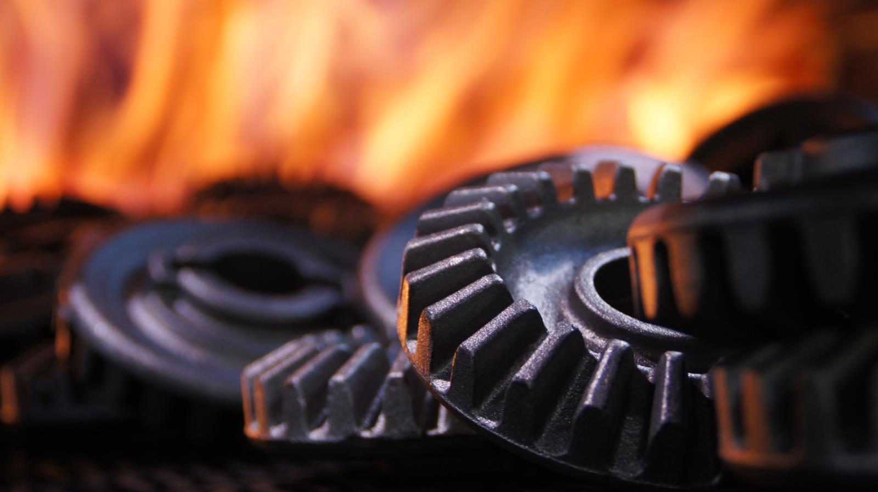

Need a custom solution?

Let us know how we can help.

[CONTACT US](https://bluewaterthermal.com/locations/)

CONTACT US

[**1-877-990-0050**](tel:1-877-990-0050)

[**GET A QUOTE**](https://bluewaterthermal.com/contact-us-about-heat-treating/?quote=1)

* [**Careers**](https://bluewaterthermal.com/jobs/)

* [**Terms of Use**](https://bluewaterthermal.com/normalizing-heat-treatment/#TermsofUse)

* [**Privacy Policy**](https://bluewaterthermal.com/normalizing-heat-treatment/#PrivacyPolicy)

* [**Sales Terms**](https://bluewaterthermal.com/normalizing-heat-treatment/#SalesTerms)

©2022 Bluewater Thermal Solutions. All rights reserved.

CONNECT WITH US

[Created by](http://yourcreativepeople.com/web-site-design/).  Easy site updating through [Backstage CMS](http://yourcreativepeople.com/backstage-cms/).