**Tableau**

**1.**What industries have had the strongest involvement in Bike MS in the last five years and what occupations were responsible for most of our fundraising?

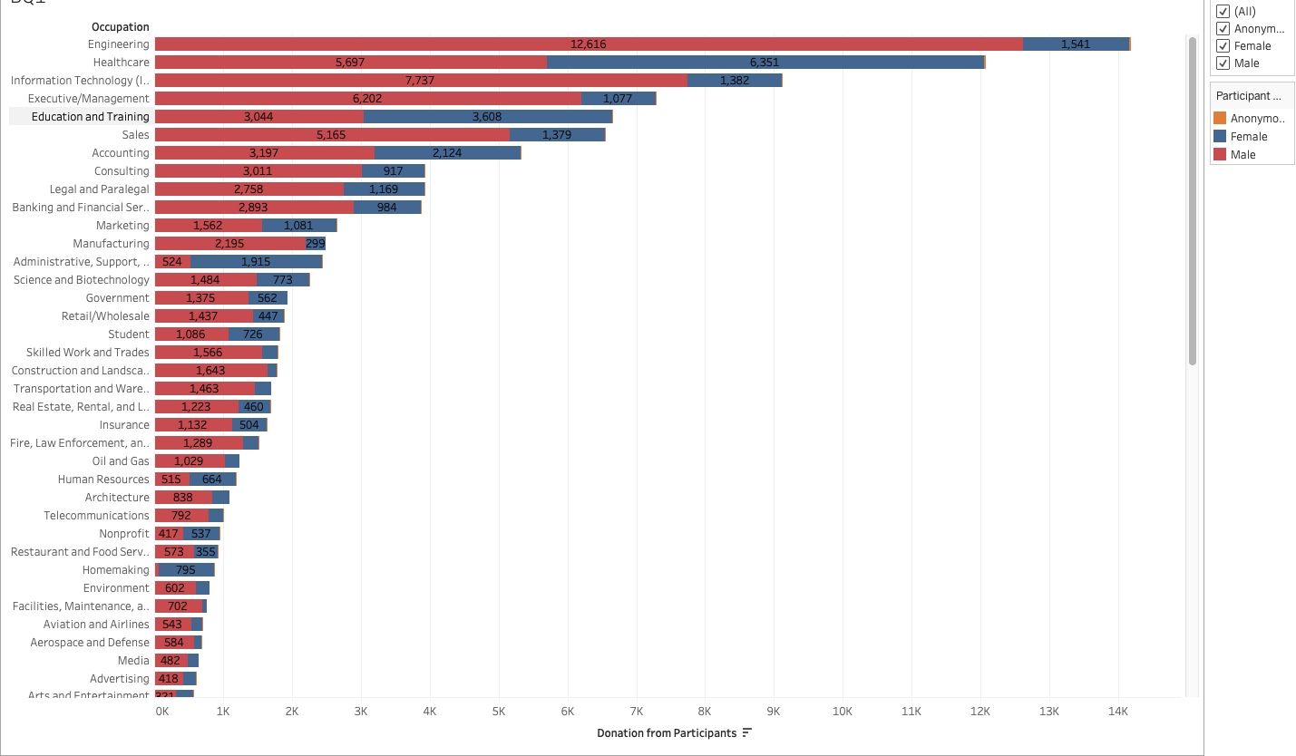

Bike MS is an event where people can participate as cyclist or donors.The visualization of the data shows that the major occupation of participants are Engineering.We can also define the top 10 occupations of participants:Engineering,Healthcare,IT,Executive/Management,Education and training,Sales,Accounting,Consulting,Legal and Paralegal,Banking and Financial… that are responsible for the majority of fundraising.

The red colour shows that men are responsible for a larger sum of donations and also because most of participants are men.

The blue colour shows that the average donation from women is not as much as men.

**2**. Which are the areas where the outbreak of MS is the most and which are the areas that are donating most?

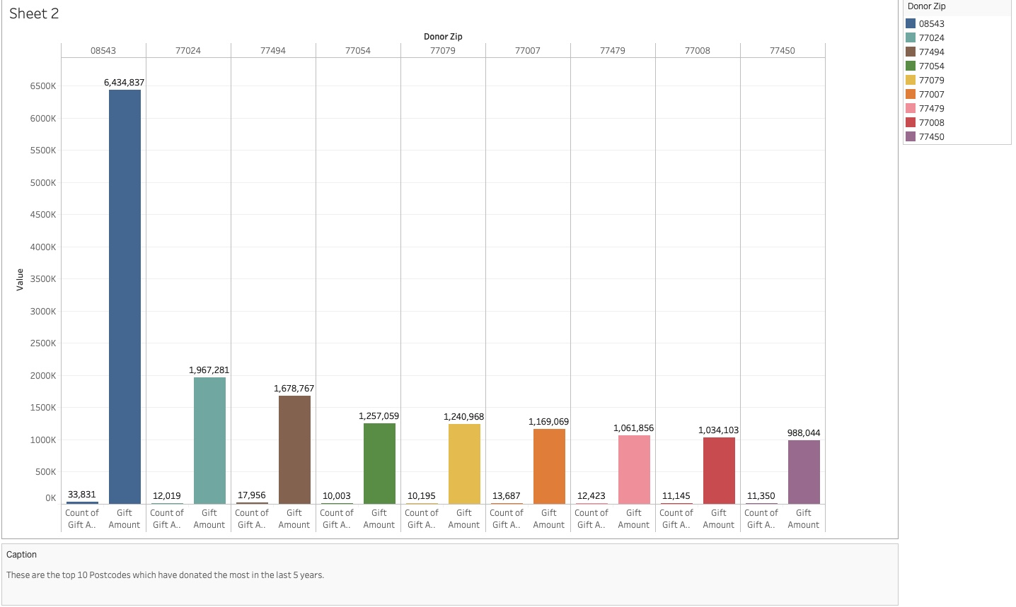

This visualization of data shows us the top 10 Postcode which have donated the most in the last 5 years (2013-2017).

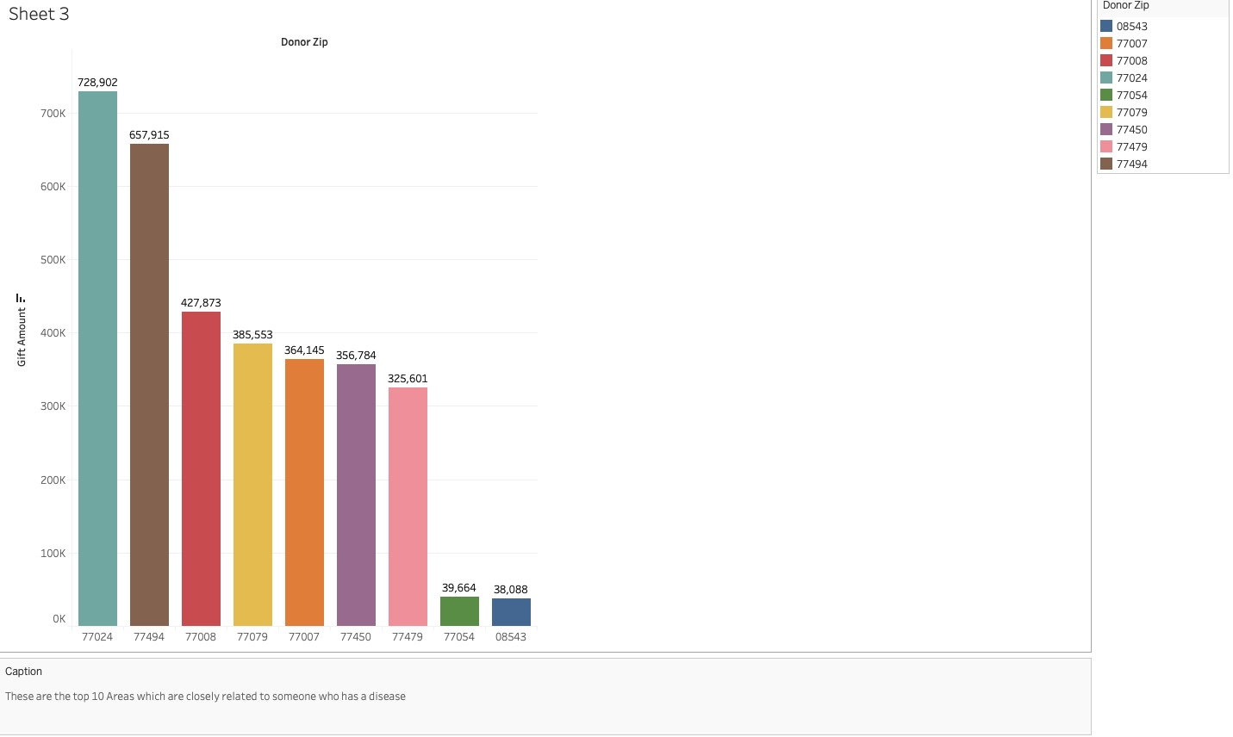

Here, we wanted to visualize that are the donations related to someone who have a connection with the MS disease?

**3**.Can we apply those opportunities to specific markets ?

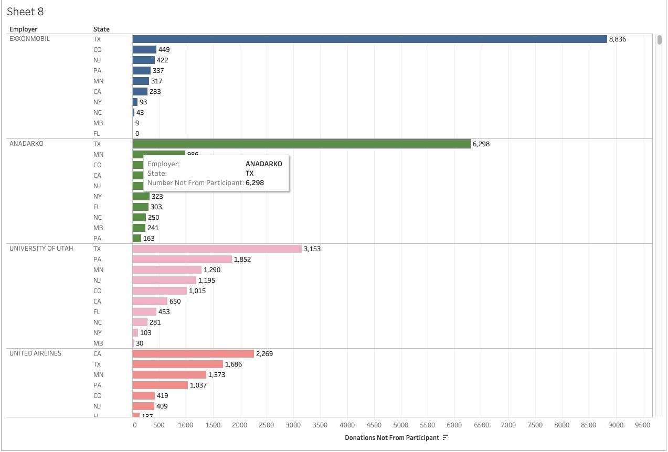

In the visualization of the data we can see the amount of donations that come from people that are not participant in the event but they just donate based on states and the largest employer. As we can see, Texas is the state where the most donations come from.

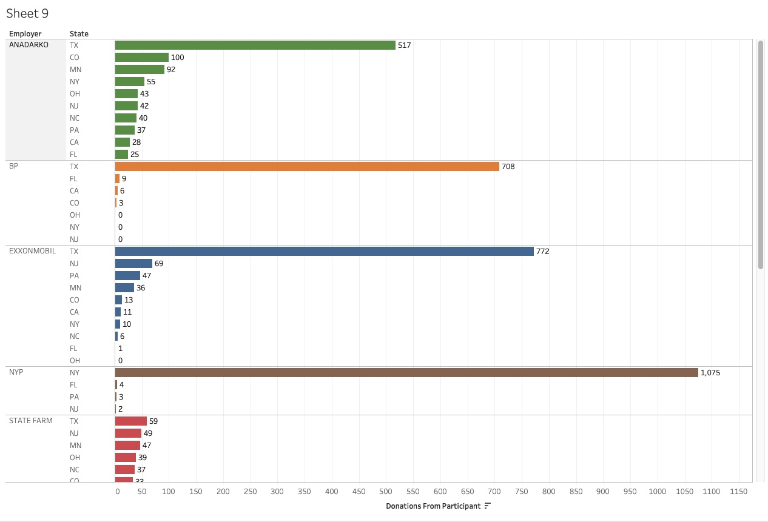

Here, we have the visualization of the amount of donations from people that participate on the event based on states and employer.

From the visualizations, we can safely conclude that ANADARKO and EXXONMOBIL have donated the most in Texas State and we have a lot of opportunities in other states to advertise and market.

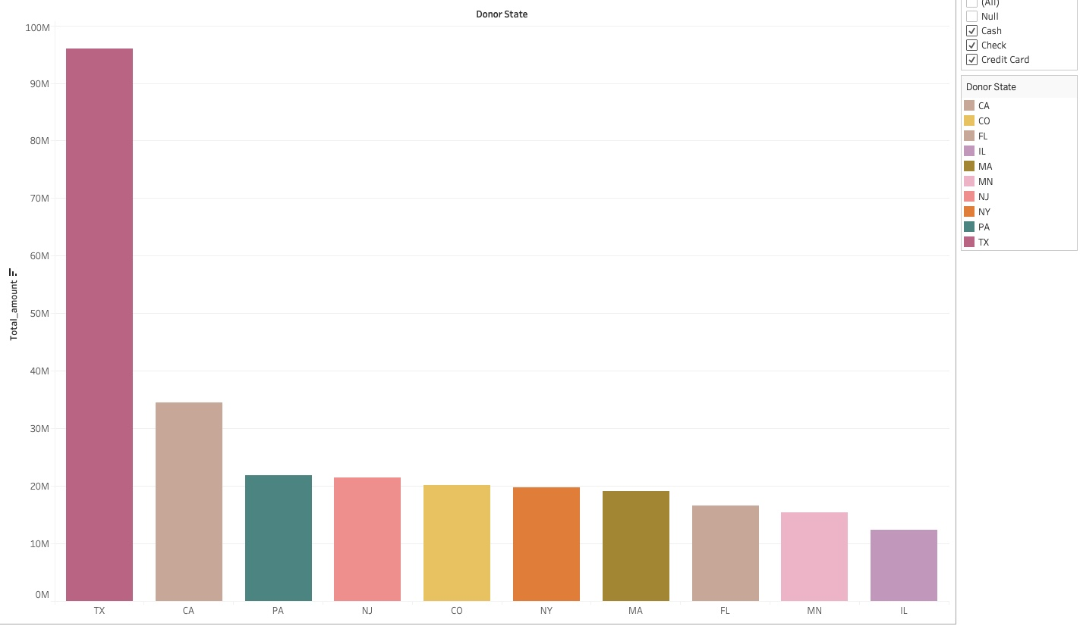

-FROM THE PREVIOUS SLIDES, WE CAN SAFELY CONCLUDE THAT TEXAS HAS DONATED THE MOST IN THE PAST YEARS.

-WE CAN INVEST THE MONEY TO ADVERTISE ABOUT BIKE MS IN SOME OTHER STATES

**4**.**Lets see how the participants have increased/decreased over the years**

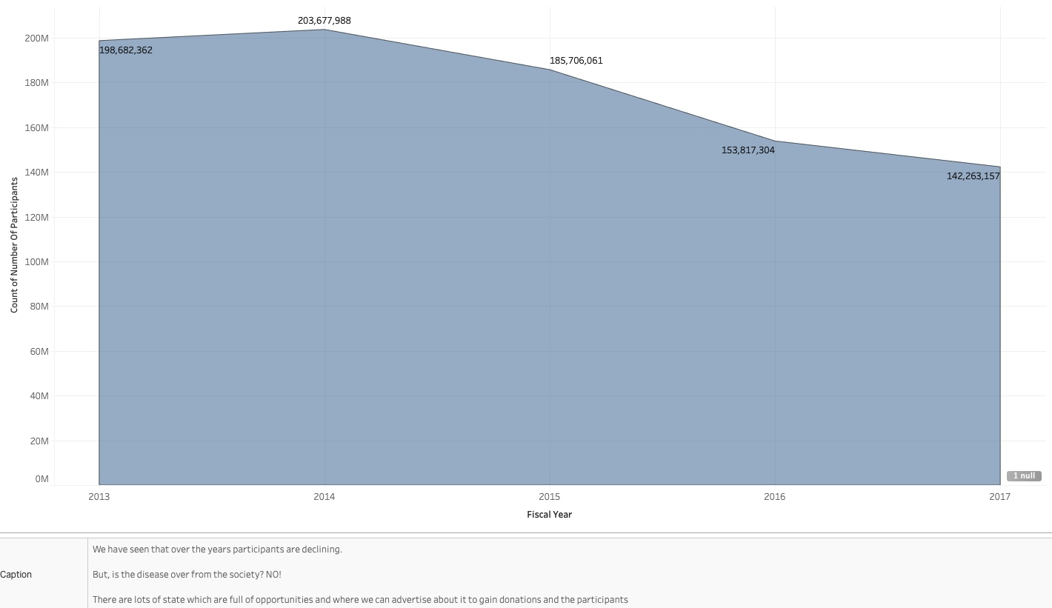

**5.Lets see the total amount of donations over the years**

