Contents

**Introduction** 2

**Cascade Sheet Style (CSS)** 3

**W3C Validation:** 4

**Testing pages in different web browsers:** 6

**Testing and resolving the pages:** 7

**Critical Evaluation:** 7

**Some of the advantages website:** 7

**Disadvantages of website:** 8

**Recommendation:** 8

# **Introduction**

The website was design and developed by using ***Adobe Dreamweaver CS6*** doctype XHTML 1.0 Strict. In the same way, cascade style sheet (CSS) was designed by using this software. Resolution of the website was set to 1024*786 to prevent horizontal scrolling. The home page of the website and other pages has menu bars at the top so that user can easily navigate through different pages.

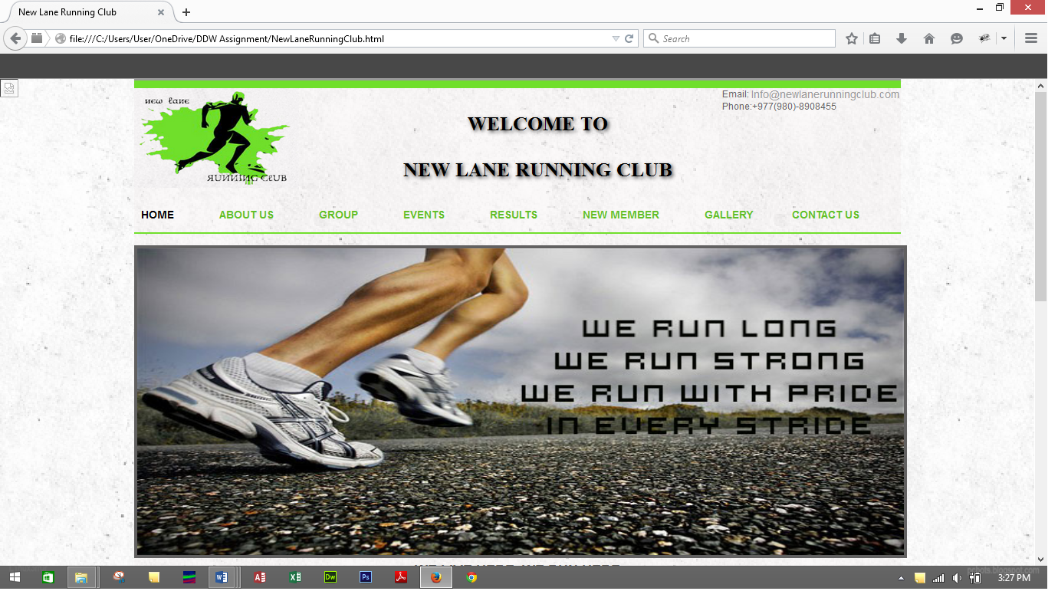

Figure 1: Home page opened from Mozilla Firefox.

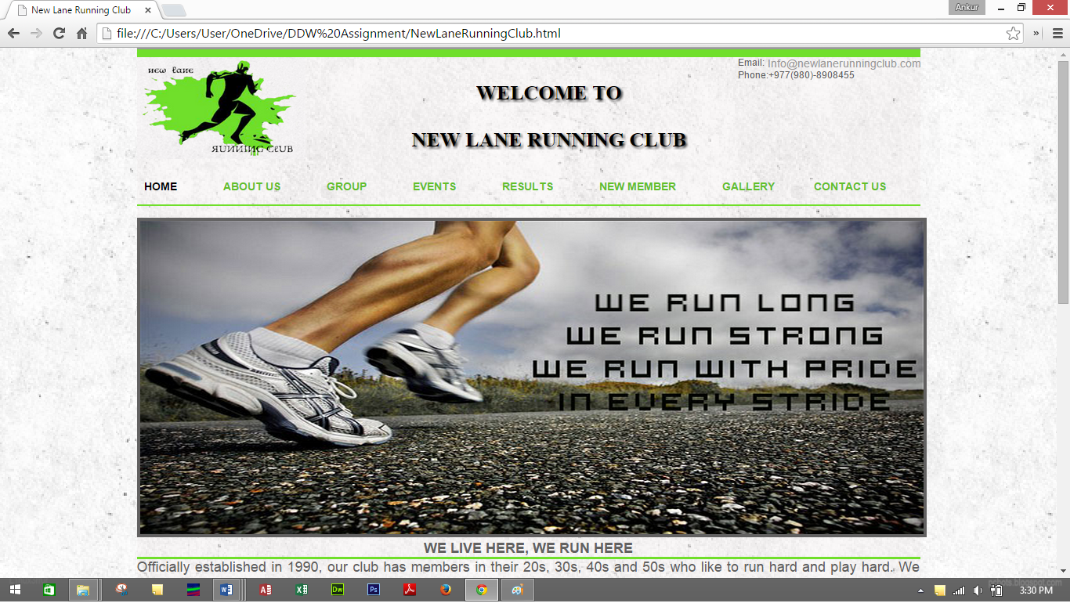

Figure 2: Home page opened from Google Chrome

Images were downloaded from google which was free and does not have any copyright issues.

# **Cascade Sheet Style (CSS)**

A single external CSS file was used while designing the website. For each HTML pages, this CSS file was linked. The use of “style” attribute was avoided. A glimpse of CSS code for making HTML pages is given below:

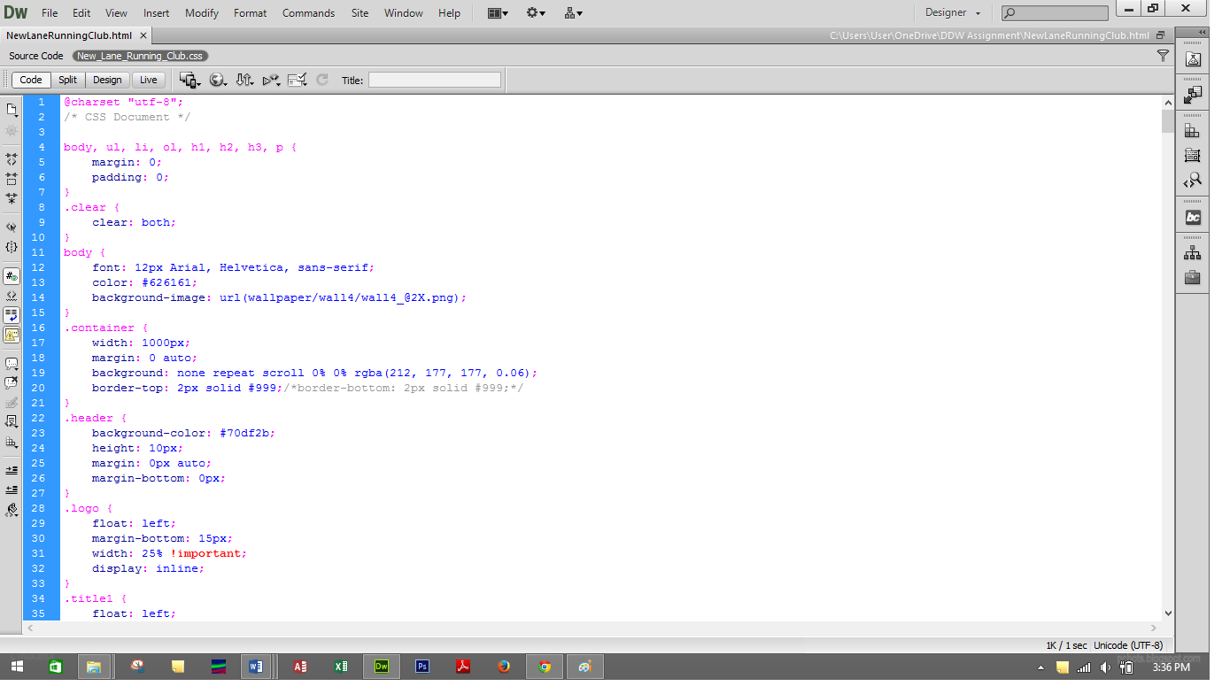

Figure 3 : Screen shots of CSS code while developing the website

Below is the glimpse of source code which was linked to CSS file:

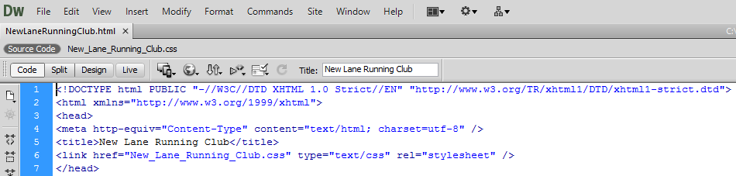

Figure 4: HTML code to link CSS with source code.

# W3C Validation of webpage:

World Wide Web Consortium (W3C) was used to check the HTML pages to ensure if the pages are free of errors or not. Along with HTML pages, CSS file was also checked by W3C. There are total of 8 pages in this HTML file. Each file was check by W3C along with CSS file which is given below:

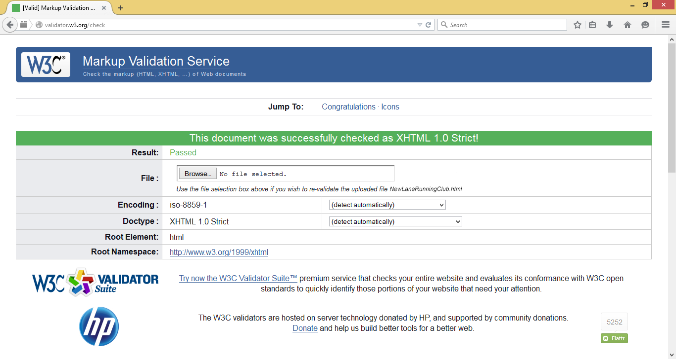

Figure 5: Error free' result shown in validator

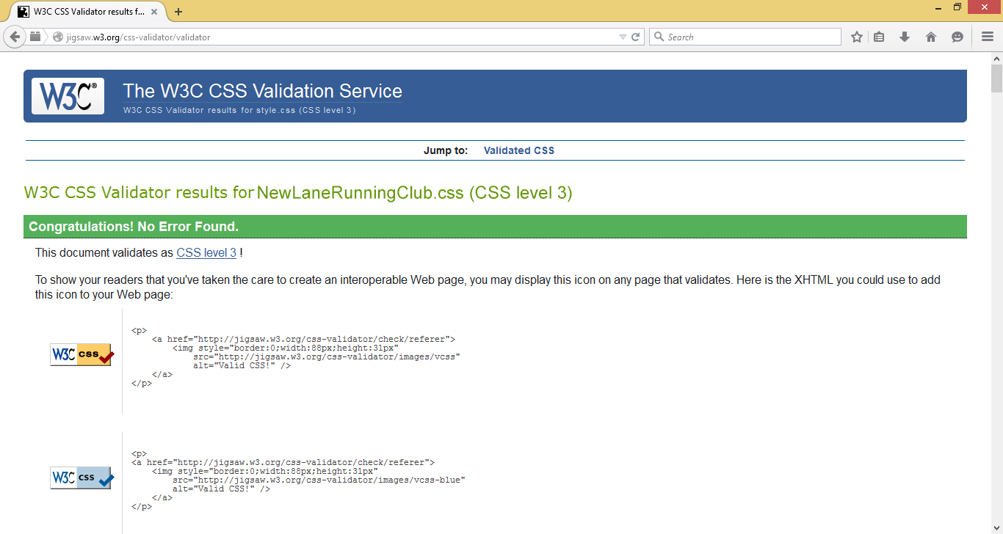

Figure 6: Error free result in validator of CSS file

# 

# **Testing pages in different web browsers:**

To check the compatibility to support HTML pages, two different browsers were used, *Mozilla Firefox* and *Google Chrome.* The pictures below shows us the compatibility of the two web browsers.



Figure 7: Webpage compatible in Mozilla Firefox.



Figure 8: Webpage compatible in Google Chrome

# Testing and resolving the Website:

Some minor errors were found in the process of designing the pages which was solved using W3C validator and also with the help of tutors.

# Critical Evaluation:

New Lane Running Club is a club for people who like to stay fit and healthy.

## **Some of the** **advantages website:**

1. As a website seems to be more user friendly nowadays, it helps a lot on advertising. The website is user friendly which helps users to navigate through pages easily. This also helps a lot in advertising.
2. The advertisement and the marketing of the website helps to increase customers from different places.
3. People can get information about the club at any time anywhere through website.
4. Making a website for advertising is much cheaper nowadays.

## **Disadvantages of website:**

1. The website is not tested on mobile phones.
2. The website is tested only in two web browsers.
3. There are no audio or video contents in the website.
4. The contents are limited comparing to other websites.

# Recommendation:

The website should be user friendly and must be compatible on any devices. The accessibility is what most people want from any webpages.

Smart phones user are rapidly increasing nowadays. So, the website should be compatible with mobile phones.

Users are attracted towards eye-catching websites with sufficient information which includes audio and video functions as well.