pushd C:/Users/Admin/Documents/DataScience/Assignment2/pipeline

docker build -t part1_accepted .

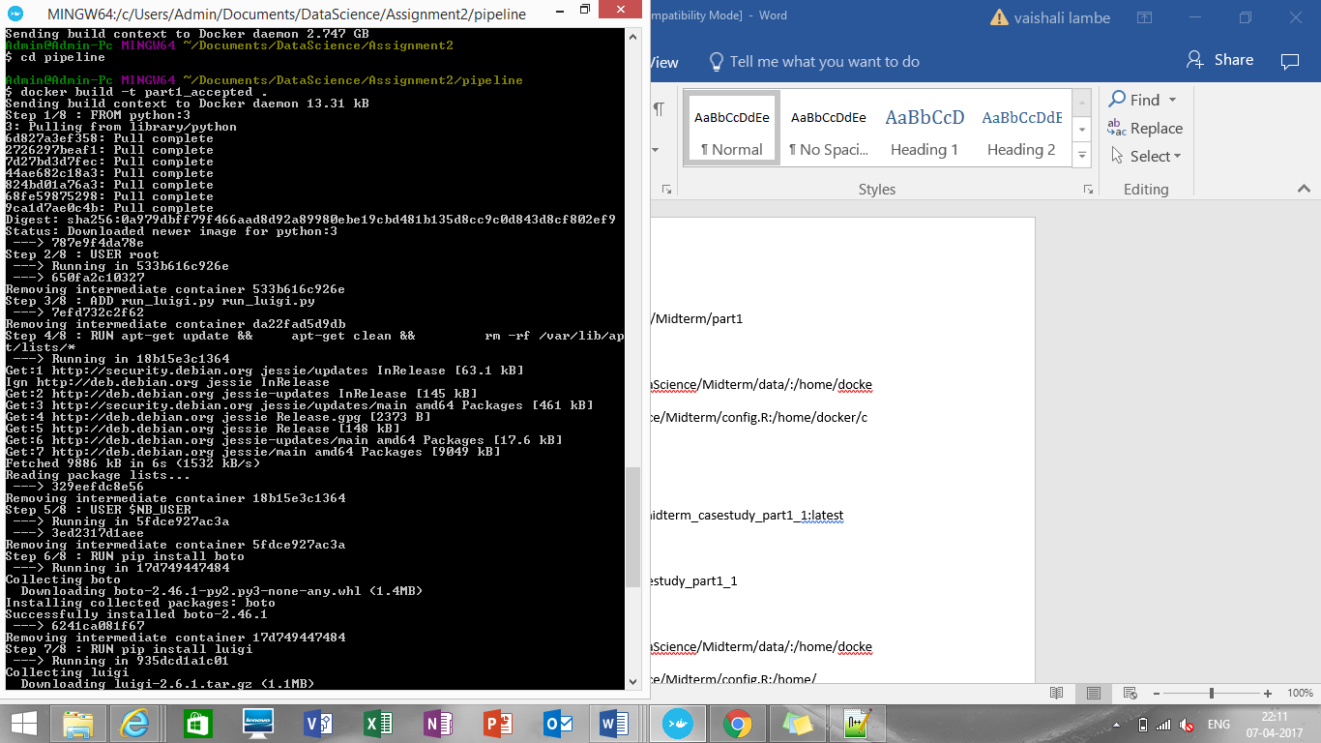

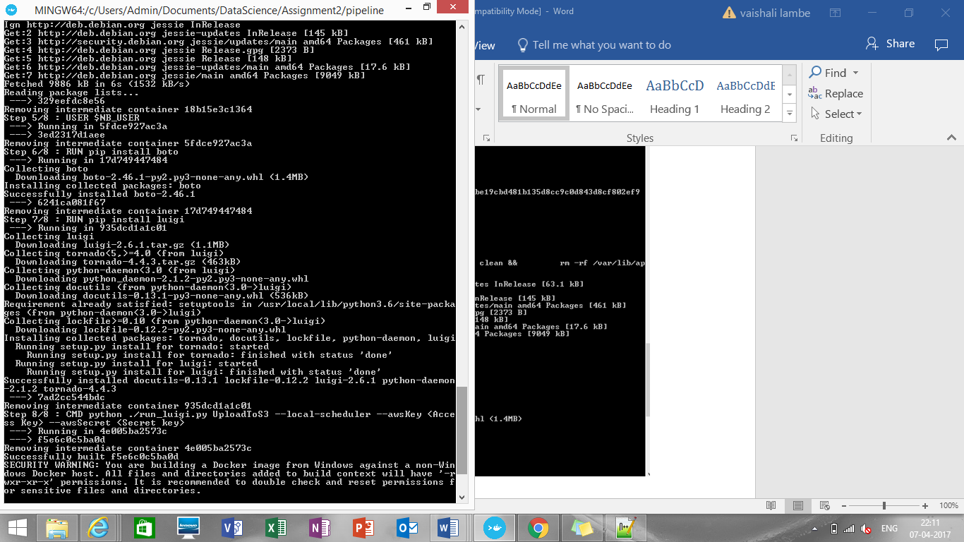

docker images

docker tag <IMAGE ID> [vaishalilambe](https://hub.docker.com/u/vaishalilambe/)/[team11_ass2_accepted_pipeline](https://hub.docker.com/r/vaishalilambe/team11_ass2_accepted_pipeline/):latest

docker login

docker push [vaishalilambe](https://hub.docker.com/u/vaishalilambe/)/[team11_ass2_accepted_pipeline](https://hub.docker.com/r/vaishalilambe/team11_ass2_accepted_pipeline/)

**To run the image**

$ docker run [vaishalilambe](https://hub.docker.com/u/vaishalilambe/)/[team11_ass2_accepted_pipeline](https://hub.docker.com/r/vaishalilambe/team11_ass2_accepted_pipeline/)