ITC 5104 Database Design and SQL

Name: Ankur Prajapati StudentID: N01324892 Section:0NA

1. Determine how many books are in the Cooking category.

SELECT COUNT (\*) FROM BOOKS WHERE CATEGORY = 'COOKING';

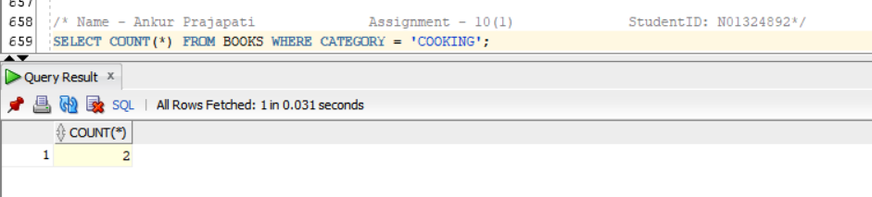

1. Display the number of books with a retail price of more than $30.00.

SELECT COUNT (\*) FROM BOOKS WHERE RETAIL > 30;

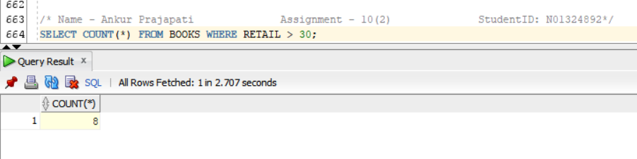

1. Display the date of the most recently published book.

SELECT MAX (PUBDATE) FROM BOOKS;

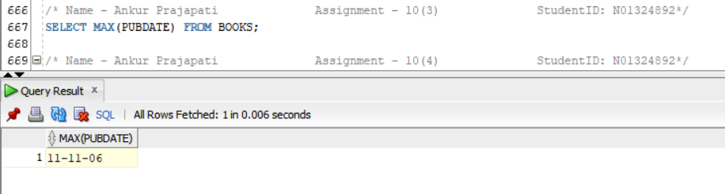

1. Determine the total profit generated by sales to customer 1017. Note: Quantity should be reflected in the total profit calculation.

SELECT SUM ((retail-cost) \*quantity) AS "Total Profit"

FROM orders JOIN orderitems USING (order#) JOIN BOOKS USING (isbn)

WHERE customer#=1017;

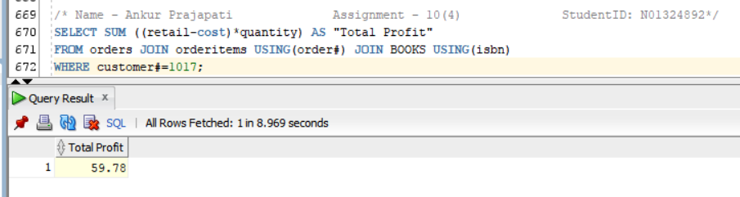

1. List the retail price of the least expensive book in the Computer category.

SELECT MIN (RETAIL) AS "Price of Least Expensive Book"

FROM BOOKS

WHERE CATEGORY = 'COMPUTER';

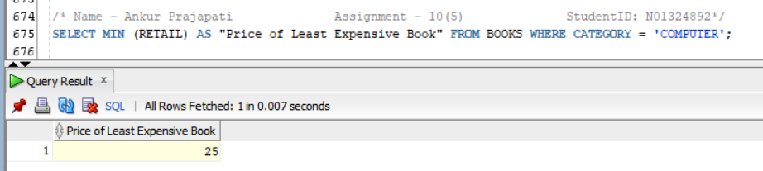

1. Determine the average profit generated by orders in the ORDERS table. Note: The total profit by order must be calculated before finding the average profit.

SELECT AVG(SUM((retail-cost) \* quantity)) AS "AVG PROFIT"

FROM orders JOIN orderitems USING (order#) JOIN BOOKS USING (isbn)

GROUP BY order#;

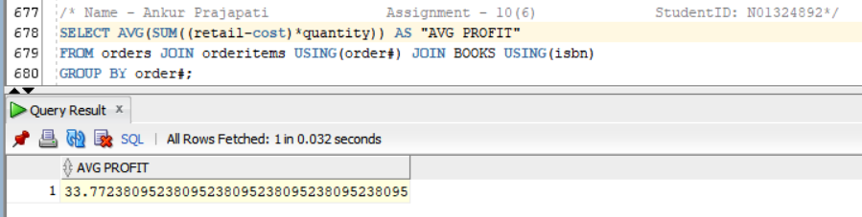

1. Determine how many orders have been placed by each customer in the CUSTOMERS table. Do not include in the results any customer who has not recently placed an order with Just Lee Books. In other words, display only the customers who have made purchases.

SELECT CUSTOMER#, COUNT (\*) AS "Order Placed"

FROM ORDERS

GROUP BY CUSTOMER#;

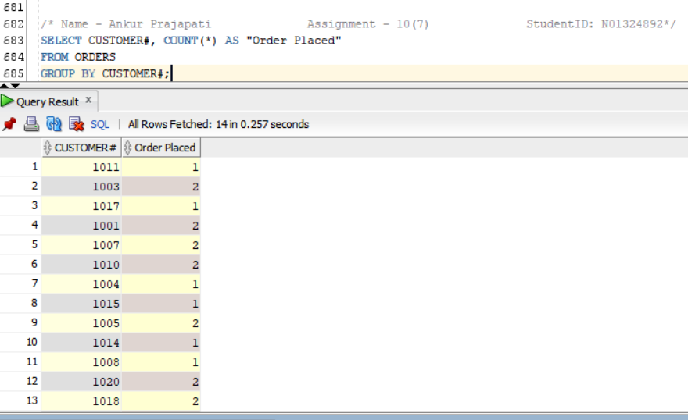

1. Determine the average retail price of books by publisher name and category. Include only the categories Children and Computer and the groups with an average retail price greater than $50.

SELECT NAME, CATEGORY, AVG (retail)

FROM BOOKS JOIN publisher USING (pubid)

WHERE CATEGORY IN('COMPUTER','CHILDREN')

GROUP BY NAME, CATEGORY;

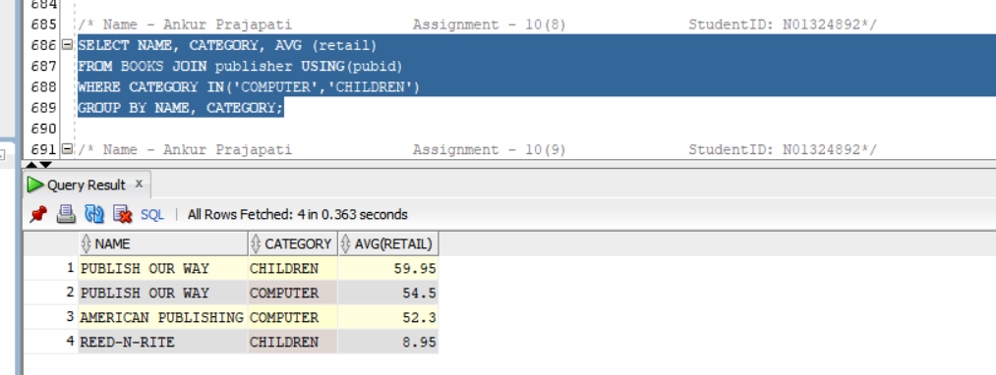

1. List the customers living in Georgia or Florida who have recently placed an order totalling more than $80.

SELECT DISTINCT firstname, lastname

FROM CUSTOMERS JOIN ORDERS USING(CUSTOMER#) JOIN ORDERITEMS USING(ORDER#) JOIN BOOKS USING(isbn)

WHERE (STATE = 'FL' or STATE = 'GA')

GROUP BY ORDER#, firstname, lastname

HAVING SUM(retail\*quantity) > 80;

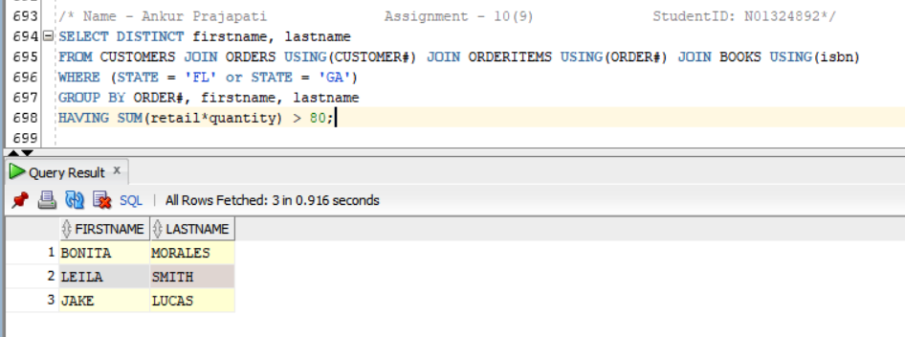

1. What’s the retail price of the most expensive book written by Lisa White?

SELECT MAX (retail) AS "Price of Expensive BOOK"

FROM BOOKS JOIN BOOKAUTHOR USING(ISBN) JOIN AUTHOR USING(AUTHORID)

WHERE FNAME = 'LISA' AND LNAME = 'WHITE';

