**ITC 5104 Database Design and SQL**

**Ankur Prajapati Assignment 7 StudentID: N01324892**

To perform the following assignments, refer to the tables created in the **JLDB_Build_8.sql** script at the beginning of the chapter. Give the SQL statements and output for the following data requests:

1. Which customers live in New Jersey? List each customer’s last name, first name, and state.

**SELECT lastname, firstname, state**

**FROM CUSTOMERS**

**WHERE STATE ='NJ';**

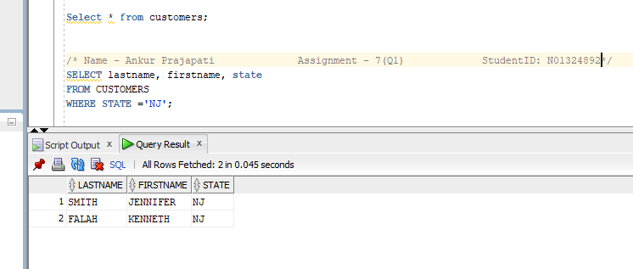

1. Which orders shipped after April 1, 2009? List each order number and the date it shipped.

**SELECT order#, shipdate**

**FROM ORDERS**

**WHERE SHIPDATE > '01-04-09';**

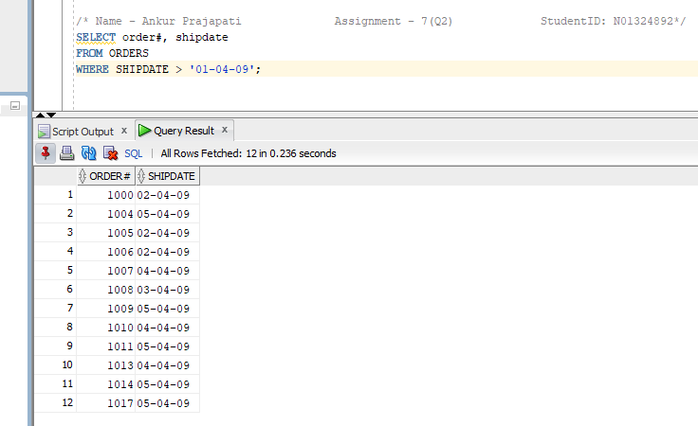

1. Which books aren’t in the Fitness category? List each book title and category.

**SELECT title, category**

**FROM BOOKS**

**WHERE CATEGORY != 'FITNESS';**

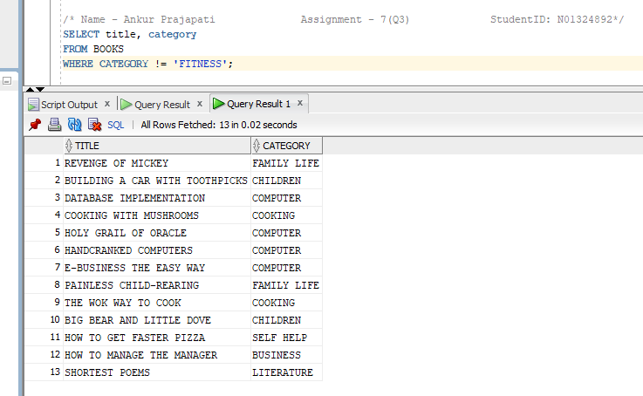

1. Which customers live in Georgia or New Jersey? Put the results in ascending order by last name. List each customer’s customer number, last name, and state. Write this query in two different ways.

**1st Way:**

**SELECT customer#, lastname, firstname, state**

**FROM CUSTOMERS**

**WHERE STATE IN ('GA','NJ')**

**ORDER BY lastname;**

**2nd Way:**

**SELECT customer#, lastname, firstname, state**

**FROM CUSTOMERS**

**WHERE STATE = 'GA' OR STATE = 'NJ'**

**ORDER BY lastname;**

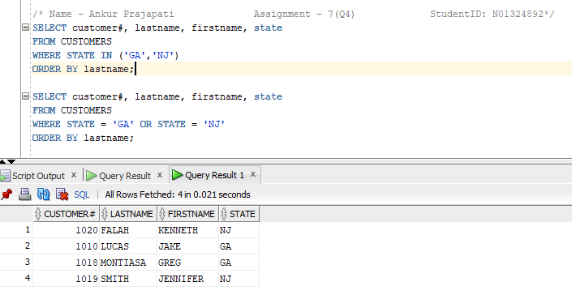

1. Which orders were placed on or before April 1, 2009? List each order number and order date. Write this query in two different ways.

**SELECT order#, orderdate**

**FROM ORDERS**

**WHERE orderdate <= '01-04-09';**

**SELECT order#, orderdate**

**FROM ORDERS**

**WHERE orderdate < '02-04-09';**

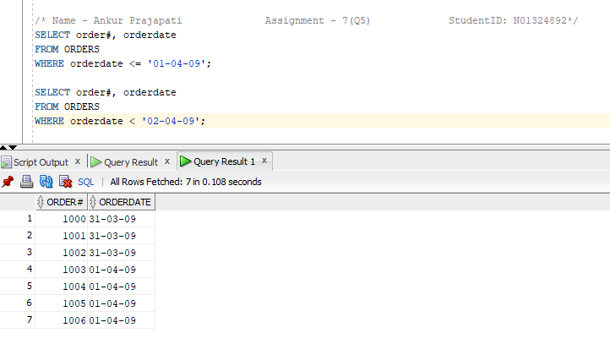

1. List all authors whose last name contains the letter pattern “IN.” Put the results in order of last name, then first name. List each author’s last name and first name.

**SELECT lname, fname**

**FROM AUTHOR**

**WHERE lname LIKE '%IN%'**

**ORDER BY lname, fname;**

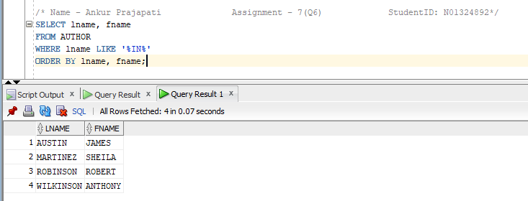

1. List all customers who were referred to the bookstore by another customer. List each customer’s last name and the number of the customer who made the referral.

**SELECT lastname, referred**

**FROM CUSTOMERS**

**WHERE REFERRED IS NOT NULL;**

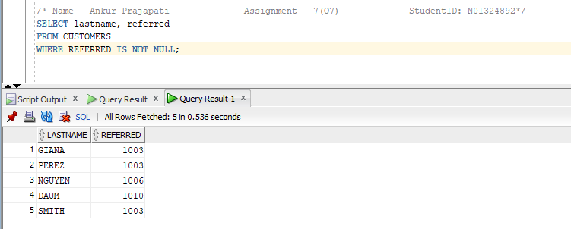

8. Display the book title and category for all books in the Children and Cooking categories. Create three different queries to accomplish this task:

a) a search pattern operation,

b) a logical operator, and

c) another operator not used in a or b.

**SELECT title, category /* Comparison Operators*/**

**FROM BOOKS**

**WHERE CATEGORY IN ('CHILDREN','COOKING');**

**SELECT title, category /*Logical Operators*/**

**FROM BOOKS**

**WHERE CATEGORY = 'CHILDREN' OR CATEGORY = 'COOKING';**

**SELECT title, category**

**FROM BOOKS**

**WHERE CATEGORY LIKE 'C%N%';**

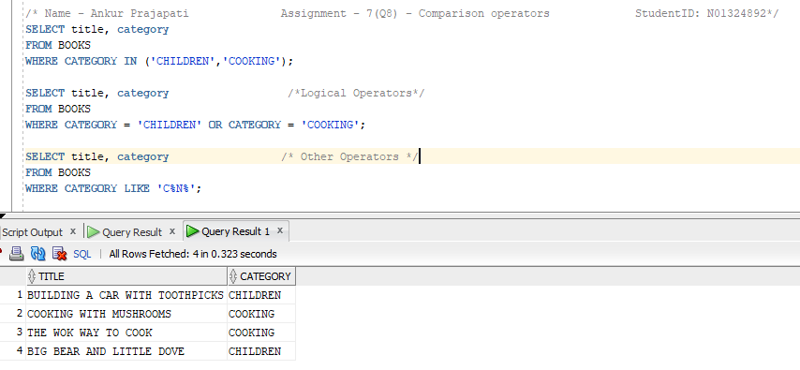

1. Use a search pattern to find any book title with “A” for the second letter and “N” for the fourth letter. List each book’s ISBN and title. Sort the list by title in descending order.

**SELECT ISBN, title**

**FROM BOOKS**

**WHERE title LIKE '_A_N%'**

**ORDER BY title DESC;**

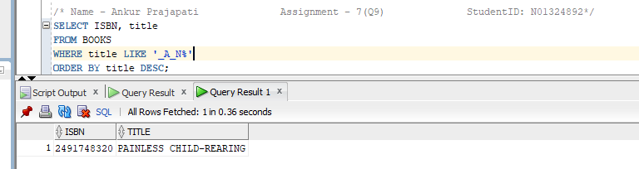

10. List the title and publish date of any computer book published in 2005. Perform the task of searching for the publish date by using three different methods:

a) a range operator,

b) a logical operator, and

c) a search pattern operation.

**SELECT title, pubdate /* Logical Operator*/**

**FROM BOOKS**

**WHERE CATEGORY = 'COMPUTER' AND PUBDATE LIKE '%05';**

**SELECT title, pubdate /* Comparison Operator*/**

**FROM BOOKS**

**WHERE (PUBDATE BETWEEN '01-01-05' AND '31-12-05') AND CATEGORY = 'COMPUTER';**

**SELECT title, pubdate /* Search Pattern Operation*/**

**FROM BOOKS**

**WHERE CATEGORY LIKE 'COM%' AND PUBDATE LIKE '%05';**

