**Assignment#1 (Week 1 Activities)**

**Ankur Prajapati (n01324892)**

1. Database Connection status: success

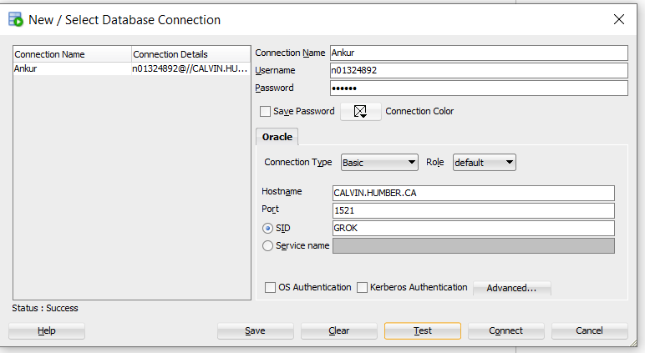

1. Connected Username:

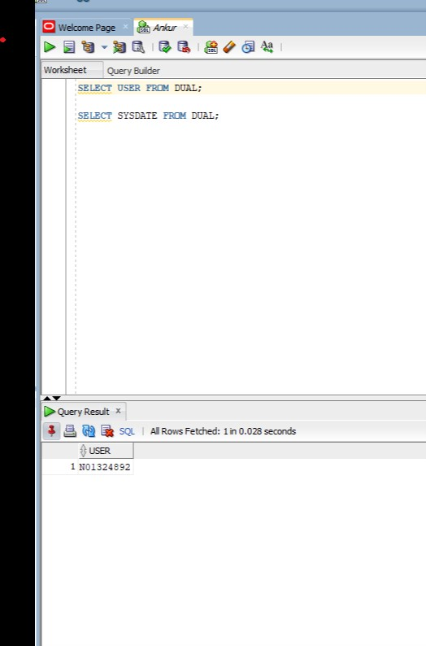

1. Display System Date:

